Project Profile
- Project Profile
Project Name: SegmentFlow SaaS
Type of Application: Web-based Application
Project Description: In the contemporary world, highly competitive business landscape, e-commerce and retail companies face the constant challenge of retaining customers and maximizing their Customer Lifetime Value (CLV). With the exponential growth of transactional data, businesses can no longer rely on intuition or broad demographic segmentation to design their marketing strategies. This necessitates a shift towards behavioral data analysis. The “SegmentFlow Platform” is conceptualized as a multi-tenant B2B Software as a Service (SaaS) solution designed to bridge this gap. SegmentFlow empowers companies to ingest massive amounts of raw transactional data and, utilizing advanced Machine Learning (ML) techniques, automatically distill it into clear, actionable customer segments and predictive insights.
Team Size: 3
Front End: React, Tailwind CSS, JavaScript, Vite
Back End: SQLite, Python-FastAPI, Uvicorn
Tools used: Visual Studio Code, SQLite Browser, Supabase

Introduction to tools

- Introduction to Tools

- Front End Tool:
- React: A JavaScript library used to build interactive and component-based user interfaces for the platform dashboard.
- Tailwind CSS: A utility-first CSS framework used for quick and consistent styling of the UI.
- JavaScript: Enables dynamic behavior and interaction within the frontend.
- Vite: A fast development and build tool used to efficiently run and bundle the frontend application.

- Back End Tool:
- Python (FastAPI): A modern backend framework used to create high-performance APIs, best for AI driven platforms and suitable for handling high traffic making it significantly faster for I/O bound tasks.
- SQLite: A lightweight relational database used to store customer, transaction, and analytics data.
- Uvicorn: It serves as the bridge between asynchronous frameworks and the web, it acts as the ‘engine’ that listens for the network requests and delivers them to your code.

- Tools:
- Visual Studio Code: The primary code editor used for developing both frontend and backend components.
- SQLite Browser: A graphical tool used to view and manage the SQLite database.
- Supabase: A backend service platform used for additional database support, integration, or extended functionality.

System Study

- System Study

- Existing System:
- The current systems used by businesses mainly rely on:
- Manual spreadsheet analysis, where marketers use tools like Excel to segment customers.
- Traditional CRM/ERP systems, which store customer data but lack advanced analytics or intelligent segmentation.
- Key Limitations:
- Manual and Time-Consuming Process: Customer segmentation (RFM analysis) is done manually, which takes a lot of time. By the time the analysis is completed, the data may already be outdated, reducing the effectiveness of marketing decisions.
- Lack of Smart Algorithms: Existing systems use fixed rules (e.g., number of purchases) to segment customers. These rules are too simple and cannot accurately reflect real customer behavior or adapt to changing trends.
- No Predictive Insights: Most systems only show past data (what happened) but do not predict future behavior, such as customer churn. Also, they do not provide suggestions for marketing actions, leaving decision-making fully manual.
- Weak Data Isolation (Multi-Tenancy Issues): Older systems may not properly separate data between different companies, leading to potential security risks and compliance issues.
- Proposed System:
- The proposed system, SegmentFlow, is an automated SaaS-based platform designed to improve customer segmentation and marketing decision-making using intelligent and data-driven techniques.
- It eliminates the need for manual data processing by introducing an automated pipeline that cleans and prepares uploaded data for analysis.
- The system ensures secure multi-tenant architecture by isolating each company’s data using a unique identifier, maintaining privacy and controlled access.
- Instead of relying on fixed rules, SegmentFlow uses machine learning, specifically the K-Means algorithm, to group customers based on their behavior such as recency, frequency, and monetary value.
- In addition to segmentation, the system also predicts customer churn by assigning a probability score, helping businesses identify customers who may stop engaging.
- Furthermore, it includes a recommendation mechanism that suggests appropriate marketing actions for each customer segment, such as rewarding loyal users or re-engaging inactive ones.
- Overall, SegmentFlow provides a smart, automated, and efficient solution that not only analyzes customer data but also guides businesses in taking effective marketing decisions.
- Scope of the Proposed System:
- The scope of SegmentFlow includes collecting and analyzing customer transaction data in a secure way for multiple companies.
- It automatically cleans and processes the data, then uses machine learning to segment customers and predict their future behavior.
- The system also suggests suitable marketing actions for each type of customer and generates reports for easy understanding.
- However, the system is limited to analysis and recommendations and does not directly perform marketing activities or deep integration with external platforms.

- Aim and Objective of the Proposed System:

- Development of SegmentFlow, an automated system for customer data analysis.
- Enabling businesses to better understand customer behavior and make informed decisions.
- Automation of data collection and processing to reduce manual effort.
- Ensuring secure and isolated data handling for multiple companies.
- Application of RFM (Recency, Frequency, Monetary) analysis to evaluate customer value.
- Use of machine learning techniques to intelligently segment customers.
- Identification of customers likely to churn through predictive analysis.
- Providing targeted marketing recommendations for different customer groups.
- Generation of clear and actionable reports for business insights.

- Feasibility Study:
          - Operational Feasibility: -
- The system is easy to use and designed for non-technical users like marketers.
- Users can simply upload data and get results without complex processes.
- It provides clear insights and reports, making it practical for real-world use.
- The system fits well into existing business workflows.

          - Technical Feasibility: -
- The system uses reliable and widely used technologies like FastAPI, React, and Python.
- Machine learning tools such as Pandas and Scikit-learn are used for data processing and customer segmentation.
- The system is capable of handling multiple users efficiently and provides fast performance.
- Overall, the required technology is available and suitable for implementing the system.

- Economic Feasibility: -

- The system is cost-effective as it uses open-source technologies, reducing development costs.
- A multi-tenant architecture allows multiple companies to share resources, minimizing infrastructure expenses.
- The system helps businesses improve marketing efficiency and reduce customer loss, providing good return on investment.

System Analysis

- Requirements Specification (along with System Modules):

- Functional Requirements:
      - The system must provide the following functionalities:
      - User registration and authentication for secure access.
      - Support for multiple companies with proper data separation.
      - Upload and processing of customer transaction data (CSV/Excel).
      - Automatic data cleaning and transformation (ETL process).
      - Calculation of RFM (Recency, Frequency, Monetary) values.
      - Customer segmentation using machine learning (K-Means clustering).
      - Prediction of customer churn probability.
      - Generation of marketing recommendations based on customer segments.
      - Visualization and reporting of customer insights.
      - Export of reports in a readable format (e.g., PDF).

- Non-Functional Requirements:
- Performance: Fast processing of data and quick API responses.
- Scalability: Ability to handle multiple companies (multi-tenant system).
- Security: Data isolation using company-based access and authentication.
- Usability: Simple and user-friendly interface for non-technical users.
- Reliability: Accurate and consistent results from analytics and predictions.
- Maintainability: Modular backend structure for easy updates and improvements.

- System Modules
- Authentication Module
- Handles user login, logout, and secure access.
- Ensures only authorized users can access the system.

- Data Ingestion Module
  - Allows users to upload customer data (CSV/Excel).
  - Stores data securely for further processing.

- ETL (Extract, Transform, Load) (Data Processing) Module
  - Cleans and transforms raw data.
  - Prepares data for analysis and machine learning.

- RFM (Recency, Frequency, and Monetary) Analysis Module
  - Calculates Recency, Frequency, and Monetary values.
  - Evaluates customer behaviour based on these metrics.

- Clustering Module
  - Uses machine learning (K-Means) to group customers.
  - Identifies different customer segments automatically.

- Churn Prediction Module
  - Predicts the probability of customer churn.
  - Helps businesses identify at-risk customers.

- Recommendation (NBA (Next Best Action)) Module
- Suggests marketing actions based on customer segments.
- Helps improve engagement and retention.

- Reporting Module
- Generates reports and visual insights.
- Allows users to export results for decision-making.

- Use Case Diagram: -
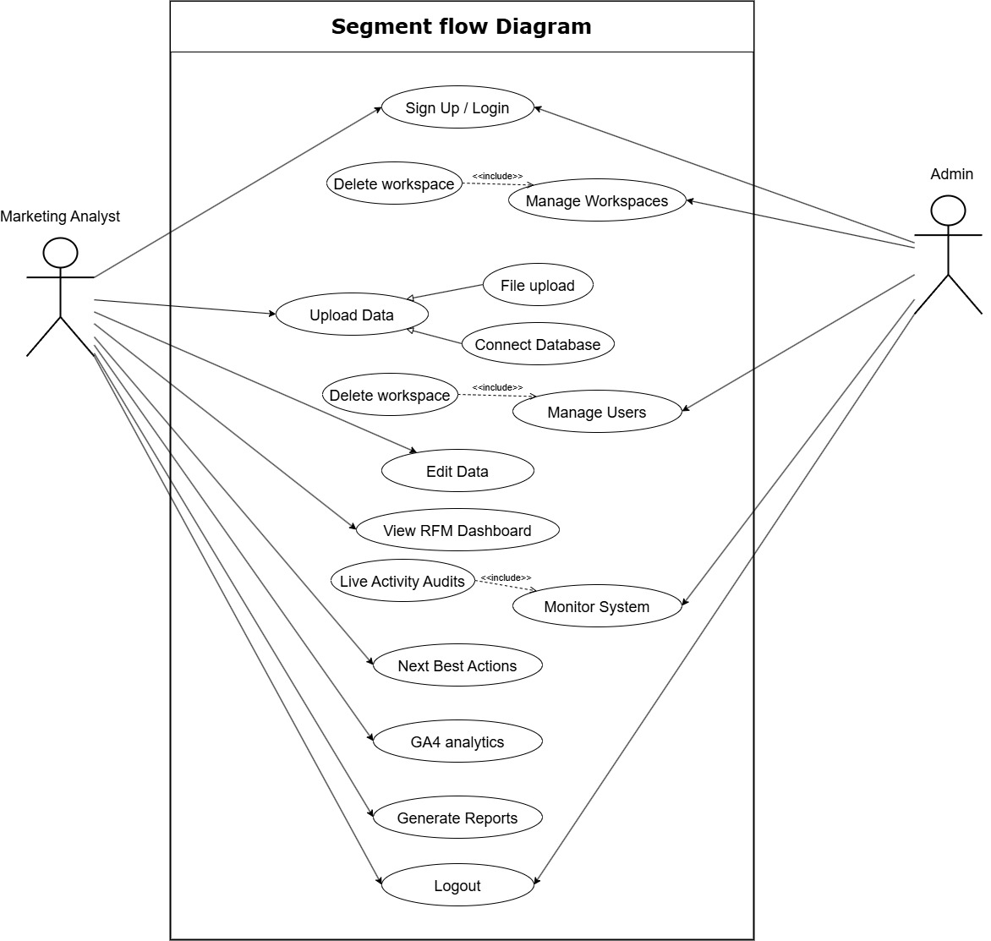
- Activity Diagram: -
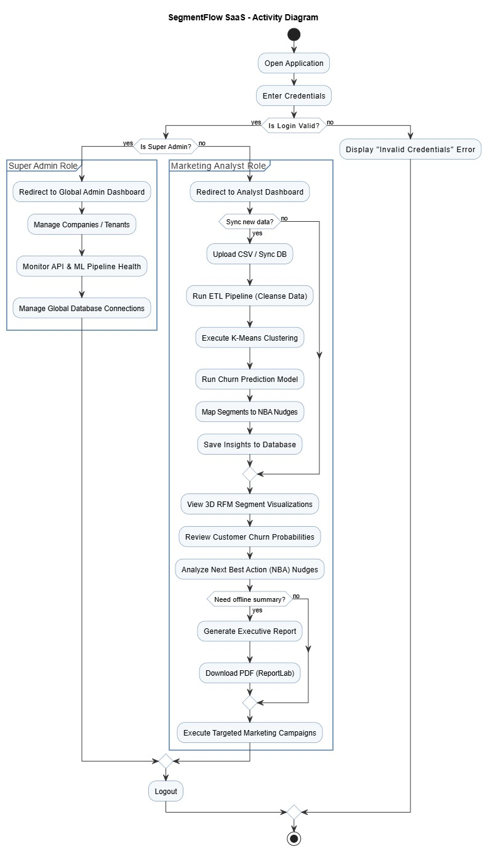
- Class Diagram: -
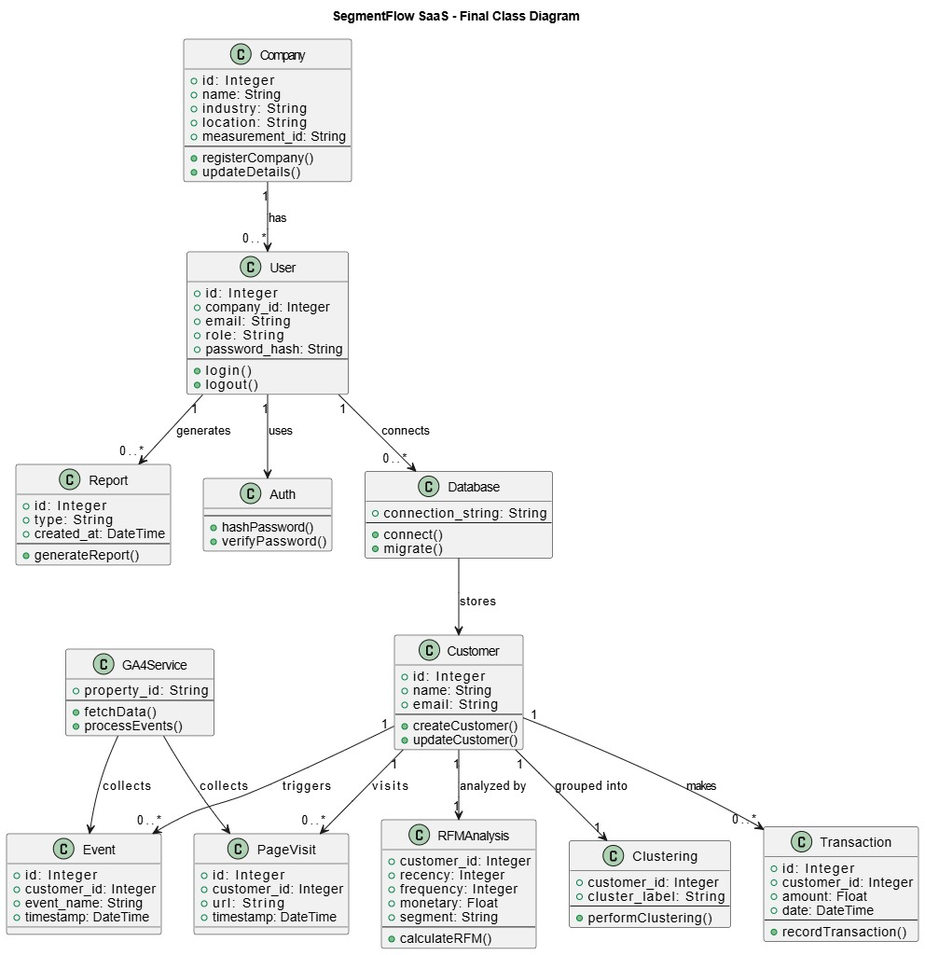

System Design

- Data Dictionary:

- User Table: -
Column | Type | Constraint | Description
id | Int | Primary key | Unique identifier for the user.
company_id | Int | Foreign Key | Reference company_id from companies table
email | Varchar | Not Null | Email address (login credential)
hashed_password | Varchar | Not Null | Encrypted user password

- Companies Table: -
Column | Type | Constraint | Description
company_id | Int | Primary key | Unique identifier for companies.
name | Varchar | Not Null | Name of the company
indusrty | Varchar | Not Null | Sector of the company
company_size | Varchar | Not Null | Number of employees
bussines_structure | Varchar | Not Null | Type of business
location | Varchar | Not Null | Location of the company
primary_objective | Varchar | Not Null | -

- Customers Table: -
Column | Type | Constraint | Description
id | int | Primary key | Unique identifier for customers.
company_id | int | Foreign key | Reference company_id from companies table
email | varchar | Not Null | Email address (login credential)
name | varchar | Not Null | Name of the customer
recency | float | Not Null
frequency | int | Not Null
monetary | float | Not Null
segment | varchar | Not Null
churn_probability | float | Not Null
clv_prediction | float | Not Null

- Database Connections Table: -
Column | Type | Constraint | Description
id | int | Primary Key | Unique database ID
company_id | int | Foreign key | Reference company_id from companies table
database_name | varchar | Not Null | Name of the database
db_type | varchar | Not Null | Type of database
host | varchar | Not Null
port | int | Not Null
username | varchar | Not Null | Name of the user
password | varchar | Not Null | Encrypted user password

- Page Visits Table: -
Column | Type | Constraint | Description
id | int | Primary Key | Unique page visit ID
company_id | int | Foreign Key | Reference company_id from companies table
url | varchar | Not Null
referrer | varchar | Not Null
user_agent | varchar | Not Null
timestamp | DateTime | Not Null | Time of the page visit

- Transaction Table: -
Column | Type | Constraint | Description
id | int | Primary Key | Unique transaction ID
company_d | int | Foreign key | Reference company_id from companies table
customer_id | int | Foreign key | Reference customer_id from customers table
amount | float | Not Null | Amount that has been transacted
date | DateTime | Not Null | Daye of transaction
transaction_ref | varchar | Not Null

- Custom EventsTable: -
Column | Type | Constraint | Description
id | int | Primary key | Unique custom events ID
company_id | int | Foreign key | Reference company_id from companies table
event_name | varchar | Not Null | Name of the event
event_data | varchar | Not Null
timestamp | DateTime | Not Null | Time of the event

- Audit Logs Table: -
Column | Type | Constraint | Description
id | int | Primary Key | Unique settings ID
user_id | int | Foreign Key | Reference user_id from user table
company_id | Int | Foreign Key | Reference company_id from companies table
action | varchar | Not Null
details | varchar | Not Null
timestamp | DateTime | Not Null | Time of the audit logs

- Screen Layouts:

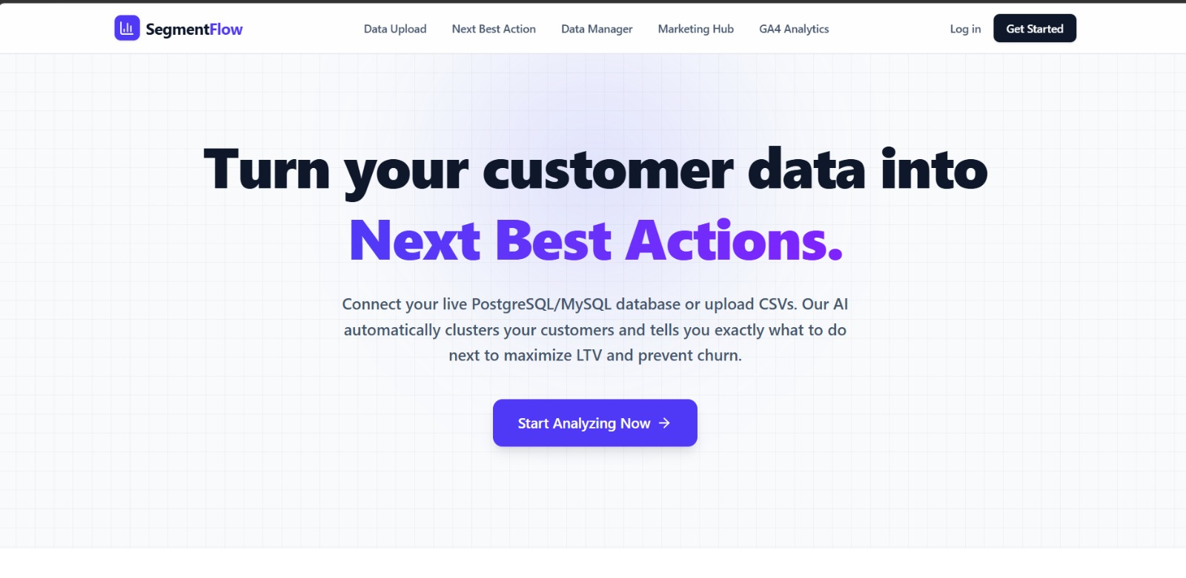

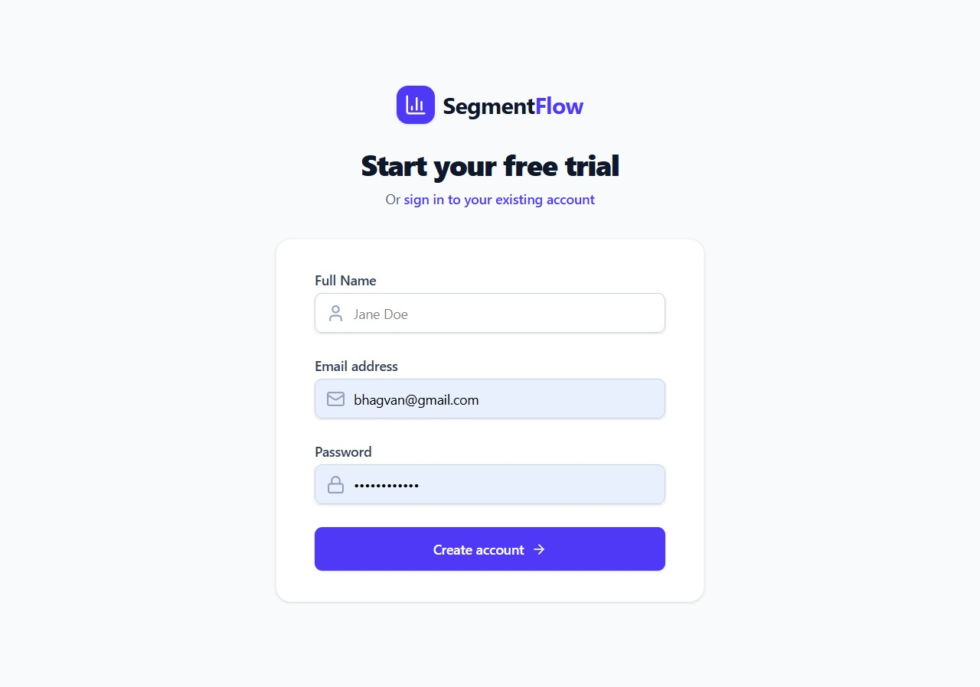

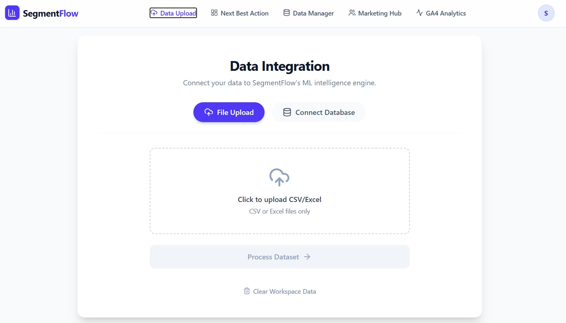

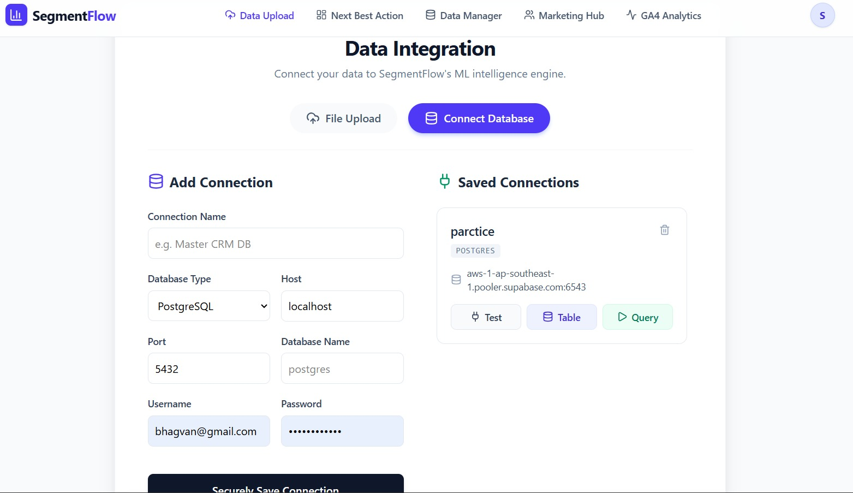

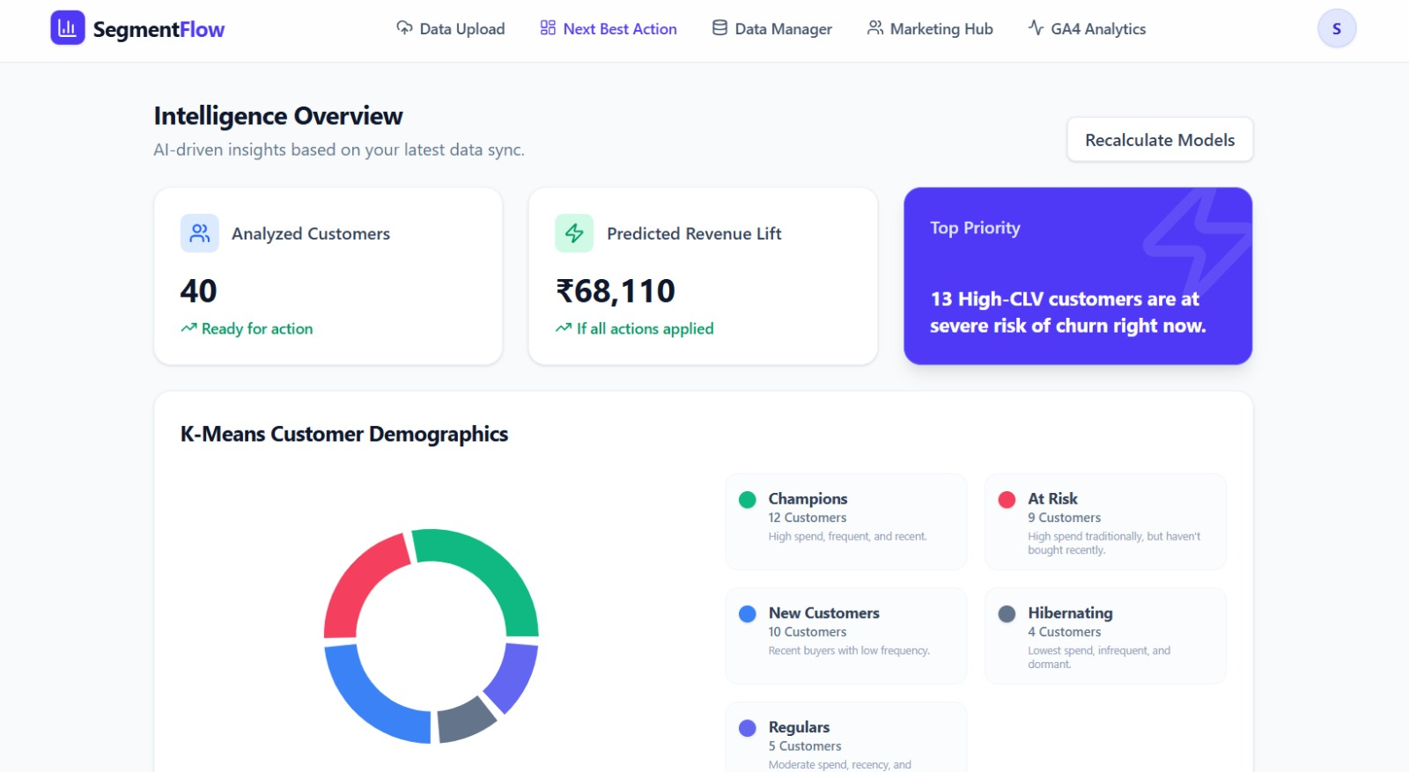

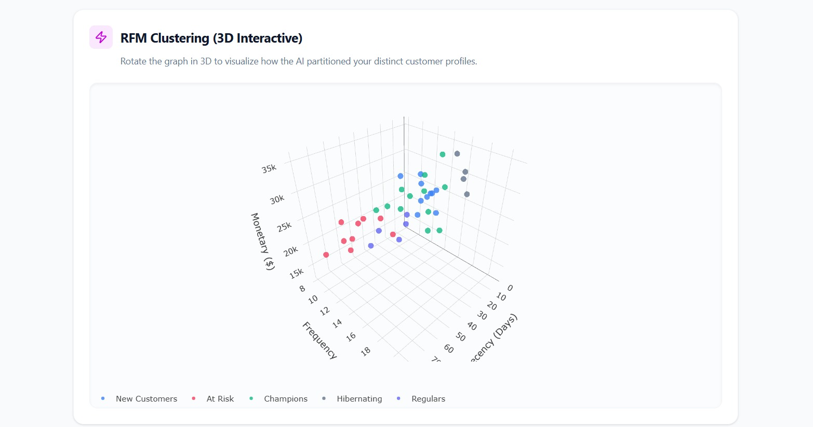

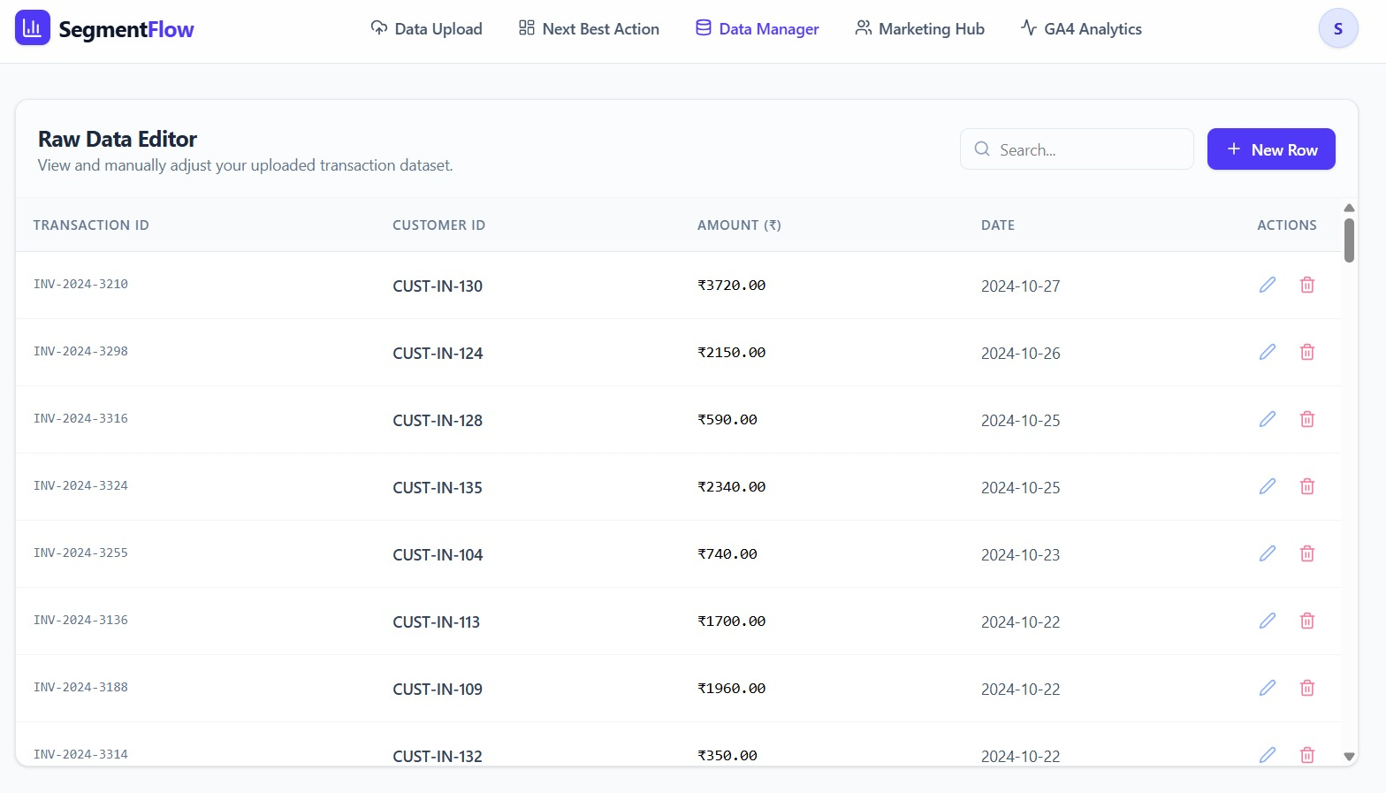

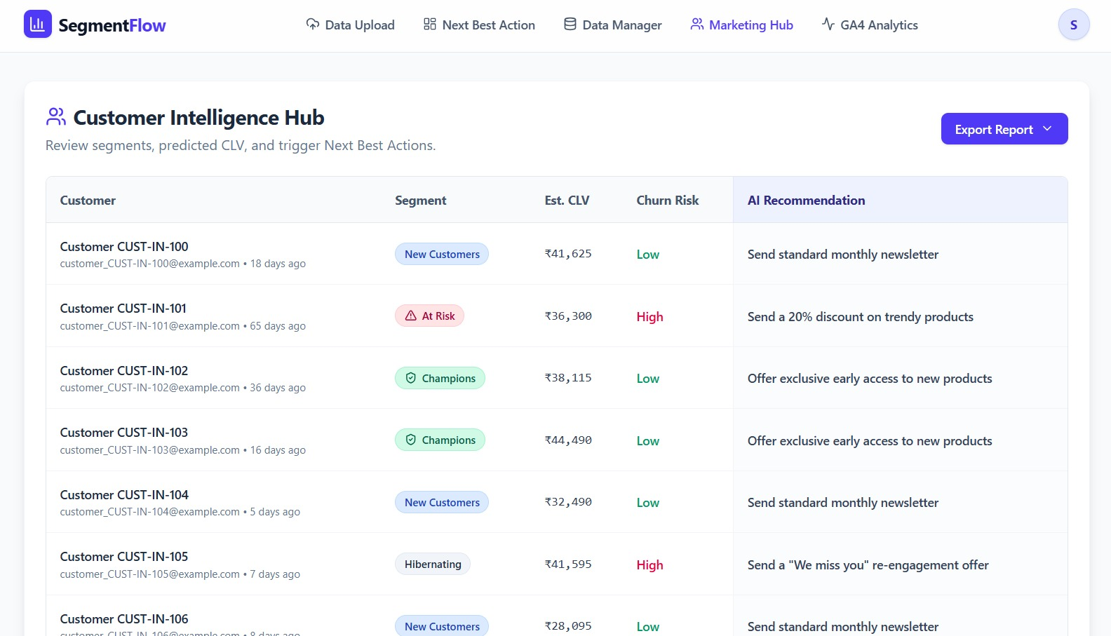

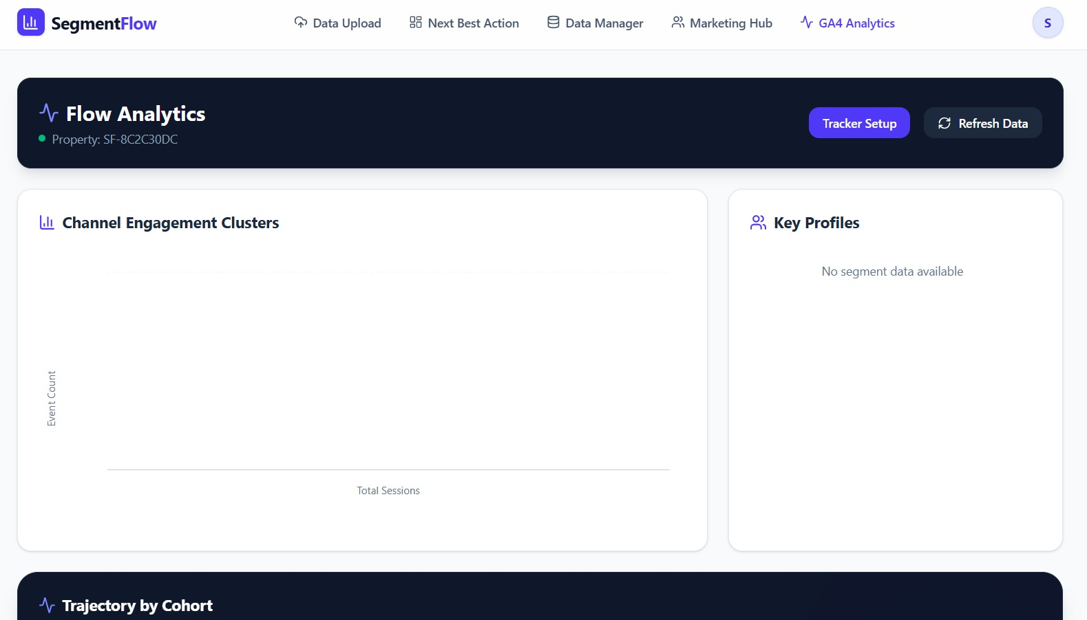

System Testing

- Testing Strategies: -

      - Unit Testing
- Unit testing is used to verify individual components of the system.
- In this project, functions such as RFM calculation, data preprocessing (ETL), and API endpoints are tested separately to ensure each module performs its intended task correctly.
      - Integration Testing
- Integration testing ensures that different modules of the system work together properly.
- For example, it checks whether data uploaded by the user is correctly processed by the ETL module and then passed to the machine learning modules for segmentation and prediction.
      - System Testing
- System testing is performed on the complete application to validate the overall workflow.
- It ensures that all features, from user authentication to report generation, work together seamlessly without errors.
      - User Interface (UI) Testing
- UI testing verifies that the frontend is user-friendly and all interface elements function correctly.
- It ensures that users can easily upload data, view results, and interact with the dashboard without confusion.
      - Performance Testing
- Performance testing evaluates how the system behaves under heavy load, such as large datasets or multiple users.
- It ensures that the system remains responsive and efficient during real-world usage.
      - Security Testing
- Security testing ensures that the system properly protects user data.
- It verifies authentication, authorization, and multi-tenant data isolation so that one company cannot access another company’s data.
      - User Acceptance Testing (UAT)
- User Acceptance Testing is conducted to confirm that the system meets user requirements.
- It ensures that the system is easy to use and provides meaningful insights for non-technical users like marketers.

- Test Cases: -

      - Security & Multi-tenancy:
Test Case ID | Feature | Scenario | Expected Result | Actual Result | Status
SEC-01 | Authentication | Access protected API without JWT | API returns 401 Unauthorized | API returned 401 Unauthorized | Pass
SEC-02 | Tenant Isolation | User tries to access another company's data | Access denied (403/404) | Access blocked with 403 Forbidden | Pass
SEC-03 | Data Isolation | Run ML model for a specific company | Only that company's data is used | Data processed only for selected company | Pass
SEC-04 | Token Expiry | Use expired JWT token | API returns 401 Unauthorized | API returned 401 Unauthorized | Pass

      - Data Ingestion & ETL:
Test Case ID | Feature | Scenario | Expected Result | Actual Result | Status
ETL-01 | Valid Upload | Upload correct CSV file | File uploaded and data stored | File uploaded successfully and stored | Pass
ETL-02 | Missing Columns | Upload CSV without required column | Validation error shown | System showed missing column error | Pass
ETL-03 | Data Cleaning | Upload data with missing/invalid values | Invalid data handled/removed | System cleaned invalid records properly | Pass
ETL-04 | Large File | Upload large CSV file | File processed without crash | File processed successfully without errors | Pass
ETL-05 | Invalid File | Upload unsupported file format | Error message displayed | System rejected file with error message | Pass

      - Machine Learning:
Test Case ID | Feature | Scenario | Expected Result | Actual Result | Status
ML-01 | RFM Calculation | Calculate RFM values | Correct RFM values generated | Correct RFM values calculated | Pass
ML-02 | Outlier Handling | Dataset with extreme values | System handles outliers properly | Outliers handled using normalization | Pass
ML-03 | Churn Prediction | Low activity customer input | High churn probability predicted | Model predicted high churn probability | Pass
ML-04 | Model Update | New data triggers model update | Updated segmentation results | Model updated and results refreshed | Pass

      - NBA (Next Best Action) Engine:
Test Case ID | Feature | Scenario | Expected Result | Actual Result | Status
NBA-01 | Champion Segment | High-value customer | Reward suggestion generated | Correct suggestion generated | Pass
NBA-02 | At-Risk Segment | Inactive high-value customer | Re-engagement offer | Correct offer suggested | Pass
NBA-03 | Low-Value Segment | Low engagement customer | Minimal-cost action | Correct action suggested | Pass

      - API & UI:
Test Case ID | Feature | Scenario | Expected Result | Actual Result | Status
API-01 | Pagination | Request paginated data | Correct records returned | Correct records returned | Pass
API-02 | Report Generation | Export report | Report generated successfully | Report downloaded successfully | Pass
UI-01 | Visualization | Load clustering graph | Graph displayed properly | Graph loaded correctly | Pass
UI-02 | Empty State | No data available | "No Data" message shown | Message displayed correctly | Pass
UI-03 | Invalid Upload UI | Upload invalid file | Error message shown | Error shown correctly | Pass

Future enhancement

- Future Enhancement: -

- Visual Query Builder:
- Implement a drag-and-drop UI for no-code data exploration, allowing users to select tables, filter, and aggregate metrics visually.

- Generative AI (NBA):
- Replace hardcoded rules with an LLM-driven "Next Best Action" engine to create personalized marketing copy and subject lines based on individual purchase history.

- CLV Forecasting:
- Shift from binary churn alerts to predictive revenue modeling using probabilistic models (BG/NBD, Gamma-Gamma) or LSTMs to forecast 12-month customer value.

- GA4 Data Enrichment:
- Integrate SegmentFlow with GA4 to append Traffic Source data, enabling the ML engine to analyze how acquisition channels (e.g., Paid Social vs. SEO) impact long-term churn.

bibliography/
references

