**ID:** BC200401263 **Name:** Imtenan Ahnaf

**Instructions**

1. **Upload your project to GitHub.**

Link: <https://github.com/ImtananAhnaf/DialogFlow_Chatbot_Prototype.git>

1. **Create a PowerPoint presentation covering all the key concepts of your project. The presentation should be professional, concise, and to the point. Use simple and clear language, as if you were presenting this to a client or as part of a start-up pitch.**

**You may use ChatGPT for assistance, but make sure you understand and can explain the concepts. Avoid just copying and pasting.**

Presentation has been developed and attached.

1. **Include all relevant screenshots and diagrams to illustrate the project's features, design, and functionality.**

All requirements are fulfilled, and also pasted in presentation.

1. **Include the GitHub link to your project in the PowerPoint presentation.**

Requirement fulfilled.

1. **Zip the presentation and upload it to the LMS.**

Done, and currently my work is continue related to the prototype.

1. **Screenshot(s)**

**1-Login Page:**

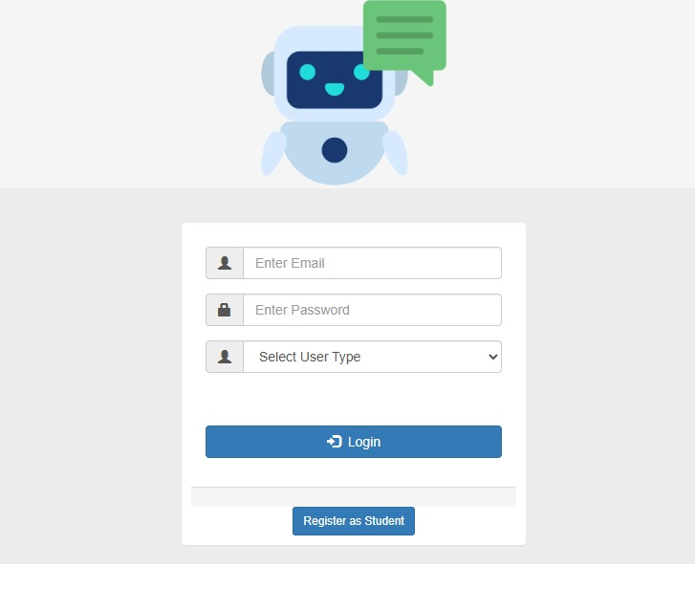

**2-Registration Page:**

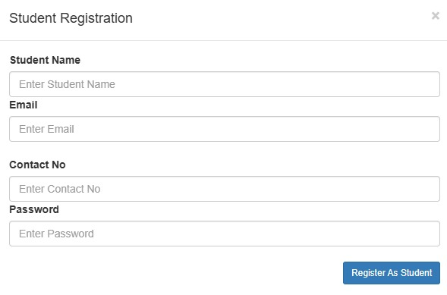

**3-Student Dashboard Page:**

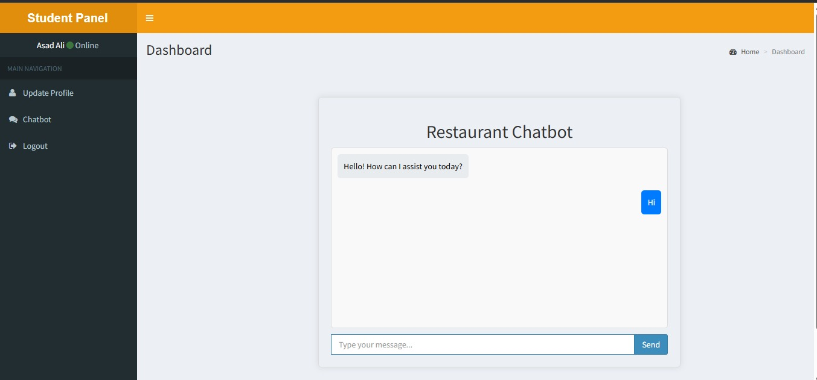

**4-Admin Dashboard Page:**

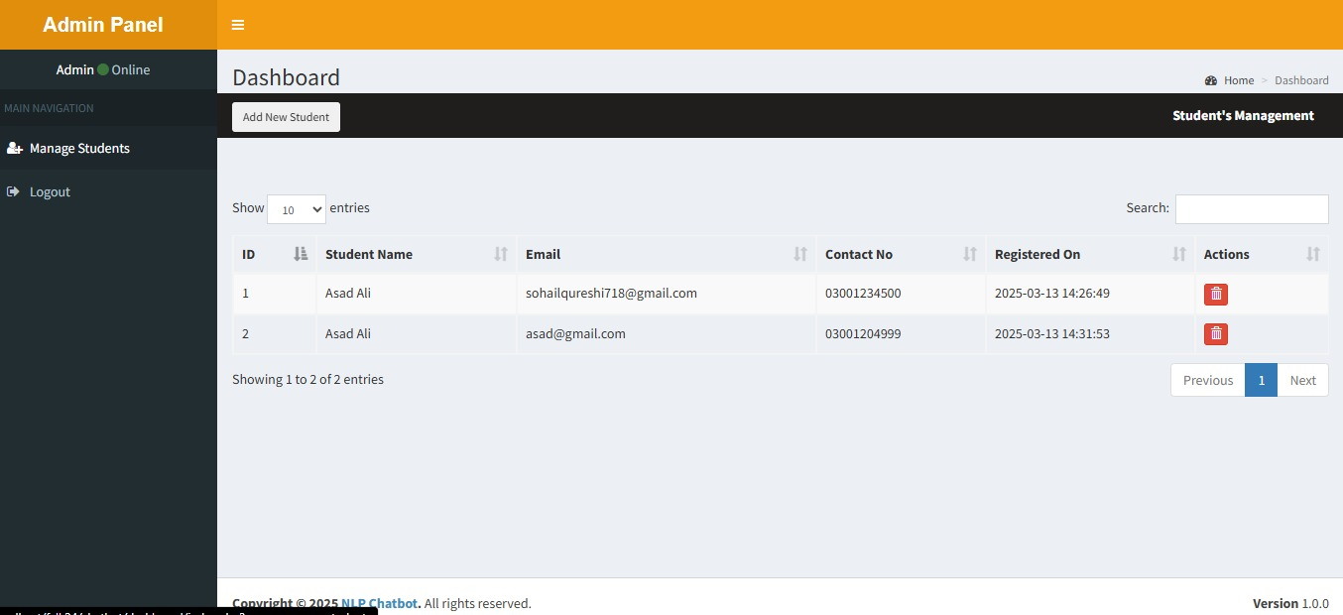

**5-Database:**

