Curriculum Vitae 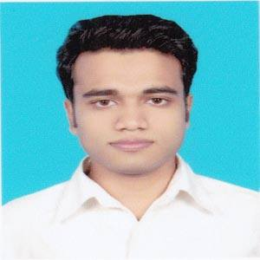
Of
Kazi Imtiaj Ahammed
Contact NO: +8801738-185495
E-Mail:imtiaj6498@gmail.com
CAREER OBJECTIVES

To Develop a Career in a renowned organization that provides structured career advancement and where I will get the opportunities to build up a career and be a part of the organization growth utilizing experiences, hard work and honesty.
EDUCATIONAL QUALIFICATION S

Secondary School Certificate (SSC)
Institute Name : Patuakhali Govt. Jubilee High School
Group : Science
Passing Year : 2014
Result : 5.00 out of 5.00
Grade : A+
Board : Barisal

Higher Secondary Certificate (HSC)
Institute Name : Patuakhali Govt. College
Group : Science
Passing Year : 2016
Result : 4.92 out of 5.00
Grade : A
Board : Barisal

Bachelor Of Science (B.SC)
Institute Name : Tejgaon University And College
Subject : Computer Science And Engineering
Passing Year : Running

COMPUTER EXPERTISE

Languages : C, HTML, HTML5,JAVASCRIPT,PHP,PYTHON.
Web Design : HTML, HTML5, CSS3, BOOTSTRAP,JQUERY,PHP,PYTHON.
Devloper : WordPress , Laravel 8.x
Operating Systems : Windows® XP, Windows 7, 8, 8.1 & Windows 10
Graphics Software : Adobe Photoshop
Typing Speed : Bangla-20 & English-30

Good command over speaking, writing & communication skill in English and Bangla
COMPUTER SKILLS

- Microsoft Word
- Microsoft PowerPoint
- Internet Browsing and E-mail correspondence
PERSONAL DETAILS

Father’s Name : Kazi Mostafa Harun
Mother’s Name : Mst. Israt Jahan

Permanent Address:
Vill : Lohalia
P/O : Patuakhali
P/S : Patuakhali Sadar
DIRST : Patuakhali

Present Address:
: House-386, Khan Manjeel, Road No.12,
Shahinbag, Tejgoan, Dhaka-1215

Date of Birth : 06.04.1998
Religion : Islam
Blood Group : B+
Nationality : Bangladeshi
Sex : Male
Marital Status : Unmarried
Height : 5’7”

REFERENCES

Mohammad Abdul Hadi Mohammad Faruk Ahmed Bhyua
Chairman Senior Vice President and
Computer Science & Engineering (CSE). Head of Asset Operations
Tejgaon College, Dhaka LankaBangla Finance Limited
Cell No. +8801746167075 Cell No.01711395865
E-mail: hadiblu@gmail.com E-mail:faruk.ahmed@lankabangla.com
SIGNATURE

I, hereby declare that the information is correct.
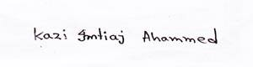
Kazi Imtiaj Ahammed

