Adding Technology Stocks to a Coffee, Cocoa and Sugar Portfolio
Analyst report on returns, risk and diversification
Prepared by Abdulazeez Imtisal Saidu
October 2026

1. Summary
The firm investing in coffee, cocoa and sugar and is considering an expansion into technology stocks. This report compares ten large technology companies with those three commodities and asks one practical question: how much technology should be added so that the firm gains exposure to the new market without taking on more risk?
The main findings are as follows.
- Technology earned far more than commodities. Since January 2015 the ten technology stocks earned between 1% and 53% a year (the commodities earned 3% to 6%), and six of the ten were above 20%. Risk, however, was similar for the two groups.
- Technology and commodities rarely move together. Daily price changes in the commodities were almost unrelated to those of the technology stocks, which is what makes mixing them useful.
- A mix has lower risk than either group alone. Risk was lowest when about 40% of the money was in technology. At that mix the annual return was 11.4%, against 4.8% for commodities alone, and risk fell by about one fifth.
Recommendation: place between 30% and 50% of the portfolio in a spread of technology stocks if the aim is the lowest risk. If the firm is willing to hold the same risk it has today and wants more return, it can go as high as 70% to 80% technology. In both cases the money should be spread across several companies instead of resting on one.

2. Why this analysis
Commodity prices depend on weather, harvests and trade conditions, while technology share prices depend on company earnings and investor mood. Because these forces are different, a portfolio holding both may be steadier than one holding either. The idea that combining assets that do not move together reduces overall risk is the basis of modern portfolio theory (Markowitz, 1952). This report tests that idea on real prices and turns the result into a clear suggestion for the investment committee.

3. Data and method

3.1 Data
Daily closing prices were downloaded from Yahoo Finance (2026) for ten technology companies: Apple (AAPL), Amazon (AMZN), Alibaba (BABA), Salesforce (CRM), Meta, formerly Facebook (META), Alphabet (GOOG), Intel (INTC), Microsoft (MSFT), Nvidia (NVDA) and Tesla (TSLA). The same source supplied daily futures prices for coffee (KC), cocoa (CC) and sugar (SB). All series start in January 2015 and run to the most recent day available when the data was downloaded, so every asset is judged over the same period.

3.2 Steps
First, the closing prices were loaded and the last price, the total percentage gain and the month-end prices were found for each asset. Second, daily returns were calculated, meaning the percentage change in price from one day to the next. The average daily return was scaled to a yearly figure (annual return), and the spread of daily returns was scaled to a yearly figure as well (annual volatility, which is the standard measure of risk). Third, a return-per-risk ratio was obtained by dividing annual return by annual volatility, so that assets can be compared fairly. Fourth, a correlation was computed for every pair of assets. A correlation near 1 means two assets rise and fall together, and a value near 0 means they move independently. Finally, portfolios were built that begin with equal amounts of the three commodities, then move money into technology in steps of 10%, with the technology share divided equally among the ten stocks. Return and risk were measured at each step using days on which all thirteen assets traded.

4. Findings

4.1 How each asset performed
Table 1 summarizes all thirteen assets. Among the technology stocks, Meta has the highest closing price at about $721, followed by Microsoft at about $530. Nvidia has had by far the largest percentage gain, roughly 47,000% since January 2015, ahead of Tesla (about 2,500%) and Amazon (about 1,600%). Part of this reflects how low Nvidia's price was in 2015 after adjusting for share splits (see Figure 1). Alibaba is the weakest, with a gain of only about 3%.
Table 1. Performance of the thirteen assets, January 2015 to the latest data, sorted by percentage gain
Asset | Group | Last close | Gain since 2015 (%) | Annual return | Annual volatility | Return per risk
NVDA | Tech | 237.47 | 47,087 | 53% | 48% | 1.11
TSLA | Tech | 377.81 | 2,484 | 28% | 57% | 0.50
AMZN | Tech | 259.92 | 1,585 | 24% | 33% | 0.74
GOOG | Tech | 347.37 | 1,227 | 22% | 29% | 0.77
AAPL | Tech | 336.67 | 1,132 | 22% | 29% | 0.76
MSFT | Tech | 529.76 | 1,033 | 21% | 28% | 0.76
META | Tech | 721.31 | 819 | 19% | 38% | 0.50
CRM | Tech | 224.56 | 279 | 12% | 36% | 0.33
INTC | Tech | 113.12 | 211 | 10% | 43% | 0.23
Cocoa (CC) | Commodity | 5,535.00 | 89 | 6% | 39% | 0.15
Coffee (KC) | Commodity | 289.25 | 80 | 5% | 34% | 0.14
Sugar (SB) | Commodity | 20.86 | 47 | 3% | 29% | 0.12
BABA | Tech | 107.00 | 3 | 1% | 42% | 0.02
Note: stock prices are in US dollars. Coffee, cocoa and sugar are futures prices in the units quoted by Yahoo Finance. Volatility is the standard measure of risk.
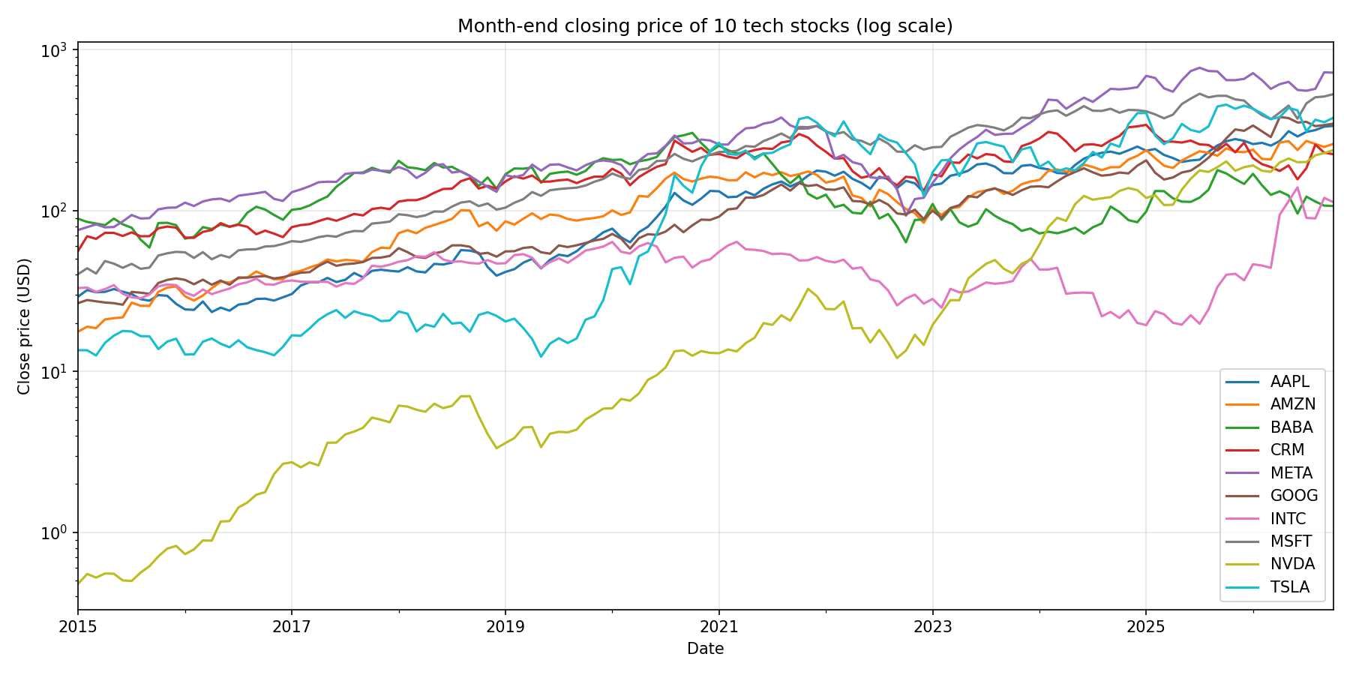
Figure 1. Month-end closing price of the ten technology stocks (log scale, so equal vertical distances mean equal percentage changes).
Figure 1 also shows that most of the stocks fell together in early 2020 and again during 2022. Technology stocks therefore protect one another only partly in a downturn, which is one reason to look beyond technology for diversification.

4.2 Return and risk compared with commodities
Figure 2 plots each asset by its risk (horizontal) and return (vertical). The three commodities sit near the bottom of the chart. They earned 3% to 6% a year while carrying risk of 29% to 39%, which is about the same as most technology stocks. Microsoft, Apple and Alphabet had the lowest risk of all assets (about 28% to 29%) and still returned 21% to 22% a year. Nvidia stands apart with a return of about 53%, and Tesla is the riskiest asset at about 57%.
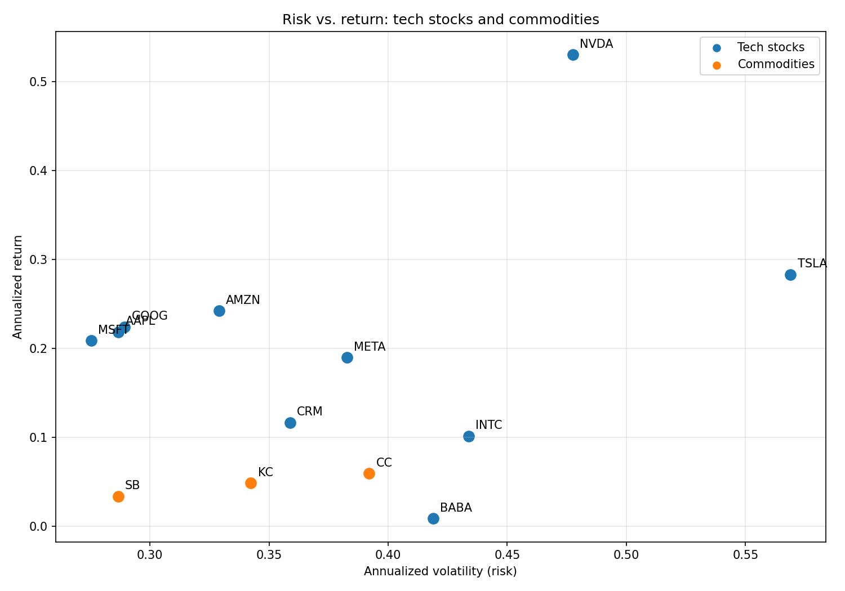
Figure 2. Risk and return of the technology stocks (blue) and commodities (orange).

4.3 Do they move together?
Correlations between pairs of technology stocks were moderate, mostly between about 0.3 and 0.6, so they tend to rise and fall together. Correlations between a commodity and any technology stock were between 0.01 and 0.09, which is almost no relationship. The three commodities were also only weakly related to one another (0.09 to 0.19). This is the strongest evidence for diversification: a bad month for technology says very little about what coffee, cocoa or sugar will do.

4.4 What happens when technology is added
Table 2 and Figure 3 show the effect of moving money from commodities into technology. With no technology the portfolio returned 4.8% a year with risk of 22.3%. As technology was added, return rose steadily, and risk fell until technology reached about 40% of the portfolio, where risk was lowest at 18.0%. After that point, risk began to climb because the portfolio became dominated by technology stocks, which are more volatile than the combination.
Table 2. Portfolio return and risk as the technology share increases
Technology share (%) | Annual return | Annual volatility | Return per risk
0 | 4.8% | 22.3% | 0.215
10 | 6.5% | 20.6% | 0.314
20 | 8.1% | 19.2% | 0.422
30 | 9.7% | 18.3% | 0.532
40 | 11.4% | 18.0% | 0.633
50 | 13.0% | 18.3% | 0.714
60 | 14.7% | 19.1% | 0.769
70 | 16.3% | 20.4% | 0.800
80 | 18.0% | 22.1% | 0.813
90 | 19.6% | 24.2% | 0.812
100 | 21.3% | 26.4% | 0.804
Note: the starting portfolio is an equal split of coffee, cocoa and sugar, and the technology share is divided equally among the ten stocks.
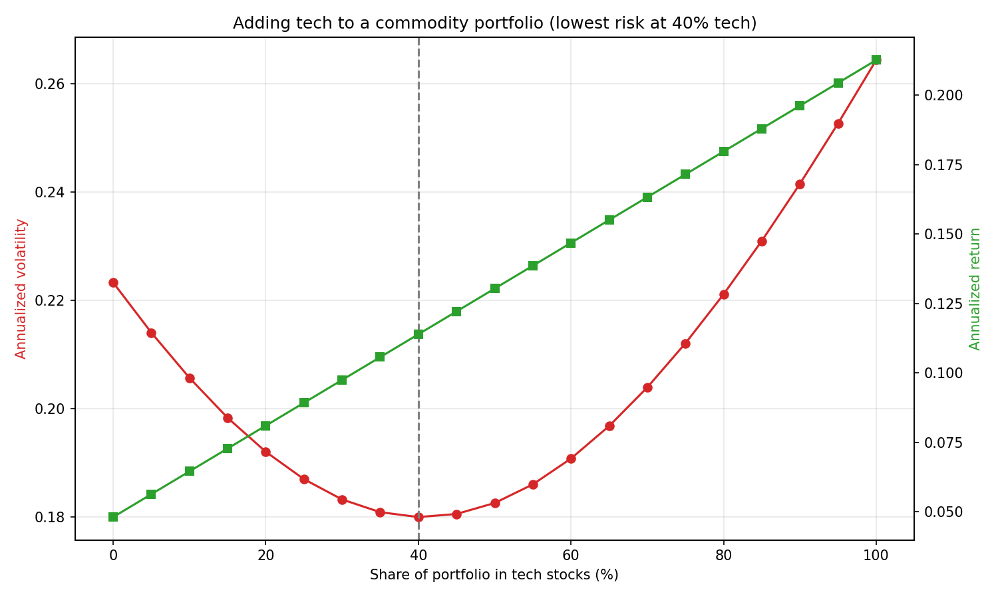
Figure 3. Risk (red, left axis) and return (green, right axis) as the technology share rises. The two lines use different scales, so the point where they cross has no meaning.
Three points stand out. First, going from 0% to 40% technology cut risk by about 19% (from 22.3% to 18.0%) while more than doubling the return. Second, the lowest-risk zone is wide: anything from 30% to 50% technology kept risk between 18.0% and 18.3%, so the exact figure does not need to be hit. Third, at 80% technology the portfolio returned about 18.0% with risk of 22.1%, which is almost the same risk as the commodity-only portfolio, and this mix had the best return per unit of risk (0.813).

5. Recommendation
The results support adding technology stocks to the commodity portfolio. The size of the allocation depends on the firm's priority.
- To minimize risk: hold 30% to 50% in technology. Risk falls to about 18% and the return rises to roughly 10% to 13% a year.
- To raise return at today's level of risk: hold 70% to 80% in technology. Risk is about the same as for commodities alone, while the return is about 16% to 18% a year.
- To avoid concentration: spread the technology share across several companies. Holding a single stock, and in particular a very volatile one such as Tesla, would remove much of the benefit.
A sensible first step would be an allocation of about 30% to 40% technology, which captures nearly all of the risk reduction, and then a review as the firm gains experience with the new holdings.

6. Limitations
- The past is not a forecast. Technology returned unusually well after 2015, partly because of a few winners such as Nvidia and Tesla. Future returns may be lower.
- Equal weights only. Each group was split equally. A mathematically optimized mix might do somewhat better, but it would also be more likely to depend on past quirks.
- Futures prices. Commodity prices come from futures contracts, which are replaced when they expire. These changeovers can cause price jumps and may overstate commodity volatility slightly.
- Simple risk measure. Volatility treats upward and downward swings alike and does not capture rare crashes. Costs, taxes and currency effects were not included.
- Correlations can change. In a severe market crisis, assets that normally move independently can fall together.

References
Markowitz, H. (1952). Portfolio selection. The Journal of Finance, 7(1), 77–91.
Yahoo Finance. (2026). Historical prices for AAPL, AMZN, BABA, CRM, META, GOOG, INTC, MSFT, NVDA, TSLA, and coffee, cocoa and sugar futures [Data set]. https://finance.yahoo.com

