**Kubernetes Architecture Explained**

* [Control Plane (Master Node Components)](https://github.com/Imtiyaj5791/kubestarter/blob/main/kubernetes_architecture.md#control-plane-master-node-components)
* [Worker Node Components](https://github.com/Imtiyaj5791/kubestarter/blob/main/kubernetes_architecture.md#worker-node-components)
* [Other Components](https://github.com/Imtiyaj5791/kubestarter/blob/main/kubernetes_architecture.md#other-components)

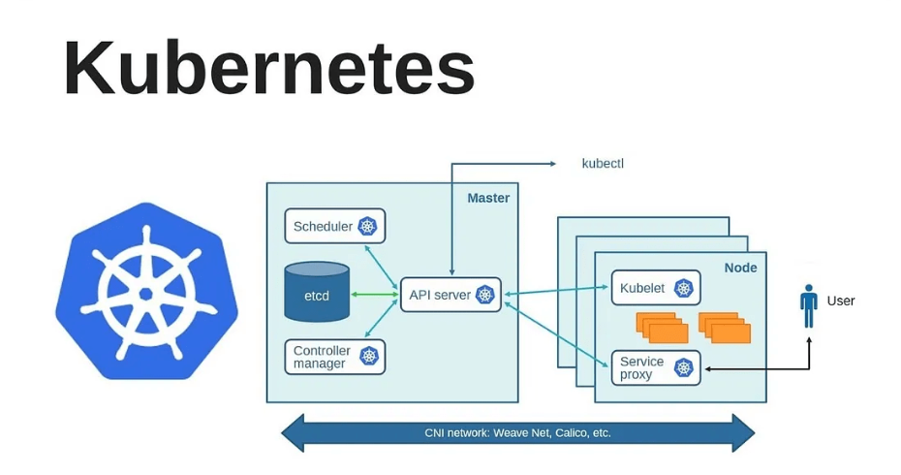**Control Plane (Master Node Components)  
  
API Server: -** This is the "front desk" of Kubernetes. Whenever you want to interact with your cluster, your request goes through the API Server. It validates and processes these requests to the backend components.  
  
**etcd: -** Think of this as the "database" of Kubernetes. It stores all the information about your cluster—what nodes are part of the cluster, what pods are running, what their statuses are, and more.  
  
**Scheduler: -** The "event planner" for your containers. When you ask for a container to be run, the Scheduler decides which machine (Node) in your cluster should run it. It considers resource availability and other constraints while making this decision.

### **Controller Manager: -** Imagine a bunch of small robots that continuously monitor the cluster to make sure everything is running smoothly. If something goes wrong (e.g., a Pod crashes), they work to fix it, ensuring the cluster state matches your desired state. **Cloud Controller Manager: -** This is a specialized component that allows Kubernetes to interact with the underlying cloud provider, like AWS or Azure. It helps in tasks like setting up load balancers and persistent storage.

## **Worker Node Components: -**

### **Kubelet: -** This is the "manager" for each worker node. It ensures all containers on the node are healthy and running as they should be. **kube-proxy: -** Think of this as the "traffic cop" for network communication either between Pods or from external clients to Pods. It helps in routing the network traffic appropriately. **Container Runtime: -** This is the software used to run containers. Docker is commonly used, but other runtimes like containerd can also be used.

## **Other Components: -**

### **Pod: -** The smallest unit in Kubernetes, a Pod is a group of one or more containers. Think of it like an apartment in an apartment building. **Service: -** This is like a phone directory for Pods. Since Pods can come and go, a Service provides a stable "address" so that other parts of your application can find them. **Volume: -** This is like an external hard-drive that can be attached to a Pod to store data. **Namespace: -** A way to divide cluster resources among multiple users or teams. Think of it as having different folders on a shared computer, where each team can only see their own folder. **Ingress: -** Think of this as the "front door" for external access to your applications, controlling how HTTP and HTTPS traffic should be routed to your services.

**How to Create a K8s Cluster: -**

**EC2 with kubeadm**

**Minikube (K8s in a Docker container)**

**KinD (K8s in Docker)**

**KinD (Master and worker are container)**

**Managed Kubernetes (EKS, AKS, GKE)**

**KillerKoda**

**Rancher**