**A VISIT TO SHEDUA COMMUNITY**

Background

On Friday, 22nd April, 2022, Mr. Paul A. Asianab, Chief Executive Officer and Founder of the Heritage for Voluntary Partnership Initiative(H4VPI) in the company of some friends embarked on a trip to a community called Shedua in the Kunbungu district to make a donation to school children in the community. The visit was following stories Mr. Asianab had heard about the deplorable state of education in the community. The rationale for the visit was therefore, to ascertain at first hand, the realities of the educational situation in the community.

Community Profile

Shedua is a small community located about 8 kilometers from the Kunbungu District capital of the Northern region of Ghana. It is predominantly an Islamic community with spots of Christians who are mostly Catholics. Agriculture is the main economic activity of the community.

Shedua has a very youthful population. Children of school going ages in the community are disadvantaged because they neither have schools nor qualified teachers in the community. The nearest community where basic education can be accessed is about 5 kilometers from Shedua. Children desiring to acquire basic education either have to walk 10 kilometers or more each day or forget about education altogether. This is especially so for children who are between the ages of 4 years and 10 years.

Voluntary Services by a community member, Zenabu Mahami

To keep the hopes for a brighter future alive for the poor children in Shedua community, Mahami Zenabu, a Junior High School dropout took the initiative to voluntarily help the underprivileged children in her community. Zenabu has been volunteering for the past seven (7) years without any form of financial support from the education authorities or the community. Her efforts at keeping hopes alive for this future generation are further exacerbated by the non-existence of classrooms and teaching and learning materials for effective teaching and learning. Teaching is done under trees and at the mercy of the weather. Children sit on the bare floor for lessons and have no books and writing materials. Zenabu, the volunteer teacher has no opportunities for capacity building. The educational challenges are numerous!

Donation to Shedua Community by H4VPI

Presenting some educational materials to the children, Mr. Paul A. Asianab of H4VPI indicated that the materials were mobilized from the individual resources of himself and his friends. He added that, the gesture was H4VPI’s small way of contributing to the educational development of the young ones. The materials included chalk, textbooks, copy books, exercise books, pencils, story books and a cash donation to Zenabu. Receiving the items on behalf of the children, a community elder and Zenabu thanked H4VPI and said that the materials will go a long way to help them.

Brief Profile of H4VPI

Heritage for Voluntary Partnership Initiatives (H4VPI) is a voluntary non-profit organization established with the sole aim of creating opportunities for the empowerment of the vulnerable in society and providing educational support to deprived children in rural communities in Northern Ghana. It largely depends on support in the form of cash and kind, from international volunteers, groups and individuals donations, who are touched by the need to contribute to empower the vulnerable and meeting the educational needs of the child in rural Ghana. It focuses primarily on rural communities deprived of basic social amenities.

**Mission**

To become essential in contributing to creating opportunities for deprived women and children.

**Vision**

To be the most desired, efficient and charitable organization to create socioeconomic opportunity for the vulnerable.

**Projects of H4VPI**

**H4VPI runs two (2) broad humanitarian centered projects;**

**Basic Education Foundation Project (BEFoP)**

H4VPI is a voluntary organization that focuses on the provision of educational needs to basic schools in northern Ghana. Its BEFoP is committed to supporting basic schools through voluntary support in kind and in cash, to among others, undertake the following;

* donating teaching and learning materials
* collaborating for voluntary teaching and mentoring
* internship support activities
* soliciting assistance to provide school equipment
* developing proposals to fund the construction of school infrastructure
* providing guidance and advisory support for pupils and teachers.

Volunteers who travel to northern Ghana are expected to support this project serving as teachers, mentors, counselors and donate in cash and kind to beneficiary schools.

**Bordewick-Dell Empowerment Project (BDEP)**

BDEP is a project initiative under H4VPI that undertakes various livelihood development projects to promote empowerment of the vulnerable. The project is a collaboration between H4VPI and the Bordewick-Dell family in Germany, who raise support and recommend volunteers, students and family, who wish to travel to Ghana to support the work of H4VPI with focus on the following project areas.

* Entrepreneurial training and capacity building for vulnerable groups
* Providing livelihood schemes for vulnerable groups
* Internship support activities
* Supporting Self-Help projects
* Cross cultural and transformation learning

All projects are funded by friends and volunteers who wish to support a humanitarian course.

H4VPI Supports Education Needs at Shedua Community

Education changes the world! Access to quality education is therefore key to global development. Unfortunately, not all children have access to quality education. For most of these kids, it doesn’t take much to put smiles on their faces. Heritage for Voluntary Partnership Initiative(H4VPI) is an NGO working to partner with individuals, groups and organizations to create opportunities for the underprivileged in society to live dignified lives.

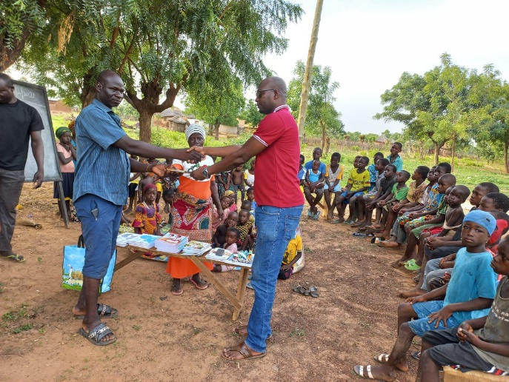 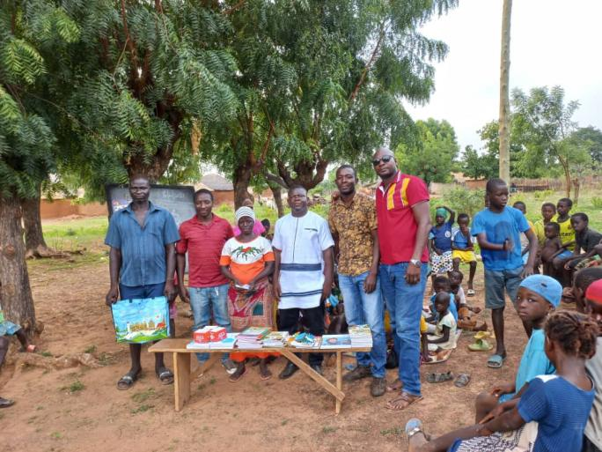

**Presentation to community elder H4VPI Team with Zenabu and Elder**

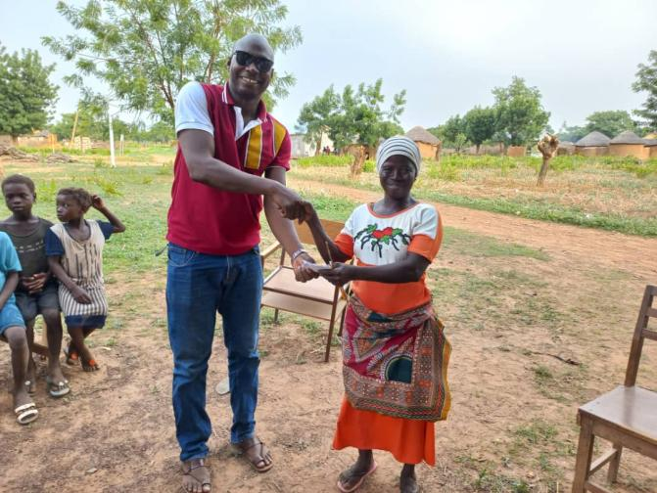 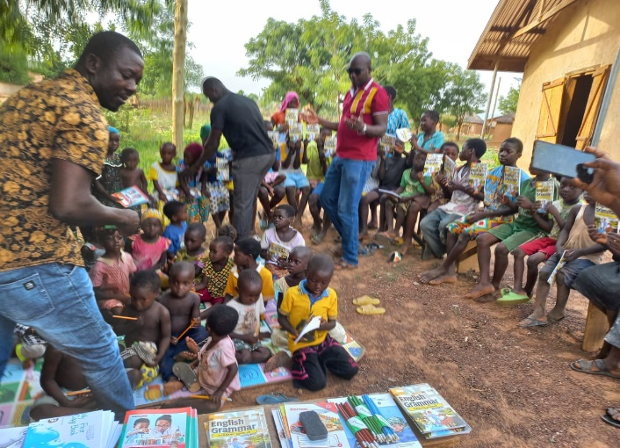

**Cash donation to Zenabu Distribution of material to children**

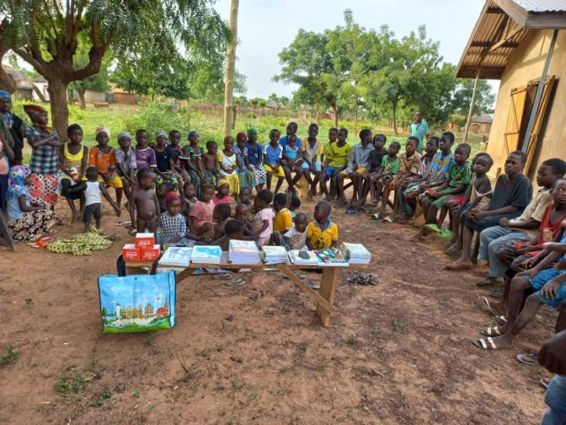 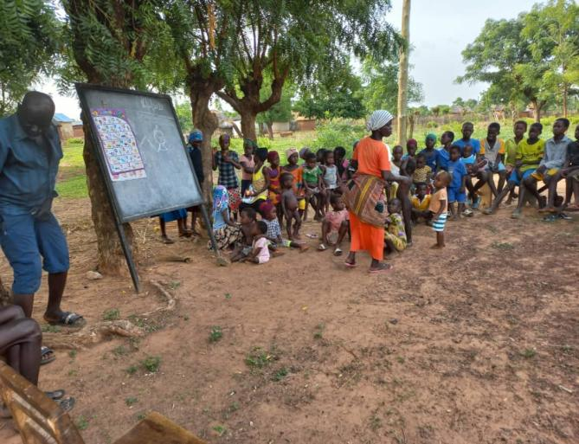

**Typical classroom settings**

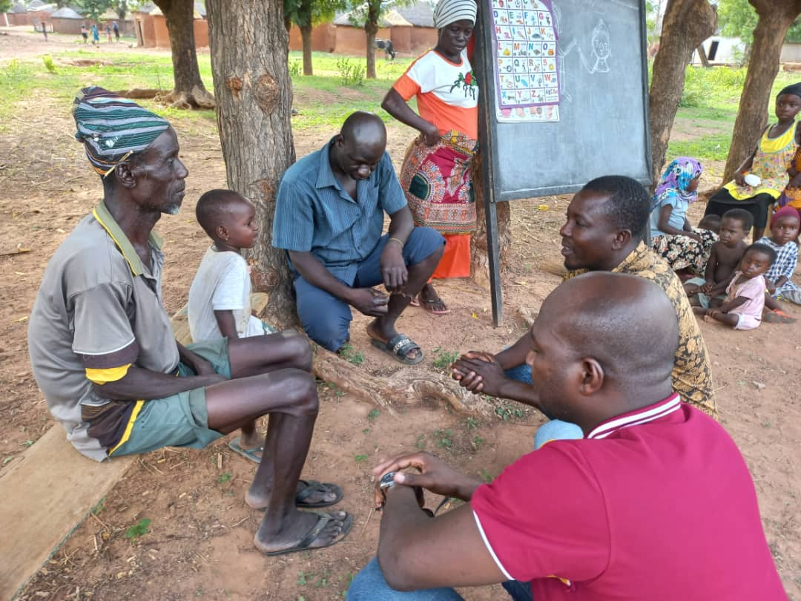

**H4VPI Team with community elders**

**Any write up?**

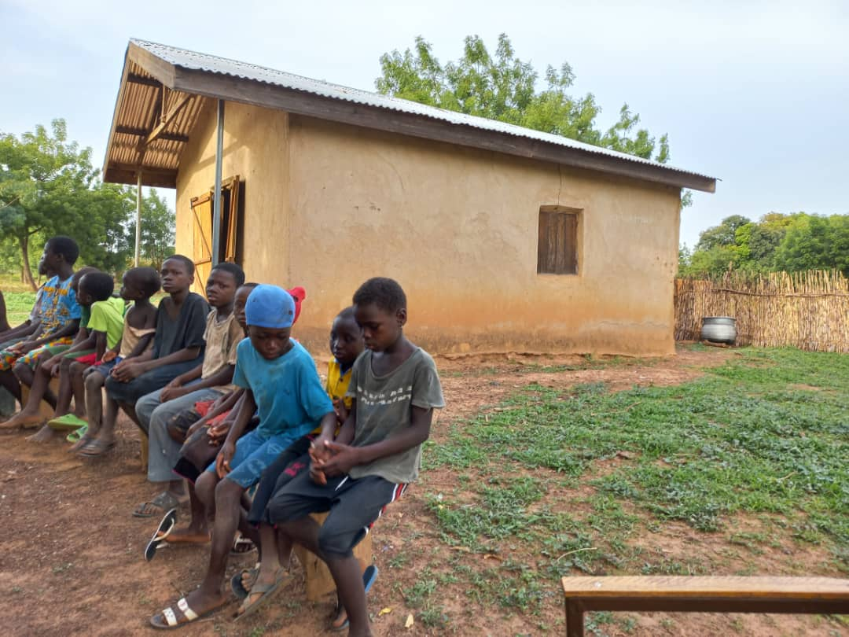

**Building of the Catholic church**

**The building shown there is the catholic church of the community, it is outside of this building that the children of the community sit to learn as their classroom. Classes are closed when there is rain or sunshine. Some of the children bring stools from their homes to sit on. Many others sit on rocks/stones to learn.**