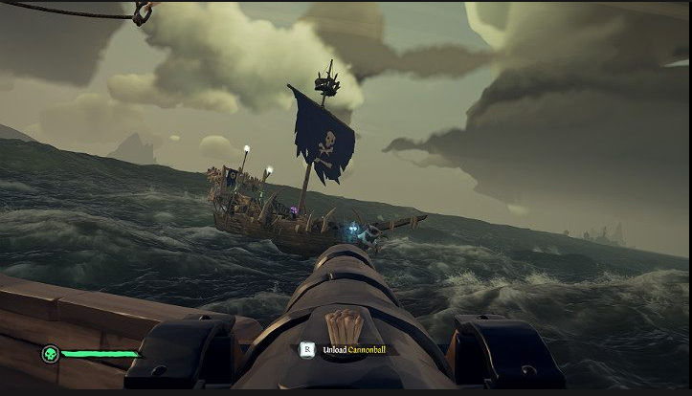

Figure : Sea of Thieves cannon mechanic

* Locked into screen like this to decide whether to shoot anchor/rod or cannonball (fishing or offense)

* Concept for how creature scales can change the water flow (bigger creatures have a more vicious whirlpool)
* Small bubbles for normal fishing?

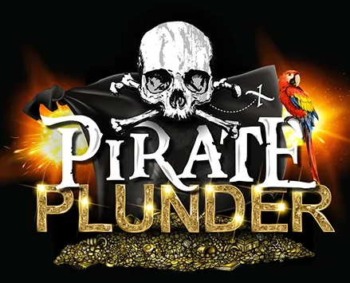

**Plundering?**

* Plundering from the sea and or enemy. (Fish and loot.)

**3 main types of pirates?**

**Buccaneer.**

* can control cannons better and has different cannonball types.

**Fishermen**

* has different wire/rope types for stronger fish/creatures.

**Righthand man.**

* Overall good user. Has one reel/wire type and cannonball type but can use everything effectively.

**2 players per ship?**

**Certain creatures can pull your ship along?**

**Reel breakage?**

**Hitting sea creatures with cannon balls?**

**Sea creatures attack ships?**

**Launch anchor out of ship to fish?**

**First person lock into cannon?**