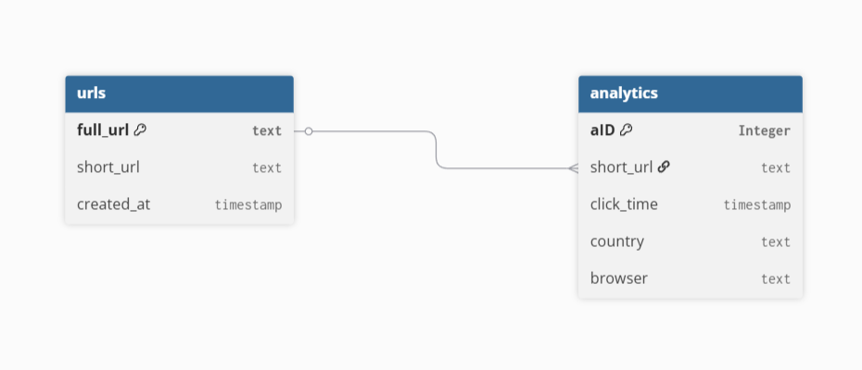
// Use DBML to define your database structure
// Docs: https://dbml.dbdiagram.io/docs

Table urls {
full_url text [primary key]
short_url text
created_at timestamp
}

Table analytics {
aID Integer [primary key]
short_url text
click_time timestamp
country text
browser text
}

Ref url_analytics: urls.full_url < analytics.short_url

