  - IoT Systems Development
  - ASSIGNMENT 1 – BLE Gateway
Abdullah Deniz (io22m018)

Inhaltsverzeichnis
Solution 3

Solution
- Inside this file
  - Adding
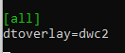

- Inside this file
  - Adding
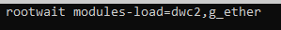

- Configured RPI
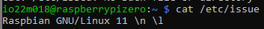

- Installing pydbus
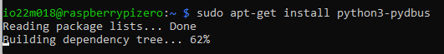

- Installing docker
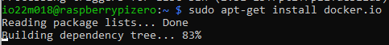

- Configuration

- Reboot the system

- Success of your installation
