**Summary of hand-held LiDAR Acquisition during Fort Davis Field Exercise.**

During the Fort Davis Field Exercise, hand-held LiDAR (Light Detection and Ranging) was acquired to evaluate the collection, in-field processing, and transfer of point cloud (3-dimentional) data to a centralized server for potential use during an emergency response scenario. The primary targets (located at Historic Prude Ranch and McDonald Observatory) were features meant to simulate damaged structures following a natural disaster event. During the exercise, the team located seven areas that contained sufficient structures and debris to simulate the damage and debris following a disaster event. The goal was to collect point-cloud data in the field, perform initial processing, and transfer the data to a server in a format that would be useful to emergency responders.

The LiDAR equipment used for this exercise was the [GeoSLAM ZEB Go Handheld Scanner](https://geoslam.com/solutions/zeb-go/).

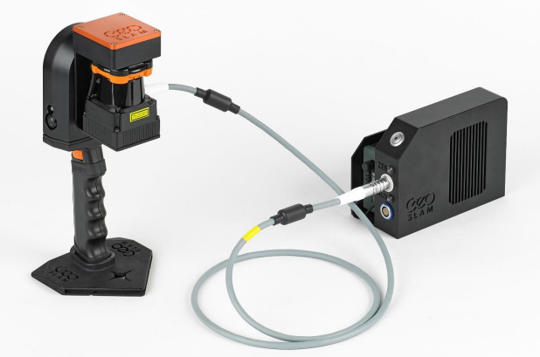

The device consists primarily of a hand-held scanner and data logger which serves as temporary storage of the raw data files. Additional components included are a backpack, data cable, USB drives, 12V battery charger, and batteries. The ZEB Go unit is capable of scanning 43,000 scanner points per second, has a range of 30 meters, and relative accuracy of 1-3 cm.

The hand-held scanner is comprised of two major components: a 2D time-of-flight laser range scanner coupled with an inertial measurement unit (IMU) on a scanning head which continuously rotates during operation of the scanner.

Operation of the scanner is fairly simple. Once the data logger unit is powered on and the cable is connected between the logger and scanner, a simple boot-up procedure is performed with LED lights indicating each stage of the boot-up. With the data logger stowed in the backpack, the operator begins a systematic scan of the area of interest, moving the scanner up and down as they walk. The operator may walk in any direction, however, the acquisition must end in the approximate position it which it began (known as loop closure). Upon completion, the raw data is automatically compressed by the on-board software and is then manually transferred to a USB drive via the auxiliary port on the data logger. The proprietary zip files are given names based on date and time.

The acquisitions varied in duration from 15-20 minutes each. The batteries (capable of 4 hours of continuous operation) were more than sufficient to cover 3-4 acquisitions in a day. The included battery charger was used nightly to recharge the batteries.

Once transferred to a laptop, the FARO Connect software is used to convert the data to a 3D point cloud. During this process, the 2D laser data and the IMU data are merged using a 3D “simultaneous localization and mapping” (SLAM) algorithm. The software is capable of exporting to any number of common point-cloud formats. For this field exercise, the files were exported to LAS format which was subsequently imported into other software for further processing.

More on the post-processing of the raw LiDAR data will be discussed in another section of this report.

Links:

GeoSLAM ZEB-Go Product Information Page:

[ZEB Go Handheld 3D Scanner: Laser Scanning for Everyone (geoslam.com)](https://geoslam.com/solutions/zeb-go/)

GeoSLAM ZEB-Go User Guide:

<https://geoslam.com/wp-content/uploads/2021/02/ZEB_Go_User_Guide_1.0.7.pdf>

FARO Connect Software:

<https://www.faro.com/en/Products/Software/FARO-Connect-Software>

**Write up for Post Processing**

Faro Connect was the post processing. The Lidar collection starts in a proprietary .geoslam format that requires this software to download and process. The software goes through an algorithm to generate both a raw point cloud and a ‘clean’ version that removes anomalies and outliers from the cloud. We found the best results using the cleaned version of the point cloud format. Once exported it was imported into open-source 3d point cloud and mesh processing software CloudCompare.

The point cloud data needed to be reprojected to a real world projection. To do so, an existing UTM Z13 point cloud from the 2019 USGS Lidar Campaign for the area was used. The results worked very well with areas that included easily defined structures for ground truthing. More work is necessary to rectify results in areas without such features.

After reconciling the point cloud data, it could be imported into ArcGIS Pro and classified using its geoprocessing tools for LiDAR. After classification, filtering and surfaces can be created based on the desired use from DSMs to DTMs.