Prediction of Cardiovascular Disease Using Machine Learning Model

Result Submission

**By:**

ADHITHIYA M.S – CH.EN.U4AIE22002

JEROME SANTIAGO J - CH.EN.U4AIE22019

SRI BHUVANA SANKAR T - CH.EN.U4AIE22053

SHASHIDHAR R - CH.EN.U4AIE22058

VIGNESH S - CH.EN.U4AIE22069

**KNN:**

Accuracy on Training data: 0.9926829268292683

Accuracy on Test data: 0.9365853658536586

F1 Score: 0.937799043062201

Precision: 0.9423076923076923

Recall: 0.9333333333333333

Overall Accuracy: 0.9365853658536586

Confusion Matrix:

[[94 6]

[ 7 98]]

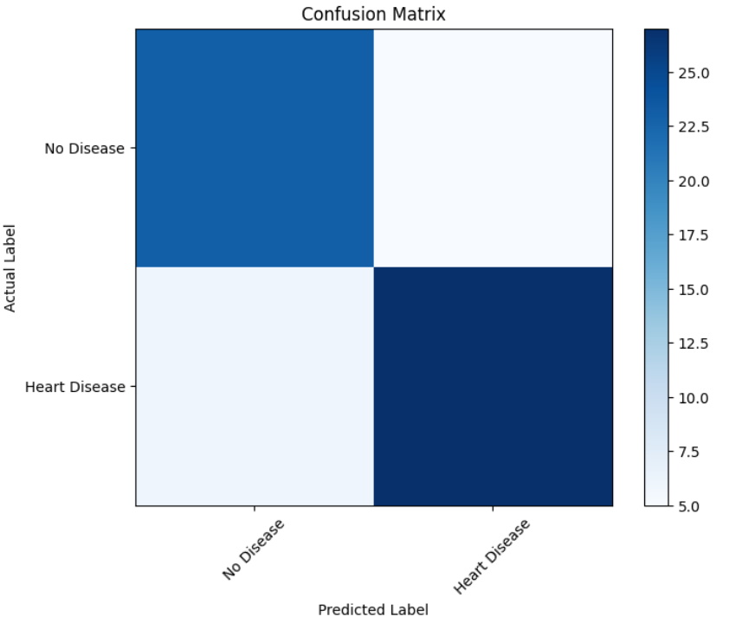

**ROC Curve:**

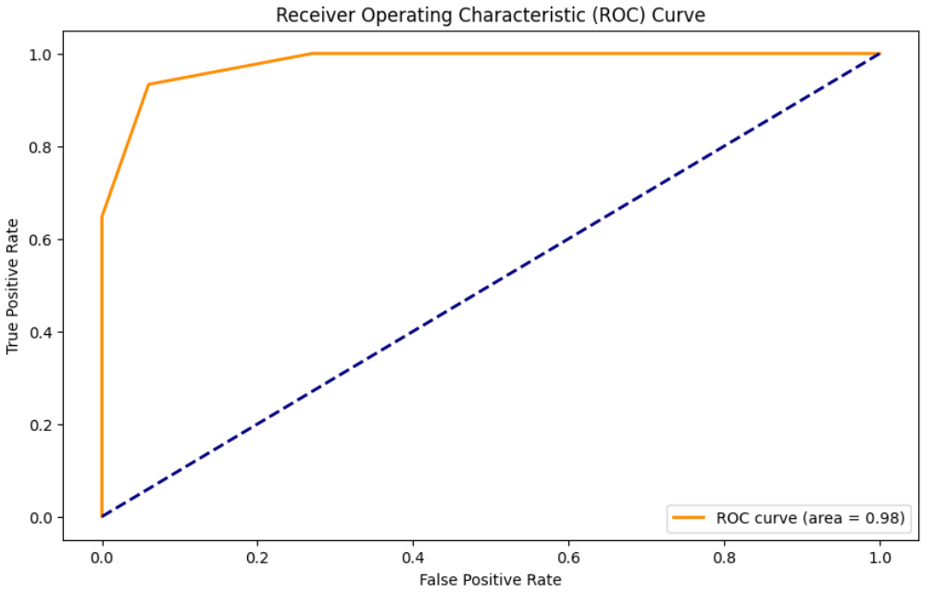

**Naive Bayes:**

Accuracy on Training data: 0.8390243902439024

Accuracy on Test data: 0.7804878048780488

Confusion Matrix:

[[75 25]

[20 85]]

F1 Score: 0.7906976744186046

Precision: 0.7727272727272727

Recall: 0.8095238095238095

Overall Accuracy: 0.7804878048780488

**ROC Curve:**

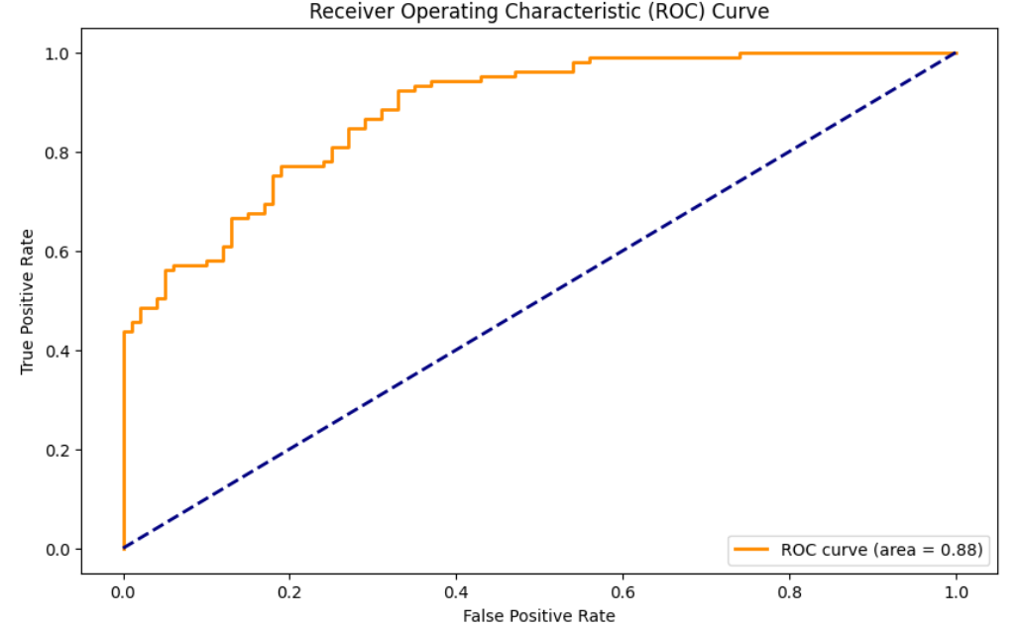

**SVM:**

Accuracy on Training data: 0.8695121951219512

Confusion Matrix:

[[72 28]

[ 8 97]]

F1 Score: 0.8434782608695652

Precision: 0.776

Recall: 0.9238095238095239

Overall Accuracy: 0.824390243902439

**ROC Curve:**

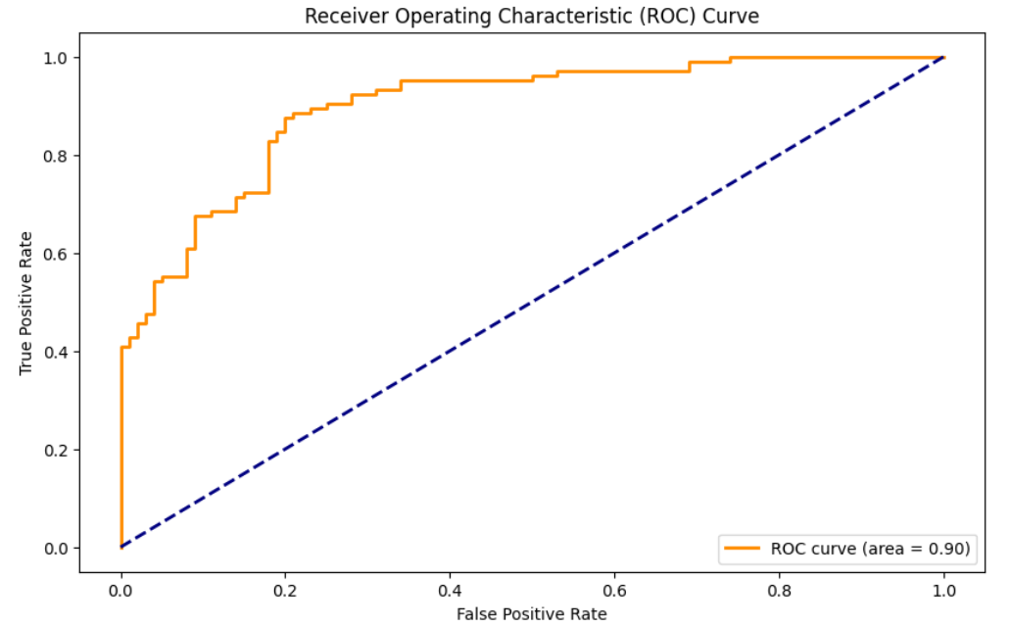

**Logistic Regression:**

Accuracy on Training data: 0.8524390243902439

Confusion Matrix:

[[72 28]

[12 93]]

F1 Score: 0.8230088495575221

Precision: 0.768595041322314

Recall: 0.8857142857142857

Overall Accuracy: 0.8048780487804879

**ROC Curve:**

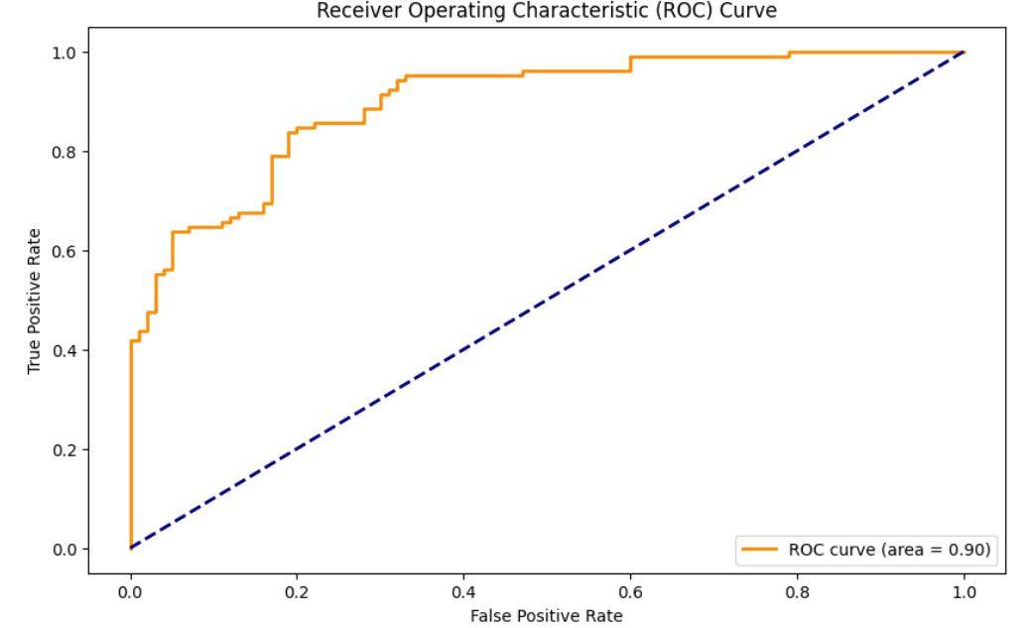

**Comparison Table:**

|  |  |  |  |  |  |  |
| --- | --- | --- | --- | --- | --- | --- |
| S.NO | Algorithm | Accuracy on Training Data | F1score | Precision | Recall | Overall Accuracy |
| 1 | KNN | 0.9927 | 0.9378 | 0.9423 | 0.9333 | 0.9366 |
| 2 | Naive Bayes | 0.8390 | 0.7907 | 0.7727 | 0.8095 | 0.7805 |
| 3 | SVM | 0.8695 | 0.8435 | 0.7760 | 0.9238 | 0.8244 |
| 4 | Logistic Regression | 0.8524 | 0.8230 | 0.7686 | 0.8857 | 0.8049 |

**Comparison Charts**

**:** 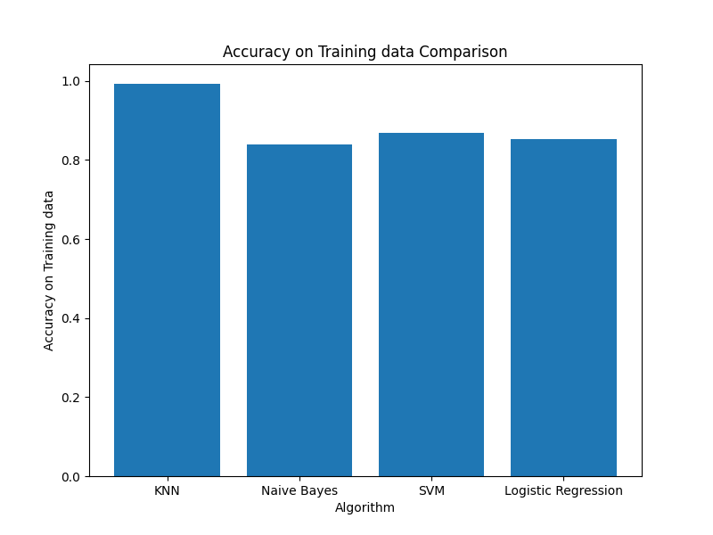

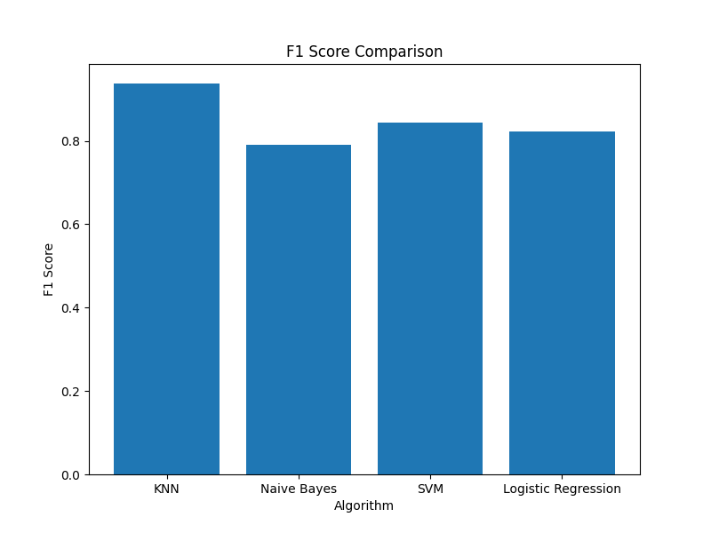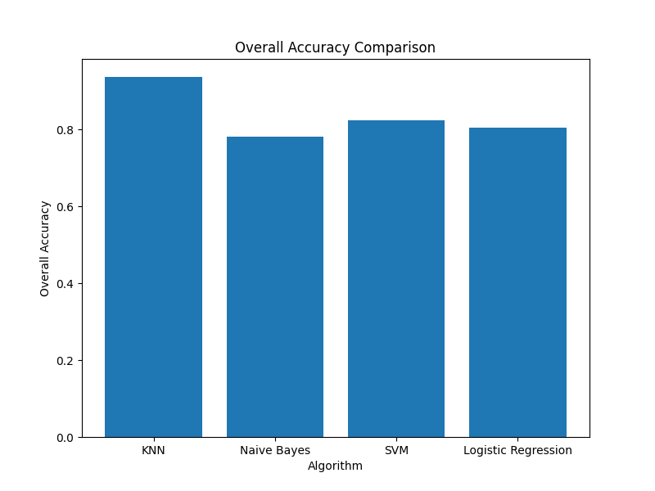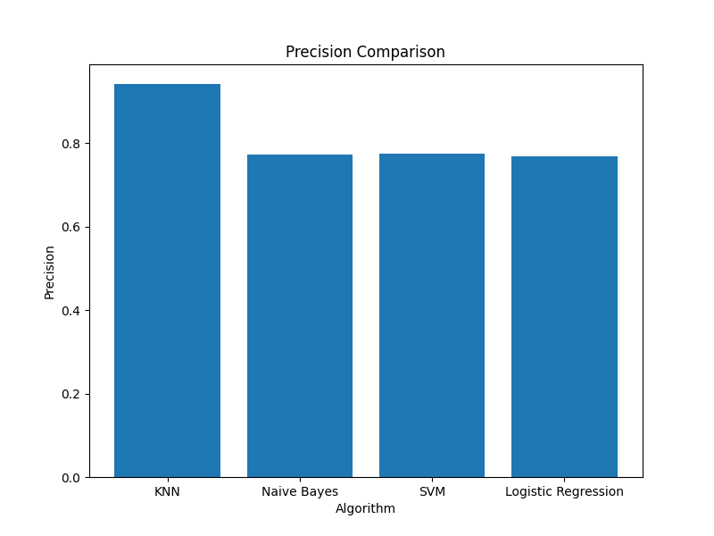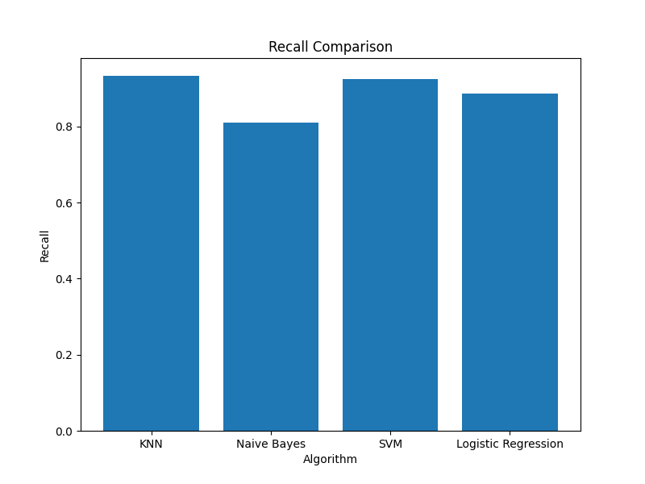

**Conclusion:**

Therefore, by comparing these 4 algorithms we get the following result. By the result we can come to a conclusion that KNN algorithm give the highest accuracy.