DPM Wallet (dpmw) — Technical Specification
Version: 0.1 (draft) · Status: for review · Owner: Plaee DPM

1. Summary
The DPM Wallet (dpmw) is a lightweight, operator-hosted TypeScript service that does two things and nothing else:
- Creates and manages blockchain addresses for an operator and its customers.
- Signs payloads — trading orders, proxy meta-transactions (allowance, redeem, withdrawal), and raw treasury transactions.
It is delivered as a single Docker image that each operator runs inside their own infrastructure. The only caller into the dpmw is the operator's backend (the "Operator DPM Gateway"). The dpmw never talks to Plaee except for one read-only call needed to assemble a meta-transaction (see Section 5).
Key custody is pluggable. In self-custody (mnemonic) mode the service generates a BIP-39 mnemonic on first run and derives every address from it. In Turnkey mode the private keys live in the Turnkey TEE and the service asks Turnkey to sign. Both modes sit behind one interface, so a third provider (e.g. Fireblocks) can be added without touching business logic.
The service is built on top of the existing dpm-sdk rather than reimplementing any cryptography. All EIP-712 order construction, proxy-call encoding, and RelayHub struct hashing is reused from the SDK, which is vendored into the image.

2. Goals and non-goals

2.1 Goals (v1)
- Generate and persist a master wallet, an operational wallet, and any number of customer wallets.
- Derive and return each customer's on-chain proxy wallet address without a chain round-trip.
- Sign CLOB orders (EIP-712) and return the signed order to the operator.
- Build and sign proxy meta-transactions — USDC/CTF allowance, redeem, proxy withdrawal, split, merge — and return a ready-to-submit request body to the operator.
- Sign raw treasury transactions (master ↔ operational rebalancing, master → external) and return the signed transaction hex.
- Maintain a secure address directory (customer reference → EOA → proxy → derivation index) in an embedded database.
- Authenticate every inbound request from the operator with an API key.
- Emit structured audit logs for every address creation and signing action.

2.2 Non-goals (v1 — stubbed interfaces only)
These appear in the product PDF but are explicitly deferred. The spec defines the interface seams so they drop in later without redesign.
- On-chain deposit/withdrawal monitoring (Polygon watcher, confirmations, balance tracking).
- Per-user recipientId trading ledger (orders/fills/positions per customer).
- WebSocket event streaming to PlaeeOS.
- Broadcasting any transaction to Polygon. The dpmw signs; the operator (or Plaee) broadcasts. The single exception discussed for treasury is still sign-only in v1 — the signed hex is returned, not sent.

2.3 Explicitly out of scope forever
- Submitting orders or meta-transactions to Plaee. The dpmw returns signed artefacts to the operator, who routes them onward.
- Holding or reconciling customer balances. That is the operator's ledger and Plaee's shared-balance DB.

3. Confirmed design decisions
These were settled with the product owner and are treated as fixed for this spec.
# | Decision
1 | The dpmw is sign-only. It never submits to Plaee.
2 | It is built on dpm-sdk, vendored and compiled inside the image. No re-implementation of encoding/hashing.
3 | It has exactly one outbound dependency to Plaee: GET /relay-payload on relayer-api.
4 | v1 scope is address management and signing. Monitoring, ledger, and WebSocket are stub interfaces only.
5 | The EIP-712 order domain name is "DPM CTF Exchange" (a change is required in dpm-sdk; see Section 7).
6 | Orders carry an optional recipient address, not an identifier. If omitted (or zero), the exchange pays the maker. When supplied, it is constrained to the operational wallet or one of the operator's customer wallets known to the dpmw — never an arbitrary external address.
7 | Address creation precedes DPM registration. The dpmw mints the address; the operator sends it to Plaee; Plaee persists it in the DPM database.

4. Roles and responsibilities
Entity | Owns
Plaee / Plaee DPM | The CLOB and matching engine, on-chain settlement, market/CTF operations, recipientId generation, event streaming, and the relayer-api that broadcasts meta-transactions.
Operator DPM Gateway | Orchestration middleware. The only caller into the dpmw. Enforces its own API key with Plaee, applies business rules (trade holds, balance updates), and routes signed payloads from the dpmw onward to Plaee.
DPM Wallet (dpmw) | Address lifecycle and signing. Holds keys (mnemonic mode) or delegates to Turnkey. Nothing else.
The dpmw's world is deliberately small: it receives a request from the gateway, does key work or signing, and returns an artefact to the gateway.
Trading ledger and event streaming are not dpmw concerns. Per-customer positions/fills and order/trade event streaming are owned by Plaee / PlaeeOS (see the responsibility matrix in the product PDF). The operator sends trading activity to Plaee directly; the dpmw only signs. The one Phase-2 interface the dpmw does own is ChainMonitor (see Section 13), because it watches the dpmw's own on-chain addresses and needs no Plaee data.

5. Trust boundary and outbound dependencies
The container is designed to have near-zero egress to Plaee. Everything the dpmw needs to build a signature is either supplied in the request or configured as an environment variable:
- Contract addresses (collateral, ctf, ctfExchange, proxyFactory, relayHub), chain ID, and the exchange address all come from config, replacing what would otherwise be a GET /contract-info call.
- The one unavoidable network read is GET /relay-payload on relayer-api, which returns the relayer admin address and the RelayHub nonce for a given EOA. These cannot be known ahead of time (the nonce is stateful and lives in the DPM users table), so they must be fetched at signing time.
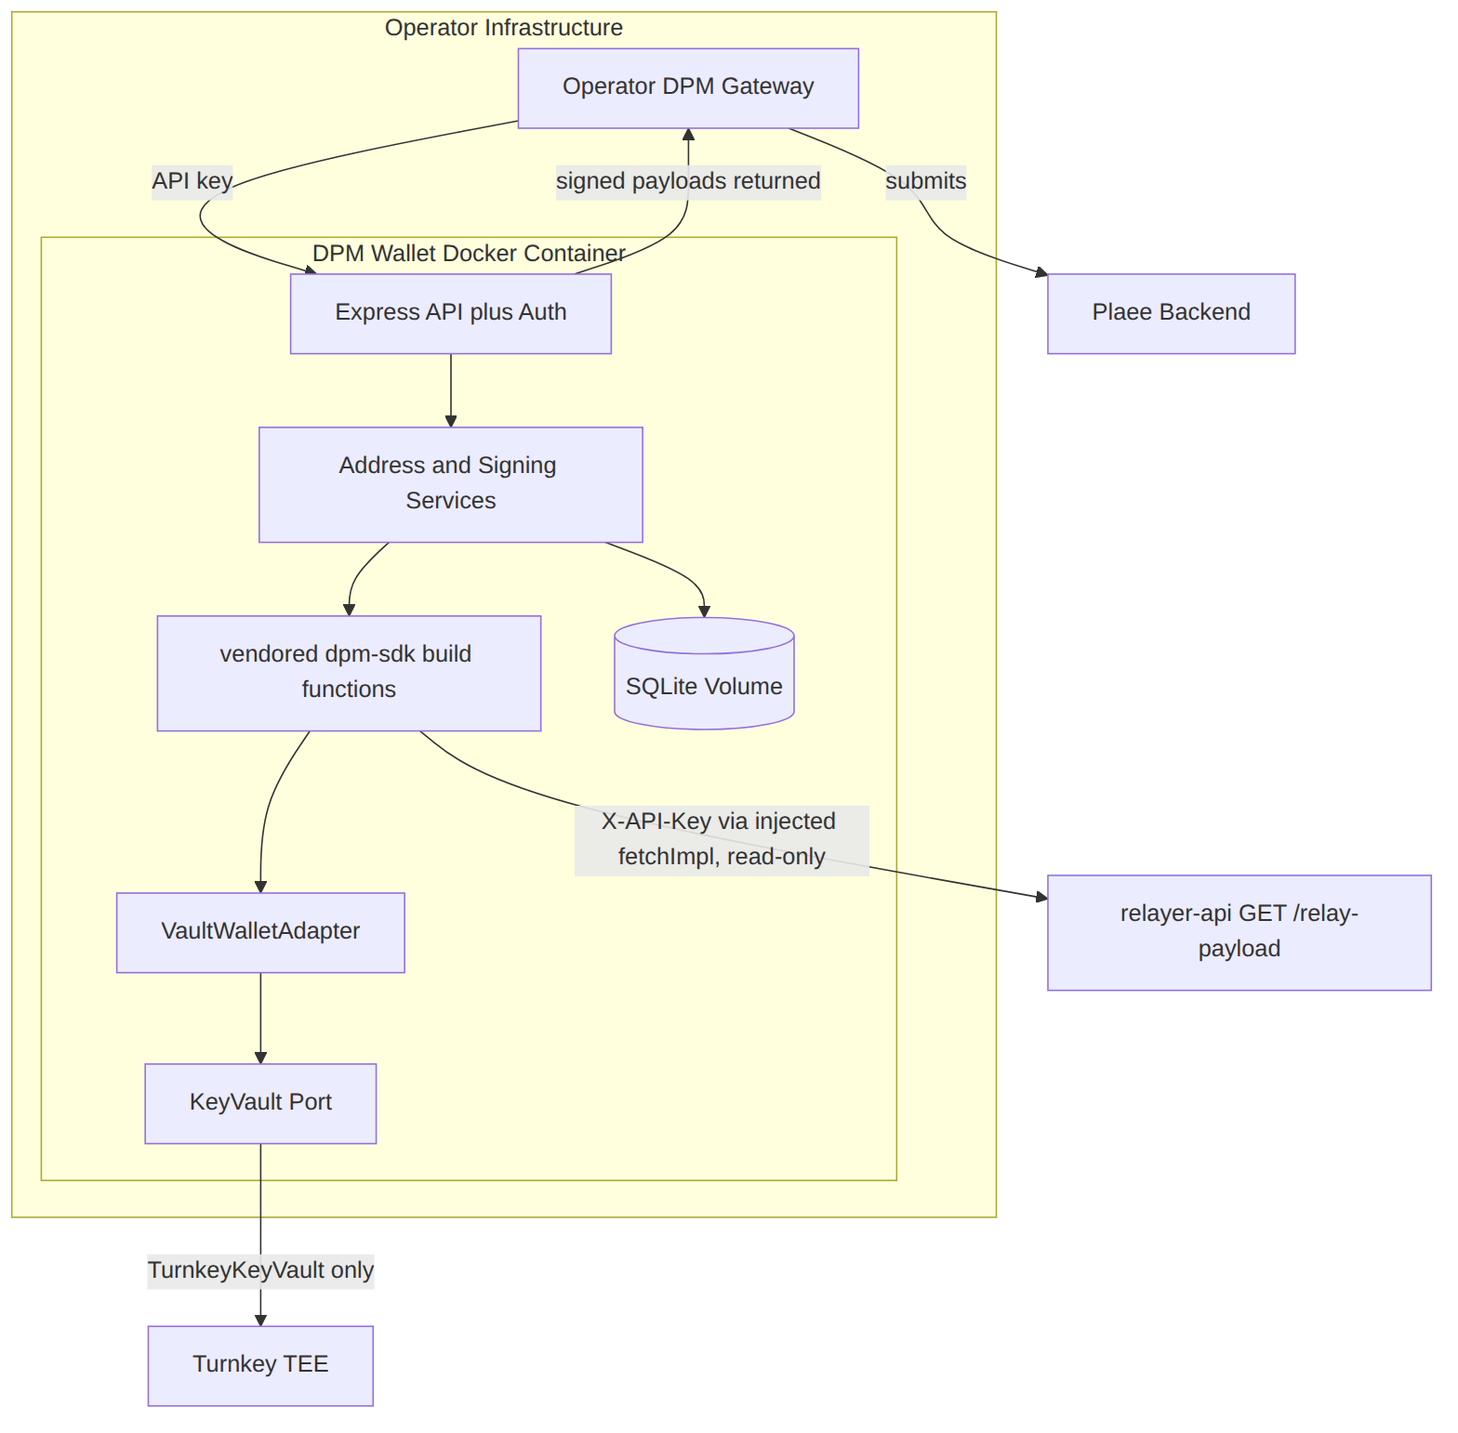
GET /relay-payload is registered above relayer-api's authenticated route group, so it requires only the service-level X-API-Key header — not a JWT or the poly_* builder HMAC. The dpmw supplies that header by injecting a fetchImpl into the SDK's getRelayPayload (see Section 7.4).

6. Architecture

6.1 Layered view
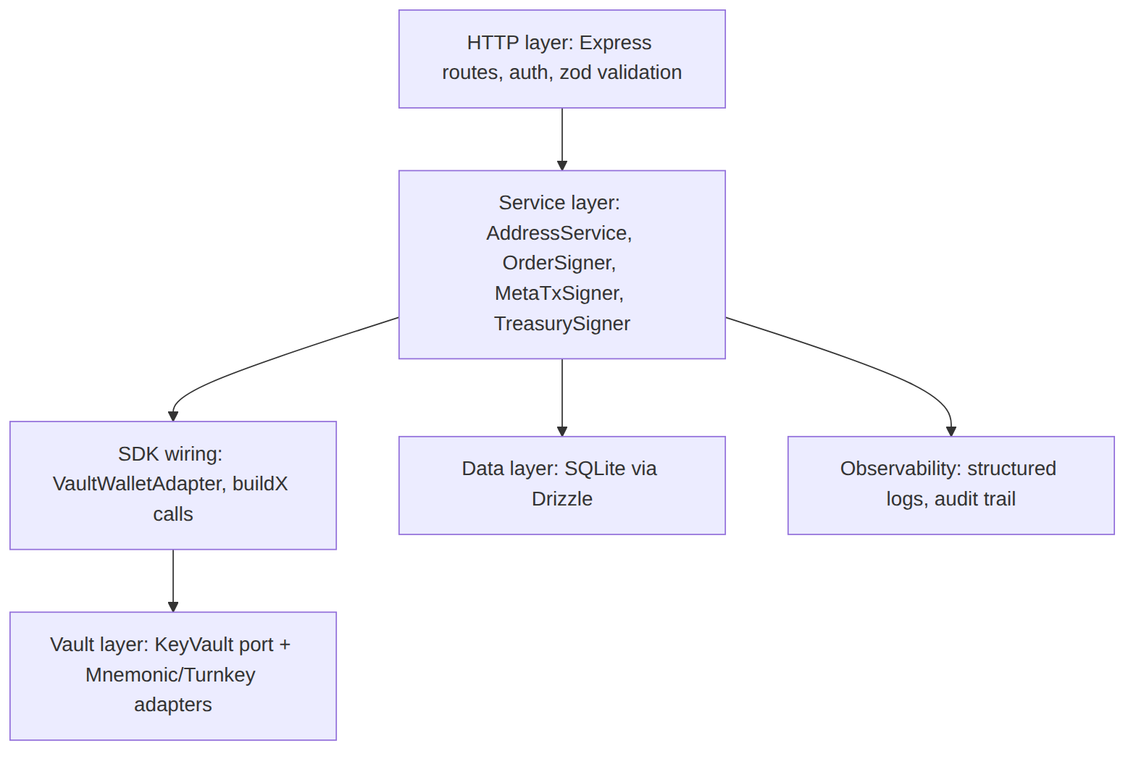
A request flows top-down: the HTTP layer validates and authenticates, a service orchestrates the steps, the SDK wiring produces the signature via the vault, and the data layer records what happened.

6.2 The KeyVault port
KeyVault is the single seam every custody mode implements. No service code above it knows whether a key is local or in a TEE.
export type VaultMode = "mnemonic" | "turnkey";

/**
* Where the master wallet's key lives. "internal" = derived/held by this vault
* (mnemonic index 0, or a Turnkey account). "external" = held by a third-party
* custody (Fireblocks, Qredo, MetaMask, …); the dpmw knows only its address and
* cannot sign for it. See Section 6.6.
*/
export type MasterLocation = "internal" | "external";

export interface MasterInfo {
address: Address;
location: MasterLocation;
/** Present only when location === "internal". */
index?: 0;
/** For location === "external": the custody provider label (e.g. "fireblocks"). */
custodian?: string;
/** Whether this vault can produce signatures for the master address. */
signable: boolean;
createdAt: string;
}

export interface VaultAccount {
address: Address;
index: number;
/** Operator-supplied opaque reference (e.g. customer id). */
ref: string;
}

export interface VaultHealth {
mode: VaultMode;
initialized: boolean;
/** For turnkey: reachability of the TEE. For mnemonic: keystore decrypted. */
ready: boolean;
}

export interface KeyVault {
readonly mode: VaultMode;

/**
* First-run: establish the master wallet. When the master is internal, this
* creates/loads the key (BIP-44 index 0 for mnemonic, or a Turnkey account).
* When the master is external, this records the configured address and marks
* it non-signable. Idempotent.
*/
initializeMaster(): Promise<MasterInfo>;

/** Derive/create the account at `index`, tagging it with `ref`. Idempotent per index. */
createAccount(index: number, ref: string): Promise<VaultAccount>;

/** EIP-712 typed-data signature (orders). */
signTypedData(address: Address, typedData: TypedDataDefinition): Promise<Hex>;

/** EIP-191 personal_sign (meta-tx struct hash, cancel messages). */
personalSign(address: Address, message: Hex | string): Promise<Hex>;

/**
* Raw EVM transaction signing (treasury). Throws MASTER_NOT_SIGNABLE when the
* address is an externally-custodied master wallet.
*/
signTransaction(address: Address, tx: TransactionSerializable): Promise<Hex>;

health(): Promise<VaultHealth>;
}
Every signing method takes an address and uses it to select the correct key out of many — this is what lets one process drive thousands of wallets.

6.3 Wallet roles and the derivation model
Both modes share one addressing scheme rooted at the BIP-44 path m/44'/60'/0'/0/{index}:
Index | Role | Notes
0 | Master wallet | Central treasury. Used only when the master is internal (see §6.6). Reserved/unused when the master is externally custodied.
1 | Operational wallet | Active liquidity ("O1" in the product draft). The operator creates a user for this address.
2 … N | Customer wallets | One EOA per customer; each maps 1:1 to a proxy wallet.
In Turnkey mode the same indices map onto Turnkey wallet accounts at matching derivation paths. When an operator wants per-user policy isolation, the alternative is a Turnkey sub-organisation per customer; this is documented as a configuration variant, not the default.
The operational-wallet and customer-wallet indices are stable regardless of where the master lives: when the master is external, index 0 is simply reserved and the operational wallet remains at index 1.

6.4 Proxy wallet address derivation
A customer's on-chain proxy wallet address is a deterministic function of their EOA, so the dpmw returns it at creation time with no chain call:
salt = keccak256(abi.encodePacked(eoaAddress)) // 20-byte address, packed
initCodeHash = keccak256(minimalProxyCloneBytecode(implementation))
proxyAddress = CREATE2(proxyFactory, salt, initCodeHash) // last 20 bytes
This mirrors ProxyWalletFactory in the proxy-factories repo (salt is keccak256(abi.encodePacked(msgSender))). The dpmw computes it locally with viem, using the proxyFactory and implementation addresses from config.

6.5 The two custody modes

Mnemonic (self-custody) mode
- On first run, generate a BIP-39 mnemonic (256-bit entropy → 24 words).
- Derive the HD root; addresses are children at m/44'/60'/0'/0/{index}.
- The mnemonic is encrypted at rest with AES-256-GCM. The encryption key is derived with scrypt from a passphrase supplied via env (DPMW_KEYSTORE_PASSPHRASE) plus a per-install random salt stored alongside the ciphertext.
- The encrypted keystore is written to the SQLite volume (vault_state table), never to plaintext disk.
- A guarded encrypted export endpoint returns the ciphertext (never plaintext) so the operator can back it up. Requires the passphrase to be re-presented.
- Signing loads the key into memory only for the duration of the operation; keys are never logged.

Turnkey mode
- On first run, when the master is internal, ensure a Turnkey wallet (or sub-organisation) exists for the master; create if absent. When the master is external (§6.6), skip master key creation and only record its address.
- createAccount(index, ref) calls Turnkey to create the wallet account at the derivation path and returns its address.
- Signing calls Turnkey's sign APIs (signRawPayload / typed-data equivalent). The service holds no private key material — only the operator's Turnkey API credentials (TURNKEY_API_PUBLIC_KEY / TURNKEY_API_PRIVATE_KEY / TURNKEY_ORGANIZATION_ID).
- Turnkey is reached through a TurnkeyProvider abstraction (see Section 8) so a different signer (Fireblocks, Qredo) can replace it.
Both modes must reproduce the SDK's personalSign hex/UTF-8 branching exactly (see Section 9.5).

6.6 Master wallet location (internal vs external)
The vault mode (mnemonic / Turnkey) and the master wallet location are two independent axes. The operational and customer wallets are always managed by the active vault, but the master wallet — the central treasury — need not be. Per the product requirements it "can be managed natively within Turnkey or via an external enterprise custody provider (e.g., Fireblocks, Qredo)", and in practice it may also be a wallet the operator controls through MetaMask or a hardware/enterprise custodian. The dpmw therefore does not assume the master is a key it holds.
Two locations are supported, selected by config:
Location | Who holds the key | dpmw capability
**internal** | The active vault: mnemonic index 0, or a Turnkey master account. | Full — the dpmw can sign treasury transactions from the master.
**external** | A third-party custodian (Fireblocks, Qredo, MetaMask, hardware). | Address-only — the dpmw records the master address for policy and reporting but cannot sign for it.
Identifying the master location is a first-run concern. At POST /v1/vault/init the dpmw resolves the master from config:
- DPMW_MASTER_LOCATION=internal (default): the vault creates/loads the master key. MasterInfo.signable = true, index = 0.
- DPMW_MASTER_LOCATION=external: DPMW_MASTER_ADDRESS (required) is recorded and DPMW_MASTER_CUSTODIAN (optional label) is stored. No key is derived. MasterInfo.signable = false.
Consequences when the master is external:
- Treasury signing that draws from the master is not performed by the dpmw. POST /v1/treasury/rebalance and POST /v1/treasury/external-withdraw return MASTER_NOT_SIGNABLE for the master-signed leg; the operator executes that leg through the external custodian. Legs signed from the operational wallet (which is always vault-managed) remain available — e.g. operational → master sweeps.
- Deposit/withdrawal monitoring (phase 2) still tracks the master address; it is an observation target regardless of who signs.
- Policy (Section 12.3) still treats the master address as an allowed rebalancing counterparty and as the only source permitted to reach external addresses.
This keeps the three-tier model intact while letting the operator custody the highest-value wallet wherever they already trust it.

7. dpm-sdk integration and required changes
The dpmw reuses dpm-sdk for all cryptography. The SDK's meta-transaction functions are already stateless and take the signer as a parameter, so one process can drive many addresses without per-address SDK instances. Two things block direct reuse: those functions end by POSTing to /submit, and the primitives they use are not exported. The following changes are required in dpm-sdk. All are backwards compatible.

7.1 Split "build" from "submit" in meta-tx.ts
Today each function fetches the relay payload, encodes calls, hashes, signs, and POSTs:
export async function submitUsdcCtfAllowance(params: {
wallet: InternalWalletPort;
relayerBaseUrl: string;
contractInfo: ContractInfo;
proxyWallet: string;
fetchImpl?: FetchLike;
requestAuth?: RequestAuth;
}): Promise<{ transactionID: string; state: string }> {
// ... getRelayPayload → encode calls → createProxyStructHash → personalSign ...
return submitTransaction(/* ... */);
}
Extract a build-only variant for each, returning the SubmitTransactionRequest it currently POSTs, and reduce each submitX() to a two-line wrapper:
New build-only function | Backs dpmw endpoint
buildUsdcCtfAllowanceTx(params) | POST /v1/meta-tx/allowance
buildRedeemPositionsTx(params) | POST /v1/meta-tx/redeem
buildFundWithdrawTx(params) | POST /v1/meta-tx/withdraw
buildSplitPositionTx(params) | POST /v1/meta-tx/split
buildMergePositionsTx(params) | POST /v1/meta-tx/merge
// after refactor — existing behaviour preserved
export async function submitUsdcCtfAllowance(params) {
const body = await buildUsdcCtfAllowanceTx(params);
return submitTransaction(body, params.relayerBaseUrl, params.fetchImpl, params.requestAuth);
}
prediction-ui and any other current caller are unaffected because the submitX() signatures and return types do not change.

7.2 Export a pure order typed-data builder
Order signing lives in submitOrder, which builds the order, signs it, and POSTs to /order. The signOrder helper and the ORDER_EIP712_TYPES typed-data assembly are module-private:
async function signOrder(
wallet: InternalWalletPort,
makerSigner: string,
chainId: number,
exchangeAddress: string,
order: OrderFields,
): Promise<string> {
const typedData = {
types: ORDER_EIP712_TYPES,
domain: {
name: "Polymarket CTF Exchange",
version: "1",
chainId,
verifyingContract: exchangeAddress,
},
primaryType: "Order",
message: orderMessage(order),
};
return wallet.signTypedDataV4(makerSigner, JSON.stringify(typedData));
}
Add and export a pure buildOrderTypedData(order, chainId, exchangeAddress, domainName) that returns the typed-data object without signing or network I/O, alongside the already-public buildOrderFields. The dpmw then builds the fields, gets the typed data, and signs through the vault.

7.3 Change the EIP-712 domain name
Change "Polymarket CTF Exchange" to "DPM CTF Exchange" (line 238 above), ideally exposed as a parameter/config value rather than a literal so both the SDK and the dpmw read it from one place. Until this lands, an order signed by dpm-sdk and an order signed by the dpmw produce different digests for identical inputs — one of them will be rejected by the exchange. The dpmw keeps the name in config with "DPM CTF Exchange" as the default and runs a startup self-check (see Section 9.2).

7.4 Injecting X-API-Key without an SDK change
relayer-api gates every route on X-API-Key. RequestAuth currently supports only jwt, lp, and none. No SDK change is needed: getRelayPayload already accepts a fetchImpl, so the dpmw injects a fetch wrapper that adds the header.
const apiKeyFetch: typeof fetch = (input, init = {}) => {
const headers = new Headers(init.headers);
headers.set("X-API-Key", config.relayerApiKey);
return fetch(input, { ...init, headers });
};
// passed as fetchImpl into buildUsdcCtfAllowanceTx(...) etc.
Optionally, dpm-sdk may add { mode: "apiKey"; apiKey: string } to RequestAuth for tidiness. This is a nice-to-have, not a requirement.

7.5 Widen the export surface (server-only entry)
The dpmw needs InternalWalletPort, the new buildX functions, the proxy-encoding primitives, buildOrderFields / buildOrderTypedData, and getRelayPayload. These should be exported from a new server-only subpath entry (e.g. @inabit-com/dpm-sdk/server). The root . entry re-exports the Privy and Magic facades, which would drag @privy-io/react-auth and React into a Node container. The existing ./lp entry is already documented as server-side and is an acceptable fallback if a new entry is not added.

7.6 Minor: argument-order inconsistency
Worth noting for whoever implements the adapter: InternalWalletPort.signTypedDataV4(address, json) takes the address first, while personalSign(message, address) takes it second. The adapter must not transpose them.
export interface InternalWalletPort {
getEoaAddress(): Promise<string>;
signTypedDataV4(address: string, typedDataJson: string): Promise<string>;
personalSign(message: string, address: string): Promise<string>;
}

7.7 The VaultWalletAdapter
The SDK's InternalWalletPort models a single connected wallet (its getEoaAddress() takes no argument; the EOA implementation ignores the address parameter). The dpmw's KeyVault is multi-wallet. A thin adapter binds one address per request and bridges the two:
class VaultWalletAdapter implements InternalWalletPort {
constructor(private vault: KeyVault, private address: Address) {}

getEoaAddress = async () => this.address;

signTypedDataV4 = (address: string, json: string) =>
this.vault.signTypedData(address as Address, JSON.parse(json));

personalSign = (message: string, address: string) =>
this.vault.personalSign(address as Address, message);
}
A meta-transaction request then reads:
const wallet = await walletRepo.findByCustomerRef(req.body.customerRef);
const port = new VaultWalletAdapter(keyVault, wallet.eoaAddress);
const body = await buildUsdcCtfAllowanceTx({
wallet: port,
relayerBaseUrl: config.relayerBaseUrl,
contractInfo: config.contractInfo,
proxyWallet: wallet.proxyAddress,
fetchImpl: apiKeyFetch,
});
res.json(body); // operator POSTs this to relayer-api /submit

8. Third-party integrations

8.1 relayer-api (the only Plaee dependency)
- Call: GET /relay-payload?address=<eoa>&type=PROXY
- Returns: { address: <relayerAdminAddress>, nonce: <string> }
- Auth: X-API-Key only.
- Constraint: type must be PROXY; SAFE is rejected by the endpoint.
- Precondition: the EOA must already be registered in the DPM users table, because the nonce is resolved from it (see Section 11).
Reached through the SDK's getRelayPayload with the apiKeyFetch wrapper.

8.2 Signer provider abstraction (Turnkey, swappable)
Turnkey is hidden behind a SignerProvider interface consumed by TurnkeyKeyVault. Swapping providers means writing one class and changing one line of DI wiring.
export interface SignerProvider {
readonly name: string;
ensureWallet(): Promise<{ organizationId: string }>;
createAccount(derivationPath: string, ref: string): Promise<{ address: Address }>;
signRawPayload(address: Address, payload: Hex, encoding: "eip191" | "eip712" | "tx"): Promise<Hex>;
health(): Promise<{ ready: boolean }>;
}

// Turnkey today:
class TurnkeySignerProvider implements SignerProvider { /* ... */ }

// Swap illustration — no service code changes:
class FireblocksSignerProvider implements SignerProvider { /* ... */ }

8.3 Chain client (viem)
viem is used only for cryptography and ABI encoding (CREATE2 derivation, encodeFunctionData, typed-data hashing, transaction serialisation). No JSON-RPC provider is required in v1 because the dpmw does not broadcast or read chain state. (When monitoring lands in a later phase, a read-only RPC URL is added — see the stubbed interface in Section 13.)

9. Signing reference
Every signing operation below names the dpm-sdk function that owns it, so there is exactly one implementation of each.

9.1 EIP-712 order — field order and domain
The signed Order has 13 fields in this exact sequence (reordering or omitting one yields a signature the exchange rejects):
# | Field | Type
0 | salt | uint256
1 | maker | address
2 | signer | address
3 | taker | address
4 | recipient | address
5 | tokenId | uint256
6 | makerAmount | uint256
7 | takerAmount | uint256
8 | expiration | uint256
9 | nonce | uint256
10 | feeRateBps | uint256
11 | side | uint8
12 | signatureType | uint8
Domain:
{
"name": "DPM CTF Exchange",
"version": "1",
"chainId": 137,
"verifyingContract": "<ctfExchange address>"
}
For a standard customer order: maker = the customer's proxy wallet (source of funds), signer = the customer's EOA (which produces the signature), taker = zero address (public order), signatureType = 1 (POLY_PROXY).
Recipient is optional. recipient may be omitted by the operator. When it is omitted — or supplied as the zero address — the exchange resolves recipient == address(0) ? maker : recipient, so proceeds go to the maker. The dpmw encodes an omitted recipient as the zero address in the signed order (the two are equivalent on-chain), so an unset recipient always means "pay the maker".
Recipient constraint (when supplied). When the operator does supply a non-zero recipient, the dpmw validates it against its address directory before signing: it must be either the operational wallet address or a wallet belonging to one of the operator's customers (present in the wallets table). Any other value is rejected with POLICY_VIOLATION. This prevents an order from directing proceeds to a wallet outside the operator's control. An omitted or zero recipient is always allowed (it resolves to the maker).
Owned by: buildOrderFields + the new buildOrderTypedData in clob-order.ts; signed via KeyVault.signTypedData.

9.2 Order EIP-712 — worked example and self-check
Amounts are 6-decimal micro-units. For a BUY of 100 shares at price 0.40 with feeRateBps = 200:
priceMicro = 400000
sharesMicro = 100000000
collateralMicro = priceMicro * sharesMicro / 1_000_000 = 40000000
makerAmount (BUY) = collateralMicro = 40000000
takerAmount (BUY) = sharesMicro = 100000000
The resulting order fields:
{
"salt": "<random uint256>",
"maker": "<proxyWallet>",
"signer": "<eoa>",
"taker": "0x0000000000000000000000000000000000000000",
"recipient": "<operator-supplied or zero>",
"tokenId": "<CTF token id>",
"makerAmount": "40000000",
"takerAmount": "100000000",
"expiration": "0",
"nonce": "0",
"feeRateBps": "200",
"side": 0,
"signatureType": 1
}
Startup self-check: at boot the dpmw recomputes the digest of a fixed known order with the configured domain name and compares it to a pinned expected value. A mismatch (e.g. domain name still "Polymarket CTF Exchange") fails startup loudly, rather than silently producing orders the exchange rejects at runtime.

9.3 Proxy meta-transaction — the rlx: struct hash
Allowance, redeem, withdrawal, split, and merge are not EIP-712. They are GSN/RelayHub meta-transactions. The signed digest is:
keccak256(
"rlx:" ++ from ++ to ++ data ++
pad32(txFee) ++ pad32(gasPrice) ++ pad32(gasLimit) ++ pad32(nonce) ++
relayHub ++ relay
)
signed with personalSign (EIP-191) by the customer's EOA. from = EOA, to = proxy factory, data = ABI-encoded proxy(ProxyCall[]), nonce and relay come from GET /relay-payload.
Owned by: createProxyStructHash in proxy-encoding.ts; the encoded calls come from encodeApproveCalldata, encodeSetApprovalForAllCalldata, encodeRedeemPositionsCalldata, encodeTransferCalldata, encodeSplitPositionCalldata, encodeMergePositionsCalldata, wrapped by encodeProxyCall / encodeProxyTransactionData.

9.4 Meta-transaction — worked example (allowance)
buildUsdcCtfAllowanceTx produces three proxy calls in one batch:
- USDC.approve(ctf, maxUint256) — for split/mint
- USDC.approve(ctfExchange, maxUint256) — for BUY orders
- CTF.setApprovalForAll(ctfExchange, true) — for SELL orders/transfers
and returns a complete SubmitTransactionRequest the operator POSTs verbatim to relayer-api:
{
"from": "<eoa>",
"to": "<proxyFactory>",
"proxyWallet": "<proxyWallet>",
"data": "0x<encoded proxy(calls)>",
"nonce": "<from relay-payload>",
"signature": "0x<personal_sign of rlx: hash>",
"signatureParams": {
"gasPrice": "0",
"gasLimit": "300000",
"relayerFee": "0",
"relayHub": "<relayHub>",
"relay": "<relayer admin address>"
},
"type": "PROXY",
"metadata": "approve USDC + setApprovalForAll CTF exchange"
}

9.5 A required personalSign detail
The SDK's EOA personalSign branches on the message shape: a 0x-prefixed hex string is signed as raw bytes, anything else as UTF-8:
async personalSign(message: string, _address: string) {
// Relayer meta-tx passes a 0x-prefixed struct hash; attestation / cancel
// pass plain UTF-8. Match Magic's personal_sign behavior.
if (message.startsWith("0x") && /^0x[0-9a-fA-F]+$/.test(message)) {
return account.signMessage({ message: { raw: message as Hex } });
}
return account.signMessage({ message });
},
Both KeyVault implementations (mnemonic and Turnkey) must reproduce this branch exactly. The rlx: struct hash is hex and must be signed as raw bytes; a cancel message is UTF-8. Getting this wrong computes the signature over the wrong preimage and the RelayHub rejects it.

9.6 Cancel message
Order cancellation uses EIP-191 personal_sign of the plaintext:
Cancel order: <orderHash> on market: <marketId>
Owned by: formatCancelOrderMessage in clob-order.ts; the dpmw converts to hex with viem's toHex before signing (matching provider behaviour), then returns the signature.

9.7 Raw treasury transaction
Master ↔ operational rebalancing and master → external transfers are ordinary EVM transactions serialised and signed with KeyVault.signTransaction. The dpmw returns the signed transaction hex; broadcasting is out of v1 scope. Master → external is documented as bypassing the Plaee proxy per the product security constraint.

10. HTTP API
Base path: /v1. All requests require the inbound X-API-Key header (Section 12). All bodies are validated with zod; a validation failure returns 400 with the error envelope. All responses are JSON.

10.1 Error envelope
{ "error": { "code": "STRING_CODE", "message": "human readable", "details": {} } }
Code | HTTP | Meaning
UNAUTHORIZED | 401 | Missing/invalid API key.
VALIDATION_FAILED | 400 | zod validation error.
VAULT_NOT_INITIALIZED | 409 | Master not yet created.
ADDRESS_NOT_FOUND | 404 | Unknown customer ref / address.
CUSTOMER_NOT_REGISTERED | 409 | EOA not yet registered with DPM; relay-payload unavailable.
RELAYER_UNAVAILABLE | 502 | GET /relay-payload failed.
MASTER_NOT_SIGNABLE | 409 | The master wallet is externally custodied; the dpmw cannot sign that leg (see §6.6).
SIGNING_FAILED | 500 | Vault/provider signing error.
POLICY_VIOLATION | 403 | Destination or recipient disallowed by policy (treasury allowlist, or an order recipient that is not the operational/a customer wallet).
IDEMPOTENCY_CONFLICT | 409 | Same idempotency key, different body.

10.2 Vault
Method | Path | Purpose
GET | /v1/health | Liveness + vault health. Public (no key), per prediction-gateway convention.
POST | /v1/vault/init | First-run: establish the master (internal or external) per config. Idempotent.
GET | /v1/vault/status | { mode, initialized, master: { address, location, signable, custodian? }, operationalAddress }.
POST | /v1/vault/export | Mnemonic mode only: returns encrypted keystore; requires passphrase re-presentation.
POST /v1/vault/init response (internal master):
{ "mode": "mnemonic", "master": { "address": "0x…", "location": "internal", "index": 0, "signable": true } }
POST /v1/vault/init response (external master):
{ "mode": "turnkey", "master": { "address": "0x…", "location": "external", "custodian": "fireblocks", "signable": false } }

10.3 Addresses
Method | Path | Purpose
POST | /v1/addresses | Create the next customer wallet; returns EOA + derived proxy.
GET | /v1/addresses | List addresses (paginated).
GET | /v1/addresses/:ref | Look up one address by customer ref.
POST /v1/addresses request:
{ "ref": "customer-12345", "role": "customer" }
Response:
{ "ref": "customer-12345", "index": 2, "address": "0x<eoa>", "proxyAddress": "0x<proxy>" }
role is one of customer (default) or operational (index 1, created once). The master is created only via /v1/vault/init.

10.4 Order signing
Method | Path | Purpose
POST | /v1/sign/order | Build + sign an order; return the signed order.
POST | /v1/sign/cancel | Sign a cancel message for an existing order.
POST /v1/sign/order request:
{
"ref": "customer-12345",
"side": 0,
"tokenId": "71321045…",
"shares": 100,
"price": 0.40,
"feeRateBps": 200,
"recipient": "0x<operator-supplied, optional>"
}
Response:
{
"order": { "salt": "…", "maker": "0x…", "signer": "0x…", "taker": "0x0…0",
"recipient": "0x…", "tokenId": "…", "makerAmount": "40000000",
"takerAmount": "100000000", "expiration": "0", "nonce": "0",
"feeRateBps": "200", "side": 0, "signatureType": 1 },
"signature": "0x…",
"orderHash": "0x…"
}
The operator forwards this to PlaeeOS. The dpmw does not call clob-api. recipient is optional: omit it (or pass the zero address) to have the exchange pay the maker. If a non-zero recipient is supplied and is neither the operational wallet nor a known customer wallet, the request is rejected with POLICY_VIOLATION (see the recipient constraint in Section 9.1).

10.5 Meta-transactions (return a submit-ready body)
Method | Path | Backing SDK function
POST | /v1/meta-tx/allowance | buildUsdcCtfAllowanceTx
POST | /v1/meta-tx/redeem | buildRedeemPositionsTx
POST | /v1/meta-tx/withdraw | buildFundWithdrawTx
POST | /v1/meta-tx/split | buildSplitPositionTx
POST | /v1/meta-tx/merge | buildMergePositionsTx
Common request shape:
{ "ref": "customer-12345", "conditionId": "0x…", "amountDecimal": "10.0", "recipient": "0x…" }
(conditionId for redeem/split/merge; recipient + amountDecimal for withdraw; allowance needs only ref.) Every response is a complete SubmitTransactionRequest (see Section 9.4). Each of these endpoints requires the customer EOA to be DPM-registered; otherwise CUSTOMER_NOT_REGISTERED.

10.6 Treasury
Method | Path | Purpose
POST | /v1/treasury/rebalance | Sign a master↔operational transfer; return signed tx hex.
POST | /v1/treasury/external-withdraw | Sign a master→external transfer; dual-control gated.
When the master is externally custodied (§6.6), the master-signed leg of either endpoint returns MASTER_NOT_SIGNABLE; the operator performs it through their custodian. Operational-wallet legs (e.g. operational → master sweeps) remain signable.

10.7 Audit
Method | Path | Purpose
GET | /v1/audit | Query the audit trail (paginated, filter by ref/action/time).

10.8 Idempotency
All POST signing and address-creation endpoints accept an Idempotency-Key header. The dpmw stores the key with a hash of the request body and the response; a replay with the same key and body returns the stored response, and the same key with a different body returns IDEMPOTENCY_CONFLICT. Address creation is additionally idempotent by derivation index.

11. Onboarding sequence
Address creation and DPM registration have a strict order, because GET /relay-payload resolves the nonce from the DPM users table. A customer EOA that Plaee has never seen cannot yield a relay payload, so no meta-transaction can be signed for it until registration completes.
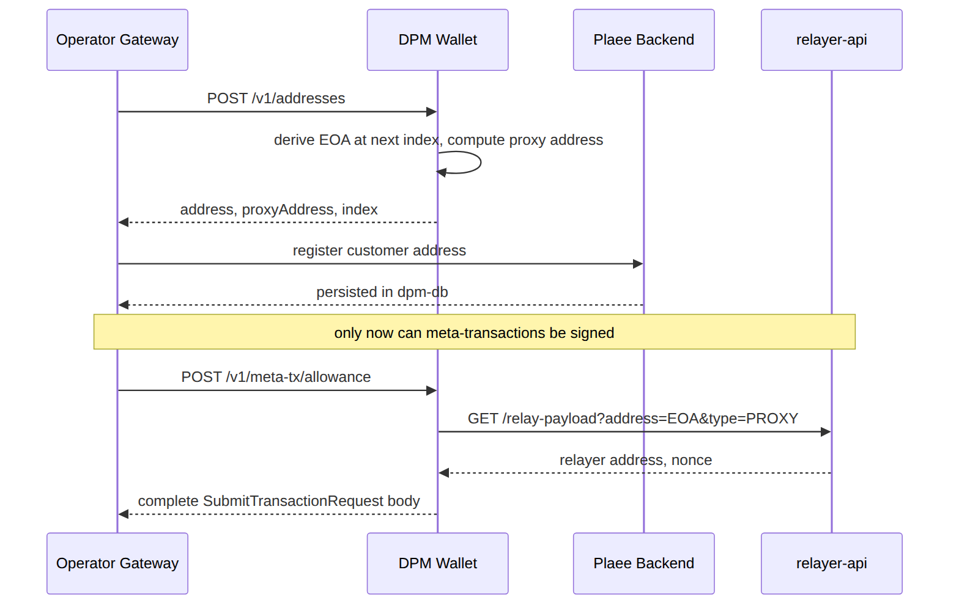
This is a hard precondition on every meta-transaction endpoint, surfaced as the distinct CUSTOMER_NOT_REGISTERED error so the operator can tell "not yet registered with Plaee" apart from a genuine signing failure.

12. Security

12.1 Inbound authentication
- Every /v1 route except /v1/health requires X-API-Key, compared in constant time against DPMW_API_KEY. This is the operator back-office authentication called for in the product requirements.

12.2 Outbound credential handling
- The X-API-Key for relayer-api (RELAYER_API_KEY) and the Turnkey credentials are read from env and never logged.
- The mnemonic keystore passphrase is read from env at boot; the decrypted mnemonic is held only transiently during signing.

12.3 Treasury policy engine
A policy layer enforces the product's wallet constraints before any signature is produced:
- Order recipient must be the operational wallet or a known customer wallet (or the zero address, meaning the maker). Arbitrary recipients are rejected.
- Customer proxy funds may only move to the operational wallet (redeem/withdraw destinations are checked against the configured operational address).
- The operational wallet may rebalance with the master but may not pay external addresses.
- Master → external is allowed but only via /v1/treasury/external-withdraw, never through a proxy/relayer path.
Destinations are checked against an allowlist derived from the vault's own addresses plus a configured external-withdrawal allowlist. A disallowed destination returns POLICY_VIOLATION.

12.4 Dual control for external withdrawals
POST /v1/treasury/external-withdraw requires two distinct approver tokens (DPMW_APPROVER_KEYS, a set) presented in the request. A single key is insufficient. This is deliberately simple in v1 (shared approver keys); a later phase can move to per-approver signatures.

12.5 Log redaction
Structured logs (one JSON object per line, matching the prediction-gateway convention) redact: mnemonics, private keys, passphrases, API keys, HMAC secrets, and full signatures (logged as a truncated prefix). Addresses, indices, refs, and non-secret request metadata are logged in full for support.

13. Phase-2 stub interfaces
These are defined now so later work does not force a redesign. v1 ships the interfaces with no-op or "not implemented" adapters.
Only on-chain deposit/withdrawal monitoring is a dpmw responsibility, because it watches the dpmw's own wallet addresses on-chain and needs no data from Plaee. The per-customer trading ledger and the order/trade/position event stream are not dpmw concerns — see the note in Section 4.
/** On-chain deposit/withdrawal monitoring (Polygon). */
export interface ChainMonitor {
start(): Promise<void>;
onSettledDeposit(handler: (e: DepositEvent) => void): void;
onSettledWithdrawal(handler: (e: WithdrawalEvent) => void): void;
}

14. Data model (SQLite)
Embedded SQLite via Drizzle ORM with better-sqlite3, in WAL mode, on a persistent Docker volume. One database file, migrated on boot.

14.1 Tables
vault_state — one row; the vault's initialisation and (mnemonic mode) encrypted keystore.
Column | Type | Notes
id | INTEGER PK | Always 1.
mode | TEXT | mnemonic
initialized | INTEGER | 0/1.
keystore_ciphertext | BLOB | AES-256-GCM ciphertext (mnemonic mode).
keystore_salt | BLOB | scrypt salt.
keystore_iv | BLOB | GCM IV.
turnkey_org_id | TEXT | Turnkey mode.
master_location | TEXT | internal
master_address | TEXT | Recorded master address (both locations).
master_custodian | TEXT | Custody label when external (nullable).
created_at | TEXT | RFC3339.
wallets — the address directory.
Column | Type | Notes
id | INTEGER PK
ref | TEXT UNIQUE | Operator customer reference.
role | TEXT | master
derivation_index | INTEGER UNIQUE | BIP-44 index.
eoa_address | TEXT UNIQUE | Lowercased hex.
proxy_address | TEXT | Lowercased hex; derived.
turnkey_account_id | TEXT | Turnkey mode.
dpm_registered | INTEGER | 0/1; set when the operator confirms Plaee registration.
created_at | TEXT
Indices: wallets_ref, wallets_eoa_lower, wallets_proxy_lower, wallets_index.
signing_requests — every signing action, for audit and idempotency linkage.
Column | Type | Notes
id | TEXT PK | UUID.
ref | TEXT | FK-ish to wallets.ref.
kind | TEXT | order
request_hash | TEXT | keccak256 of the canonical request.
result_summary | TEXT | orderHash / txId prefix (no secrets).
status | TEXT | ok
created_at | TEXT
audit_events — human-facing event log for support.
Column | Type | Notes
id | INTEGER PK
ref | TEXT | Nullable.
action | TEXT | e.g. address.create, sign.order, meta.allowance.
outcome | TEXT | success
detail | TEXT | Redacted JSON.
created_at | TEXT
idempotency_keys
Column | Type | Notes
key | TEXT PK | From Idempotency-Key.
request_hash | TEXT | keccak256 of the body.
response_json | TEXT | Stored response.
created_at | TEXT | TTL-eligible.

14.2 Migrations
Drizzle migrations live in src/db/migrations/ and run on boot before the HTTP server binds. WAL mode is set via PRAGMA journal_mode=WAL at connection open.

14.3 Durability across container restarts
Yes — SQLite is durable in Docker, provided the database file lives on a mounted volume rather than the container's writable layer. The container filesystem is discarded when the container is removed; the volume is not. With DATABASE_PATH=/data/dpmw.sqlite and /data backed by the named volume dpmw-data, the database survives docker stop/start, docker restart, docker rm + re-create, and image rebuilds or version upgrades. It is destroyed only by an explicit docker volume rm dpmw-data or a docker compose down -v (note the -v).
Four rules make this safe in practice:
Rule | Why
Mount the directory, never the file. Bind-mount /data, not /data/dpmw.sqlite. | WAL mode writes two sidecar files next to the database — dpmw.sqlite-wal and dpmw.sqlite-shm. They must sit on the same filesystem as the main file, and SQLite recovery may recreate them. A single-file bind mount breaks both.
Local disk only — no NFS/SMB/network volumes. | SQLite relies on POSIX advisory locking, which is unreliable over network filesystems and can silently corrupt the database.
Exactly one writer. Never run more than one dpmw container against the same volume (replicas: 1). | SQLite permits one writer at a time; two containers sharing a volume will produce lock contention and, on a network mount, corruption.
PRAGMA synchronous=FULL. | In WAL mode the SQLite default is NORMAL, which fsyncs only at checkpoint — a host crash or power loss can lose the most recently committed transactions. For a wallet directory, losing a just-created address record means losing track of customer funds, so the write-latency cost is worth paying.
Connection pragmas set in src/db/client.ts at open:
db.pragma("journal_mode = WAL"); // concurrent reads during writes; crash-safe
db.pragma("synchronous = FULL"); // fsync every commit — no lost address rows
db.pragma("foreign_keys = ON");
db.pragma("busy_timeout = 5000"); // wait rather than throw SQLITE_BUSY
Crash safety. A docker kill, OOM kill, or host power loss leaves a populated -wal file; SQLite replays it automatically on the next open, so every committed transaction is present and no partial transaction is. No manual repair step is needed.
Graceful shutdown. On SIGTERM (what docker stop sends, forwarded by tini), the process stops accepting new requests, lets in-flight ones finish, then closes the database — which runs a final WAL checkpoint and folds the -wal contents back into the main file. This is not required for correctness, but it means the volume holds a single self-contained file, which makes backups and restores simpler.
Because the dpmw is sign-only, there is no in-flight state to recover. Signing is deterministic and holds nothing across requests; RelayHub nonces are fetched from relayer-api at signing time rather than stored. A crash mid-request loses at most that one response, and the caller can safely retry with the same Idempotency-Key.

15. Project structure
A flat, tsc-built ESM service in the style of prediction-gateway, with viem-based crypto in the style of dpm-sdk.
dpm-wallet/
├── docs/
│ └── TECHNICAL-SPEC.md
├── src/
│ ├── index.ts # entry: load config, run migrations, start server
│ ├── config.ts # env → typed Config (manual parse + validation)
│ ├── app.ts # Express app factory + route wiring
│ ├── http/
│ │ ├── middleware/
│ │ │ ├── api-key.ts # X-API-Key
│ │ │ ├── idempotency.ts
│ │ │ └── error-handler.ts # error envelope
│ │ ├── routes/
│ │ │ ├── vault.routes.ts
│ │ │ ├── address.routes.ts
│ │ │ ├── sign.routes.ts # order + cancel
│ │ │ ├── meta-tx.routes.ts
│ │ │ ├── treasury.routes.ts
│ │ │ └── audit.routes.ts
│ │ └── dto/ # zod schemas (request + response)
│ ├── services/
│ │ ├── address.service.ts
│ │ ├── order-signer.service.ts
│ │ ├── meta-tx.service.ts
│ │ ├── treasury.service.ts
│ │ └── policy.ts # treasury destination allowlist / dual control
│ ├── vault/
│ │ ├── key-vault.ts # KeyVault port + types
│ │ ├── mnemonic-vault.ts # BIP-39/44 + AES-256-GCM keystore
│ │ ├── turnkey-vault.ts # uses SignerProvider
│ │ └── providers/
│ │ ├── signer-provider.ts
│ │ └── turnkey.provider.ts
│ ├── sdk/
│ │ ├── vault-wallet-adapter.ts # InternalWalletPort bridge
│ │ ├── api-key-fetch.ts # fetchImpl injecting X-API-Key
│ │ └── wiring.ts # picks SDK build functions
│ ├── db/
│ │ ├── client.ts # better-sqlite3 + drizzle, WAL
│ │ ├── schema.ts
│ │ ├── repositories/
│ │ └── migrations/
│ ├── crypto/
│ │ └── proxy-address.ts # CREATE2 derivation (viem)
│ ├── observability/
│ │ ├── log.ts # JSON console logging + redaction
│ │ └── audit.ts
│ └── startup/
│ ├── bootstrap.ts # rehydrate vault + directory from the volume
│ ├── self-check.ts # EIP-712 domain digest check
│ └── shutdown.ts # SIGTERM: drain, close DB, WAL checkpoint
├── vendor/
│ └── dpm-sdk/ # git submodule (built in the image)
├── Dockerfile
├── docker-compose.yml
├── .env.example
├── drizzle.config.ts
├── tsconfig.json
├── package.json
└── README.md

15.1 Stack choices
Concern | Choice | Rationale
Runtime | Node ≥ 22 | Matches the workspace's engines.node >= 20; 22 for current LTS.
Language/module | TypeScript 5, ESM (NodeNext), tsc build | Matches prediction-gateway.
HTTP | Express 5 | Matches prediction-gateway.
Validation | zod | Matches prediction-backoffice; strong DTO typing.
Crypto/ABI | viem v2 | Matches dpm-sdk; reused via the vendored SDK.
DB | SQLite + better-sqlite3 + Drizzle | Embedded, single-file, in-project as required; Drizzle gives typed migrations.
Tests | vitest | Matches dpm-sdk.
Logging | JSON to stdout | Matches prediction-gateway log.ts.

15.2 Vendoring dpm-sdk
dpm-sdk is added as a git submodule under vendor/dpm-sdk and referenced as a path/workspace dependency. The Docker build compiles it before the app so the required changes (Section 7) and the app ship as one coordinated build with no npm release in between. The app imports from the SDK's server-only entry (or ./lp as fallback) to avoid pulling React/Privy/Magic into the container.

16. Configuration
All configuration is via environment variables, parsed and validated at boot (missing required values throw before the server binds).
Variable | Required | Default | Description
PORT | no | 8090 | HTTP listen port.
DPMW_VAULT_MODE | yes | — | mnemonic
DPMW_MASTER_LOCATION | no | internal | internal (vault holds the master key) or external (third-party custody). See §6.6.
DPMW_MASTER_ADDRESS | external only | — | Master wallet address when DPMW_MASTER_LOCATION=external.
DPMW_MASTER_CUSTODIAN | no | — | Optional custody label for an external master (e.g. fireblocks, qredo, metamask).
DPMW_API_KEY | yes | — | Inbound API key from the operator gateway.
DPMW_KEYSTORE_PASSPHRASE | mnemonic mode | — | scrypt passphrase for the encrypted mnemonic keystore.
TURNKEY_API_PUBLIC_KEY | turnkey mode | — | Turnkey API public key.
TURNKEY_API_PRIVATE_KEY | turnkey mode | — | Turnkey API private key.
TURNKEY_ORGANIZATION_ID | turnkey mode | — | Turnkey organisation/sub-org id.
RELAYER_BASE_URL | yes | — | Base URL of relayer-api (for /relay-payload).
RELAYER_API_KEY | yes | — | X-API-Key sent to relayer-api.
CHAIN_ID | yes | 137 | Polygon mainnet.
EXCHANGE_DOMAIN_NAME | yes | DPM CTF Exchange | EIP-712 order domain name; self-checked at boot.
CONTRACT_COLLATERAL | yes | — | USDC address.
CONTRACT_CTF | yes | — | ConditionalTokens address.
CONTRACT_CTF_EXCHANGE | yes | — | CTF Exchange (verifyingContract).
CONTRACT_PROXY_FACTORY | yes | — | ProxyWalletFactory address.
CONTRACT_PROXY_IMPL | yes | — | Proxy implementation (for CREATE2 derivation).
CONTRACT_RELAY_HUB | yes | — | RelayHub address.
OPERATIONAL_ADDRESS | no | derived | Cached operational wallet address (index 1).
DPMW_EXTERNAL_ALLOWLIST | no | — | Comma-separated external withdrawal destinations.
DPMW_APPROVER_KEYS | no | — | Comma-separated approver tokens for dual control.
DATABASE_PATH | no | /data/dpmw.sqlite | SQLite file on the mounted volume.
LOG_LEVEL | no | info | debug
The six CONTRACT_* values plus CHAIN_ID are exactly what a GET /contract-info call would return; supplying them as config removes that outbound dependency.

17. Docker and operations

17.1 Image
Multi-stage Alpine build (Node 22), building the vendored SDK first, running as a non-root user, with better-sqlite3 compiled against the runtime.
# ---- build ----
FROM node:22-alpine AS build
RUN apk add --no-cache python3 make g++ # better-sqlite3 native build
WORKDIR /app
COPY vendor/dpm-sdk ./vendor/dpm-sdk
RUN cd vendor/dpm-sdk && npm ci && npm run build
COPY package*.json ./
RUN npm ci
COPY . .
RUN npm run build

# ---- runtime ----
FROM node:22-alpine AS runtime
RUN apk add --no-cache tini
WORKDIR /app
ENV NODE_ENV=production
COPY --from=build /app/node_modules ./node_modules
COPY --from=build /app/vendor/dpm-sdk/dist ./vendor/dpm-sdk/dist
COPY --from=build /app/dist ./dist
RUN addgroup -S dpmw && adduser -S dpmw -G dpmw && mkdir -p /data && chown dpmw:dpmw /data
USER dpmw
VOLUME ["/data"]
EXPOSE 8090
ENTRYPOINT ["/sbin/tini", "--"]
CMD ["node", "dist/index.js"]
Native-module caveat: better-sqlite3 compiles a native addon. Building and running on the same Node major/Alpine base (as above) avoids ABI mismatches; a prebuilt binary is used when available.

17.2 Compose (operator convenience)
services:
dpmw:
build: .
ports: ["8090:8090"]
env_file: .env
# Named volume holding dpmw.sqlite plus its -wal/-shm sidecars.
# Mount the directory, not the file, and keep it on local disk (§14.3).
volumes: ["dpmw-data:/data"]
restart: unless-stopped
stop_grace_period: 30s # let in-flight signs finish and the WAL checkpoint
healthcheck:
test: ["CMD", "wget", "-qO-", "http://localhost:8090/v1/health"]
interval: 30s
timeout: 5s
retries: 3
volumes:
dpmw-data: # survives `down`; destroyed only by `down -v`
Do not scale this service beyond one replica — SQLite allows a single writer per database file (§14.3).

17.3 Health and readiness
- GET /v1/health (liveness) returns 200 with { status: "ok" } once the process is up.
- Readiness additionally checks vault health: mnemonic keystore decrypts, or Turnkey is reachable, and the DB is writable. Not ready until POST /v1/vault/init has run at least once.

17.4 First-run
- Operator sets env (mode, keys, contract addresses, and the master location — internal, or external with DPMW_MASTER_ADDRESS).
- Container boots, runs migrations, passes the EIP-712 self-check.
- Operator calls POST /v1/vault/init → internal master (index 0) is created and, in mnemonic mode, the encrypted keystore is written to the volume; an external master is recorded as non-signable (no key created).
- Operator calls POST /v1/addresses with role: "operational" to create index 1.
- Customer onboarding proceeds per Section 11.

17.5 Restart and cold-start recovery
On every subsequent boot the container rebuilds its entire working state from the volume. Nothing is held only in memory between runs, and no step requires the operator to re-supply anything except the environment variables (crucially DPMW_KEYSTORE_PASSPHRASE, which is never written to disk).
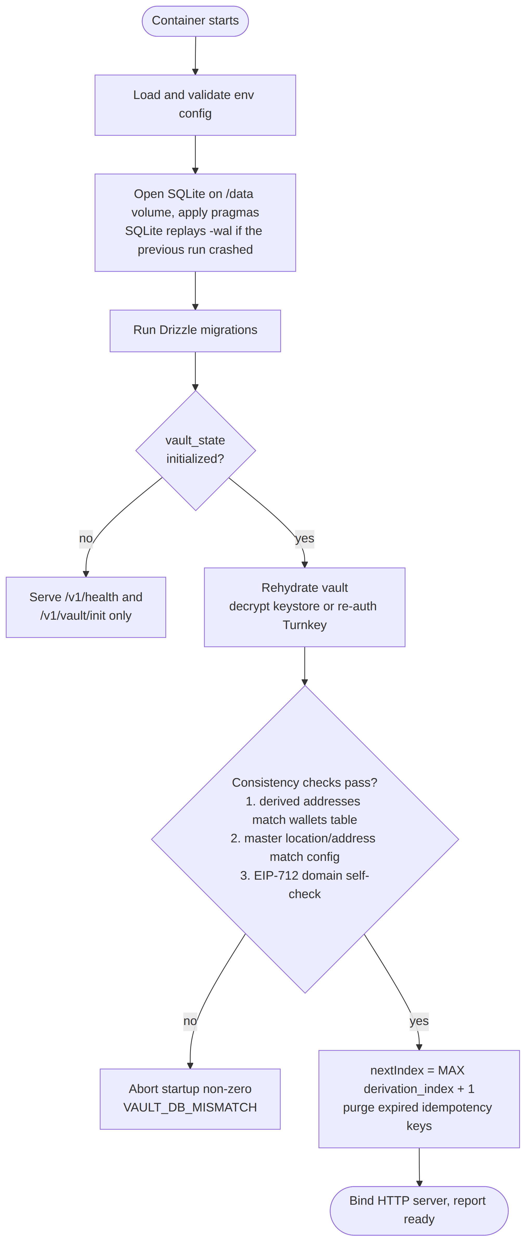
src/startup/bootstrap.ts runs this sequence before the HTTP server binds:
export async function bootstrap(config: Config): Promise<Runtime> {
const db = openDatabase(config.databasePath); // pragmas from §14.3
await runMigrations(db); // no-op when already current

const state = await vaultStateRepo.load(db);
if (!state?.initialized) return uninitialized(db); // only /v1/health + /v1/vault/init

const vault = await rehydrateVault(state, config); // decrypt keystore, or re-auth Turnkey
await assertVaultMatchesDirectory(vault, db); // re-derive and compare stored addresses
await assertMasterMatchesConfig(state, config); // location/address drift check
await assertExchangeDomain(config); // existing EIP-712 self-check

const nextIndex = await walletRepo.maxDerivationIndex(db) + 1;
await idempotencyRepo.purgeExpired(db);
return ready({ db, vault, nextIndex });
}
What each step recovers:
Step | Recovered from | Notes
Migrations | src/db/migrations/ | Idempotent; brings an older volume up to the current schema after an image upgrade.
Vault state | vault_state (single row) | Mode, master location, master address, custodian label, and the encrypted keystore blob.
Signing keys | keystore_ciphertext + keystore_salt + keystore_iv | Decrypted with DPMW_KEYSTORE_PASSPHRASE into memory only. Turnkey mode holds no key — it re-reads turnkey_org_id and re-authenticates.
Address directory | wallets | Refs, roles, derivation indices, EOA and proxy addresses, Turnkey account ids, dpm_registered flags.
Next derivation index | MAX(derivation_index) + 1 | Read from the database, never from memory or config, so a restart can never reissue an index and collide with an existing address.
Idempotency window | idempotency_keys | Survives restart, so a client retrying across a restart still gets the original response instead of a second signature.
Audit history | audit_events, signing_requests | Continuous across restarts; the log is append-only.
Three of these steps are fail-fast consistency checks rather than loads, and the container refuses to become ready if any fails:
- assertVaultMatchesDirectory re-derives the EOA for the stored wallets and compares against wallets.eoa_address. A mismatch means the volume and the key material have diverged — a database restored from a different install, or a new mnemonic dropped onto an existing volume. Continuing would silently mint a second, unrelated address tree for existing customer refs, so this aborts startup with VAULT_DB_MISMATCH and exits non-zero (a boot failure, not an HTTP error — the server never binds).
- assertMasterMatchesConfig compares vault_state.master_location / master_address with DPMW_MASTER_LOCATION / DPMW_MASTER_ADDRESS. This catches an operator flipping custody mode against a volume that was initialised the other way.
- A wrong DPMW_KEYSTORE_PASSPHRASE fails earlier and unambiguously: AES-256-GCM authentication fails during decryption, so the container never reaches the address checks.
Readiness (§17.3) only reports ready after bootstrap completes, so an orchestrator will not route traffic to a container whose vault could not be rehydrated.

17.6 Backup and restore
The volume is the unit of backup. Because the database may have an active -wal file, do not cp the .sqlite file from a running container — that can capture a torn state. Use SQLite's online backup, which is safe against a live writer and produces a single consistent file:
docker exec dpmw node -e "require('better-sqlite3')(process.env.DATABASE_PATH)\
.exec(\"VACUUM INTO '/data/backup-\$(date +%F).sqlite'\")"
Restore is the reverse: stop the container, place the file at DATABASE_PATH on the volume (removing any stale -wal/-shm sidecars), and start. In mnemonic mode the backup contains the encrypted keystore, so a restore also needs the original DPMW_KEYSTORE_PASSPHRASE — and the mnemonic itself should additionally be backed up out of band via the guarded export endpoint (§6.4). A database backup alone is not a key backup.

18. Open items for implementation
- Confirm the Turnkey signing API surface for EIP-712 typed data vs raw payloads, and map it onto SignerProvider.signRawPayload.
- Confirm the exact SubmitTransactionRequest field set accepted by the deployed relayer-api matches the SDK's SubmitTransactionRequest type (they align today; pin it with a contract test).
- Decide whether EXCHANGE_DOMAIN_NAME becomes an SDK parameter (preferred) or stays a dpmw-side override until the SDK change lands.
- Decide dual-control model beyond v1 (shared approver tokens → per-approver signatures).
- Decide whether an external master should later become signable through the SignerProvider seam (e.g. a Fireblocks provider that assembles and signs master treasury transactions), versus remaining fully operator-driven. v1 treats it as address-only / non-signable.

