Question 3. Q3: Count of records in fct_monthly_zone_revenue? (1 point)
- 12,998
- 14,120
- 12,184
- 15,421
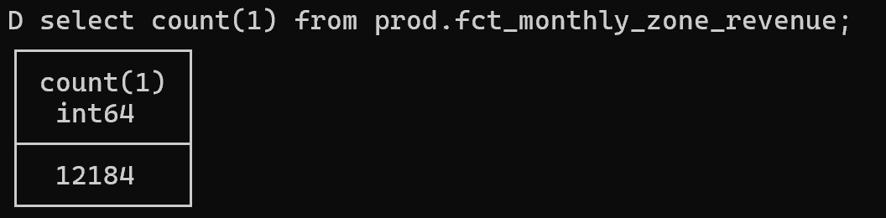

Question 4. Q4: Zone with highest revenue for Green taxis in 2020? (1 point)
- East Harlem North
- Morningside Heights
- East Harlem South
- Washington Heights South

select YEAR(revenue_month) AS revenue_year, pickup_zone, service_type, max(revenue_monthly_total_amount) from prod.fct_monthly_zone_revenue where service_type='Green' and revenue_month between '2020-01-01' and '2020-12-01' group by revenue_year, pickup_zone, service_type order by max(revenue_monthly_total_amount) DESC;
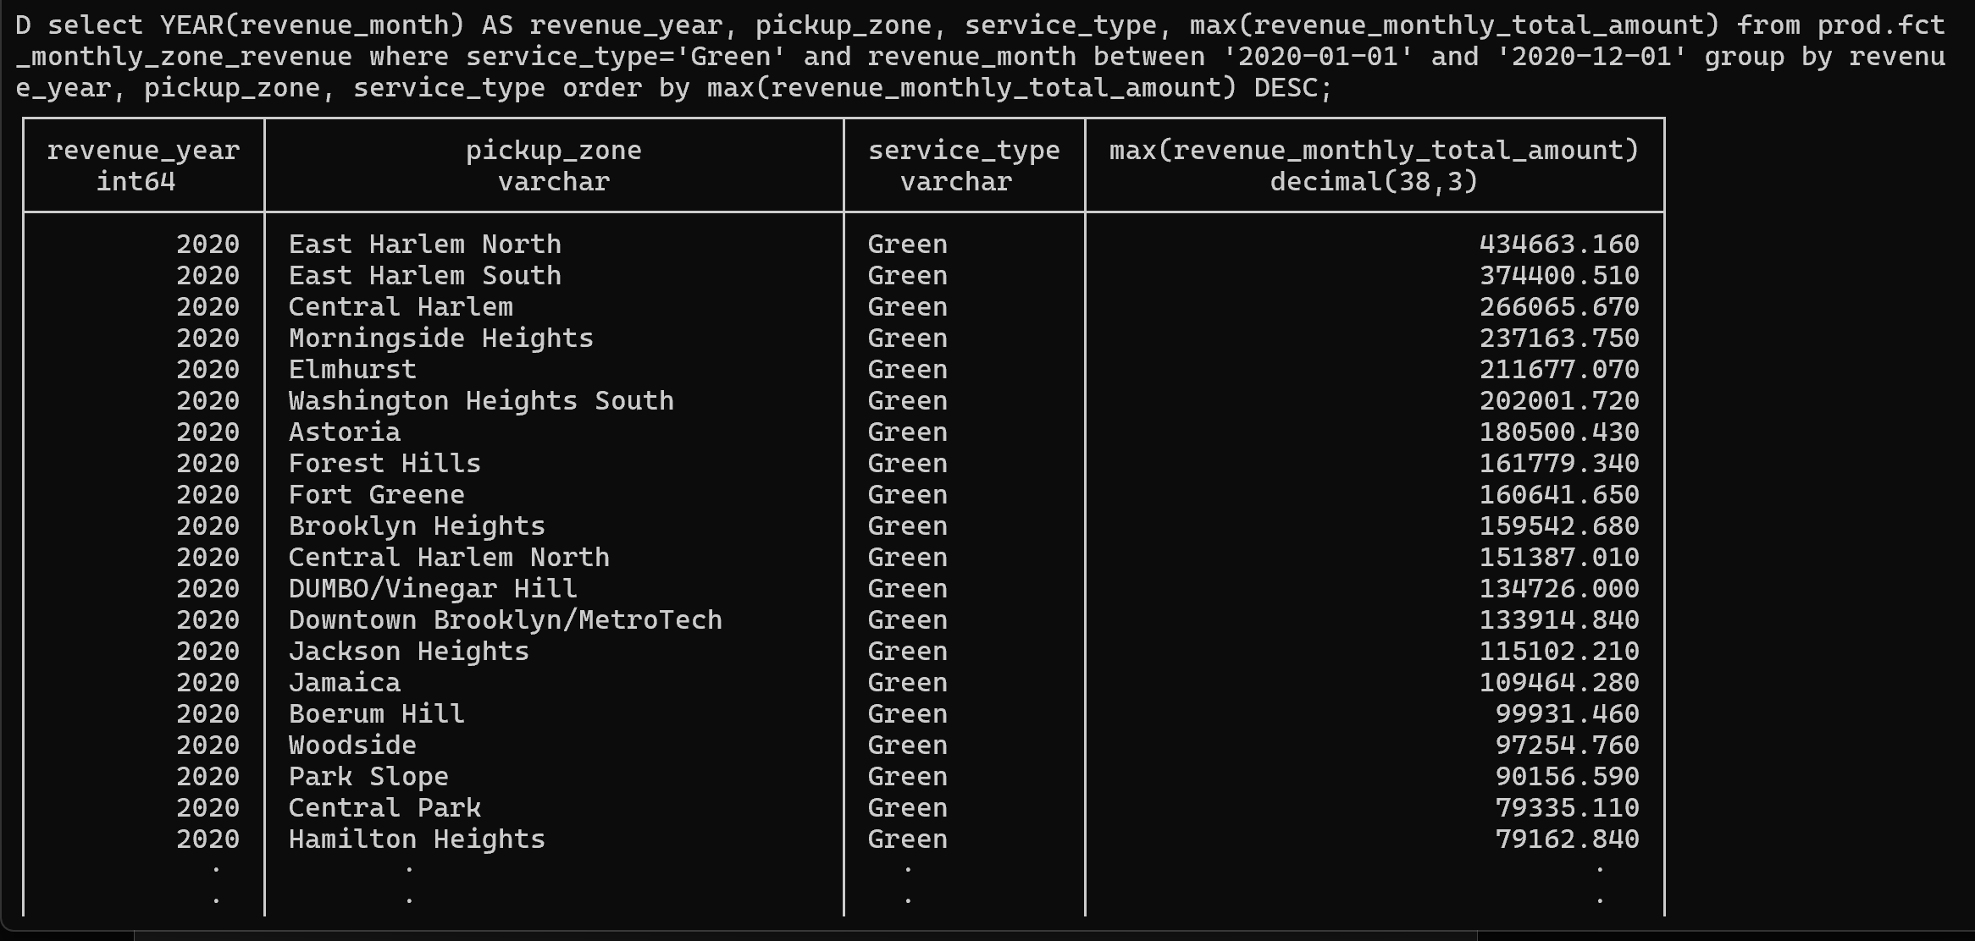

Question 5. Q5: Total trips for Green taxis in October 2019? (1 point)
- 500,234
- 350,891
- 384,624
- 421,509

select strftime(revenue_month, '%Y-%m') AS revenue_year_month, service_type, sum(total_monthly_trips) from prod.fct_monthly_zone_revenue where service_type='Green' and revenue_month between '2019-10-01' and '2019-10-01' group by revenue_year_month, service_type
