

Ministerul Educatiei, Culturii și Cercetarii al Republicii Moldova Universitatea Tehnică a Moldovei
Facultatea Calculatoare, Informatică şi Microelectronică Departamentul Ingineria Software și Automatica

Report
for laboratory work No. 3
course "Cryptography and Security"

Done by:
Carp Daniel, gr.
FAF-211
Checked by:
Cǎtǎlin MÎŢU

Chișinău – 2023

Subject: Cryptanalysis of monoalphabetic ciphers

Tasks:
To create a Playfair algorithm implementation in a programming language suitable for processing messages in Romanian, which consists of 31 letters, you need to ensure that the characters in the text fall within the 'A' to 'Z' and 'a' to 'z' range. Any characters outside this range should be flagged as incorrect. It's essential for the key to be at least 7 characters long. Users should have the option to choose between encryption and decryption, input their key, message, or cryptogram, and receive the decrypted cryptogram or message. Adding new spaces, as necessary, based on the chosen language and the message's logic, will be a manual step in the final stage of processing.
Theory :
The Playfair cipher, often associated with Lord Playfair but originally invented by Charles Wheatstone in 1854, is a historic encryption technique. This digraph substitution cipher became prominent in the 19th century. It hinges on the creation of a 5x5 key matrix derived from a secret key phrase, which could be any combination of letters, including omitting duplicates and treating 'I' and 'J' as one.
It was used for tactical purposes by British forces in the Second Boer War and in World War I and for the same purpose by the Australians during World War II. This was because Playfair is reasonably fast to use and requires no special equipment
Implementation:
Step 1: Prepare the Text for Encryption

Convert the entire plaintext to uppercase.
Replace all occurrences of "J" with "I" to treat them as the same letter.
Create letter pairs (couples) from the plaintext.
Remove any spaces and punctuation from the letter pairs.
If any letter pairs contain the same letter, insert a filler character ("Q," "X," or "Z") between them.

Step 2: Construct the Encryption Matrix (Playfair Table)

Ensure there are no duplicate letters in the key and handle "J"s by treating them as "I."
Create the Playfair matrix by adding the key and the remaining letters of the alphabet without duplication. The key letters are placed first, and then the remaining letters are filled in, usually from left to right and top to bottom.

Step 3: Encrypt the Message

For the encryption process, you'll perform the following substitutions based on the position of the letters within the Playfair matrix:

For Different Rows and Columns:

If the two letters of a letter pair are in different rows and columns, replace each letter with the letter in the same row but from the column of the other letter.

For the Same Rows:

If the two letters are in the same row, replace each letter with the next letter in the same row. If a letter is at the end of the row, wrap around to the beginning of the row.

For the Same Columns:

If the two letters are in the same column, replace each letter with the next letter in the same column. If a letter is at the bottom of the column, wrap around to the top of the column .
After applying these rules, you will have successfully encrypted the plaintext using the Playfair cipher.

By applying these rules in reverse, you will successfully decrypt the ciphertext back into the original plaintext using the Playfair cipher.

Code Snippets:
romanian_language(string): This function checks if a string consists of characters within the Romanian language (both uppercase and lowercase). It uses a regular expression pattern to match valid characters, ensuring that only valid characters are used in the encryption process.
add_letters(message): This function adds "Q," "X," or "Z" between letters of pairs with the same letter and ensures that the message length is even. It helps comply with the Playfair cipher rules, where double letters need separation, and the message should be of even length. The function inserts one of the specified characters between repeated letters and appends an 'F' if the message length is odd.
def add_letters(message):
to_insert = ['Q', 'X', 'Z']
message, i = list(message), 0
while i < len(message) - 1:
if message[i] == message[i + 1]:
message.insert(i + 1, random.choice(to_insert))
i += 2
# Add additional letter to the end if the message has an odd length
if len(message) % 2 != 0:
message.append('F')
return message
find_letter_indices(letter, matrix): This function finds the row and column indices of a given letter within a matrix. It is used during encryption and decryption to locate letters within the matrix.
encrypt(message, matrix): This function performs the encryption of a given message using a Playfair matrix and key. It iterates through the message in pairs and follows three conditions for substitution, based on the relative positions of the letters in the matrix. The result is the encrypted ciphertext.
decrypt(ciphertext, matrix): This function reverses the encryption process. It decrypts a ciphertext using the same Playfair matrix and key. It follows conditions opposite to the encryption process to reveal the original message. It also eliminates the additional characters introduced during encryption.
create_matrix(key): This function generates a 5x6 matrix for the Playfair cipher using a provided key. The matrix combines the key and the Romanian alphabet, eliminating duplicates. The Playfair matrix helps determine the letter substitutions during encryption and decryption.
def create_matrix(key):
# matrix with 5 rows and 6 columns
matrix = []
alphabet = "AĂÂBCDEFGHIÎKLMNOPQRSȘTȚUVWXYZ"
new_alphabet = ''.join(dict.fromkeys(key + alphabet))
for i in range(0, 30, 6):
row = new_alphabet[i:i + 6]
matrix.append(list(row))
return matrix
input_key(): This function takes user input for the encryption key, ensuring that it consists of Romanian characters and is at least seven characters long. It also converts the key to uppercase, replaces 'J' with 'I,' and eliminates duplicate characters.
The code's main section manages user interaction. It presents a menu for encryption, decryption, and exiting the program. The user can input a message or ciphertext, and the program guides them through the process, enforcing rules to maintain data integrity. The result is either an encrypted ciphertext or a decrypted message.
In summary, this code implements the Playfair cipher, which is a simple but effective manual encryption technique. It ensures that the encryption and decryption processes adhere to the rules of the Playfair cipher while maintaining data consistency.
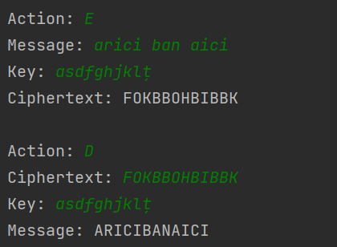
Figure 1 Example of Encryption/Decryption
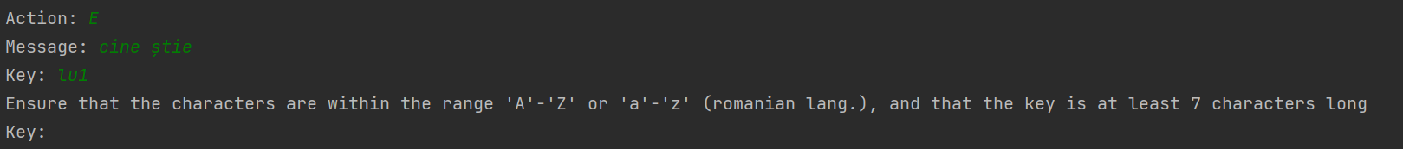
Figure 2 Example of Error

Conclusion:
In the lab, we've learned about the Playfair cipher, an old encryption method. It showed us how to encrypt and decrypt messages following certain rules. This understanding is a building block for data security. The Playfair cipher has its place in history and connects with today's data security practices. This experience encourages me to explore more in cryptography and its applications.

