## 2.1: Here are 5 results:

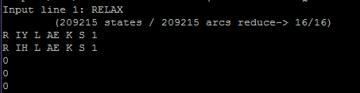

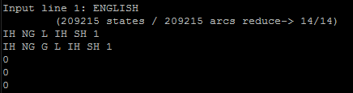

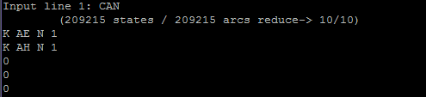

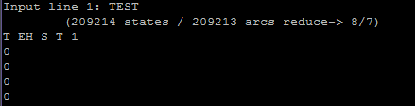

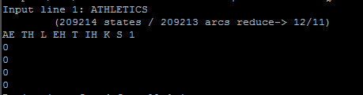

## 2.2: Here are 5 results:

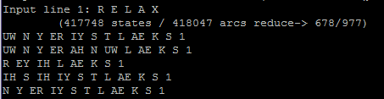

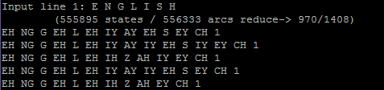

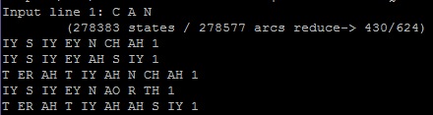

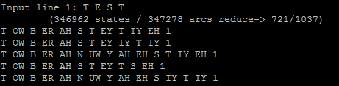

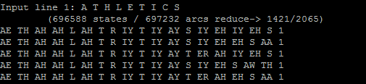

## 2.3: Here are 5 results:

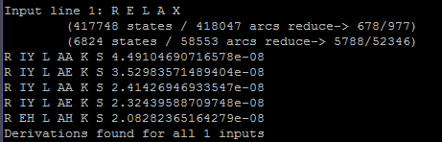

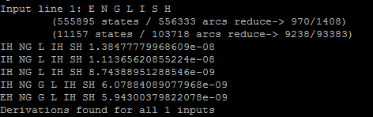

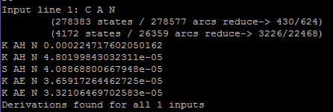

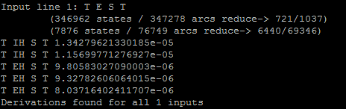

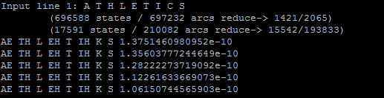

## 2.4: Here are 5 results (cause each result is too long, I only pick up first 10 line for each result)

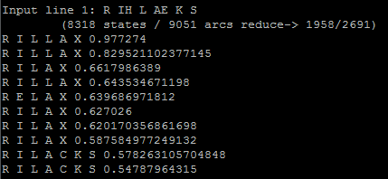

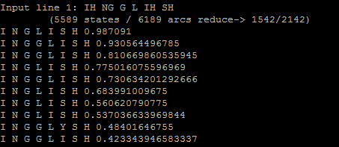

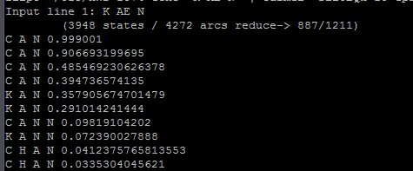

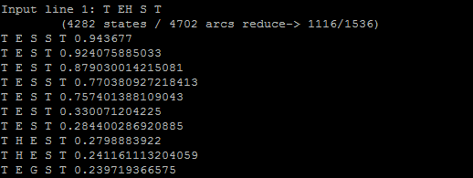

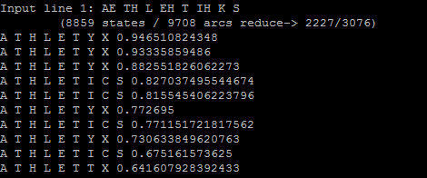

## 2.5 Here are 5 results

## 2.6: Here are 5 results:

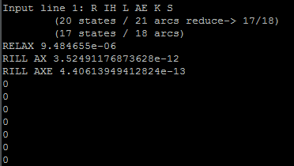

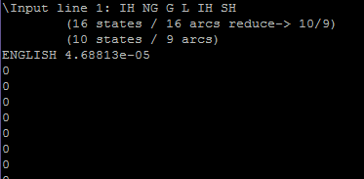

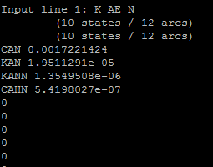

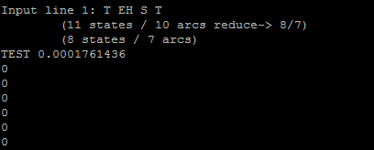

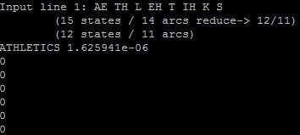

## 2.7 Here are 5. Results: The words I used here is: lamian, kunfu, and pneumokoniosis

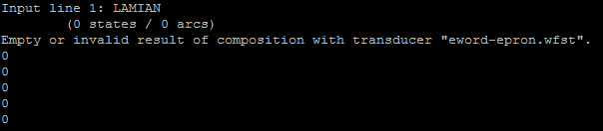

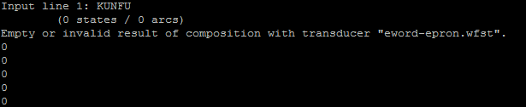

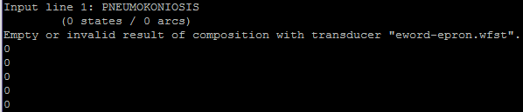

## 2.8 Here are 5 results(lack of pronouciation)

## 2.9 Here are 5 results

## 2.10 Here the result

## 