Part 1

1. bigram.wfsa
2. lexicon.wfst

3.

I hope that this works

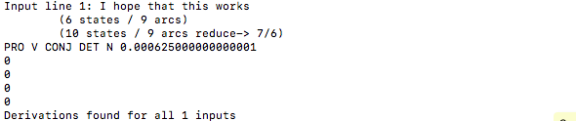

They can fish

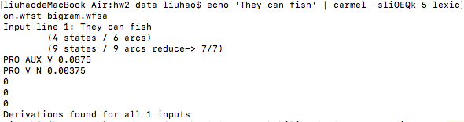

A panda eats shoots and leaves

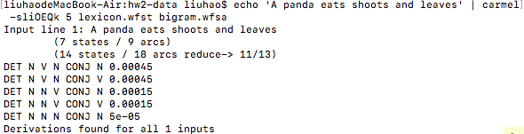

They can can a can.

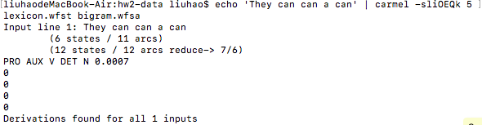

Time flies like an arrow

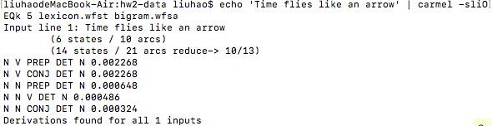

4. The combination of lexicon.wfst and input string will give a probability of

P1 (w…w | t…t)

And the probability of bigram.wfsa is like P2 (t…t)

So we need to composite these two probabilities.

Then the total result is P1 \* P2

Use “They can fish” as an example:

As I defined: P2 (PRO AUX V) = 0.25 \*1.0 = 0.25

P1 (they can fish | PRO AUX V) = 1.0\*0.7\*0.5 = 0.35

So the total probability P1 \* P2 = 0.25\*0.35 = 0.0875

5. We can see for the third and fifth sentences there are lot of means.

For the third one:

Such as panda eats something and goes away or a type of eat uses gun to shoot and goes away ☹

For the fifth one:

One mean can be time goes fast, or a kind of fly looks like an arrow ☹

These are all meaningful sentences, if we want the mean become more common, we can use an N-gram to memory more high frequency sentence. In that case we may get a normal structure of each sentence.