Utah State University  
November 10, 2015

Proposal for

Plaque Laser Engraving Device

I. Project Summary 3

II. Introduction 4

III. Problem 4

IV. Objectives 5

V. Solution 5

VI. Method 5

VII. Resources 7

VIII. Schedule 7

IX. Qualifications 8

X. Management 8

XI. Costs 8

# Project Summary

Utah State University is a public university located in Logan Utah. Most well-known for its engineering programs, Utah State provides many high quality engineers to revolutionize the industry each year. As students at Utah State, our purpose is to gain meaningful knowledge and experience which will lead us to provide new developments to future generations.

The product proposed in this document is a plaque laser engraving device (PLED) which will engrave high quality images into wooden plaques. Our purpose it to gain engineering experience to propel us into a position in which we can be competitive in the work force. Likewise, our product will provide people with quality decoration for their homes and offices, and could be used for awards and recognition.

We request $400 for the cost of materials. The most expensive materials will be the laser module and the structural components. We feel that $400 will enable us to build a prototype as a proof of concept and give us invaluable experience. We also request regular meetings to discuss project progress and developments during the design and testing phases of the project.

# Introduction

Utah State University was founded in 1888 with the commitment to produce quality students who will change the world. Engineering projects are at the forefront of USU innovations and have always been an integral part of an engineering student’s education. We feel this project will give us valuable experience on how to design an effective controls system and how lasers are used in industry. It will also put artistic design tools in the hands of the general public to help improve people’s homes.

We want this product to be usable by the general public. To accomplish this, we want a user to be able to choose a piece of wood to engrave the image on and clamp it to the frame of the plaque laser engraving device (PLED). They then upload an image from a phone or digital camera to a computer and easily run a program that will start the PLED. The software will then send the image information to the microcontroller on the PLED and it will engrave the image on the plaque.

There are many laser engraving machines on the market today. Our goal is not to outdo products that are currently available. Our primary purpose is to learn what it takes to build a complicated controls device like this and how feasible it is to engineer one from scratch. We may improve upon issues that we find with current systems along the way, but our goal is mainly educational and we would love to inspire others on senior design night as something to be proud of here at Utah State.

The sections that follow will detail the problem, or the inspiration behind our project. Our objectives and end goal will be laid out, and we will define the means by which we will accomplish them, such as available resources, schedule, qualifications, management and budget.

# Problem

Ever since lasers were developed in the 1950’s they have been quite expensive and not very powerful. Only in the last 20 years have semiconductor lasers become widely available and even more recently at higher power outputs. Because they have become affordable to hobbyists more recently, their useful applications are still forming. Laser engraving at the hobbyist level is now possible but not many have done it. We don’t intend to make the most sophisticated laser engraver available, but we do want to prove it is possible to build an affordable, easy-to-use unit and learn about controls systems along the way.

One concern people often have with new or specialty technology is that it often very expensive. Our target budget for this project is $400 which is within reach of many of the people looking for a solution like ours. If hobbyists can obtain a PLED for $400, they would be able create works of art, gain experience with evolving technology and possibly even contribute to further development in the field.

In a generation that is interested in finding new and unique ways to decorate, it is clear that hanging photos is only one of many available options. Painting and burning wood has been a long standing form of decoration. Despite its beauty and novelty, the precision and intricacy of laser engravings have been expensive and difficult to obtain. If someone wants a family photo engraved on a wooden plaque they would likely have to pay in excess of $100 to have one made. This product, beyond providing experience to potential engineers, provides people with quality decoration to make their home or office unique at a more affordable price.

# Objectives

We have three primary goals for this project:

* Goal 1: Create high quality, laser engraved images on wooden plaques.
  + Benefit: Make engraved plaques affordable and easily available to the general public.
* Goal 2: Create an affordable, hobbyist level engraving machine.
  + Benefit: Allow hobbyists and engineers to learn about the design and construction of a CNC machine using lasers at a low cost.
* Goal 3: Learn to control a mechanical system with a microcontroller and computer.
  + Benefit: Allows for our personal edification, and the opportunity for others to make improvements on the original design.

# Solution

We will design and construct a CNC type laser engraving machine that will reproduce digital images on wood. The process will start with a user having a photo on their computer. They will then run a program that will convert the image to 8 bits of grayscale resolution and the program will compile the instructions for the microcontroller. The instructions will take the form of G-code commands which tell the servos to move the laser module over the target surface.

The microcontroller will interpret the G-code commands and monitor the engraving process. These messages will be sent by a serial cable to the microcontroller. The PC will also monitor the process of engraving and if, at any time, the laser module is nudged out of position the PLED will halt operation as a safety feature. The laser will be tuned to the user’s desired level of engraving power and the finished engraving will be left unfinished to preserve the beauty of the wood.

The major savings in the cost of reproducing our PLED will come from the fact that all of our software will be made open source, and the frame of our machine will be made from inexpensive aluminum rails. The laser module is the most inexpensive semiconductor laser available, and using a microcontroller for this project will be relatively inexpensive compared to custom made CNC control chips.

# Method

A number of tasks, divided into different phases, must be accomplished in order for the PLED project to be successful. Those tasks are as follows:

**Phase 1: Initial documentation**

*Specifications document* – Determine program requirements and compile them into a specifications document which will drive the design of the PLED.

*Proposal* – A proposal must be written to outline the design and details of the PLED project and how it will be conducted.

*Select specific components to be used* – The PLED team will use the specifications document and proposal to determine which components will be used for the PLED, then the specific manufacturers and models will be identified.

*Preliminary Design Review Slides* – In preparation for a preliminary design review, the last details of the design will be determined and a presentation will be prepared outlining those details and that design.

**Phase 2: Build prototype**

*Procure components* – Components will be procured in order to begin development of the PLED.

*Preliminary Design Review* – A Preliminary Design Review will be conducted. This review will determine if the initial PLED design is acceptable and if any revisions should be made prior to proceeding with the design.

*Test components* – The components and their performance will be characterized to assure that they perform acceptably to carry out their tasks in the PLED.

*Design laser driver circuit* – A circuit must be designed to assure that the appropriate amount of power is provided to the laser. Insufficient power will not burn the wood sufficiently, while too much power will damage the laser diode.

*Construct mechanical system* – A mechanical frame must be constructed to house the PLED.

*Write software to ingest image* – Software will be written to ingest the initial image and convert it into a format that can be read and converted into code that we can manipulate.

*Write software to process image* – Software will be written to convert the image to an 8-bit grayscale image.

*Write software to convert image to G-Code –* Software will be designed to convert the image to G-Codes in order to be burned adequately into a wooden plaque.

*Configure serial communications between PC and microcontroller –* A serial communications line will be configured and used to pass the G-Codes to the interpreter housed in the microcontroller.

*Configure communications from microcontroller to servos –* The microcontroller will be programmed to be able to adequately control the servos with high resolution.

*Integrate G-Code interpreter into microcontroller –* A G-Code interpreter will be installed onto the microcontroller which will be capable of passing the G-Code coordinate information to values that can control the servos.

*Critical Design Review –* A critical design review will be conducted to assure that the design is on track and that no modifications need to be made or additional features need to be considered.

**Phase 3: Testing, final documentation, additional features**

*Configure pulse-width-modulation PWM for resolution (time permitting)* – If time permits, the PLED will be configured to use a PWM or alternate method to allow for 8 – 16 bit resolution images.

*Testing and Verification –* Testing, as outlined in the specifications document, will be conducted to assure that the PLED system meets all of the required specs.

*Write User’s Manual –* A user’s manual will be written to outline how to configure and use the PLED. It will be written in such a way that even non-technical users can utilize a fully designed and engineered PLED system.

*Design poster –* A poster will be designed to advertise and outline the PLED, its capabilities, and its positive qualities.

# Resources

The PLED will require a PC and microcontroller which we already possess that we will use. The program to run the PLED and microcontroller firmware will be written and calibrated by Casey Wood and Zachary Garrard. Additionally, we have several pairs of laser safety glasses to protect our eyes while testing the laser.

We still need to obtain the laser module, the PLED frame aluminum rails, fasteners, the servo motors, and the wood for engraving. We will likely borrow a DC power supply from the ECE department or design a circuit to generate the necessary voltages and currents using an AC power plug. We will need data and power wires. This list of smaller, miscellaneous components will grow as we enter the construction phase of the project but these resources will be needed for certain.

# Schedule

For the duration of the PLED program, work will be divided into three phases, described below in Table 1. The schedule in Fig. 1 will be followed in order to keep on track and complete the work on time. We will work concurrently on each task to achieve it.

|  |  |  |
| --- | --- | --- |
|  | Description of Work | Start and End Dates |
| Phase One | Initial documentation | 10/07/2015 – 01/15/2016 |
| Phase Two | Build prototype | 01/16/2015 – 03/15/2016 |
| Phase Three | Testing, final documentation, additional features | 03/16/2016 – 05/05/2016 |

Table 1. PLED phase schedule.

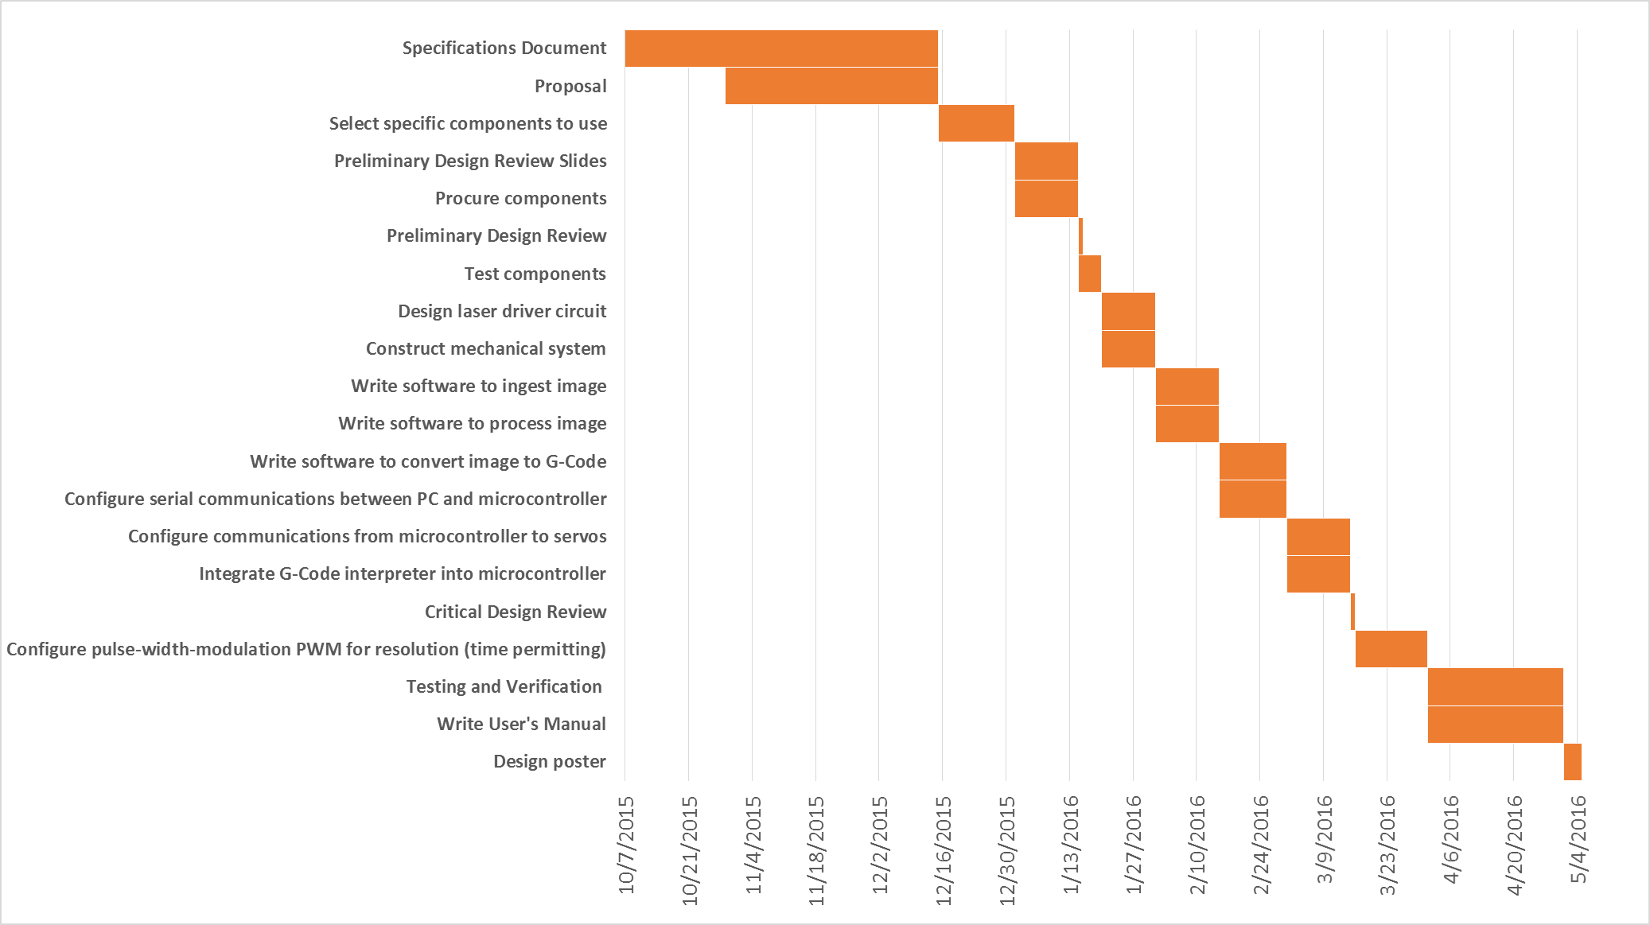  
Figure 1. PLED schedule by task.

**Phase 3**

**Phase 2**

**Phase 1**

# Qualifications

Zachary Garrard is a  
  
Casey Wood is a senior in the electrical engineering program at Utah State University. His qualifications are primarily experience based, as he has worked on many engineering projects outside of a scholastic environment. He has been employed by the Space Dynamics Laboratory for the past three years, supporting space science missions and radio based ground station development. Additionally, he has been employed as a summer intern at the Air Force Research Lab in the summers of 2014 and 2015, working on spacecraft mission simulations and conducting an intricate RFI survey respectively. In addition to his work experience, Casey has performed satisfactorily scholastically and gained knowledge and understanding of electrical engineering concepts during his stay at Utah State University. Casey has always enjoyed opportunities to tinker, learn and create, and therefore serves as a useful contributing member of the PLED team.

# Management

In addition to accountability for assigned tasks within the team, the PLED team will be consistently reviewed by Dr. Don “Darth” Crippes and Dr. Jolynne Berret to assure consistent progress.

# Costs

This section details a preliminary cost estimate, however as components are selected, they will be integrated into a bill of materials (BOM) and an updated cost estimate will be provided.

|  |  |  |
| --- | --- | --- |
|  | Description of Work | Anticipated Costs |
| Phase One | Initial documentation | $ 0.00 |
| Phase Two | Build prototype | $ 400.00 |
| Phase Three | Testing, final documentation, additional features | $ 0.00 |
|  | Total | $ 400.00 |