**Databases Laboratory Work Nr 7**

**Title:** Diagrams, Schemes and Synonyms

**Prerequisites:** SQL Server 2019 and SSMS

**Objectives:** get practical experience on creating diagrams and schemes

**Tasks:**

1. Create Diagram of database which is described in practical part of chapter 4.
2. Add necessary constraints for column ‘Sef_grupa’ and ‘Prof_Indrumator’ (described in task3, chapter 6) from table ‘grupe’.
3. Add to the constructed diagram new table – ‘orarul’, described in chapter 6 with following columns: Id_Disciplina, Id_Profesor, Bloc. Table’s key is built from 3 columns: Id_Grupa, Zi, Auditoriu.
4. ‘orarul’ table must have 2 foreign keys: (Zi, Ora, Id_Grupa, Id_Profesor) and (Zi, Ora, Id_Grupa, Id_Disciplina).
5. Table should also contain referential constraints for Id_Disciplinam Id_Profesor, Id_Grupa.
6. Create 3 new schemes: cadre_didactice, plan_studii, studenti. Move table ‘profesori’ into ‘cadre_didactice’ scheme. Move table ‘orarul’, ‘discipline’ into ‘plan_studii’ scheme. Move tables ‘sudenti’, ‘studenti_reusita’ into ‘studenti’ scheme.
7. Modify 2-3 queries from practical tasks from chapter 4, so table names will have explicitly defined names (including new schemes).
8. Create synonyms in order to simplify queries from previous tasks.

**Implementation:**

1. Created diagram for ‘universitatea’ database.

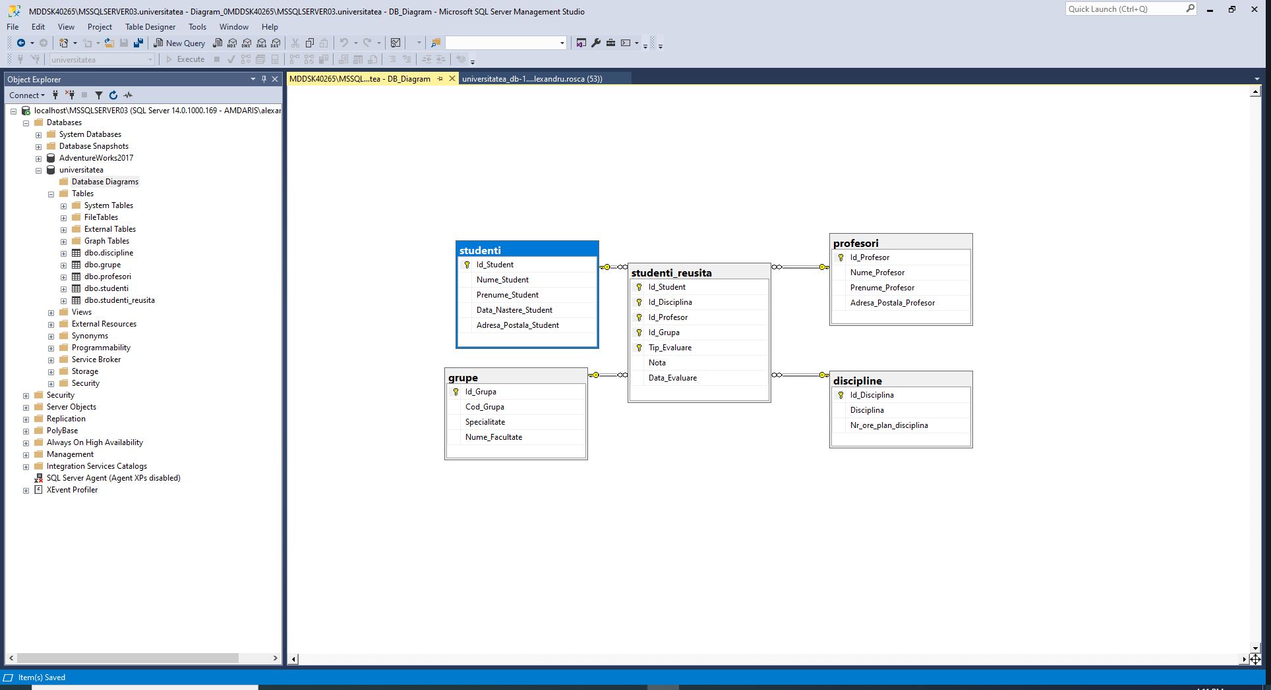

**2.**

I’ve created 2 column in table ‘grupe’ and changed their type to ‘int’

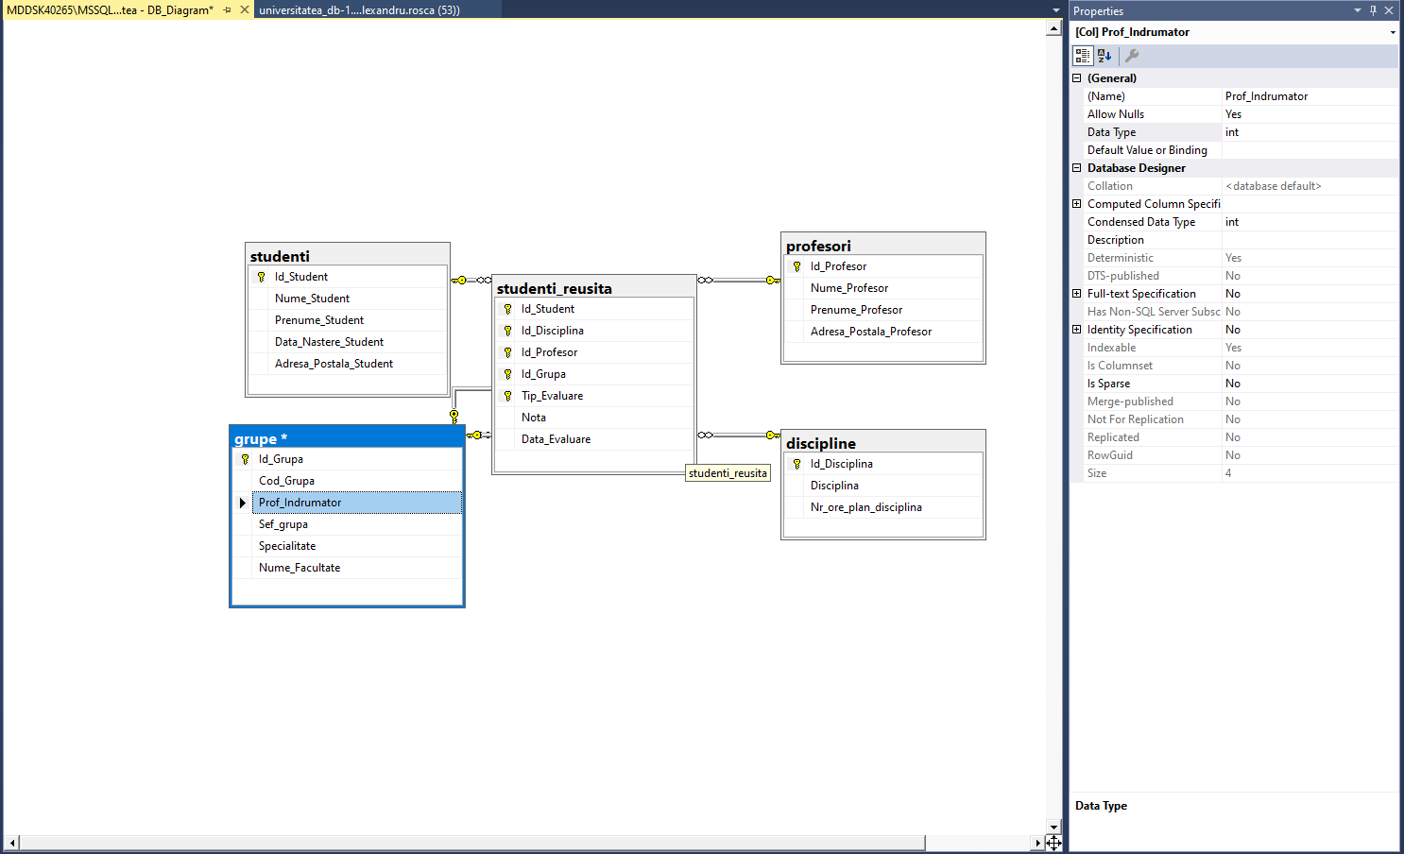

Then I’ve added a foreign key constraint as it is required in task

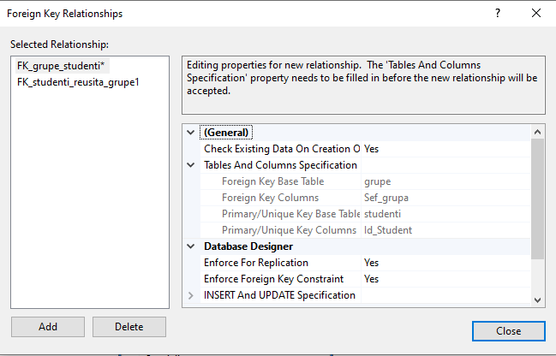

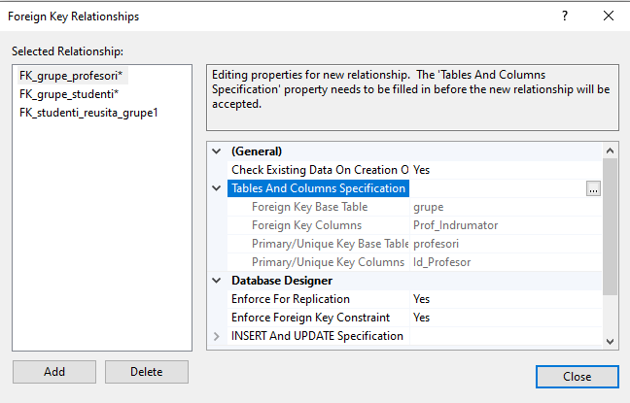

Know diagram looks like this

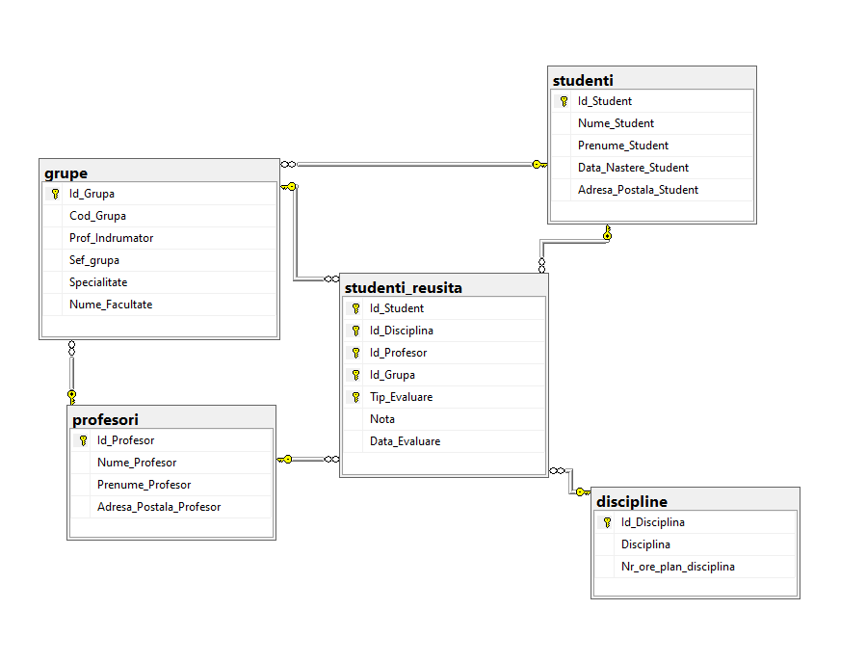

**Conclusion:**