

Smart SunTracker

PAPER FOR OBTAINING THE PROFESSIONAL CERTIFICATION IN COMPUTER SCIENCE

Student: Indru-Alexandru Păun
Class: 12B
Supervising teacher: Mihai Chelariu

2026

Introduction

The project investigates the photoelectric effect, the physical phenomenon by which the Sun’s light energy is converted into electrical energy by means of a semiconductor. It is important because it highlights how the intensity and angle of solar radiation, as well as environmental conditions (temperature, humidity), influence the energy efficiency of solar panels. The relevance of the project lies in optimizing green energy production by automatically orienting the panel according to the Sun’s position, contributing to energy efficiency and reducing dependence on polluting sources. This optimization is essential for the development of renewable energy solutions, because current solar energy systems often face performance and efficiency limitations that prevent them from reaching their full potential. In addition, this device can be used in agriculture to make climate control in greenhouses more efficient. In this context, the device can be used to measure environmental conditions at multiple points, thereby increasing the energy efficiency of climate control installations.

Structure

The project consists of numerous electronic components programmed in C++ using the ArduinoIDE application, with all the devices mounted on a wooden board. The project uses 4 photoresistors fixed with screws at the edges of the wooden board, which are used to determine the optimal position of the solar panel. In the center of the board is the solar panel movement assembly, which consists of 2 servomotors, one that rotates the panel horizontally and one that rotates it vertically.
To start the robot, simply connect the 9V battery to the holder, and the robot starts automatically.

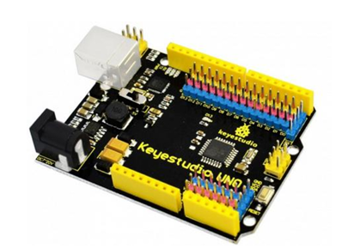
The components used and their purposes are as follows:

- Arduino-compatible KeyeStudio board - used as the Master board: the commands for the rest of the device originate from it;

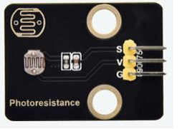
- Solar panel with two servomotors - charges the device with energy, while the motors move the panel to the optimal position;
- 4 photoresistors - continuously scan the intensity of the sun in the environment;

- Light intensity scanner - analyzes and stores the light intensity at a given point;

- 4 servomotors - provide the movement of the platform;

- Dedicated motor board - transmits power to the wheels;

- Gyroscope & accelerometer - detects rotational movements;
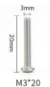
- Sensor that detects light intensity
- M3 20mm screws - for fixing the components;

Technical Details

The device has 4 photoresistors located at the edges of the wooden frame which, together with the light intensity sensor placed above the photovoltaic panel, record the light values during a scan. The device scans 180 degrees horizontally and 90 degrees vertically by means of the solar panel’s servomotor assembly. The remaining uncovered area can be scanned by turning the robot using its wheels. After the scan has finished and the ideal point has been found, the LCD screen displays the light intensity measured in lux, the resulting voltage from the solar panel, and the ambient temperature.

The role of the GPS in this project is, for now, only to log data, since it has a rough error of approximately 3-5 meters, while the robot moves in steps of 20 centimeters.
Every time the robot stops at a point and scans the light, it also reads the GPS coordinates (Latitude and Longitude). This can be useful when, instead of a 100x100 square, we place the robot in a large field or a huge yard: at the end of the day we can download the data and know exactly where on the Google Maps map it found the best light. Besides this, the GPS also provides the atomic time. The robot can note: “At 12:45, at coordinates 44.439, 26.096, I found a light score of 2000”.

What could it be used for in the future?
Calculating the Sun’s position: If the robot knows the geographic coordinates (where you are on the globe) and the exact time, it can mathematically calculate where the sun should be in the sky, even when it is cloudy, and point the panel directly at it without scanning again.
“Geofencing”: Before letting the robot cover a specific area, we define its location using exact coordinates, thus creating “digital fences”.
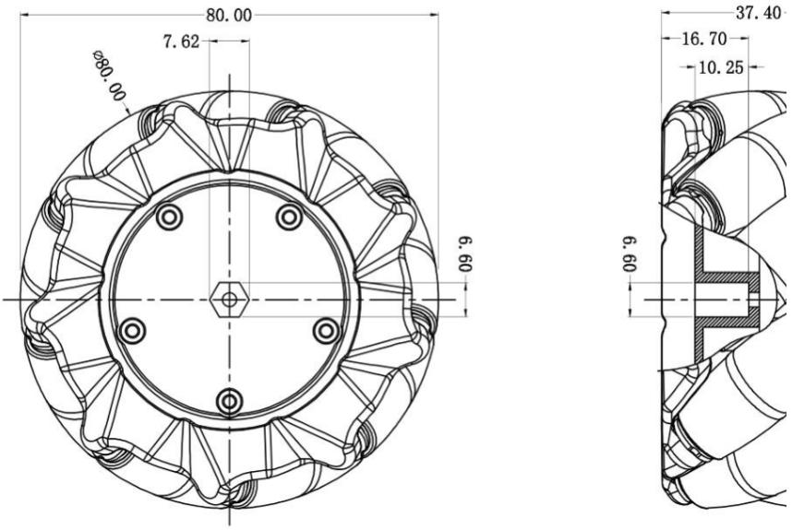
One of the central aspects of the device is the wheel system that allows it to move. For this, 2 mecanum wheels attached to 2 servomotors were used. The design of these wheels allows the robot to move along any axis, so no mechanical steering system is needed. To make a turn, the system can change the direction of rotation of the wheels so that the robot turns. For example, for a 180-degree turn the wheels spin in opposite directions.

During the scanning process, the robot moves the solar panel and calculates the score of each scanned point, then stores the position of the maximum and orients itself toward it. The scanning functions run while the robot is at rest. They compute the voltage and the light intensity, which are then used to find the ideal point. The scanned points are defined in advance by the user. A larger step between points results in faster but less efficient scans.

The most important function of the entire program is the one that scans the light intensity and the environment. The main purpose of the panelScan function is to implement an active solar tracking system, capable of orienting the photovoltaic panel on two axes (azimuth and elevation) in order to maximize energy conversion efficiency. It uses a three-stage heuristic search algorithm to identify the point of maximum light intensity in minimal time.

- Mathematical Evaluation Model (Score Function)
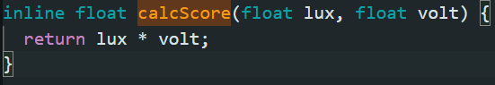
To determine the optimal position, the algorithm does not rely on brightness alone, but on a combined score function:
Score=Lux×Voltage

Light intensity (Lux): Read via the BH1750 digital sensor over the I2C protocol.
Electrical voltage (Voltage): Measured through a voltage divider connected to an analog pin of the microcontroller.

This approach ensures that the robot prioritizes positions that actually generate electrical energy, eliminating errors caused by diffuse light sources that are not useful for charging.

- Stages of the Search Algorithm
The scanning algorithm is designed to avoid “blind search” (Brute Force), which would consume excessive time and energy. It runs sequentially in three phases:
- Global Scan (Coarse Scan)
In this stage, the servomotors sweep the entire range of motion (H: 30°-150°, V: 20°- 80°) with a large step of 10 degrees. Its purpose is to quickly identify the approximate area in which the main light source is located.
- Refinement Scan (Fine Scan)
Once the area of interest has been identified, the algorithm narrows the search area to a perimeter of
± 20 degrees around the previous maximum, using a smaller step of 5 degrees. The purpose of this step is to precisely locate the geometric center of the light source.
- Optimization Algorithm “Hill-Climbing”
The final stage is a high-precision iterative optimization. Starting from the previous point, the robot checks all 8 adjacent directions at a distance of only 1 degree.
Logic: If a 1-degree move produces a higher score, the system moves to the new position and resumes testing.
Stopping condition: The algorithm ends when no adjacent move can produce a higher score, indicating that the performance “peak” (the absolute maximum) has been reached.
- Logic Flow Diagram (Pseudocode)
Initialize the variables bestScore = -1, bestLR and bestUD.
Stage 1: Double loop (Left-Right / Up-Down) with a 10° step.
Read Lux and Voltage. If (Lux×Voltage) > bestScore, update the coordinates.
Stage 2: Double loop around bestLR/bestUD with a 5° step.
Update the coordinates if a better score is found.
Stage 3: While improved == true:
Check the 8 neighboring points at a distance of 1°. If the score increases, move the search center; otherwise, set improved = false. Position the servomotors at the final coordinates and return the data to the navigation system.
- Advantages of the Implementation
Energy Efficiency: Scan time is reduced by approximately 70% compared to a full degree-by-degree scan.
Angular Precision: The algorithm achieves a precision of 1 degree, which is necessary for photovoltaic panels that have a critical angle of incidence.

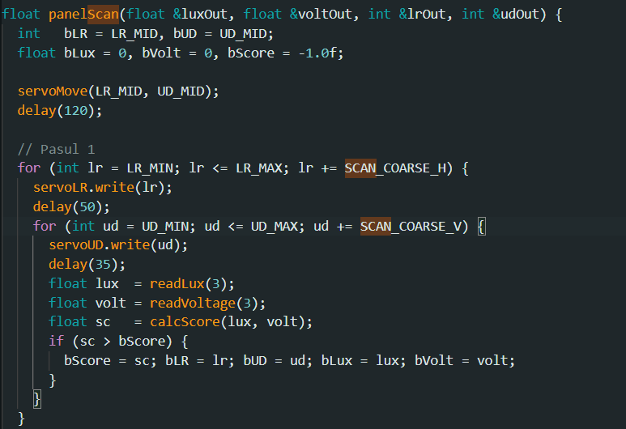
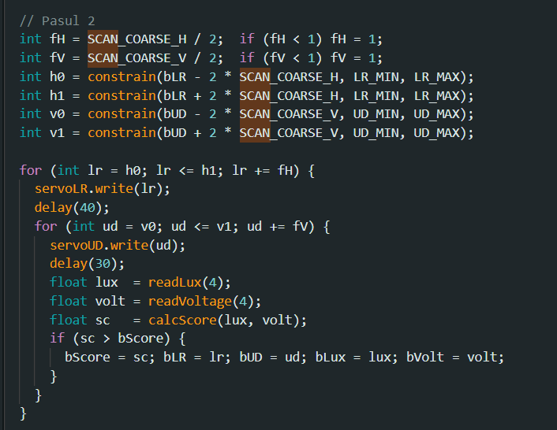
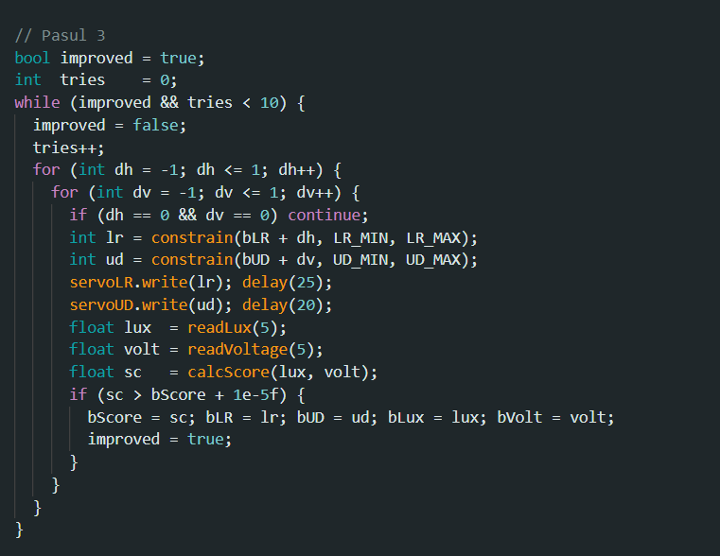

Observations and Difficulties

- Limited rotation of the servomotors on the solar panel platform;
- Movement on 2 wheels;
- Designed for long distances; for short ones it may produce errors, and the surface must be set by hand for small areas.
- The GPS, even though it has a small error of 0.02 km/h, can destabilize the program when it reconnects to or disconnects from certain satellites;
- Gyroscope: on uneven surfaces it may produce errors, as it is attached to a rigid board;
- Environmental impact on the photovoltaic panel: this device is extremely sensitive to environmental conditions and requires regular maintenance;
- Not waterproof
- The GPS may lose signal if it is located inside a building;

Technical Requirements
- A 9V battery
- If you want to edit the code, the ArduinoIDE application and a USB 2.0 cable
- For the GPS to work, the robot must be positioned outdoors

Bibliography

https://uk.robotshop.com/products/80mm-left-mecanum-wheel
https://docs.keyestudio.com/projects/KS0530/en/latest/KS0530.html



