|  |
| --- |
| InHarmsWay |
| Assignment 1: Choose Your Own Zombie Apocalypse Adventure |
|  |
| Version 1.0  All work Copyright © 2012 by InHarmsWay Games.  All rights reserved. |
| **Andrew Harmathy** |
|  |



|  |
| --- |
| May 16th 2012 |

**Table of Contents**

Version History … page 3

Game Overview … page 4

Gameplay Mechanics … page 4

Controls … page 4

Interface Sketch … page 4

Game World … page 5

Game Progression … page 5

Enemies … page 5

Weapons … page 5

Items … page 5

Story Index … page 6

Art / Multimedia Index … page 7

Design Notes … page 7

Future Features … page 7

# Version History

Version 0.5

* Game opens up and gives an intro
* User can choose whether to check the door or window
* After choosing the door the user can select one of two weapons to attack the zombie with
* User can select the window and enters the yard
* In crowbar scenario (from the two weapon choices), the user can choose whether to fight or run
* User dies in both scenarios
* In baseball bat scenario, the bat breaks and leaves the user the choice whether to fight or run
* User dies in both scenarios

Version 1.0

* In the yard (in the window scenario), the user can decide whether to fight or leave
* If they fight, they are bitten and given the choice of suicide or fighting to their death
* If they leave, they can choose to run to the city or the countryside
* Countryside choice is the only one that results in the player living
* Looping bug removed (stops asking if they want to play again over and over)
* Removed issue where the ending of one scenario played out for another
* Comments expanded upon

# Game Overview

*The goal of the game is to survive the experience of zombies attacking your home. The only way to win this game is by escaping through the window, leaving and then making the countryside your destination.*

# Game Play Mechanics

*The game tells a story and when it gets to certain points, it will ask the user to make a choice. The user will make a choice through a specific text input. The story will then progress to either the next choice or the ending.*

# Camera

*N/A.*

# Controls

*The game is based on text input. It will only accept specific text input from the user.*

# Saving and Loading

*N/A*

# Interface Sketch

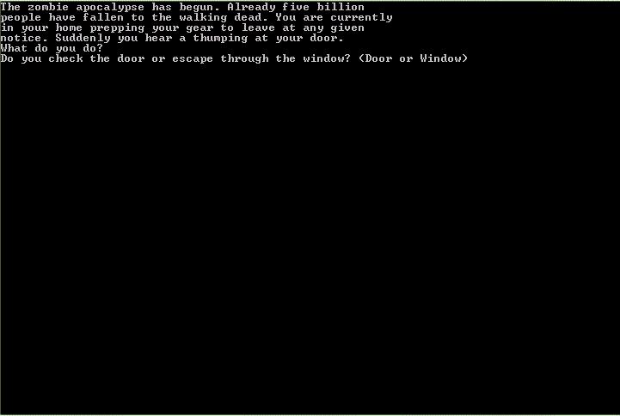

# Menu and Screen Descriptions

*N/A*

# Game World

**The game is text-based and so it only describes the situation the user is in.**

# Levels

*N/A*

# Game Progression

**The user types in their choice and then the game progresses to the next choice.**

# Characters

*N/A*

# Non-player Characters

N/A

# Enemies

*The main enemy of this game are zombies. Zombies are human that have been infected with the Solanum virus and have died and have come back to life as undead cannibals.*

# Weapons

*While not directly available for the user to use, there is a crowbar, a baseball bat and a 9mm pistol involved in the story’s decisions.*

# Items

*A baseball bat, a crowbar and 9mm pistol are available to the user for the purpose of the story. The baseball bat will break after killing one zombie and leave the user defenseless. The crowbar is used longer, but will still not save the user. The 9mm pistol is only used for the suicide ending.*

# Abilities

**N/A**

# Vehicles

**N/A**

# Script

**N/A**

# Scoring

**N/A**

# Puzzles/Mini-games

**N/A**

# Bonuses

**N/A**

# Cheat Codes

**N/A**

# Sound Index

*N/A*

# Story Index

*The user plays as a person packing to leave their neighbourhood during a zombie apocalypse. The person hears a thumping and decides whether to check it out or leave. If they check the door, a zombie will attack and the player has to pick either a crowbar or bat to fight with. The bat will break. In both scenarios, the other zombies begin to attack and the player decides whether to fight or run. Both result in death.*

*If the player goes through the window, they will see some zombies. They can fight or leave. If the player stays to fight, they will get bitten. Here they can continue fighting and die or commit suicide. If the player decides to leave, they can go to the city or the countryside. If they go to the city, they will be swarmed and die. If they go to the countryside, they will survive.*

# Art / Multimedia Index

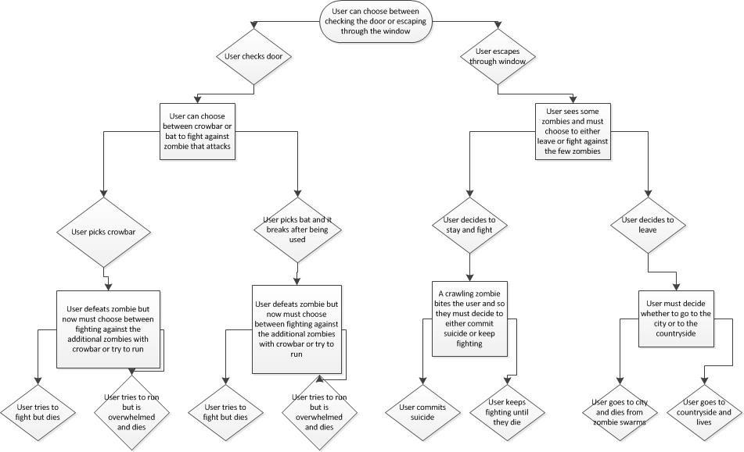

# Design Notes

*N/A*

# Future Features

*In the future, I hope to have the items picked up by the user to have an affect whether they survive a situation. Such as using the crowbar instead of the baseball bat would have created a new line of choices since they now have a stronger weapon.*