CREATE ARROWHEAD CLIENT SELF SIGNED CERTIFICATE
with KeyStore Explorer 5.4.1
KeyStore Explorer is a free GUI tool for managing certificates, which is available for all common operation systems: https://keystore-explorer.org/downloads.html
1st STEP:
Open your cloud p12 certificate file.
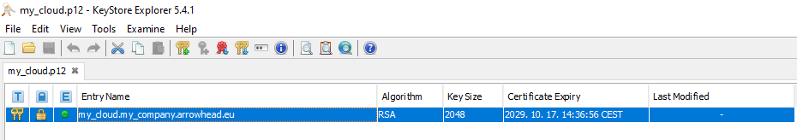

2nd STEP:
Right click on your cloud key pair entry and select “Sign New Key Pair” and enter its password:
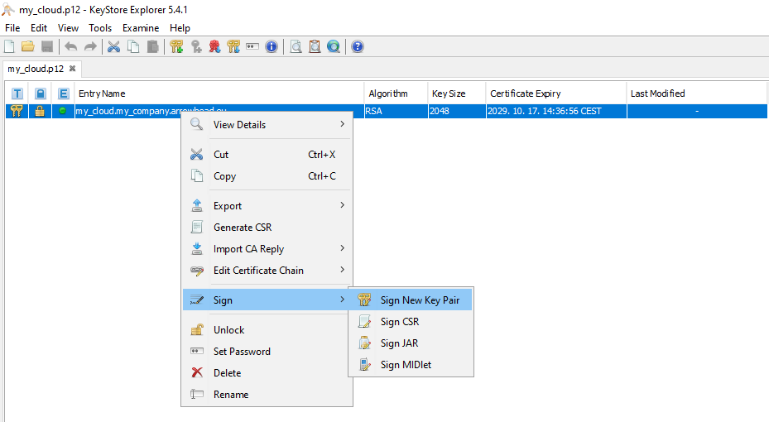

3rd STEP:
Select “RSA” and set “Key Size” to 2048:
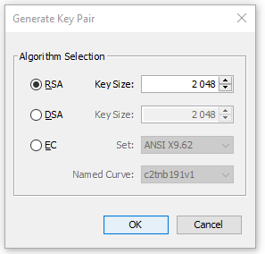

4th STEP:
Set the “Validity Period” and hit “Apply”, then click on “Edit name”:
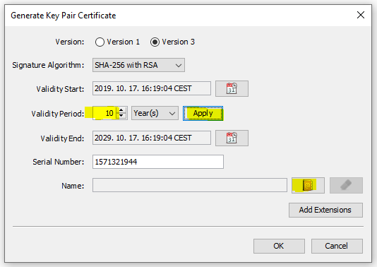

5th STEP:
Fill out the “Common Name (CN)” and hit “OK”. The certificate naming convention have strict rules:
- The different parts are delimited by dots, therefore parts are not allowed to contain any of them.
- A client certificate name has to consist of five part and the last two part have to be 'arrowhead' and 'eu'.
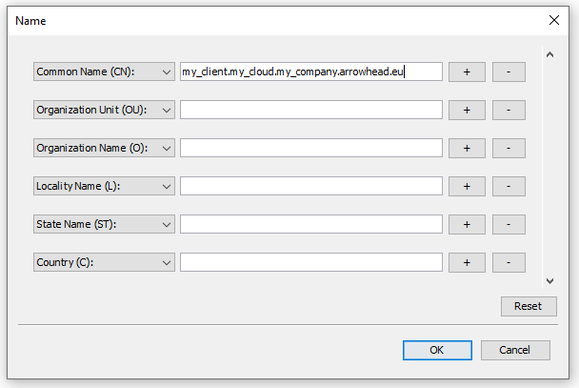

6th STEP:
Click on “Add Extension”, then on the green “+” button:
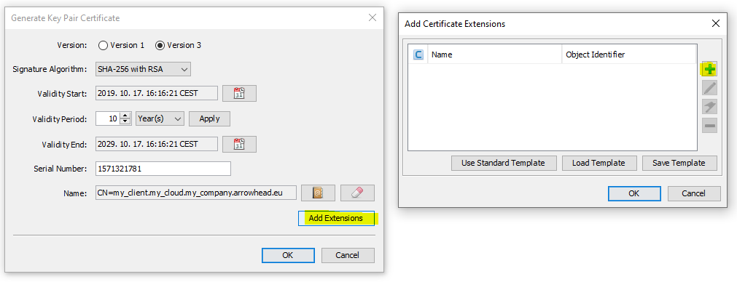

7th STEP:
Select “Authority Key Identifier”, then click on “key” button and select “160-bit Hash”:
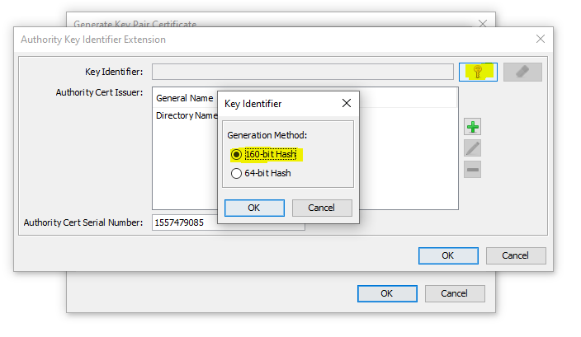

8th STEP:
Click again on green “+” button of the “Add Certificate Extensions” window and choose “Subject Alternative Name”:
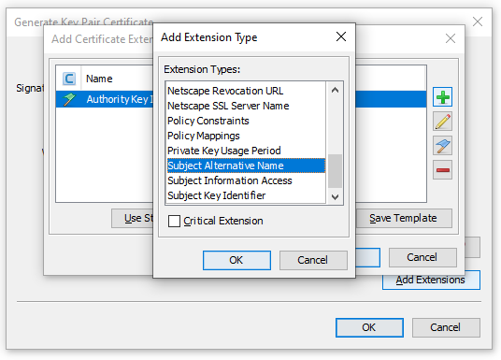

9th STEP:
Click on green “+” button, select “DNS Name” and fill the “General Name Value” with “localhost” and press “OK”:
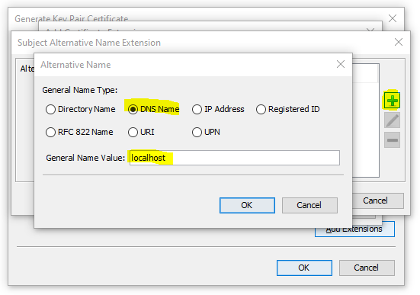
Repeat if you want to add your other DNS Name (for accessing remote services).

10th STEP:
Click on green “+” button again, select “IP Address” and fill the “General Name Value” with “127.0.0.1” and press “OK”:
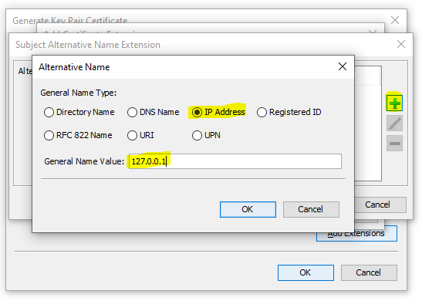
Repeat if you want to add your other IP Address (for accessing remote services).

11th STEP:
Click again on the green “+” button of “Add Certificate Extensions” window, select “Subject Key Identifier”, then click on “key” button and selest “160-bit Hash”:
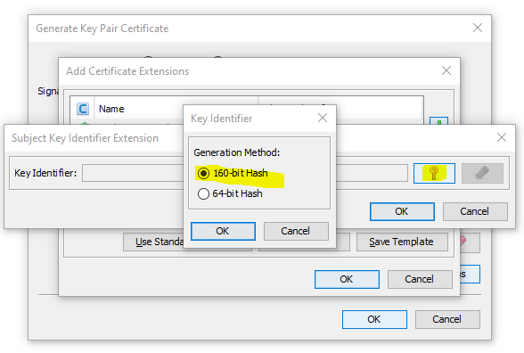

12th STEP:
Click on “OK” button of “Generate Key Pair Certificate” window:
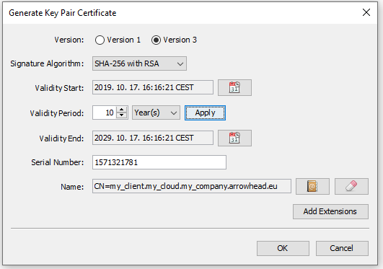
13th STEP:
Set alias (eg.: “my_client”), then give a password.
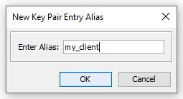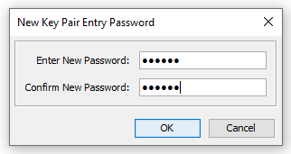

14th STEP:
Drag & Drop your newly created key-pair entry to a new tab (It will ask for the password given in the step before.):
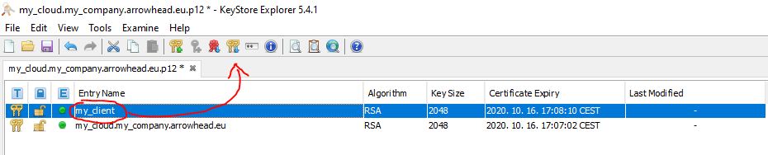
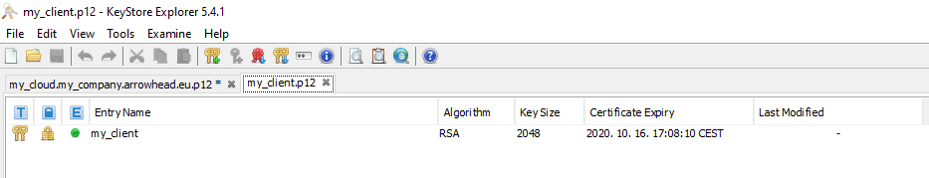
Close the “my_cloud.p12” and DO NOT SAVE THE CHANGES!

15th STEP:
Click on “Tools” menu and set the “KeyStore Password” (It must be the same as the key-pair password given in the 13th step.):
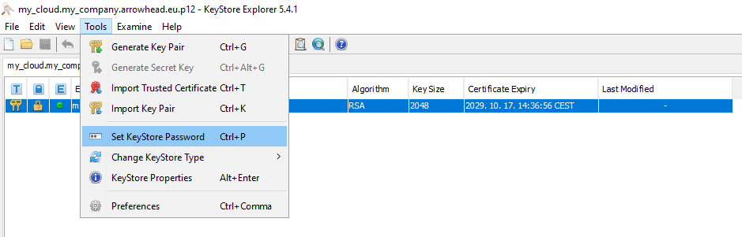

16th STEP:
Verify that the “KeyStore type” is settled to “PKCS#12”:
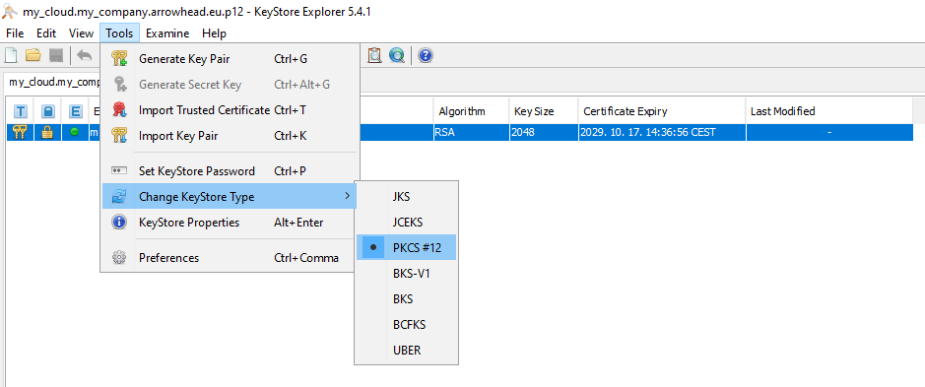

15th STEP:
Save your new key-pair certificate as my_client.p12.
(“File”->”Save as”-> declare the extension as “.p12”)
