*The computer code in this project is provided as-is and without warranty as a demonstration of implementing an extension for irAuthor. It is not considered production-ready code, but rather is an example of what is possible.*

**Instructions for Installation and Testing**

The following guide will detail how to compile and test the spreadsheet import extension for irAuthor that is included in this project.

Dependencies

To compile this project:

* Microsoft Visual Studio 2013 or later required
* The InRule irSDK must be installed.
* OpenXMLSDK 2.5 must be installed (available from Microsoft at <https://www.microsoft.com/en-us/download/confirmation.aspx?id=30425>)
* .NET 4.0 (for InRule 4.x) or .NET 4.5 (for InRule 5.x) required

The project as-provided depends on the following Excel spreadsheet characteristics:

* The spreadsheet to be imported must reside in the workbook as “Sheet 1”
* The columns must have headers that label them as Conditions or Actions. The form of these labels is Condition:ColumnName or Action:ColumnName. (see example spreadsheets).

Compile and Install

1. Open the .sln file with Visual Studio and Rebuild the project. The most likely issues with rebuilding would be related to the location of the irSDK files, in which case you may have to delete and re-add the references to the InRule components. The default installation directory for irSDK files is C:\Program Files (x86)\InRule\irSDK\bin
2. After compiling, retrieve the file DecisionTableImporter.dll from the bin\Debug folder of the project and copy it to the Extensions folder where irAuthor is installed. The Extensions folder is typically located at C:\Program Files (x86)\InRule\irAuthor\Extensions and you may require administrative rights for your computer to be able to copy it there.
3. If irAuthor is open, close it and re-open. Select File🡪Extensions

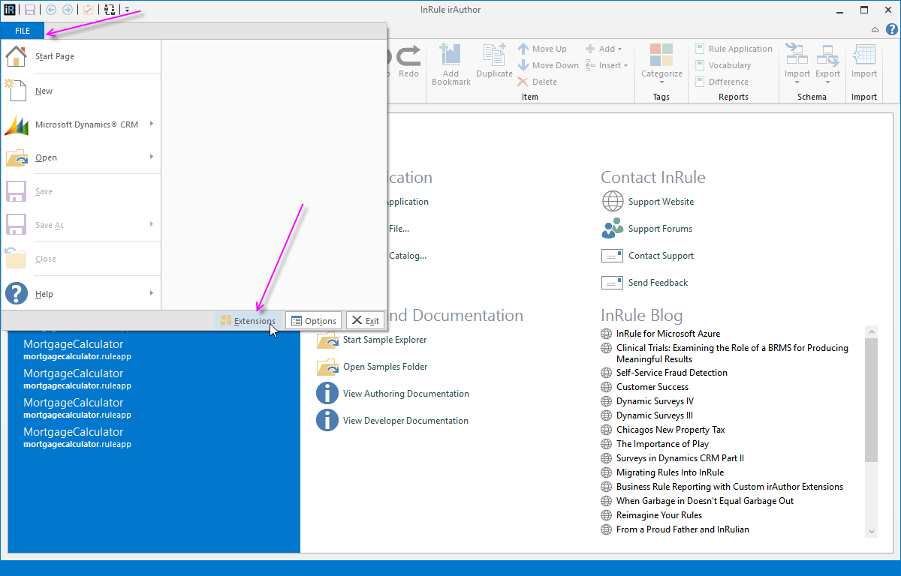

1. When the Extensions window appears, select the Decision Table Importer and click the OK button.

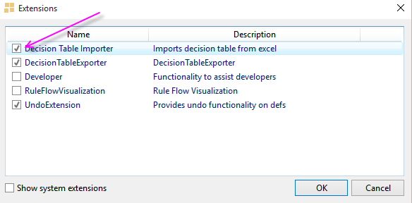

1. Open an existing Rule Application. If the extension is properly installed, when you click on a Rule Set in the left-hand navigation, you should see an Import option in the top ribbon.

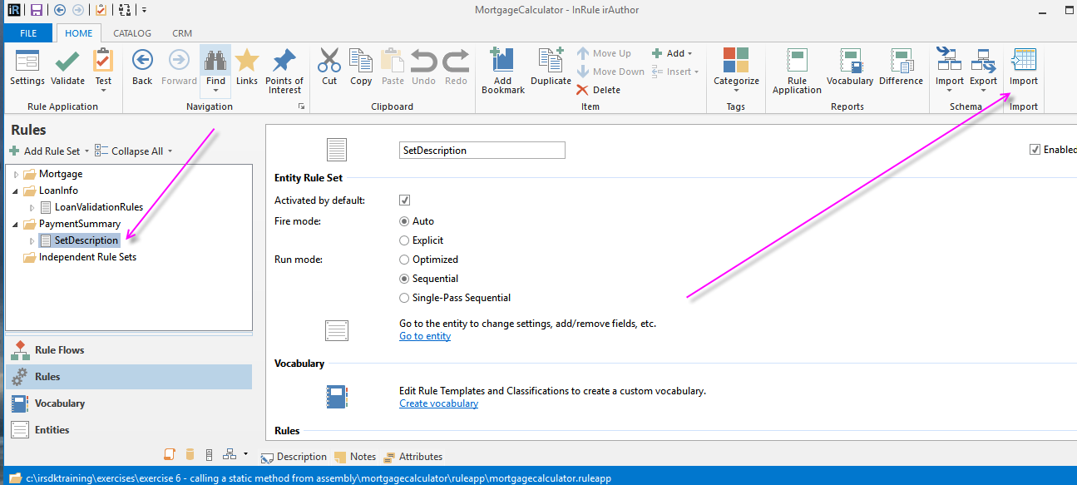

Performing an import in irAuthor

1. Create a new Rule Application in IrAuthor called Rock_Paper_Scissors.
2. Change the name of the top-level entity to “RPS_Game”.
3. Select Create rules in the right-side panel.

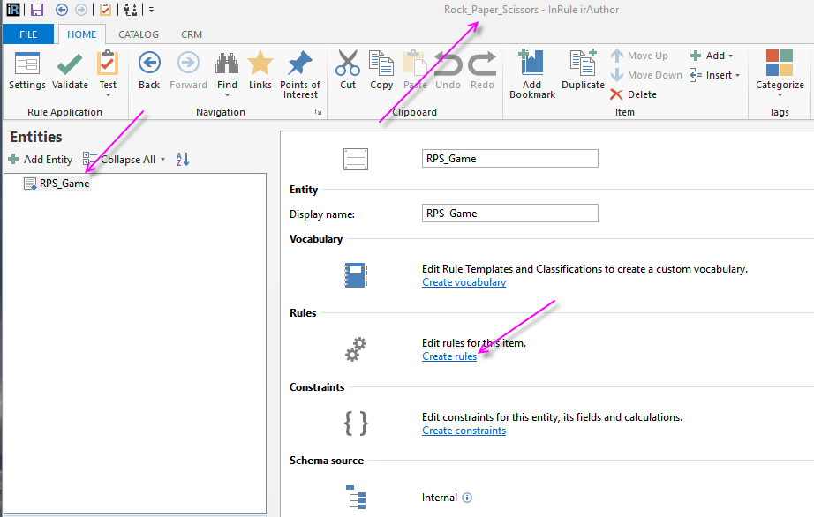

1. With RuleSet1 selected, click on the new Import button in the top ribbon.
2. Navigate to the RockPaperScissors.xlsx spreadsheet example included with the project and select Open.

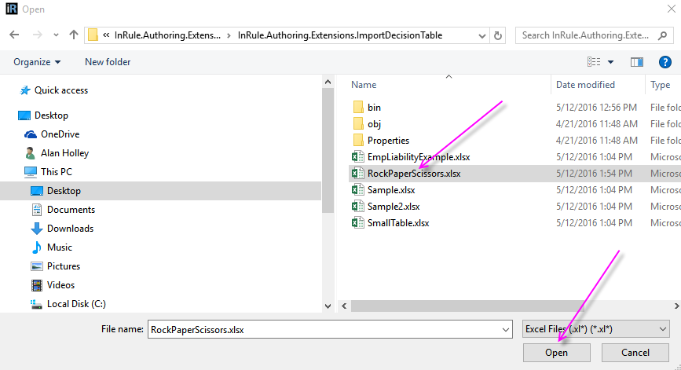

1. Expand RuleSet1 and select Imported_RockPaperScissors to see the new decision table.

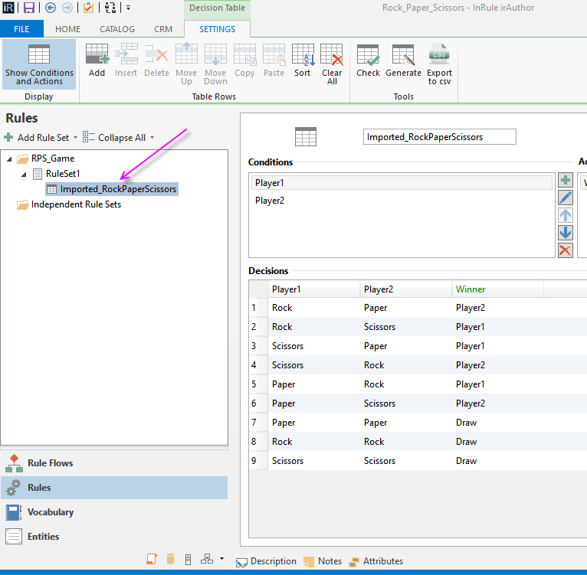

1. The decision table is not quite ready to use, as the conditions and actions are not yet tied to any data. Return to your RPS_Game entity and add text fields for Player1, Player2 and Winner.

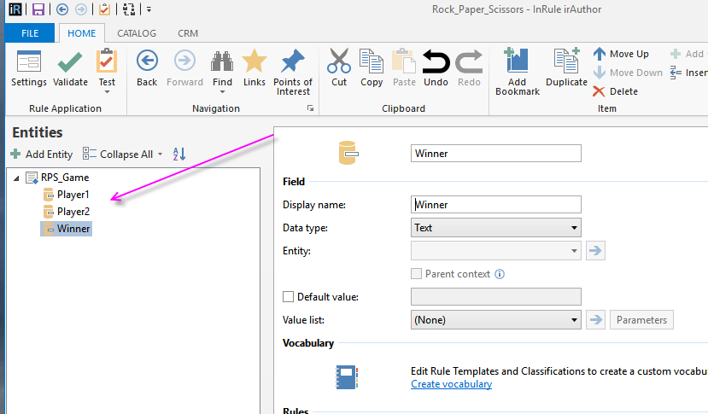

1. Now return to your Imported decision table and map the Player1 and Player2 conditions to their matching fields on the RPS_Game entity.

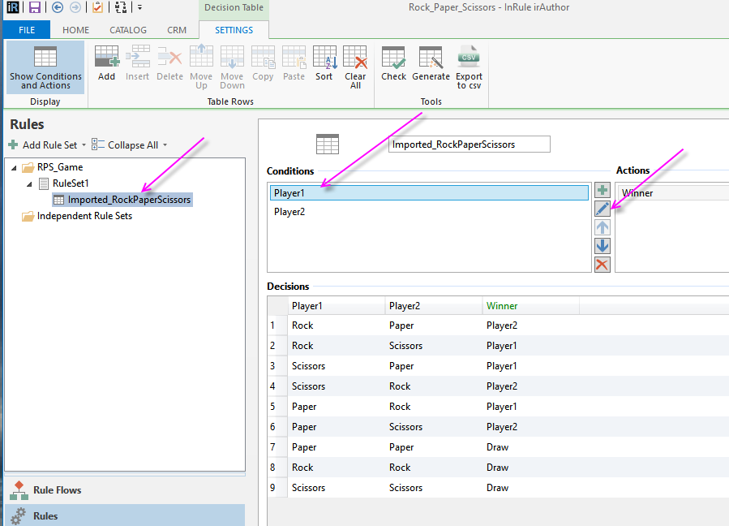

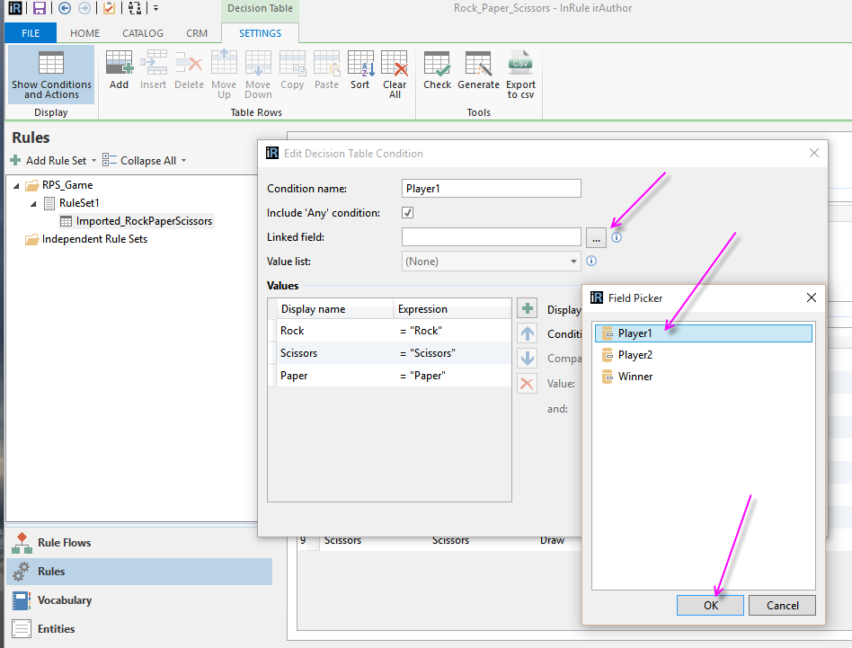

1. Review the Winner Action to ensure it looks like the image below.

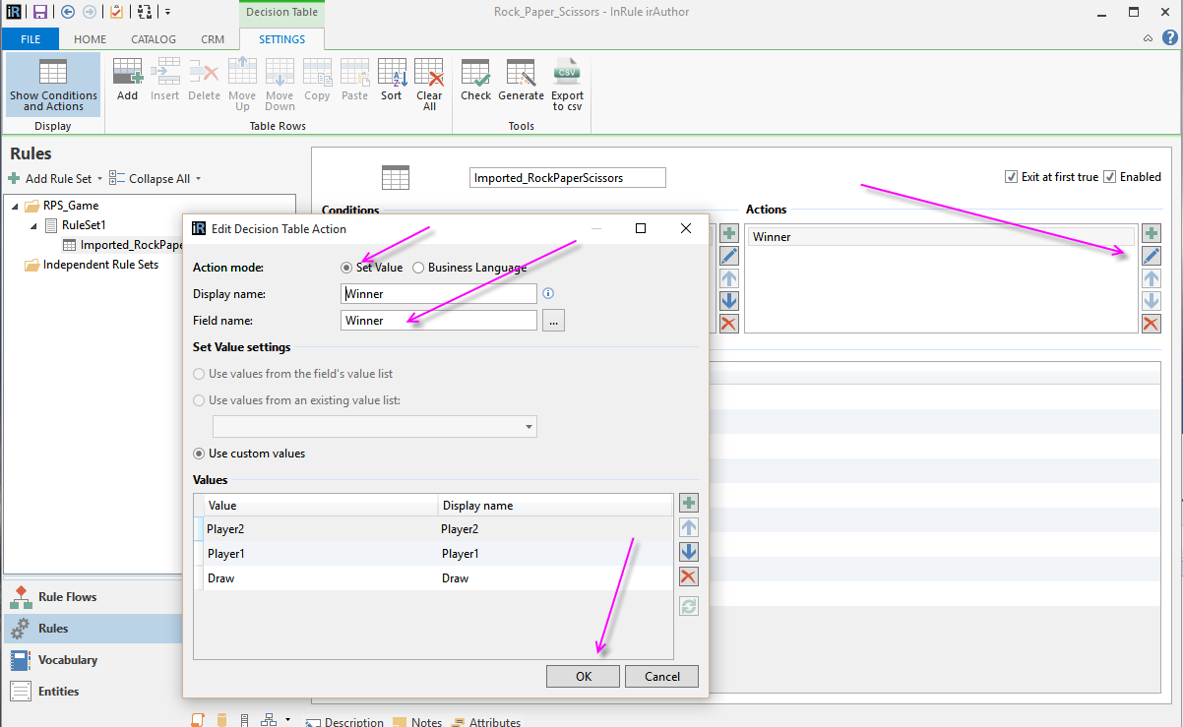

1. Test the RPS_Game entity in irVerify by entering Rock, Paper or Scissors for values for Player1 or Player2 and selecting “Apply Rules”

