**Acknowledge**

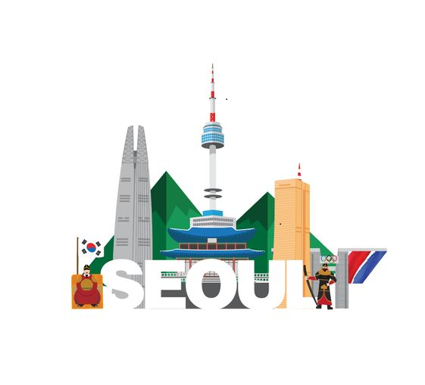The information in this white paper is subject to change and does not provide any commitments or warranties for services or future usability related to using GURI TOKEN. This white paper is not an offer for the sale of stocks or securities and cannot be used as evidence of contracts or promises. It does not rely on the information or take responsibility for losses caused by errors, omissions, or inaccuracies.

In addition, this white paper is not intended for investment solicitation or financial advice but for informational purposes. All investments risk price volatility and principal loss, so you should seek professional help if you consider investing.

The information in the white paper is from a reliable source, but we cannot guarantee the accuracy of market prices and data, etc. It reveals that future predictions and prospects may differ from actual results due to uncertainty, which may be beyond GURI TOKEN's control.

**Introduction**

GURI TOKEN's vision is to eliminate centralized power through DAO and build a transparent and reliable ecosystem where users can take the initiative. Although the blockchain and digital asset markets are growing rapidly, users still need to benefit from the complexity and barriers to entry fully. In addition, the issue of unfairness in the traditional financial system needs to be resolved.

To solve this problem, we will provide educational content to help users understand and use blockchain technology and financial systems. In addition, we plan to give users familiar access to the blockchain with content that combines K-culture and K-meme and to provide an opportunity to experience the integration of real and digital assets by linking DeFi and NFTs. Through this, we will create an environment that creates real economic value in the blockchain ecosystem and present new alternatives to the problems of traditional finance.

**Project Overview**

The GURI TOKEN project seeks to solve the problem of relying on the existing blockchain's technical limitations and speculative factors. The project's core is to build an autonomous and sustainable ecosystem through decentralized autonomous organizations (DAOs). DAOs allow users to participate directly in community operations and decision-making, and they operate transparently without centralized power.

**Project Goals**

**Decentralization of decision making:** community participants determine and realize the direction of the project.

**Transparency:** All decisions and financial operations are recorded and disclosed on the blockchain.

**Compensation for participation:** Provide compensation based on contribution to DAO participants.

**Realization**

Delivering educational content: Education on blockchain, virtual assets, and traditional finance enables users to participate effectively in the ecosystem.

K-Culture and Global Cultural Content: Create Korean culture and cultures from each country as NFTs to help users easily access and own them.

**Real-DeFi Experience:** A hands-on DeFi experience provides users with reliable monetization opportunities.

GURI TOKEN seeks to create a new economic environment where users can experience digital and real assets in an integrated way, thereby creating real value within the blockchain ecosystem.

**Problem-raising and resolution**

Blockchain and digital asset ecosystems need help to connect digital and real assets effectively, making integrated management difficult. Users need help with access due to the complexity of blockchain, the opacity of traditional finance, and the inefficiency of the financial system and the reserve ratio system, which risk a severe financial crisis. In addition, there is a problem that cannot create economic synergy as NFTs and DeFi develop, respectively.

**GURI TOKEN's Solution**

**Delivering an integrated asset experience:** Combine traditional cultures, such as digital assets, with K culture to let users experience cultural values.

**Providing educational content:** Systematic training helps users easily understand blockchain and traditional finance.

**Real DeFi Realization:** Combine NFTs and DeFi to enable integrated utilization of real and digital assets and create real economic value.

**DAO Operations:** Create an autonomous environment where users determine platform direction and are rewarded.

GURI TOKEN is a DAO-based decentralized finance platform that aims to help users overcome the challenges of traditional finance, integrate and manage digital-real assets, and create new economic value.

**Project Vision, Purpose and Strategy**

**Project Vision**

****GURI TOKEN aims to combine traditional Korean culture with modern trends through blockchain technology and build a DAO where global users can experience digital and real assets together. This will create new economic value by combining educational content, NFTs, and DeFi ecosystems that understand blockchain and traditional finance.

**Project Purpose**

By realizing DAO, we intend to create an environment where users can freely own and operate digital assets by establishing an autonomous and decentralized economic ecosystem. This will provide a global platform for users to participate in economic activities without intermediaries.

**Strategy**

**Providing educational content:** Facilitate ecosystem participation by providing training to help people understand the concepts of blockchain and traditional finance.

**Combining K-culture and K-meme:** By creating Korean culture as digital content and linking it with NFTs, it provides an opportunity for global users to experience and own Korean culture.

**Real DeFi Ecosystem Implementation:** Combine NFTs and DeFi to provide an integrated experience of real and digital assets, creating real economic value.

With this approach, GURI TOKEN aims to realize innovative DAOs in the global economic environment and provide new economic opportunities.

**Token economics**

**Role of tokens**

GURI TOKEN is integral to our platform, enabling users to own digital assets and engage in various financial activities. It is used as a means of trading and performs multiple functions in the DeFi ecosystem, including NFT purchases, content utilization, and more.

**Token issuance volume and distribution**

The total issue volume of GURI TOKEN is distributed sequentially according to the development stage of the project. Airdrops are available in NUTS TOKEN form to users who meet certain conditions to induce community activation.

**Air-drop mechanism**

Airdrops are staged in stages and are designed for initial community activation and user influx. The airdrop-received NUTS TOKEN offers opportunities for various rewards through the draw system.

**Token Use Cases**

GURI TOKEN will be used to purchase NFTs, use content, and participate in DeFi ecosystems, while NUTS TOKEN will be used to participate in drawing systems and events.

**Linkage with DAO**

GURI TOKEN holders can vote on the platform's critical decisions, allowing the community to make direct decisions about its operations and developments.

**Wallet compatibility**

GURI TOKEN can be safely stored and managed in various wallets, including metamasks and trust wallets.

**Technical details**

**Blockchain Network**

GURI TOKEN is based on the Polygon blockchain and offers high scalability and low commission. Polygon processes 65,000 transactions per second, and at a low commission (average of less than $0.02), smooth transactions are possible even on a large user base. Safe asset conversion is planned through Atomic Swap when the mainnet is executed in the future.

**Smart Contracts and Protocols**

GURI TOKEN's core features will be automated with smart contracts. Its modules provide transparency and reliability, including NFT issuance and management, token economy and rewards, DeFi services, and decentralized exchanges (DEXs).

**Security and network reliability**

All smart contracts are reviewed by third-party auditors, and they maintain DDoS protection and data integrity. They also comply with Polygon's security protocols to provide a secure trading environment.

**Technical Roadmap**

Step 1: Develop Smart Contracts and NFT Issuing Modules and revitalize the Community.

Step 2: Introducing DeFi service modules and real-estate-linked NFT features.

**Legal Considerations and Risk Management**

**legal considerations**

Cryptocurrency Regulation: GURI TOKEN complies with each country's cryptocurrency regulations, and strictly adheres to legal requirements such as AML/KYC and GDPR.

**Tax regulation:** fulfills tax filing obligations related to all cryptocurrency transactions, and recommends appropriate tax advice.

**Legal Advice:** Clarify regulatory compliance and legal responsibility through consultation with legal professionals prior to the project.



**Risk Management**

**Security Risk:** Strengthen the security of smart contracts and prepare for hacking and cyber threats through code audit.

**Market Risk:** Ensure liquidity against price volatility and liquidity issues, and manage to maintain price stability.

**Legal risk**: maintain the legitimacy of the project by considering legal responsibility for regulatory changes, and establish an institutional mechanism for investor protection.

**Investor Protection**

GURI TOKEN provides a safe and reliable environment, with increased transparency of information and protection of investors' rights as a top priority.