Link to get all COVID19 sequences.

<https://www.ncbi.nlm.nih.gov/genbank/sars-cov-2-seqs/#nucleotide-sequences>

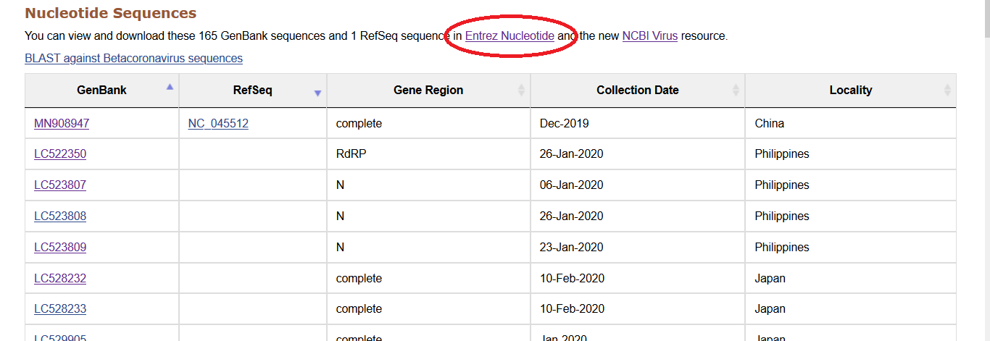

Download all records in genbank format.

