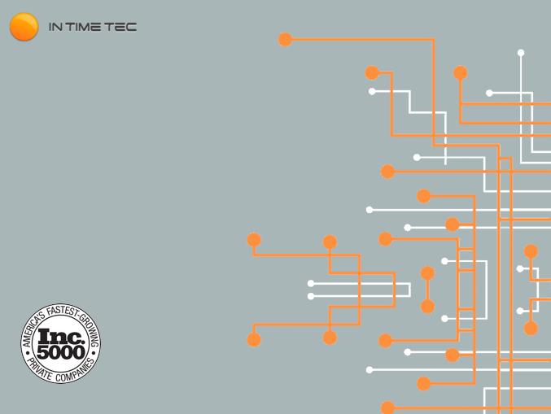

Test Plan

Prepared Exclusively For



2/21/2018

Table of Contents

1. Introduction 1

1.1 Introduction to the Test Plan 1

1.2 Introduction to the Project 1

1.3 Team Background 1

2. Scope of the Project 3

2.1 Feature Set of ADPQ KMT prototype 3

2.2 Test Environment 3

2.3 Operating Systems to be Covered 4

2.4 Overall Approach 4

2.4.1 Testing Activities 5

3. Out of Scope Functionalities 6

4. Test Methodology 6

4.1 Definition of Test Plan 6

4.2 Process and Procedures for the Test Plan 6

4.2.1 Design 6

4.2.2 Development 6

4.2.3 Implementation 7

4.2.4 Maintenance 7

4.3 Reviews 7

5. Documentation 7

6. Measurements 7

6.1 Purpose of Measurements 7

6.2 Types of Measurements 8

6.3 Process for Taking Measurements 8

6.4 Reporting Measurements 8

6.5 Corrective Action Process 8

7. Risk Management 8

8. Analysis and Milestones 8

8.1 Milestones and Process for Overall Corrective Action 9

9. Results Achieved 9

10. References 9

11. Conclusion Check list 9

12. Tools Used 9

* REVISION HISTORY

|  |  |  |  |  |
| --- | --- | --- | --- | --- |
| Revision | Date | Editor | Revision Description | Approval |
| * 1.0 | 21st February 18 | Jitendra Sen | PQVP AD-DS Working Prototype Test Plan | Vijaya Arucapalli |
|  |  |  |  |  |
|  |  |  |  |  |
|  |  |  |  |  |

1. Introduction
   1. Introduction to the Test Plan

* The Master Test Plan [MTP] has been created to communicate the test plan, strategy, activities, and results to the team members and stakeholders. Its purpose is to define the quality assurance methods that are built in the testing process in order to ensure an acceptable level of quality, and readiness for release to the production environment. Approval of this document indicates that the reviewers agree with the stated test strategy and test results.
* The objective of our test plan is to find and report as many bugs as possible to improve the integrity of our prototype. Although exhaustive testing is not possible, we will exercise a broad range of tests to achieve our goal. The objective of this plan would be defining the overall goal and achievement of test execution.
  1. Introduction to the Project
* Knowledge Management Tool is a comprehensive collaborative tool that helps to seamlessly share knowledge across cross-functional teams and organizations. Using this tool, employees can share, contribute, organize and discover information thus making the collaboration effective.
  1. Team Background
* The following individuals have been identified as the key resources for the execution of the test and use case scenarios. An initial estimate of their required involvement is included, and is expected to be revised after the test plan and test procedures are refined.

|  |  |  |  |
| --- | --- | --- | --- |
| S.No. | Name | Role | Responsibilities |
| 1 | Vijaya Arucapalli | Scrum Master / Delivery Manager |  |
| 2 | Rob Tuft | Business Analyst |  |
| 3 | Shiva Dixit | Technical Lead/Architect | Design, architecture and Code Review |
| 4 | Rakshit Rajeev | Developer | Develop code as per specifications |
| 5 | Sachin Singh | Developer | Develop code as per specifications |
| 6 | Koteswara | Developer |  |
| 7 | Ashish Y | Developer |  |
| 8 | Manoj Mewara | Developer |  |
| 9 | Harish Patidar | Frontend Developer |  |
| 10 | Inwinder Kochhar | Frontend Developer |  |
| 11 | Sweta Lavaniya | Frontend Developer |  |
| 12 | Manish Tripathi | Frontend Developer |  |
| 13 | Parul Sharma | Frontend Designer |  |
| 14 | Nidhi Saini | Frontend Designer |  |
| 15 | Jennifer | Frontend Designer |  |
| 16 | Simarpreet Gujral | DevOps Engineer |  |
| 17 | Yashwant Mahawar | DevOps Engineer |  |
| 18 | Ruanak Shah | Qualification Engineer | Qualification of the developed application |
| 19 | Jitendra Sen | Qualification Engineer | Qualification of the developed application |
| 20 | Raksha Deshpande | Qualification Engineer | Qualification of the developed application |
| 21 | Grace Arpana | Technical Documentation |  |
|  |  |  |  |

1. Scope of the Project
   1. Feature Set of ADPQ KMT prototype

* Create application user with three roles. (Admin, Manager and General User)
* Create/Edit/Delete Knowledge Articles
* Knowledge Article Review/Approval/Rejection
* User defined templates for Knowledge Articles
* Role-based security access of Knowledge Articles
* Promotion/Escalation of Knowledge Articles
  1. Test Environment

|  |  |  |
| --- | --- | --- |
| 1. | Web Browsers | * Google Chrome(Latest Version) * Mozilla Firefox(Latest Version) * IE: 11 / Microsoft Edge * Safari(11) |
| 2. | Android Mobile | * Samsung Galaxy s7 with Android 7.0 Nougat * Motorola with Android 8.0 Oreo |
| 3. | iOS Mobile | * iPhone 6 with iOS 10.0 * iPhone 7 with iOS 11.0 |

* 1. Operating Systems to be Covered
* Microsoft Windows
* Apple MAC
  1. Overall Approach
* ADPQ-KMT Test Strategy will include Manual Testing as the main area having all the functional test cases in place which will be tested to ensure all functions provide the expected result. Acceptance Criteria for passing QA check is when all identified features have passed all associated test scenarios.
* Complete QA process

Review the requirements

Test Planning  / Writing Use Cases & High Level Test Scenarios

* + - Add the user stories according to the requirement
    - Add the test scenarios according to the user story
    - Create a test suite related to user story

Executing the test scenarios for the release

* + - Functional testing
    - Integration testing
    - System testing
    - Cross-browser testing / cross-platform testing
    - Filing the defects if any and link them to related test case

Defect verification and re testing

Regression testing (Test suite)

Sign off

* Exploratory testing will allow us to think out of the box by exploring the features in a way that is not covered in the manual test suites. In Exploratory testing the execution and documentation will be simultaneous for the session.  Each session will have a Tour Document which serves as Test Report for the testing done in Exploratory Session.
* Test cases will be created based on the understanding of requirements provided by the ADPQ.
* All defects found during testing will be prioritizing by InTimeTec. On the basis of prioritization, defects will be fixed and tested.
  + 1. Testing Activities
* The QC team will pick up the requirements and write the test cases from the acceptance criteria. Then the team will execute the test cases and report any defects found to the JIRA board.
* Functional Testing:
* The functional testing (a.k.a. Black-box testing) will be done to verify the individual functional units of the system.
* Functional units will be tested by providing them input and examining the output.
* The input data will be based on the specifications of the functional unit under test.
* The actual outputs will be compared with the expected outputs.
* Functional testing will ensure a smooth release without having issues with severe impact.
* During functional testing, it will be ensured that the module to which a functionality belongs is working without breaking the existing functionalities in it.
* Regression Testing:
* Regression testing will be similar in scope like functional testing.
* During regression testing, consistent and repeatable validation will be done for new and existing features.
* The scope of regression testing will be based on the impacted area which will be defined by the development team according to the changes in the code.
* Smoke Testing:
* Smoke Testing is a type of software testing that aim at ensuring that the most important functions work.
* The results of this testing is used to decide if a build is stable enough to proceed with further testing.
* User Acceptance Testing:
* User Acceptance testing is the software testing process where system tested for acceptability & validates the end to end business flow against the business requirements.

1. Out of Scope Functionalities
2. Localization in other languages. The application is only in English.
3. Reliability/Performance Testing.
4. Usability testing: Ease of use.
5. Security testing.
6. Test Methodology
   1. Definition of Test Plan

* A Test plan is a document describing the testing scope and activities. It is the basis for formally testing any software/product in a project
  1. Process and Procedures for the Test Plan
     1. Design
* Requirements will be defined as tasks in JIRA which will be taken care of by the development team and implemented. Based on the tasks, the test cases will be added to describe the scenarios related to it.
* The same version is used to create various test cycles that contain the test cases concerning that particular release.
  + 1. Development
* The Product Owners are responsible for the following:

1. Provide the requirements or the functionalities to be implemented.
2. Review the functionalities implemented by the ITT team and provide feedback for the same.

* The ITT team is responsible for the following:

1. Features will be developed on the basis of tasks and it will be released for QC.
2. QC will execute the test cases related to the task or feature and file the bugs if found during testing.
3. Provide a verified quality application to the client.
   * 1. Implementation

* The plan will be implemented by ITT which would be subjected to review by Rob Tuft.
  + 1. Maintenance
* Not applicable as this is prototype.
  1. Reviews
* Peer review is conducted along with reviews with the development team. Plans for corrective actions will be implemented immediately.

1. Documentation

* Documentation Types
* Test Report
* Defect Report
* Project Status Report
* Meeting Notes

1. Measurements
   1. Purpose of Measurements

* Metrics are necessary to determine the progress of the QA effort and to assess risks as the project advances.
  1. Types of Measurements
* In the Test metrics section daily test execution progress, test execution by test cycle, test execution by tester as well as executions by date can be measured.
* Following types of measurements will be used:

1. Test cycle will be created to determine the number of scenarios written and covered for a feature of a module.
2. Number of scenarios covered in regression test suit.
3. Number of scenarios covered in smoke test suit.
4. Test results analysis
5. Defect analysis
   1. Process for Taking Measurements
6. After each sprint, the test engineer needs to analyze the passed/failed test cases.
7. After each sprint, the test engineer needs to analyze the defects.
   1. Reporting Measurements

* JIRA will contain real-time reports of the progress of the task in the form of reports.
  1. Corrective Action Process
* Retrospectives will occur at the end of the sprint. Corrective actions will be decided by the team and implemented immediately.

1. Risk Management

|  |  |  |
| --- | --- | --- |
| Sr. No. | Risk | Mitigation plan |
|  |  |  |
|  |  |  |
|  |  |  |

1. Analysis and Milestones
   1. Milestones and Process for Overall Corrective Action

The qualification will be completed when:

* All the test cases concerning the requirements are written and executed.
* The regression suite has been executed before the release is made to the client.
* The Test Reports are collected.
* The tasks are moved to the Done status.

1. Results Achieved

* The Test Reports are imported in the csv format from the various test cycles that are created.

1. References

* <https://intimetec.atlassian.net/secure/RapidBoard.jspa?rapidView=178>

1. Conclusion Check list

* Test Report
* Defect Report
* Review Report

1. Tools Used

* Project Management Tool - JIRA
* Test Management tool - Zephyr
* Excel sheets for Test Reports