|  |  |
| --- | --- |
|  | Eindhoven Bike Maintenance (EBM) |
|  |  |
|  | Catalin Badinescu, Nikita Andrianov  Website Design Document  2/18/18 |

1. **Web application topic**

The topic of the website is the “Eindhoven Bike Maintenance (EBM)”. A website for purchasing monthly maintenance subscriptions.

1. **Target Audience**

Who is the site for?

The website doesn’t have an age target because it’s for people who have a bike and needs monthly maintenance. The country target region is Netherlands and the languages will be **Dutch** and **English**. The target area is for people who live in **Eindhoven**. Their income can start from **1000** euro per month because there are three plans (**Basic**, **Plus** and **Premium)** to make our services more affordable for everyone. The site can be accessed by phone, tablet or computer because it will have a **responsive design**.

Why people will visit the website?

People will visit the website because they will need information about our maintenance plans and how they can subscribe to them. Also, they will have information about how to contact us in case they have any questions or issues regarding our services.

What are the visitors trying to achieve?

The reasons why people would be coming to our site:

* Get more information about how to subscribe to our plans
* Because they are looking for a maintenance for their budget
* To contact us via our contact form
* To call our Customer Supported using the phone number in the “Contact us” section

What information our visitors need?

Visitors will need information about:

* How to contacts us
* How and why to subscribe to our plans
* The area of our services in Eindhoven
* The payment methods possible for our subscription

How often people will visit our site?

Our site will be visited every time a customer or potential customer if they:

* need to find information about ours plan.
* want to give us a feedback
* want to check our social media pages
* want to renew, change or cancel their subscription.

1. **Sitemap**

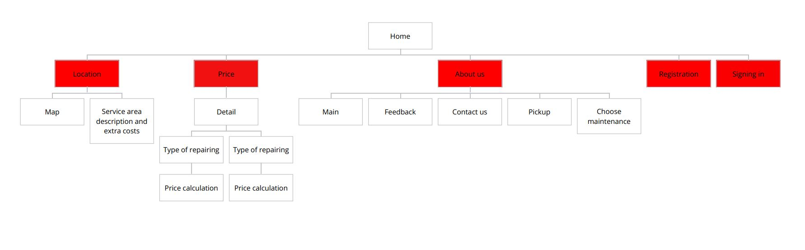

1. **Wireframes**

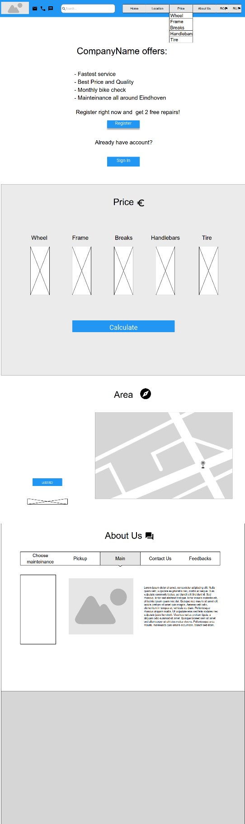

1. **Visual Design**

