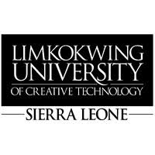
21 October, 2026
The Director General
Sierra Leone Roads Authority (SLRA)
Freetown, Sierra Leone
Dear Sir/Madam,
RE: REQUEST FOR RESEARCH SUPPORT – PUBLIC-SERVICE AND ROAD-RELATED REPORTING
Limkokwing University of Creative Technology, Sierra Leone, is pleased to introduce three final-year students undertaking their dissertation titled “SaloneFix: A Human-First Public-Service Reporting and Accountability Platform for Freetown, Sierra Leone.”
The University kindly requests SLRA’s support in helping the students understand the current processes for receiving, verifying, coordinating and following up road-related public-service reports, including the information required for a report to be actionable, how reports are assigned, and how progress and resolution are recorded.
The students may require a brief interview, observation of non-confidential reporting or coordination procedures, and access to relevant non-confidential information, subject to SLRA’s approval. All information collected will be used strictly for academic purposes and treated confidentially.
The University would greatly appreciate your cooperation and assistance in facilitating this research.
Yours faithfully,
Sheku Deen Kamara
Year Leader
Limkokwing University of Creative Technology, Sierra Leone
Email: sheku.dkamara@limkokwing.edu.sl
Student Details:
Ina M.E. Conteh | Sahid A.G. Conteh | Mark Lamin Ellie
Bachelor (Hons) in Software Engineering and Multimedia – Level 4

