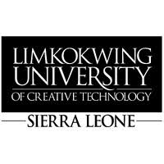
15 October, 2026
The City Council / Relevant Department
Freetown City Council (FCC)
Freetown, Sierra Leone
Dear Sir/Madam,
RE: REQUEST FOR RESEARCH SUPPORT – MUNICIPAL PUBLIC-SERVICE REPORTING
Limkokwing University of Creative Technology, Sierra Leone, is pleased to introduce three final-year students undertaking their dissertation titled “SaloneFix: A Human-First Public-Service Reporting and Accountability Platform for Freetown, Sierra Leone.”
The University kindly requests Freetown City Council’s support in helping the students understand how reports involving waste, drainage, roads, public facilities and related municipal services are currently received, verified, coordinated, assigned, updated and communicated to citizens.
The students may require a brief interview, observation of non-confidential reporting or coordination procedures, and access to relevant non-confidential information, subject to the Council’s approval. All information collected will be used strictly for academic purposes and treated confidentially.
The University would greatly appreciate your cooperation and assistance in facilitating this research.
Yours faithfully,
Sherku Deen Kamara
Year Leader
Limkokwing University of Creative Technology, Sierra Leone
Email: sheku.dkamara@limkokwing.edu.sl
Student Details:
Ina M.E. Conteh | Sahid A.G. Conteh | Mark Lamin Ellie
Bachelor (Hons) in Software Engineering and Multimedia – Level 4

