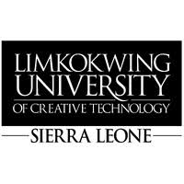
15 October, 2026.
The Director / Relevant Department
[Institution Name]
Freetown, Sierra Leone
Dear Sir/Madam,
RE: REQUEST FOR RESEARCH SUPPORT – PUBLIC-SERVICE REPORTING AND ACCOUNTABILITY
Limkokwing University of Creative Technology, Sierra Leone, is pleased to introduce three final-year students undertaking their dissertation titled “SaloneFix: A Human-First Public-Service Reporting and Accountability Platform for Freetown, Sierra Leone.”
The University kindly requests [Institution Name]’s support in helping the students understand the institution’s current processes for receiving, verifying, coordinating, assigning and following up public-service reports relevant to its mandate, including the information required for a report to be actionable and how citizens receive feedback.
The students may require a brief interview, observation of non-confidential reporting or coordination procedures, and access to relevant non-confidential information, subject to the institution’s approval. All information collected will be used strictly for academic purposes and treated confidentially.
The University would greatly appreciate your cooperation and assistance in facilitating this research.
Yours faithfully,
Sheku Deen Kamara
Year Leader
Limkokwing University of Creative Technology, Sierra Leone
Email: __________________________________________
Student Details:
Ina M.E. Conteh | Sahid A.G. Conteh | Mark Lamin Ellie
Bachelor (Hons) in Software Engineering and Multimedia – Level 4

