SALONEFIX: AN AI-POWERED INTEGRITY AND ACCOUNTABILITY PLATFORM FOR PUBLIC-SERVICE REPORTING IN SIERRA LEONE

A Final-Year Project Proposal
Student: | Ina M.E Conteh | Sahid A.G Conteh | Mark Lamin Ellie
Admission Number: | 905004473 | 905004265 | 905004456
Department: FICT
Faculty: BSEM
Institution: Limkokwing University of Creative Technology
Degree Programme: Bachelor (Hons) in Software Engineer and Multimedia
Supervisor: Ing. Oluwatosin B. Ayorinde
Date: 10 September 2026.

Declaration
I declare that this project proposal, titled “SaloneFix: An AI-Powered Integrity and Accountability Platform for Public-Service Reporting in Sierra Leone,” is my original academic work. All sources, ideas, technical documentation, and supporting materials used in preparing this proposal will be acknowledged appropriately. Any implementation, data collection, analysis, and reporting undertaken during the project will follow the ethical and academic requirements of Limkokwing University Of Creative Technology.

Student signature: ____________________Date: ____________________

Certification
This proposal has been submitted for review and approval with the knowledge of the project supervisor and the relevant academic department.

Role | Name | Signature | Date
Project Supervisor |  | _____________ | __________
Head of Department |  | _____________ | __________
External Examiner, if required |  | _____________ | __________

Abstract
Public-service reporting platforms can help citizens notify institutions about damaged roads, blocked drainage, waste, water problems, and other community issues. However, a reporting channel is only useful when its data is sufficiently accurate, verifiable, and trusted by both citizens and public institutions. SaloneFix is proposed as an AI-powered civic-technology platform for Sierra Leone that addresses this trust problem through a verify-first reporting pipeline.

The proposed platform will accept reports containing text, images, and location information through a web interface and, where feasible, a WhatsApp-compatible channel. It will combine multimodal AI classification, spatial consensus, photo-metadata analysis, human moderation, and an immutable audit trail. Spatial consensus will compare reports within a defined geographic radius to identify repeated evidence of the same incident. Metadata fingerprinting will inspect available image metadata such as capture time and location, while recognizing that metadata can be removed or manipulated and therefore cannot be treated as conclusive proof. Multimodal fusion will compare image, text, and geographic context before routing a report.

The study will evaluate three models: a human-only baseline, an AI-only model, and the proposed hybrid SaloneFix model. The comparison will use measurable indicators including classification accuracy, precision, recall, false-positive rate, duplicate-report reduction, verification confidence, resolution-evidence rejection rate, and moderator workload. The project will use an iterative software-development approach supported by requirements analysis, system modelling, prototype implementation, testing, and controlled evaluation. The expected contribution is an evidence-based design for improving the precision and accountability of civic reports in a low-resource urban context, rather than a claim that any system can guarantee absolute truth.

Keywords: civic technology, Sierra Leone, public-service reporting, artificial intelligence, spatial consensus, EXIF metadata, accountability, human-in-the-loop, multimodal verification

Table of Contents
SALONEFIX: AN AI-POWERED INTEGRITY AND ACCOUNTABILITY PLATFORM FOR PUBLIC-SERVICE REPORTING IN SIERRA LEONE 1
A Final-Year Project Proposal 1
Declaration 1
Certification 2
Abstract 2
1.1 Background of the Project 6
1.2 Problem Statement 7
1.3 Research Gap 8
1.4 Aim of the Project 9
1.5 Project Objectives 9
1.6 Research Questions 10
1.7 Research Hypotheses 11
1.8 Significance of the Project 11
1.9 Scope of the Project 12
1.10 Limitations 13
1.11 Definition of Key Terms 13
CHAPTER TWO: LITERATURE REVIEW AND EXISTING SYSTEMS 14
2.1 Introduction 14
2.2 Public-Service Accountability and Citizen Participation 15
2.3 Digital Government and Civic Technology in Sierra Leone 15
2.4 Crowdsourced Reporting and Data Quality 16
2.5 System Design 16
2.6 Artificial Intelligence for Multimodal Classification 21
2.7 Spatial Clustering and Consensus 21
2.8 Metadata and Digital-Evidence Integrity 21
2.9 Human-in-the-Loop Verification 22
2.10 Review of Existing Reporting Approaches 23
2.11 Identified Gap 25
2.12 Proposed Solution 25
2.13 Conceptual Framework 26
CHAPTER THREE: METHODOLOGY AND PROPOSED SYSTEM 27
3.1 Introduction 27
3.2 Research Design 27
3.3 Software-Development Methodology 27
3.4 Study Population and Sampling 28
3.5 Data-Collection Methods 29
3.6 Dataset and Ground-Truth Strategy 29
3.7 Ethical, Privacy, and Security Considerations 30
3.8 Analysis Plan 31
3.9 Existing-System Analysis 32
3.11 Functional Requirements 33
3.12 Non-Functional Requirements 35
3.13 Verification Pipeline 36
3.14 System Architecture 37
3.15 Use Cases 38
Use Case 1: Submit a public-service report 38
Use Case 2: Review a low-confidence report 38
Use Case 3: Assign an incident 38
Use Case 4: Submit resolution evidence 39
Use Case 5: Audit an incident lifecycle 39
3.16 Database Design 39
3.17 Proposed Technology Stack 40
3.18 Testing Strategy 42
CHAPTER FOUR: PROJECT PLAN 43
4.1 Project Activities 43
4.2 Gantt-Style Schedule 43
4.3 Estimated Budget 45
4.4 Risk Management 46
4.5 Expected Deliverables 47
REFERENCES 48
APPENDICES 49
Appendix A: Proposed questionnaire themes 49
Appendix B: Proposed interview themes 49
Appendix C: Example test-case matrix 50
Appendix D: Proposed status lifecycle 50
Appendix E: Proposal-quality checklist 51

CHAPTER ONE: INTRODUCTION

1.1 Background of the Project
Public-service institutions depend on reliable information to identify infrastructure problems, prioritize interventions, deploy field teams, and communicate progress to citizens. A digital reporting platform can improve the flow of information by allowing members of the public to submit complaints about roads, drainage, waste, water access, electricity, public facilities, and other services. However, the existence of a reporting channel does not automatically produce reliable accountability data.

The quality of a civic-reporting system depends on whether submitted reports are accurate, sufficiently specific, non-duplicative, geographically useful, and connected to verifiable action. Low-quality or malicious submissions can create operational noise. Duplicate reports can make one incident appear more severe than it is. A report can also be incorrectly categorized or routed. More seriously, an institution may mark a complaint as resolved without adequate evidence that the problem was addressed. These weaknesses create a trust gap: citizens may stop reporting because they do not believe reports will lead to action, while institutions may stop relying on the platform because they consider the data unreliable.

This project is situated within Sierra Leone’s wider movement toward digital government, civic participation, and more transparent public institutions. The Open Government Partnership identifies citizen participation, transparency, public access to information, and feedback mechanisms as important areas of Sierra Leone’s open-government commitments 2 The World Bank has also emphasized the importance of strengthening community-level participation so that citizens can influence and monitor decisions affecting services such as water, schools, health, and agriculture 3. In addition, the World Bank’s digital-economy assessment describes digital technologies as an opportunity for innovation, public services, access to information, and government transformation in Sierra Leone, while also identifying the need to address infrastructure and digital-capacity constraints 4. The African Development Bank’s DIGEST project similarly links digital solutions with improved governance, public-sector efficiency, and better coordination of resources 5.

SaloneFix is proposed in response to this context. It will not merely collect complaints. It will introduce an integrity engine that evaluates the quality and consistency of evidence before a report reaches an institution. The core design combines four mechanisms: multimodal AI classification, spatial consensus, photo-metadata analysis, and human-in-the-loop moderation. The proposed research will compare the hybrid model with simpler alternatives to determine whether combining these mechanisms improves the precision and accountability of public-service reports.

The project specification describes the platform as a way to create a “100% trustworthy dataset.” That claim should be revised for academic accuracy. No automated platform can guarantee absolute truth, particularly when users can manipulate inputs, metadata can be stripped or falsified, and field conditions change. This proposal therefore uses the more defensible objective of producing higher-confidence, more auditable, and more useful civic-reporting data.

1.2 Problem Statement
Existing public-service reporting processes often focus on receiving and forwarding complaints rather than verifying the quality of the information before institutional action. This creates five related problems.

First, citizens or automated systems may submit low-quality, prank, duplicated, or incorrectly located reports. Such noise reduces the signal-to-noise ratio of the reporting dataset and can cause institutions to waste limited field resources.

Second, a single image or text description may be insufficient to verify that a problem exists, that it is located where reported, or that it remains unresolved. A report may therefore be routed to an inappropriate institution or may receive an incorrect priority.

Third, AI classification can produce errors. An image may be unclear, the text may contradict the image, or the model may assign an inappropriate category. Automatically routing every prediction creates a risk that errors will enter the institutional workflow without human review.

Fourth, resolution evidence can be weak. An officer or contractor may mark a report as resolved using an old image, an image from a different location, or an image that does not clearly demonstrate completion. Without evidence checks and an audit trail, the public-facing status of a case may not reflect the actual state of the problem.

Fifth, a conventional database may permit records or status changes to be edited or deleted without a transparent history. This limits the ability of supervisors, auditors, researchers, and citizens to understand how a report moved through the system.

The central problem is therefore not simply the absence of a reporting platform. It is the absence of an affordable and context-sensitive mechanism for improving data precision, evidence integrity, and institutional accountability in the reporting lifecycle.

1.3 Research Gap
The proposed project identifies a gap between basic digital complaint collection and evidence-oriented civic reporting. Existing or conventional systems commonly provide a submission form, a category, a location, and a status workflow. They may not combine, within one verification pipeline, the following elements:

- Spatial consensus, in which independent reports within a defined geographic radius increase confidence that an incident is real and correctly located.
- Metadata-assisted evidence checking, in which available image metadata is compared with the reported location and time before a resolution is accepted.
- Multimodal consistency analysis, in which image content, text description, and spatial context are checked together.
- Human-in-the-loop triage, in which uncertain or conflicting cases are routed to a moderator rather than being automatically accepted or rejected.
- Comparative evaluation, in which a human-only baseline, an AI-only model, and the hybrid model are measured against the same evaluation criteria.

The academic gap is also methodological. A system may claim to improve accountability without demonstrating which component produces the improvement. The proposed Ablation of Trust study addresses this by comparing different verification configurations and measuring the change in data quality and operational usefulness.

1.4 Aim of the Project
The aim of this project is to design, develop, and evaluate SaloneFix, an AI-powered public-service reporting platform that improves the precision, verifiability, and accountability of civic reports in Sierra Leone through multimodal verification, spatial consensus, metadata-assisted evidence checks, and human oversight.

1.5 Project Objectives
The project will pursue the following objectives:
- To investigate the information, verification, privacy, and operational workflow requirements for an AI-assisted public-service reporting platform in Freetown, Sierra Leone.
- To review and analyse existing digital reporting and civic-accountability approaches and identify the technical and operational gaps that SaloneFix is designed to address.
- To design and develop a verify-first SaloneFix prototype that integrates text, image, location, spatial clustering, metadata analysis, AI-assisted classification, human moderation, institutional assignment, and audit logging.
- To implement and compare three verification approaches—a human-only baseline, an AI-only model, and the SaloneFix hybrid model—and evaluate them using classification accuracy, precision, recall, false-positive rate, duplicate reduction, resolution-evidence rejection, verification confidence, and moderator workload.
- To assess the usability, privacy, fairness, technical limitations, and overall suitability of the SaloneFix prototype for potential future pilot deployment.

1.6 Research Questions
The project will answer the following questions:

- What functional, operational, privacy, and verification requirements should guide an AI-assisted public-service reporting platform in Sierra Leone?
- To what extent does spatial consensus improve the identification and prioritization of genuine public-service incidents compared with individual reports?
- To what extent can available image metadata assist in detecting inconsistent or potentially fraudulent resolution evidence?
- How does a multimodal AI model perform when image, text, and spatial context are considered together rather than independently?
- To what extent does the hybrid SaloneFix model improve data precision and institutional accountability compared with human-only and AI-only reporting models?
- What usability, infrastructure, privacy, and fairness risks must be addressed before the platform can be deployed in a real public-service environment?

1.7 Research Hypotheses
The following hypotheses will be tested where sufficient evaluation data is available:

- H1: The hybrid SaloneFix model will achieve higher report-classification precision than the AI-only model.
- H2: The hybrid SaloneFix model will reduce false-positive and duplicate-report rates compared with a human-only or unverified digital-reporting baseline.
- H3: Metadata-assisted resolution checks will identify a measurable proportion of inconsistent resolution submissions that would not be detected by a status-only workflow.
- H4: Human review of low-confidence or conflicting cases will reduce serious routing errors compared with fully automatic AI routing.

These hypotheses are intended for evaluation, not as assumptions that the system will necessarily outperform every baseline.

1.8 Significance of the Project
The project may benefit citizens by providing a clearer channel for reporting public-service problems and tracking institutional responses. It may benefit public institutions by improving report quality, reducing duplicate field visits, prioritizing recurring incidents, and producing a more transparent case history. It may benefit civil-society organizations and researchers by providing structured, auditable information about service problems and institutional responses.

The academic contribution will be an evaluated design for combining AI classification with spatial and evidence-based verification. Rather than treating AI as a replacement for human judgment, the project will study how automated signals and human moderation can be combined in a low-resource setting.

The project also has a governance contribution. It translates broad goals of citizen participation, data access, transparency, and public accountability into a concrete workflow for collecting and auditing service-delivery reports. The project will not claim to reform public institutions by itself; its contribution is to provide a prototype and evidence about one technical mechanism that may support more accountable workflows.

1.9 Scope of the Project
The project will cover a prototype focused on public-service incident reporting in Freetown, Sierra Leone, subject to data and access constraints. The initial incident categories may include potholes and damaged roads, blocked drainage, waste accumulation, water-service problems, damaged public facilities, and other categories approved during requirements analysis.

The system will include citizen report submission, image and text capture, location capture, AI-assisted categorization, spatial clustering, confidence scoring, moderation, institutional assignment, status updates, evidence submission, audit history, dashboards, and basic reporting.

The project will not attempt to provide a nationwide production service, replace official emergency services, make legal findings of fraud, guarantee that an incident is genuine, or make final institutional decisions without accountable human authorities. Metadata checks will be treated as indicators for review rather than conclusive proof. WhatsApp integration will be implemented only if a suitable approved interface and testing access are available; otherwise, a web-based prototype will be used as the primary channel.

1.10 Limitations
The project may be limited by the availability of representative local images, access to public institutions and field officers, internet connectivity, smartphone capabilities, inconsistent GPS accuracy, image compression, missing EXIF metadata, limited computing resources, and the difficulty of obtaining a fully verified ground-truth dataset.

Spatial consensus may be biased toward areas where more people have smartphones, connectivity, or motivation to report. It may also be inappropriate for isolated incidents. Metadata can be removed by messaging applications, stripped by image-editing software, altered by device settings, or unavailable on some devices. Consequently, the system must never treat missing or conflicting metadata as proof that a citizen or officer is dishonest.

AI performance may vary across image quality, lighting, weather, language, urban environments, and incident categories. User feedback may also be affected by social desirability or limited familiarity with the prototype. These limitations will be documented and considered when interpreting the results.

1.11 Definition of Key Terms
Term | Definition in this proposal
Civic technology | Digital technology used to support communication, participation, public services, or accountability between citizens and institutions.
Spatial consensus | Increased confidence in an incident when independent reports occur within a defined geographic distance and appear to describe the same problem.
Metadata fingerprinting | Extraction and comparison of available image metadata, such as capture time, GPS coordinates, and device information, for evidence-quality assessment.
Multimodal AI | An AI system that analyzes more than one information type, such as text, images, and location.
Human-in-the-loop | A workflow in which human reviewers examine uncertain, conflicting, or high-impact cases before final action.
Verification confidence | A system-generated score or classification representing the strength of available evidence; it is not a guarantee of truth.
Immutable audit log | A protected chronological record of important events and status changes that should not be silently deleted or overwritten.
Ablation of Trust study | The comparative evaluation of different verification configurations to identify the contribution of individual integrity mechanisms.

CHAPTER TWO: LITERATURE REVIEW AND EXISTING SYSTEMS

2.1 Introduction
This chapter will review the concepts and technical approaches relevant to SaloneFix. The review will connect public accountability and citizen participation with civic technology, data quality, AI-assisted classification, geospatial clustering, digital evidence, and human oversight. It will also compare conventional reporting workflows with the proposed verify-first approach.

2.2 Public-Service Accountability and Citizen Participation
Public accountability requires more than publishing information. Citizens need meaningful channels through which they can report problems, receive feedback, and observe how institutions respond. Sierra Leone’s Open Government Partnership commitments explicitly identify citizen participation, transparency, public access to information, feedback mechanisms, and data-management systems as relevant governance goals 2. The World Bank’s 2026 roadmap similarly emphasizes community-level participation and the ability of citizens to influence and monitor decisions affecting services 3.

For SaloneFix, this literature establishes the social purpose of the system. A digital report is valuable only if it can enter a responsible workflow, remain traceable, and produce feedback. The platform’s accountability features must therefore include status history, responsible institutional assignment, resolution evidence, escalation, and audit access—not only a submission form.

2.3 Digital Government and Civic Technology in Sierra Leone
Sierra Leone’s digital transformation context creates both an opportunity and a constraint. Digital technologies can support access to information, public services, coordination, and innovation, but infrastructure, affordability, digital literacy, and institutional capacity affect who can use those systems and how reliably they operate 4. The African Development Bank’s DIGEST project further demonstrates the policy relevance of digital tools for governance efficiency, resource coordination, digital skills, and public-sector transformation

This context supports a design that is lightweight, mobile-friendly, low-bandwidth aware, and capable of human fallback. The platform should not assume that all citizens have high-speed internet, modern smartphones, continuous GPS, or equal digital literacy. The proposal therefore treats web access as the minimum viable interface and considers messaging-based reporting as a future or conditional integration rather than an unquestioned requirement.

2.4 Crowdsourced Reporting and Data Quality
Crowdsourced reporting can provide broad geographic coverage and rapid information about local conditions. However, crowdsourcing introduces problems of duplication, incomplete descriptions, inaccurate locations, malicious submissions, selection bias, and unequal participation. A high report count is not equivalent to high data quality.

SaloneFix addresses these risks by distinguishing between raw submissions and verified incidents. Multiple reports should not automatically be counted as independent evidence if they reuse the same image, originate from the same account, or describe the same incident without additional information. The system should therefore track report provenance and apply anti-duplication rules before spatial consensus is calculated.

2.5 System Design
Er Diagram
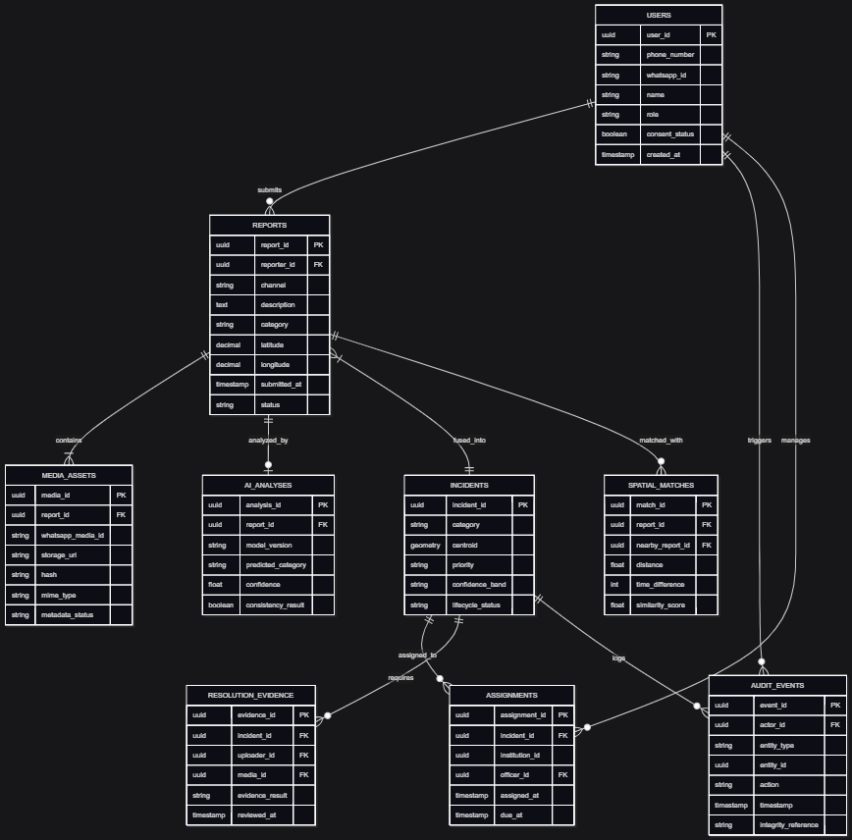
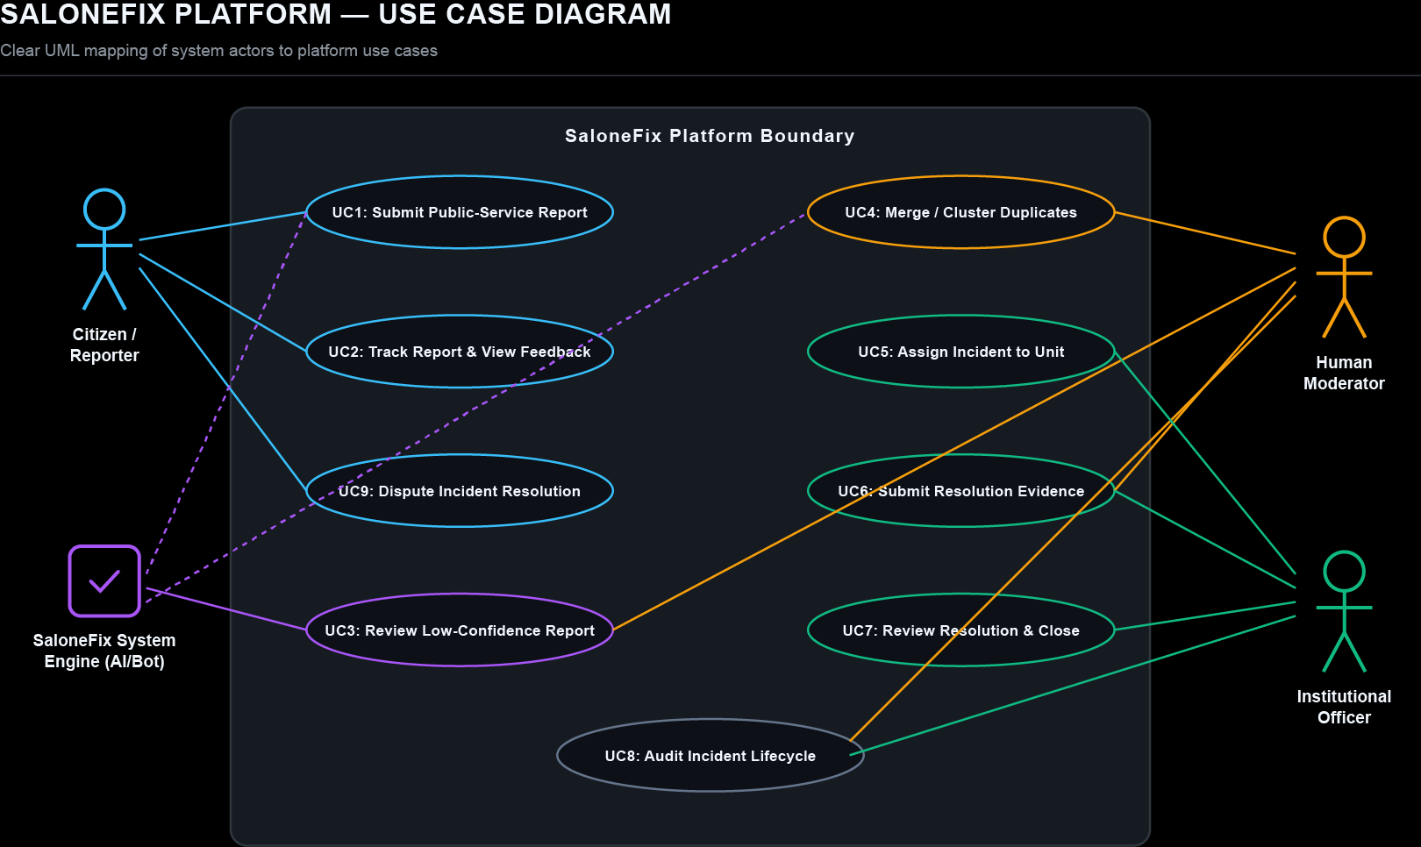

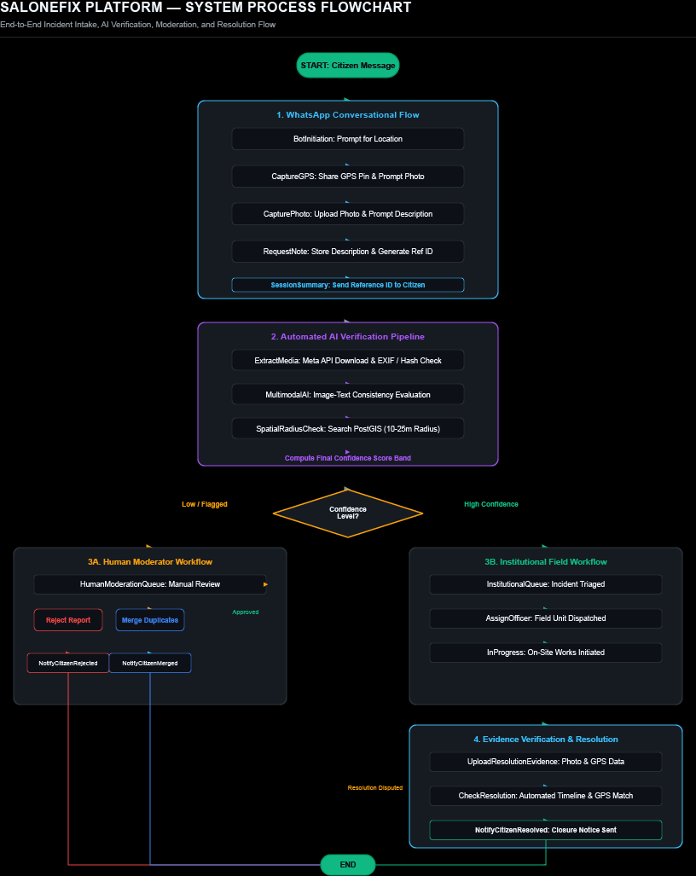

Class Diagram
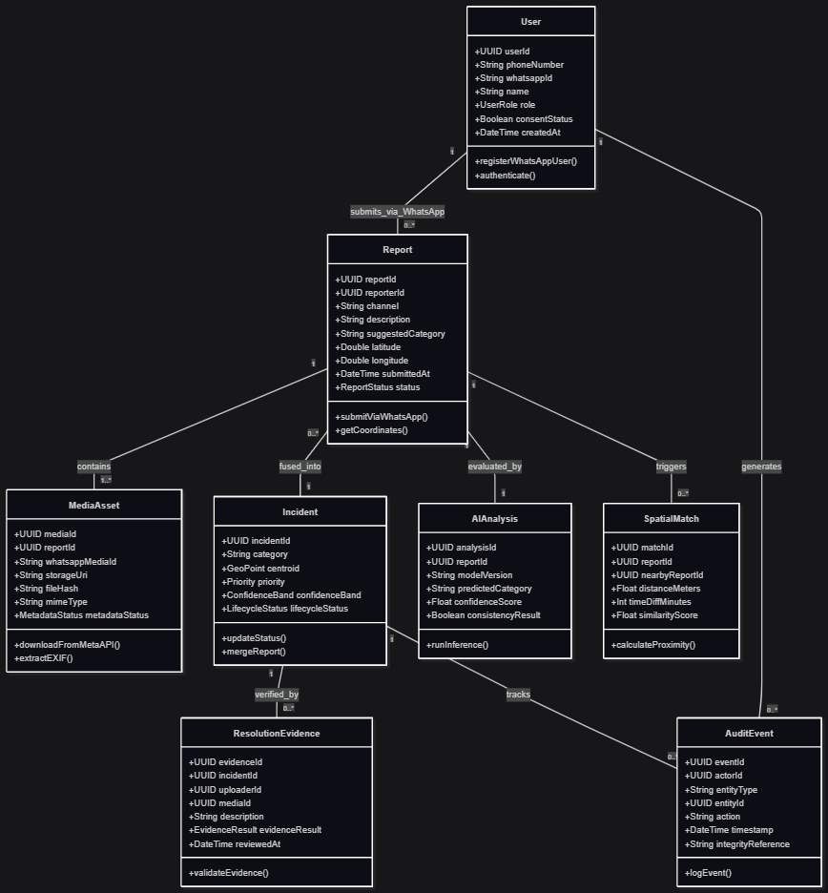

Architecture Diagram
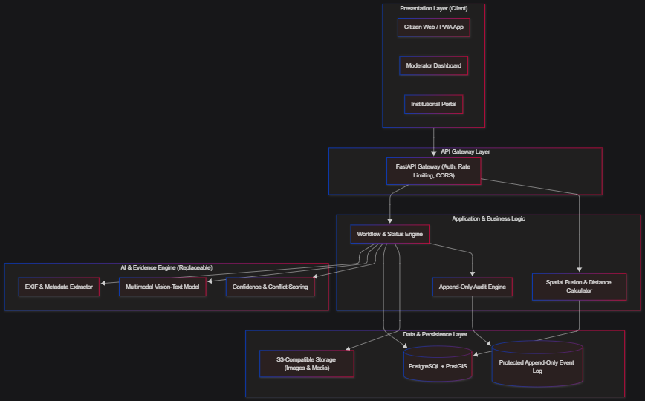

Wire frame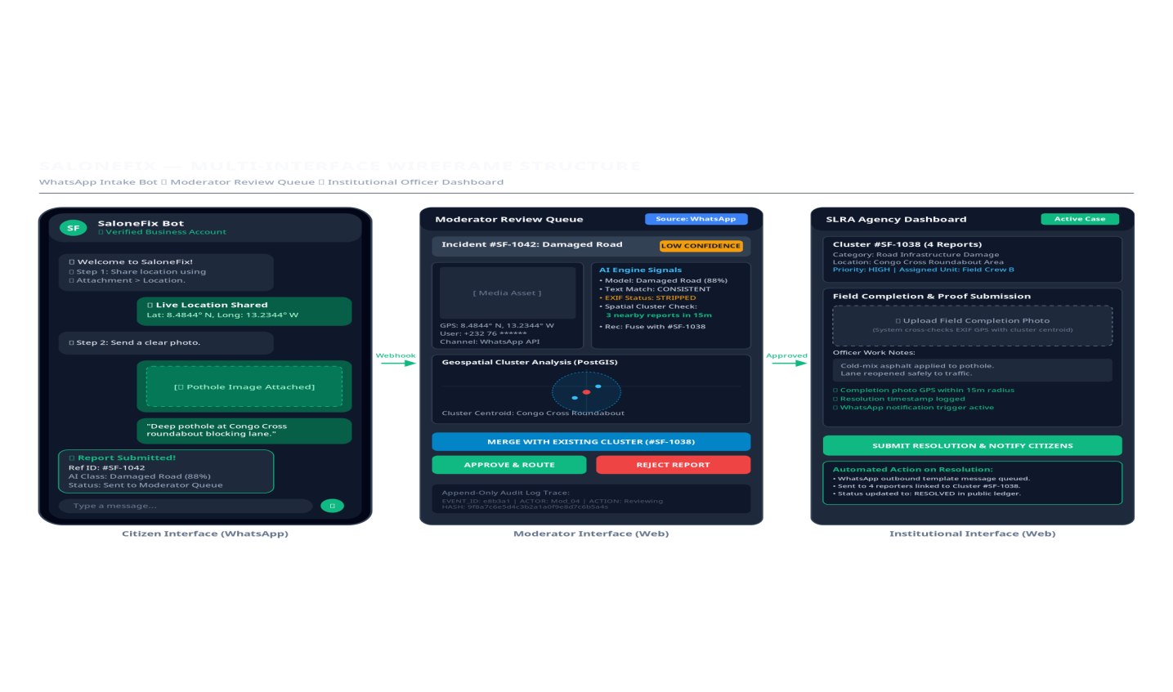

2.6 Artificial Intelligence for Multimodal Classification
The proposed platform will use AI to assist with category classification, severity or priority estimation, duplicate detection, and consistency analysis. A multimodal approach is preferable to image-only classification because text may provide contextual information that is not visible in an image, while an image may contradict an inaccurate description.

AI should be used as a decision-support mechanism. It should return a prediction, confidence estimate, supporting signals where feasible, and a route to human review when uncertainty or conflict is high. The system should preserve the original user submission and the model output so that errors can be examined later.

2.7 Spatial Clustering and Consensus
Spatial clustering groups reports that fall within a defined distance of one another. In SaloneFix, a configurable radius such as 10–25 metres will be evaluated rather than fixed permanently. The correct radius depends on GPS accuracy, road geometry, urban density, the incident type, and whether the reports refer to a point problem or a geographically extended problem.

Spatial consensus should be treated as supporting evidence, not proof. Several coordinated or copied reports can create a false consensus, while a genuine isolated problem may receive only one report. The design should therefore combine distance with time proximity, text similarity, image similarity, account independence, and incident category.

2.8 Metadata and Digital-Evidence Integrity
Image metadata may include capture time, GPS coordinates, camera or device details, orientation, and software information. Comparing available metadata with the submitted report location and the original incident timeline can identify inconsistencies that require review. However, metadata is not a complete chain of custody and should not be described as conclusive evidence.

The system will record whether metadata is present, absent, inconsistent, or apparently altered. It will not expose unnecessary device information to the public. For privacy, raw images and metadata should be access-controlled, encrypted where possible, and retained only for a justified period.

2.9 Human-in-the-Loop Verification
Human moderation is necessary for cases in which the AI is uncertain, the evidence conflicts, the incident has high public impact, or the decision could unfairly affect a person or institution. A moderator should be shown the original report, AI signals, nearby reports, metadata findings, and previous status history, while retaining the authority to accept, reject, merge, defer, or escalate a case.

The system must also record moderator decisions and reasons. This allows the project to measure disagreement between AI and humans and to identify categories where the model performs poorly.

2.10 Review of Existing Reporting Approaches
Several existing digital platforms demonstrate how technology can support citizen reporting, crowdsourced information management, and evidence-based decision-making. However, these systems differ in their primary objectives, verification mechanisms, and approaches to maintaining the reliability of submitted information.
- FixMyStreet is a civic reporting platform developed by mySociety that enables citizens to report public problems such as potholes, broken streetlights and other street-related issues. The platform uses the location and category of a reported problem to identify the appropriate authority and route the report accordingly. Reports can also be made visible to the public, allowing users to view existing reports and provide updates.
The main strength of FixMyStreet is its integration of location-based reporting with institutional routing. This provides a useful model for SaloneFix's proposed assignment of verified reports to responsible institutions. However, SaloneFix extends this approach by placing greater emphasis on the verification of the evidence submitted with a report, including multimodal consistency, metadata analysis, duplicate detection and human review.
- Ushahidi: is a crowdsourcing and mapping platform designed to collect, manage and visualize information from communities. It supports multiple data sources, including web reports, SMS and email, while providing map, list and other visualization modes. Its workflow and role-based permission features allow submitted information to be managed and processed by different users.
Ushahidi provides an important foundation for understanding how citizen-generated information can be collected and organized at scale. Its emphasis on workflows, mapping and report management is relevant to SaloneFix. However, SaloneFix focuses specifically on a verify-first pipeline in which AI-assisted analysis and human moderation are used to assess the reliability and potential duplication of submitted evidence before institutional assignment.
- Sabi Salone: provides a Sierra Leone-specific example of an AI-supported information and evidence platform. It brings together national policies, laws, evaluations, reports and other research materials and provides referenced results to improve access to credible information.
Although Sabi Salone is not a public-service incident-reporting system, it demonstrates the importance of trustworthy, traceable and locally relevant information systems in Sierra Leone. SaloneFix applies a related principle of evidence traceability to citizen-generated incident reports rather than policy and research documents.
The comparison demonstrates that existing systems already provide important components such as citizen reporting, mapping, institutional routing, crowdsourced data collection, workflow management and evidence traceability. However, the proposed SaloneFix system combines these ideas with a specific verify-first pipeline for public-service incident reporting. Its proposed contribution is the integration of multimodal AI analysis, spatial and temporal duplicate detection, metadata analysis, human moderation, institutional assignment and resolution-evidence review within one workflow.
Therefore, SaloneFix is not proposed as a replacement for existing civic-reporting or evidence platforms. Instead, it investigates whether a hybrid AI-and-human verification approach can improve the reliability and operational usefulness of citizen-generated public-service reports in the Sierra Leonean context.
The review will avoid claiming that SaloneFix is the first or only system of its kind unless a systematic literature and market review supports that claim. Its defensible contribution is the specific combination and comparative evaluation in the proposed context.

2.11 Identified Gap
The identified gap is the limited integration of report-quality verification, evidence checks, spatial corroboration, human escalation, and auditable lifecycle tracking in a single civic-reporting workflow designed for a low-resource urban context. A second gap is the lack of an explicit comparison that isolates the contribution of hybrid verification from AI-only automation.

2.12 Proposed Solution
SaloneFix will implement a verify-first pipeline. Every report will enter the platform as an unverified submission. The system will preserve the original input, assess evidence quality, classify the issue, compare it with nearby reports, calculate a confidence band, and route it either to an institution or to a human moderator.

A report will be eligible for high-confidence routing only when the available evidence meets configured requirements. A report with missing metadata will not automatically be rejected; instead, it will receive a lower evidence-confidence signal and may require corroboration or human review.

2.13 Conceptual Framework
The conceptual framework is:

Input evidence → integrity assessment → multimodal classification → spatial and temporal fusion → confidence and risk assessment → human or institutional routing→ action and resolution evidence → audit and evaluation.

The independent variable is the verification configuration: human-only, AI-only, or hybrid. The dependent variables are data precision, recall, false-positive rate, duplicate rate, resolution-evidence quality, moderator workload, and perceived usability or trust. Contextual variables include network availability, GPS accuracy, image quality, incident type, user experience, and institutional response capacity.

CHAPTER THREE: METHODOLOGY AND PROPOSED SYSTEM

3.1 Introduction
This chapter presents the proposed research design, software-development approach, data strategy, ethical controls, system requirements, architecture, technology stack, and evaluation plan.

3.2 Research Design
The project will use a design-and-evaluation research design. It will first investigate the needs and constraints of citizens, moderators, and institutional users; then design and implement a prototype; and finally evaluate the prototype through controlled test cases, comparative model evaluation, and user feedback.

The study will combine qualitative and quantitative methods. Qualitative data will be collected through document analysis, semi-structured interviews, and observation or walkthroughs of current reporting processes where access is granted. Quantitative data will be obtained from labelled test cases, controlled synthetic or collected reports, model predictions, system logs, and usability questionnaires.

3.3 Software-Development Methodology
The project will use an Agile prototyping methodology. This approach is appropriate because the system contains evolving requirements, AI behaviour that must be tested empirically, and user workflows that may require refinement based on stakeholder and usability feedback. Development will proceed through iterative cycles of requirements analysis, interface and data-model design, core system implementation, AI and integrity-engine development, testing, user evaluation, and refinement. Each iteration will produce an identifiable output that informs the subsequent development cycle.

Iteration | Main activity | Output
1 | Requirements and stakeholder analysis | Requirements specification and risk register
2 | Interaction and data-model design | Wireframes, use cases, database schema
3 | Core reporting workflow | Citizen submission and institutional dashboard
4 | Integrity engine | Metadata checks, AI classification, spatial fusion
5 | Moderation and audit | Human-review queue, audit log, resolution evidence
6 | Testing and evaluation | Comparative results and usability findings
7 | Refinement and documentation | Final prototype, dissertation chapters, appendices
The project will maintain version control, issue tracking, test records, and decision logs so that design changes can be explained in the final dissertation.

3.4 Study Population and Sampling
The proposed stakeholder groups are citizens or community representatives who report public-service problems, institutional officers who receive or manage reports, moderators or administrators who verify evidence, and technical or governance experts who can comment on feasibility and accountability.

The final sample will depend on supervisor approval and access. A feasible student-project target may include approximately 20–40 citizen or community participants for requirements and usability feedback, 5–10 institutional or domain participants for workflow interviews where available, and a labelled evaluation set of at least 150–300 report instances. These numbers are planning targets rather than claims about the final sample.

Participants will be recruited purposively for relevant experience. The study will document inclusion criteria, recruitment procedures, consent, non-response, and potential sampling bias.

3.5 Data-Collection Methods
The project will use the following methods:

- Document analysis: Review relevant institutional reporting procedures, platform documentation, public governance materials, and technical literature.
- Semi-structured interviews: Ask stakeholders about current reporting channels, evidence requirements, response workflows, common failure points, and privacy concerns.
- Observation or process walkthrough: Where permitted, map how a complaint is currently submitted, assigned, resolved, and closed.
- Questionnaire: Collect structured feedback on usability, perceived trust, clarity of status information, and willingness to use the platform.
- Controlled technical tests: Submit labelled examples with known categories, locations, duplicates, metadata conditions, and resolution-evidence conditions.

3.6 Dataset and Ground-Truth Strategy
A major methodological risk is the absence of a reliable ground-truth dataset. The project will therefore use a transparent combination of sources:

- consented and anonymized real examples, if approved and available;
- photographs captured by the research team under controlled conditions;
- clearly labelled test images and descriptions;
- deliberately constructed edge cases for missing metadata, contradictory text, duplicates, stale resolution images, and incorrect locations; and
- human-verified labels from at least two reviewers for the evaluation subset.

Each instance should receive a label for incident category, approximate location validity, duplicate status, evidence sufficiency, and resolution-evidence validity. Disagreements should be recorded and adjudicated according to a documented rule. The final dissertation must distinguish real-world data from synthetic or controlled test data.

The project will not fabricate field evidence or claim general performance from a small convenience dataset. If the dataset is too small for statistically stable conclusions, the result will be reported as a prototype feasibility evaluation.

3.7 Ethical, Privacy, and Security Considerations
The platform processes potentially sensitive location, image, account, and institutional information. The study will obtain the required departmental or institutional ethical approval before collecting personal data.

The system will apply data minimization, informed consent, role-based access control, secure authentication, encryption in transit, protected storage, and a documented retention and deletion policy. Public users should not see a reporter’s exact identity or device fingerprint unless there is a clear lawful and ethical basis. Exact locations may need to be generalized for public maps, especially for reports involving private residences or vulnerable persons.

The project will avoid identifying individuals as corrupt or fraudulent solely on the basis of AI or metadata findings. The appropriate system label is “requires review” or “evidence inconsistency detected.” Human decision-makers must review high-impact cases.

The immutable audit log should protect the history of actions without making it impossible to correct legitimate mistakes. A practical design is append-only event logging with controlled corrections that create a new event rather than silently overwriting the old one. The proposal does not require blockchain; a protected append-only database log is sufficient for the prototype.

3.8 Analysis Plan
The evaluation will compare Model A, Model B, and Model C using the same labelled test set where possible.

Model | Description
Model A: Human-only baseline | A conventional workflow in which reports are reviewed and routed by a human without AI-generated verification signals.
Model B: AI-only | AI classifies and routes reports automatically, subject to defined confidence thresholds.
Model C: SaloneFix hybrid | AI classification is combined with spatial consensus, metadata-assisted checks, confidence thresholds, and human review of uncertain cases.
Primary quantitative measures will include:

- Accuracy: the proportion of correct classifications or routing decisions among all evaluated cases.
- Precision: the proportion of reports routed to a category or status that are actually correct.
- Recall: the proportion of relevant or genuine cases that the system successfully identifies.
- F1 score: the harmonic mean of precision and recall where appropriate.
- False-positive rate: the proportion of invalid or incorrect cases incorrectly accepted.
- Duplicate-reduction rate: the percentage reduction in duplicate incidents after clustering and fusion.
- Resolution-evidence rejection rate: the proportion of intentionally inconsistent or invalid resolution submissions flagged for review or rejected.
- Moderation rate: the proportion of reports escalated to human review.
- Moderator workload: time or number of review actions required per report.
- Usability score: structured participant feedback using an approved questionnaire or adapted usability scale.

The analysis will compare models using confusion matrices and descriptive statistics. If the sample size and assumptions support it, paired statistical tests or confidence intervals will be reported. Otherwise, the study will clearly describe the comparison as exploratory.

3.9 Existing-System Analysis
The existing process will be modelled using the following questions:

- How does a citizen currently report a problem?
- What information is collected?
- Who verifies the report?
- How is responsibility assigned?
- How are duplicates handled?
- What evidence is required to mark a case resolved?
- Can historical changes be audited?
- How does the citizen receive feedback?

The resulting process map will be compared with SaloneFix to identify improvements, new risks, and responsibilities that remain outside the software.
3.10 Proposed System Overview

SaloneFix will have three main user roles:
User role | Main capabilities
Citizen or reporter | Submit a report, attach text and images, share location, view status, receive feedback, and provide follow-up evidence.
Moderator | Review low-confidence or conflicting cases, merge duplicates, request clarification, approve routing, flag abuse, and record decisions.
Institutional officer or administrator | View assigned incidents, update status, upload resolution evidence, respond to citizens, manage service categories, and review audit history.
The platform will preserve a distinction between report, incident, and resolution event. Several reports may be fused into one incident, and one incident may have several status changes and resolution attempts.

3.11 Functional Requirements
ID | Functional requirement
FR1 | The system shall allow a user to submit a public-service report with a description, category suggestion, location, timestamp, and optional image.
FR2 | The system shall validate required fields and provide clear feedback when information is incomplete.
FR3 | The system shall store the original submission separately from later AI or moderator interpretations.
FR4 | The system shall extract available image metadata and record whether it is present, absent, or inconsistent.
FR5 | The system shall compare image, text, and spatial context to generate classification and consistency signals.
FR6 | The system shall identify nearby reports within a configurable spatial and temporal window.
FR7 | The system shall suggest merging or clustering when reports appear to describe the same incident.
FR8 | The system shall assign a confidence band and route uncertain or conflicting cases to a moderator.
FR9 | The system shall allow authorized users to assign incidents to an institution or service unit.
FR10 | The system shall support status values such as submitted, under review, verified, assigned, in progress, resolved, disputed, and closed.
FR11 | The system shall require resolution evidence before an authorized user can mark an incident resolved.
FR12 | The system shall compare resolution evidence with the original incident location and timeline where data is available.
FR13 | The system shall maintain an append-only audit history of significant events and status changes.
FR14 | The system shall provide dashboards for citizens, moderators, and institutional users according to their permissions.
FR15 | The system shall support search, filtering, map-based viewing, and report export for authorized users.
FR16 | The system shall record model outputs, confidence values, and human decisions for evaluation.
FR17 | The system shall allow users to report abuse, incorrect information, or a disputed resolution.
FR18 | The system shall provide a fallback route for reports that cannot be processed automatically.

3.12 Non-Functional Requirements
Category | Requirement
Usability | The interface should be understandable to first-time users and usable on mobile screens.
Performance | Normal report submission and dashboard operations should provide a responsive experience under the prototype’s expected load.
Availability | The system should degrade gracefully when AI services or network connectivity are temporarily unavailable.
Security | Authentication, authorization, input validation, secure file handling, audit protection, and rate limiting shall be implemented.
Privacy | Personal data, precise locations, images, and device metadata shall be collected and exposed only when necessary.
Explainability | The system should show why a case was escalated or assigned a lower confidence band.
Fairness | The evaluation should examine performance differences across incident types, image quality, language, and user groups where data permits.
Maintainability | Components, model calls, thresholds, and category definitions should be modular and documented.
Scalability | Spatial queries, image processing, and audit logs should be designed so that larger datasets can be supported later.
Accessibility | Text, colour, form labels, and interaction design should support users with different abilities and devices.

3.13 Verification Pipeline
The proposed pipeline is:

- Ingestion: Receive a report through the web interface and, if available, an approved messaging integration.
- Validation: Check required fields, file type, file size, location format, and abuse controls.
- Evidence preservation: Store the original submission, creation time, and provenance information.
- Metadata assessment: Extract available EXIF fields and compare them with the user-provided location and report time. Missing metadata lowers evidence confidence but does not automatically reject the report.
- Multimodal classification: Analyze the image and text to suggest a category and priority.
- Consistency checking: Identify conflicts between image content, text description, category, and geographic context.
- Spatial fusion: Search for nearby reports using a configurable distance and time window, then assess independence and similarity.
- Confidence and risk routing: Route high-confidence, low-risk cases to the appropriate institutional queue; route uncertain, conflicting, or high-impact cases to a human moderator.
- Institutional action: Allow an authorized officer to acknowledge, assign, update, and respond to the incident.
- Resolution verification: Inspect submitted resolution evidence and compare it with the original incident context.
- Audit logging: Record all material events, decisions, evidence findings, and corrections.
- Feedback and evaluation: Notify the reporter where appropriate and store anonymized events for system evaluation.

3.14 System Architecture
The proposed architecture will contain the following layers:

- Presentation layer: responsive web interface for citizens, moderators, and institutional users.
- API layer: authenticated endpoints for reports, users, incidents, evidence, moderation, dashboards, and audit events.
- Application layer: workflow orchestration, permissions, status transitions, clustering logic, confidence rules, and notifications.
- AI and verification layer: image-text classification, similarity checks, metadata extraction, spatial queries, and human-review routing.
- Data layer: relational database for users, reports, incidents, events, classifications, and assignments; object storage for images and evidence.
- Observability layer: structured logs, model-decision records, audit events, error monitoring, and evaluation exports.

The AI layer should be replaceable. The system must continue to support manual processing if an external AI service is unavailable. This reduces operational dependence and makes the platform easier to evaluate.

3.15 Use Cases

Use Case 1: Submit a public-service report
A citizen opens the platform, selects or describes an issue, attaches an image if available, confirms the location, and submits the report. The system validates the input, assigns a reference number, and displays the initial status and evidence-confidence information in plain language.

Use Case 2: Review a low-confidence report
A moderator opens the review queue and sees the original report, AI category, text-image consistency result, nearby reports, metadata findings, and any abuse indicators. The moderator accepts, edits, merges, rejects with a documented reason, or requests clarification.

Use Case 3: Assign an incident
An institutional officer views verified incidents relevant to the institution, accepts responsibility, assigns a service unit, and records an expected action date. Every status change is logged.

Use Case 4: Submit resolution evidence
The officer uploads an image and explanation of the completed work. The system checks available location and time information against the incident and flags inconsistencies for review. A citizen or moderator may dispute the resolution.

Use Case 5: Audit an incident lifecycle
An authorized supervisor views the complete timeline, including original submission, merges, AI decisions, moderator actions, assignments, evidence uploads, corrections, and closure decisions.

3.16 Database Design
The initial relational model will include the following entities:

Entity | Key fields
User | user_id, role, contact details, consent status, created_at
Report | report_id, reporter_id, description, category, latitude, longitude, submitted_at, status
MediaAsset | media_id, report_id, storage_uri, hash, mime_type, metadata_status
Incident | incident_id, category, centroid, priority, confidence_band, lifecycle_status
ReportIncident | report_id, incident_id, merge_reason, created_at
AIAnalysis | analysis_id, report_id, model_version, predicted_category, confidence, consistency_result
SpatialMatch | match_id, report_id, nearby_report_id, distance, time_difference, similarity_score
ResolutionEvidence | evidence_id, incident_id, uploader_id, media_id, evidence_result, reviewed_at
Assignment | assignment_id, incident_id, institution_id, officer_id, assigned_at, due_at
AuditEvent | event_id, actor_id, entity_type, entity_id, action, timestamp, previous_hash or integrity_reference
Feedback | feedback_id, incident_id, user_id, rating, comment, created_at
The use of cryptographic hashes may help detect file replacement or unexpected changes, but a hash does not prove that an image is truthful. This distinction will be documented.

3.17 Proposed Technology Stack
Component | Proposed technology | Rationale
Frontend | React with TypeScript and responsive CSS | Component-based interface and maintainable client code.
Backend API | Python FastAPI | Suitable for typed APIs, asynchronous operations, and integration with Python AI and image-processing libraries.
Database | PostgreSQL with PostGIS where available | Relational integrity and efficient geographic queries.
Image processing | Pillow and a metadata-extraction library | Image validation, resizing, hashing, and available EXIF inspection.
AI service | A documented multimodal model accessed through a controlled service layer | Allows classification and consistency analysis while keeping the AI provider replaceable.
Object storage | S3-compatible storage or secure local equivalent for the prototype | Separates large media files from transactional records.
Authentication | Secure session or token-based authentication with role-based access control | Protects citizen, moderator, and institutional functions.
Version control | Git and GitHub or an approved repository | Change tracking, collaboration, and reproducibility.
Testing | Pytest, API tests, frontend tests, and structured evaluation scripts | Supports unit, integration, system, and model evaluation.
Deployment | University-approved cloud or local server environment | Depends on project resources, privacy requirements, and supervisor approval.
The final technology choice will be validated against cost, availability, security, maintainability, latency, privacy, and deployment constraints. The project should not use AI simply because it is available; every AI feature must have a clear value over a simpler rule-based alternative.

3.18 Testing Strategy
The system will be tested at four levels:

- Unit testing: Validate functions such as metadata extraction, coordinate validation, distance calculations, confidence rules, status transitions, and access-control decisions.
- Integration testing: Verify interactions among the API, database, object storage, AI service layer, clustering logic, and audit log.
- System testing: Test complete workflows from report submission through moderation, assignment, resolution evidence, and closure.
- User-acceptance testing: Ask representative users to complete realistic tasks and record success, errors, time, comprehension, and satisfaction.

Example test cases include valid and invalid submissions, missing location, unsupported images, duplicate reports, conflicting text and image, missing EXIF data, mismatched resolution location, unauthorized status changes, audit-log integrity, service downtime, and user dispute of a resolution.

CHAPTER FOUR: PROJECT PLAN

4.1 Project Activities
The project activities are requirements analysis, literature review, ethics preparation, system design, database and interface design, prototype development, AI and verification integration, testing, evaluation, analysis, documentation, and presentation.

4.2 Gantt-Style Schedule
The schedule below assumes a 24-week final-year project. It should be adjusted to the university calendar.

Activity | W1–2 | W3–4 | W5–6 | W7–8 | W9–12 | W13–16 | W17–19 | W20–22 | W23–24
Topic refinement and supervisor approval | ■
Literature review and existing-system analysis | ■ | ■ | ■
Ethics, consent, and data-management plan |  | ■ | ■
Requirements collection |  | ■ | ■
Architecture, wireframes, and database design |  |  | ■ | ■
Core reporting and dashboard prototype |  |  |  | ■ | ■
AI, metadata, and spatial-verification modules |  |  |  |  | ■ | ■
Moderation, audit, and resolution workflow |  |  |  |  |  | ■
Functional and security testing |  |  |  |  |  | ■ | ■
Comparative evaluation and user testing |  |  |  |  |  |  | ■
Data analysis and discussion |  |  |  |  |  |  | ■ | ■
Final writing, corrections, and presentation |  |  |  |  |  |  |  | ■ | ■

4.3 Estimated Budget
The following is an indicative student-project budget. It is not a quotation and should be revised using actual local prices and university resources.

Item | Estimated cost (NLe)
Internet data and communication | 2,500
Local transport for interviews and testing | 3,500
Printing, binding, and stationery | 1,500
Test-device or accessory support | 2,500
Domain or temporary hosting, if required | 2,500
Cloud storage and compute contingency | 4,000
Participant refreshments or approved research logistics | 2,000
Software and development contingency | 2,000
Presentation and demonstration materials | 1,500
Contingency reserve | 3,000
Estimated total | 25,000

4.4 Risk Management
Risk | Likelihood | Impact | Mitigation
Insufficient representative data | Medium | High | Use controlled labelled tests, document limitations, and seek supervisor-approved stakeholder access early.
AI misclassification | Medium | High | Use confidence thresholds, human review, error analysis, and a non-AI fallback.
Missing or altered metadata | High | Medium | Treat metadata as supporting evidence only and use multiple verification signals.
Poor GPS accuracy | Medium | High | Record accuracy where available, use configurable radii, and avoid overclaiming location precision.
Limited internet access | Medium | High | Optimize payloads, support retry states, and consider offline or low-bandwidth design.
Privacy breach | Low to medium | High | Minimize data, use access controls, protect media, anonymize evaluation data, and define retention.
Institutional access unavailable | Medium | Medium | Use process walkthroughs, public documents, and simulated institutional workflows with clear disclosure.
Model-service failure | Medium | Medium | Abstract the AI service, cache results for tests, and retain manual processing.
Scope expansion | High | Medium | Prioritize the web prototype and core integrity engine; make messaging integration conditional.
False accusation from automated flags | Low to medium | High | Use neutral “requires review” labels and require accountable human decisions.

4.5 Expected Deliverables
The project is expected to produce:

- An approved project proposal and literature review.
- A requirements specification and stakeholder/process analysis.
- Wireframes, use-case diagrams, architecture diagrams, flowcharts, and database design.
- A working SaloneFix prototype with citizen, moderator, and institutional workflows.
- A metadata-assisted evidence-checking module.
- A spatial clustering and incident-fusion module.
- A multimodal AI classification and consistency-analysis module or controlled mock interface where live AI access is unavailable.
- An append-only audit-history mechanism.
- Test cases, evaluation data, results, and error analysis.
- A completed dissertation and presentation demonstration.

REFERENCES
- Open Government Partnership (2021–2023) ‘Citizen Participation in Parliament (SL0030): Sierra Leone Action Plan 2021–2023’. Available at: https://www.opengovpartnership.org/members/sierra-leone/commitments/sl0030/
- World Bank (2026) Strengthening Citizen Participation in Sierra Leone: A Policy and Institutional Roadmap. Available at: https://documents.worldbank.org/en/publication/documents-reports/documentdetail/099022726040510797
- World Bank (2021) Sierra Leone Digital Economy Diagnostic. Available at: https://openknowledge.worldbank.org/entities/publication/1ef37484-3de5-553a-b58e-9867d6f146ed
- African Development Bank (2025) ‘Sierra Leone – Digital Innovation for Government Efficiency and Sector Transformation (DIGEST)’. Available at: https://mapafrica.afdb.org/en/projects/46002-P-SL-GB0-003
- FastAPI (n.d.) FastAPI Documentation. Available at: https://fastapi.tiangolo.com/
- PostgreSQL Global Development Group (n.d.) PostgreSQL Documentation. Available at: https://www.postgresql.org/docs/
- PostGIS Project (n.d.) PostGIS Documentation. Available at: https://postgis.net/documentation/
- World Wide Web Consortium (2024) Web Content Accessibility Guidelines (WCAG) 2.2. Available at: https://www.w3.org/TR/WCAG22/
- Basiri, A., Haklay, M., Foody, G. and Mooney, P. (2019) ‘Crowdsourced geospatial data quality: challenges and future directions’, International Journal of Geographical Information Science, 33(8), pp. 1588–1593. Available at: https://doi.org/10.1080/13658816.2019.1593422
- Alvarez, P. (2004) ‘Using Extended File Information (EXIF) file headers in digital evidence analysis’, International Journal of Digital Evidence, 2(3). Available at: https://www.utica.edu/academic/institutes/ecii/publications/articles/A0B1F944-FF4E-4788-E75541A7418DAE24.pdf
- National Institute of Standards and Technology (2023) Artificial Intelligence Risk Management Framework (AI RMF 1.0). NIST AI 100-1. Available at: https://doi.org/10.6028/NIST.AI.100-1
- OWASP Foundation (n.d.) Application Security Verification Standard (ASVS). Available at: https://owasp.org/www-project-application-security-verification-standard/
- Amershi, S. et al. (2019) ‘Guidelines for human-AI interaction’, in Proceedings of the 2019 CHI Conference on Human Factors in Computing Systems. Available at: https://doi.org/10.1145/3290605.3300233
- International Organization for Standardization (2019) ISO/IEC 27701:2019: Security techniques—Extension to ISO/IEC 27001 and ISO/IEC 27002 for privacy information management. Available at: https://www.iso.org/standard/71670.html
- Creswell, J.W. and Creswell, J.D. (2018) Research Design: Qualitative, Quantitative, and Mixed Methods Approaches. 5th edn. Thousand Oaks, CA: SAGE Publications.
- Brooke, J. (1996) ‘SUS: A “quick and dirty” usability scale’, in Jordan, P.W., Thomas, B., Weerdmeester, B.A. and McClelland, I.L. (eds.) Usability Evaluation in Industry. London: Taylor & Francis, pp. 189–194.

APPENDICES

Appendix A: Proposed questionnaire themes
The questionnaire will ask participants about the clarity of the reporting process, ease of attaching evidence, confidence in location capture, understanding of report status, perceived fairness of AI-assisted review, privacy concerns, willingness to use the platform, and preferred feedback channels.

Appendix B: Proposed interview themes
Interviews will examine current reporting workflows, common categories of public-service incidents, evidence normally required for action, common causes of duplicate or false reports, resolution-verification practices, institutional constraints, data-sharing concerns, escalation processes, and acceptable uses of AI.

Appendix C: Example test-case matrix
Test case | Expected result | Evidence to record
Valid report with matching text, image, and location | Report accepted and classified with normal confidence | Category, confidence, latency, audit event
Image and text describe different issues | Report routed to human review | Conflict type and moderator decision
Missing EXIF metadata | Report remains processable but receives reduced evidence confidence | Metadata status and route
Resolution image from a different location | Resolution flagged for review or rejected | Distance difference, status, reviewer outcome
Multiple independent reports nearby | Reports suggested for incident fusion | Radius, time window, number of independent reports
Copied or identical image submissions | Duplicate or suspicious cluster suggested | File hash, similarity, account relationship
Unauthorized officer status update | Action rejected and logged | User role, attempted action, audit event
AI service unavailable | Report remains available for manual processing | Fallback route and recovery event
Citizen disputes a resolution | Incident reopens or enters review queue | Dispute reason and final decision

Appendix D: Proposed status lifecycle
Submitted → Under Review → Verified → Assigned → In Progress → Resolution Submitted → Resolution Under Review → Resolved → Closed

Alternative paths include Needs Clarification, Merged, Rejected, Disputed, and Escalated. Every transition should record the actor, timestamp, reason, and supporting evidence where relevant.

Appendix E: Proposal-quality checklist
Before submission, confirm that the final institutional version contains the approved title page, declaration, certification, abstract, contents page, consistent chapter numbering, current references, research ethics requirements, diagrams, a realistic scope, measurable objectives, a justified methodology, a data-management plan, an evaluation strategy, a project schedule, and a supervisor-approved budget.

The final proposal should also replace all bracketed placeholders with the student’s actual details and should be checked against the official departmental handbook before submission.

