

Draft Guidelines – Energy ADE version 0.6

**CityGML Energy Application Domain Extension**

In collaboration with OGC and SIG 3D

**Revision Process**

|  |  |  |
| --- | --- | --- |
| **Revision updates** | **When** | **Who** |
| Basis version | 03.08.2015 | RN |
|  |  |  |
|  |  |  |
|  |  |  |
|  |  |  |
|  |  |  |
|  |  |  |
|  |  |  |
|  |  |  |

**Authors**

Romain Nouvel (RN)

Marcel Bruse

Olivier Tournaire

…

**Consortium participating institutes**

University of Applied Sciences Stuttgart, Germany

Technische Universität München, Germany

Karlsruhe Institute für Technologie, Germany

European Institute for Energy Research, Germany

RWTH Aachen University / E.ON Energy Research Center, Germany

HafenCityUniversität Hamburg, Germany

Ecole Polytechnique Fédérale de Lausanne, Switzerland

Centre Scientifique et Technique du Batiment, France

Electricité de France, France

Sinergis, Italy

M.O.S.S Computer Grafik Système, Germany

**Abstract**

The Application Domain Extension (ADE) Energy detailed in this documentation defines a standardized data model based on CityGML format for urban energy analyses, aiming to be a reference exchange data format between different urban modelling tools and expert databases.

It has been developed since May 2014 by an international consortium of urban energy simulation developers and users (University of Applied Sciences Stuttgart, Technische Universität München, Karlsruhe Institute für Technologie, RWTH Aachen University / E.ON Energy Research Center, HafenCityUniversität Hamburg, European Institute for Energy Research, Ecole Polytechnique Fédérale de Lausanne, Centre Scientifique et Technique du Batiment, Electricité de France, Sinergis and M.O.S.S Computer Grafik Systeme).

**Contents**

1 Overview of the Application Domain Extension Energy 5

2 ADE Energy Core 6

2.1 Overview 6

2.2 Building, zones and boundaries 7

2.3 Time Series 8

2.4 Schedules 9

3 Construction and Material Module 10

3.1 Construction and layers 11

3.2 Materials 11

3.3 Optical properties 11

4 Occupancy Module 13

4.1 Usage zone and Building Unit 14

4.2 Occupants 14

4.3 Facilities 14

5 Energy System Module 15

5.1 Energy Amounts and Forms 16

5.2 Energy Distribution 16

5.3 Energy Conversion 16

# Overview of the Application Domain Extension Energy

Following the philosophy of CityGML, this ADE Energy aims to be flexible, in terms of compatibility with different data qualities, levels of details, and urban energy models complexities (from monthly energy balance of ISO 13790, to sub-hourly dynamic simulation of softwares like CitySim or EnergyPlus). It takes into consideration the INSPIRE Directive of the European Parliament, as well as the recent US Building Energy Data Exchange Specification (BEDES).

Its structure is thought of as modular; some of its modules can be potentially used and extended for other applications (e.g. module Occupancy for socio-economics, module Materials for acoustics or statics, module Metadata and Scenarios for every urban analysis).

# ADE Energy Core

The Core of the ADE Energy contains the thermal building objects required for the building energy modelling. These thermal building objects are linked to the CityGML building objects through its _AbstractBuilding, _BoundarySurface and _Opening classes.



## Overview

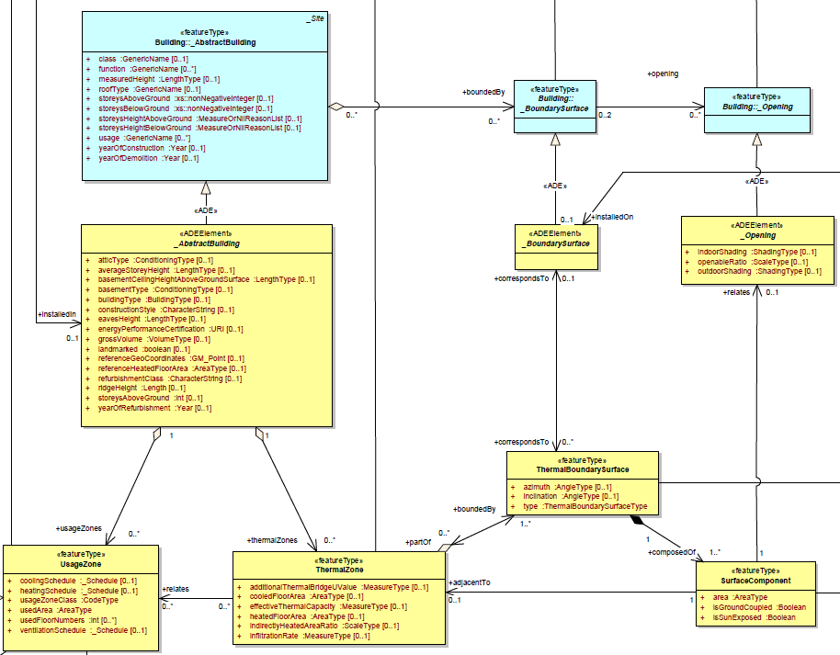

**Fig. 1:** Class diagram of ADE Energy Core – Geometrical Part

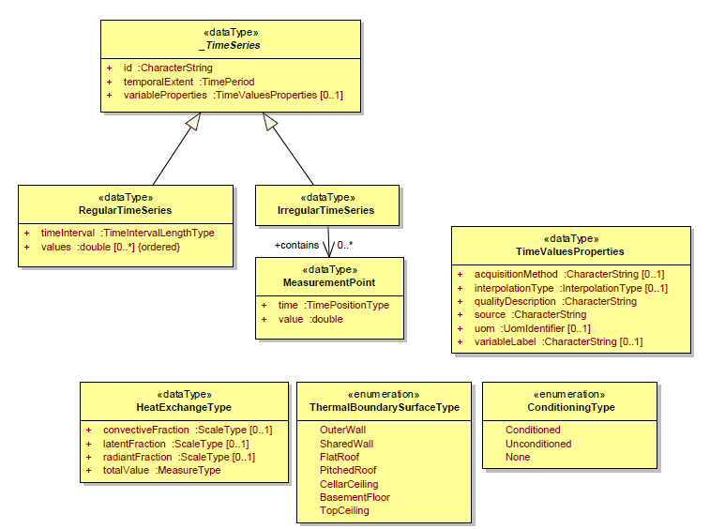

**Fig. 2:** Class diagram of ADE Energy Core – Time Series

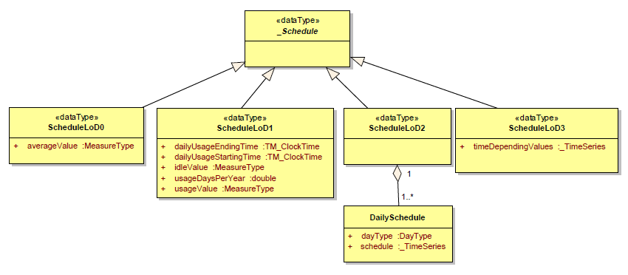

**Fig. 3:** Class diagram of ADE Energy Core – Schedules

## Building, zones and boundaries

**ThermalZone**

Zone of a building which serves as unit for the building heating/ cooling simulation. For the simulation, a thermal zone is considered as isothermal. It is a semantic object, which may be or not related to a geometric entity (Building, BuildingPart, Room etc.).

This class inherits from _CityObject, and may therefore be associated to 1 or more EnergyDemand objects (see module Energy systems).

For the requirement of the building heating/cooling simulation, the ThermalZone must be related to one or more UsageZone.

**UsageZone**

Zone of a building with homogeneous usage type.

This class inherits from _CityObject, and may therefore be associated to 1 or more EnergyDemand objects. This class is defined minimally by a usage zone class and a used area.

For further details, see module Occupancy.

**ThermalBoundarySurface**

Quasi-coplanar surface bounding the thermal zone. It may be linked to the gml:BoundarySurface (through the ADE:_BoundarySurface) when possible, but not necessary (e.g. cellar ceiling or top storey ceiling in the case of LOD1-3).

This class inherits from _CityObject, and may therefore be associated to a Construction Object (see module Construction and Material).

**SurfaceComponent**

Part of the thermal boundary surface corresponding to a homogeneous construction component (e.g. windows, wall, insulated part of a wall etc.).

This class inherits from _CityObject, and may therefore be associated to a Construction Object (see module Construction and Material).

**_AbstractBuilding**

Extension of CityGML object AbstractBuilding in Application Domain Extension Energy.

**_BoundarySurface**

Extension of CityGML object _BoundarySurface in Application Domain Extension Energy.

Even empty, this subtype is necessary for the connection of the ADE Energy to the CityGML, since a bi-directional associations to the existing definitions is added.

**_Opening**

Extension of CityGML object _Opening in Application Domain Extension Energy. Openings may have an indoor and an outdoor shading system. They are further defined by an openable ratio.

## Time Series

Time Series are used in the Energy ADE for energy amount or schedule modelling for instance. Given that the class Time Series is not specific to the Energy ADE, it should be integrated in the CityGML Core at middle-term.

Time series are homogeneous list of time-depending values.

These values are defined for a specific *temporalExtent* (= start, end and duration time). They have common properties specified in the type **TimeValuesProperties**.

These properties are the variable label, the variable unit of measure (*uom*), the interpolation type (based on the [WaterML ADE](http://def.seegrid.csiro.au/sissvoc/ogc-def/resource?uri=http://www.opengis.net/def/waterml/2.0/interpolationType/)) and some data acquisition information like the data source, the acquisition method and the quality description.

Time Series can be either regular or irregular.

**RegularTimeSeries** contain *values* generated at regularly spaced interval of time *(timeInterval*). They are relevant for instance to store automatically acquired data.

In **IrregularTimeSeries**, the data in the time series follows also a temporal sequence, but the measurement points might not happen at a regular time interval[1]. Therefore, each value must be associated with a data or time.

## Schedules

The type Schedule is used in the ADE Energy for different kinds of schedules and variables, including heating/cooling schedules (set-point temperatures), ventilation schedules (mechanical air change rate) and occupancy rate.

Schedules may be modelled with 4 Levels of Details (,LoD) depending on the available information and the application.

**Schedule LoD 0**

Constant value, generally corresponding to the average parameter value.

*<energy:operationSchedules>*

*<energy:ScheduleLoD0>*

*<energy:averageValue uom="">10</energy:averageValue>*

*</energy:ScheduleLoD0>*

*</energy:operationSchedules>*

**Schedule LoD 1**

Two-state schedule, specified by a usage value defined for usage times, and an idle value outside this temporal boundaries. Information about the approximate number of usage days per year and usage hours per usage days are also defined (if these days are precisely known, then the schedules LoD2 or LoD3 may be used instead).

This Schedule LoD 1 complies in particular with the data requirements of the Codes and Norms describing the monthly energy balance (DIN 18599-2, ISO 13790).

**Schedule LoD 2**

Detailed schedule composed of daily schedules associated to recurrent day types (weekday, weekend etc.).

These daily schedules are Time Series as described above.

**Schedule LoD 3**

Detailed schedule corresponding to a Time series as described above.

# Construction and Material Module

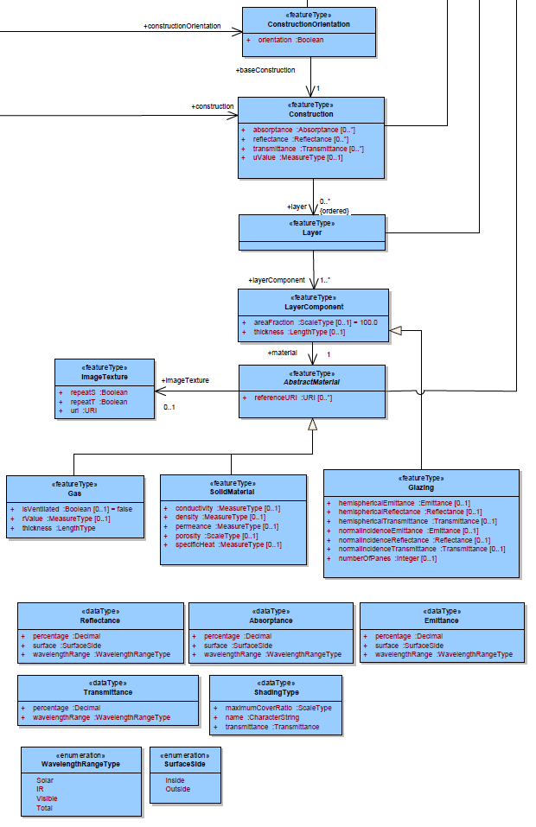

**Fig. 4:** Class diagram of Construction Module

The Construction and Material is a module of the ADE Energy, which may be extended for multi-field analysis (statics, acoustics etc.). It contains the physical characterization of the boundary surfaces, surface components and even whole building (and potentially all the objects which inherits of _CityObject).

## Construction and layers

**Construction**

Physical characterisation of building envelop or intern room partition (e.g. wall, roof, openings), it may be specified as an ordered combination of layers.

The object Construction may be associated to the (thermal) boundary surfaces, surface components, buildings (and potentially all the objects which inherits of _CityObject).

It inherits itself from _CityObject.

**ConstructionOrientation**

Class defining the orientation convention of the Construction, it means the order of the layers. A same Construction, common to different zones or buildings, will be orientated in two different directions for instance.

**Layer**

Combination of one of more materials, referenced via a layer component.

It inherits from _CityObject.

**LayerComponent**

Homogeneous part of a layer, covering a given fraction (*areaFraction*) of the layer.

## Materials

**AbstractMaterial**

Abstract superclass for all Material classes. A Material is a homogeneous substance. We distinguish opaque materials, glazings and gas.

**OpaqueMaterial**

Class of the materials which are opaque.

**Glazing**

Transparent component, which may count one or more panes. It is specified by its hemispherical/normal transmittances, emittances and reflectances.

## Optical properties

**Emittance**

Ratio of the radiation emitted by a specific surface /object to that of a black body.

It is specified for a given surface (SurfaceSide), for a given wavelength range type (solar, infrared, visible or total).

**Absorptance**

Fraction of incident radiation which is absorbed by an object.

It is specified for a given surface (SurfaceSide), for a given wavelength range type (solar, infrared, visible or total).

According with the Kirchoff and Lambert law, for a diffuse grey body (then non-metallic, non-transparent), the aborptance and the emittance are equals for a given wavelength range.

**Reflectance**

Fraction of incident radiation which is reflected by an object.

It is specified for a given surface (SurfaceSide), for a given wavelength range type (solar, infrared, visible or total).

**Transmittance**

Fraction of incident radiation passes through a specific object.

It is specified for a given wavelength range type (solar, infrared, visible or total).

The sum of the absorptance, reflectance and transmittance of a surface/object is always 1.

# Occupancy Module

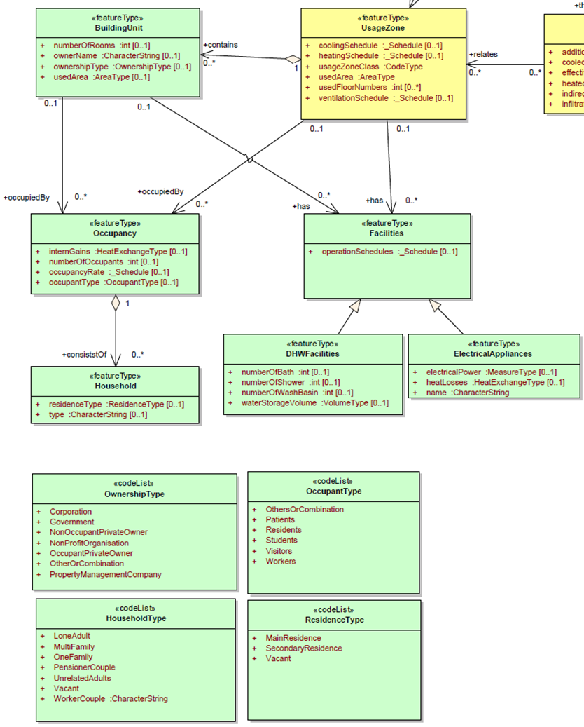

**Fig. 5:** Class diagram of Occupancy Module

The Occupancy Module is a module of the ADE Energy, which may be extended for multi-field analysis (socio-economics, demographics etc.). It contains the characterization of the building usage, it is related to the rest of the ADE Energy and CityGML model through the unique class UsageZone.

## Usage zone and Building Unit

**Usage Zone**

Zone of a building with homogeneous usage type. This usage type is defined by a *usageZoneClass* (corresponding to the CityGML Code list of the _AbstractBuilding attribute class).

This zone is operated with a single heating and cooling set-point temperature schedule (*heatingSchedule* respectively *coolingSchedule*) and single air ventilation schedule.

It inherits from _CityObject.

**BuildingUnit**

Part of usage zone which is related to a single occupant entity, such as dwelling or workplace. Owner information data (as owner name and ownership type) are specified in this class.

It inherits from _CityObject.

## Occupants

**Occupancy**

Homogeneous group of occupants of a usage zone or building unit, defined with an occupant type (e.g. residents, workers, visitors etc…).

**Household**

Group of persons living in the same dwelling, in the case where occupants are residents.

There are defined by a type (e.g. one family, worker couple etc…) and a residence type (main/secondary residence or vacant).

## Facilities

**Facilities**

Facilities and Appliances inside the usage zone or building unit, which consume and dissipate energy. They are distinguished between domestic hot water facilities (*DHWFacilities*) and electrical facilities

# Energy System Module

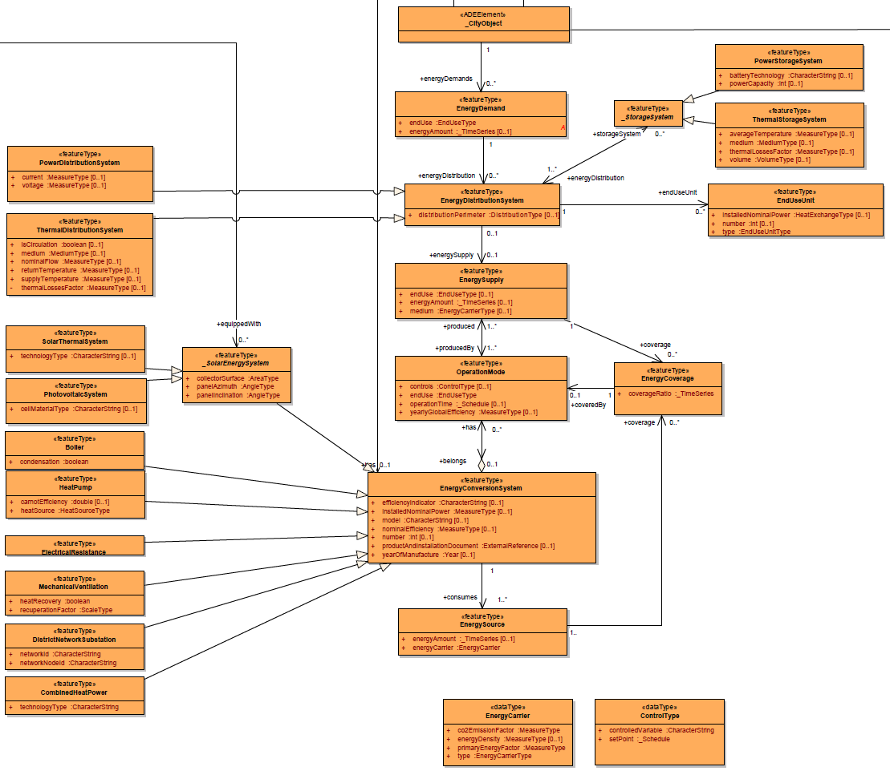

**Fig. 6:** Class diagram of Energy System Module

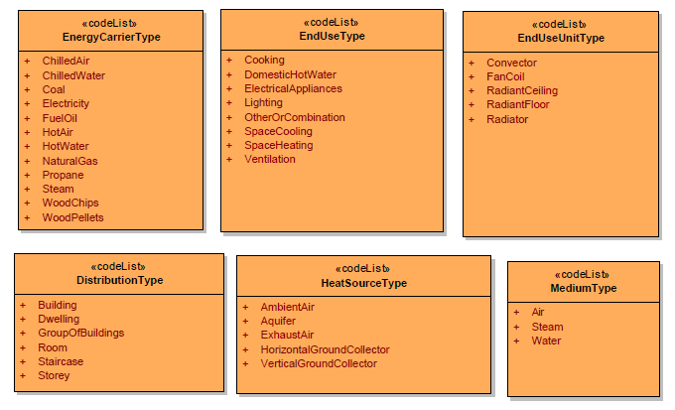

**Fig. 7:** Type classes of Energy System Module

The Energy System Module is a module of the ADE Energy, which contains the information concerning the energy forms (energy demand, supply, sources) and the energy systems (conversion, distribution and storage systems).

## Energy Amounts and Forms

**EnergyDemand**

Useful energy required to satisfy a specific end use, such as heating, cooling, domestic hot water etc… These end uses are listed in **EndUseType**.

Every _CityObject may have one or more EnergyDemand.

**EnergySupply**

Part of the energy produced by the energy conversion systems which is supplied to satisfy the end use demand of a city object.

**EnergySource**

Final energy consumed by the energy conversion system.

Its energy characteristics (primary energy and CO2 emission factors, energy density, energy carrier type) are specified in the Energy Carrier object.

## Energy Distribution

**EnergyDistributionSystem**

System in charge of delivering the energy inside the building, from the place of energy production to the place of end-use. Power and Thermal distribution systems are differentiated.

**StorageSystem**

System storing energy. A same storage may store the energy of different end-users and different end uses. Power and Thermal storage systems are differentiated.

**EndUseUnit**

Final device(s) which deliver the required energy to the end-user in his end-use place (e.g. radiators or convectors for heating etc.)

## Energy Conversion

**EnergyConversionSystem**

System converting an energy source into the energy necessary to satisfy the end-use (or to feed the networks).

Energy conversion systems have common parameters: nominal installed power, nominal efficiency (in reference to an efficiency indicator), year of manufacture, name of the model. They may be one or more (in this case, the nominal installed power corresponds to the totality). Some product and installation documents may be referenced.

Specific energy conversion systems may have in addition specific parameters:

A same system may have several operation modes (e.g. heat pump covering heating and domestic hot water demands).

**OperationMode**

It details the operation of the energy conversion system for a specific end-use and operation time. For instance, a reversible heat pump may have 3 operations modes: heating production in winter, cooling production in summer, and hot water production during the whole year.

**EnergyCoverage**

It determines the coverage rate (may be time depending) of a given energy supply by a given operation mode of an energy conversion system.

1. [IBM knowledge Center](http://www-01.ibm.com/support/knowledgecenter/SSCRJU_3.0.0/com.ibm.swg.im.infosphere.streams.timeseries-toolkit.doc/doc/timeseries-regular.html)

  