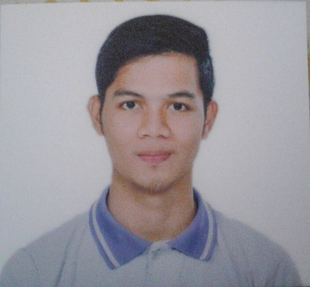

objectives



QUALIFICATIONS

SKILLS

EDUCATION

* Dedication and hardworking individual
* Willing to render overtime
* Willing to learn
* Time management
* Adaptability
* Self-motivation

FAMY ELEMENTARY SCHOOL 2011

FAMY NATIONAL HIGHSCHOOL 2015

**B.S. COMPUTER SCIENCE** COLEGION DE SAN LORENZO 2017

**B.S.** **INFORMATION TECHNOLOGY**

LAGUNA STATE POLYTECHNIC UNIVERSITY

I am looking for a suitable On-the-Job Training where I could put to use, practice and improve the knowledge I have gained, enhance and utilize my skills, and develop my personality and social skills as a career person.

**Web Development**

* Php
* Javascript/jQuery
* Html
* Css
* Bootstrap
* MYSQL / Database

**C# Development**

* MYSQL / Database
* Some frameworks that can be used to design a system.

**Basic Knowledge**

* MS Word
* MS office
* Photoshop
* Premiere

September 4, 1998

Celisinan@gmail.com

Brgy. Maulawin Pagsanjan Laguna

0926 8421 554

**FERDINAND T. CELIS**

personal information

seminar and certifications

**Certificate of Membership** - Junior Philippine Computer Society (JPCS) **2016**

**Certificate of Attendance** - “Internet of Things January” **July 2016**

**Certificate of Attendance** - ”iOS Development” **September 2016**

**Certificate of Attendance** - “Internet Protocol Version 6 **(IPV6)**” **December 2016**

**Certificate of Attendance** - “WINDOWS 10 and OFFICE 2016” **January 2017**

**Certificate of Participation** - “Bridging Creativity and Technology: Inspiring the Next Generation of Learners” **February 2017**

**Certificate of Participation** - “CLOUD 101: Introduction to Cloud Technology” **February 2017**

**NATIONAL CERTIFICATE II (NCII)** - “COMPUTER SYSTEMS SERVICING” **March 2017**

**Certificate of Participation** - “Diving into Game Development: The Fundamentals of Autodesk Maya and Unity Game Engine” **February 2018**

**Certificate of Participation** - “Expressing your Creativity and Idea Through Multimedia” **February 2018**

**Certificate of Participation** - “Y4IT Research Summit 2019” **March 2019**

references

**Jeremy Reyes** - 09494398808 jeremy_reyes33@yahoo.com LSPU-SCC (Part time Instructor)

**Armando Linga** – 09071072767 Famy, Laguna (Old Municipal Counselor)

***I hereby certify that the above information is true and correct to the best of my knowledge.***