**ENSF-381**: **Full Stack Web Development Laboratory**

**Lab01**

**Section: L02**

**Group information:**

Syed Waliullah (30153716)

Austin Bach (30171071)

**Exercise 1 Output:**

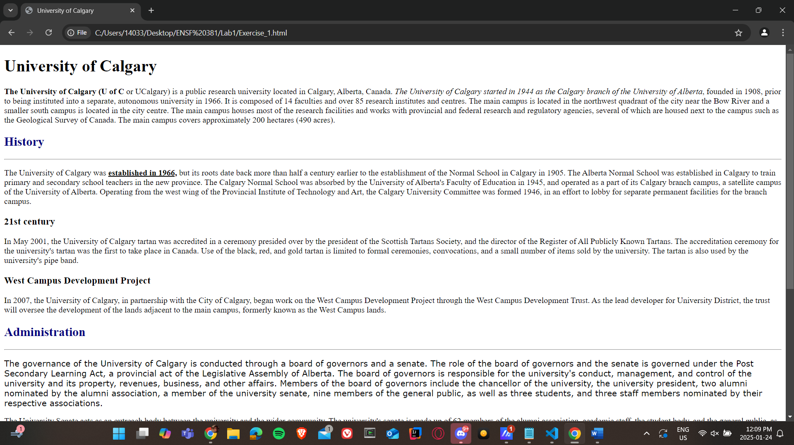

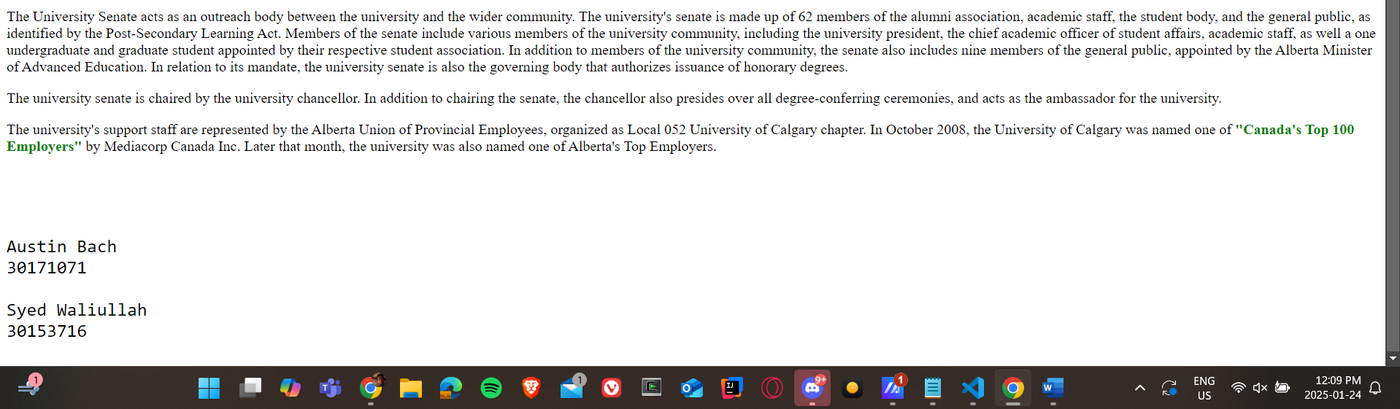

**Exercise 2 Answer:**

1. **The HTML element used for “Faculties” is: <h3> </h3>**
2. **Screenshot:**

