StudyFlow Project Report
Internet Programming / Web Programming Fundamentals
Project name | StudyFlow
Student name | [Add name]
Student number | [Add student number]
GitHub username | [Add GitHub username]
Public repository link | [Add public GitHub repository link]
Submission date | [Add submission date]
Final runtime files | index.html, styles.css, script.js
Report prepared with placeholders for personal and public repository details.

Table of Contents
- 1. Project Aim and Target Users
- 2. Planning Before Coding
- 3. Project File Structure
- 4. HTML Structure
- 5. CSS Styling and Design System
- 6. JavaScript Dynamic Features
- 7. Data Handling with localStorage
- 8. Home Page
- 9. Today Dashboard
- 10. Add Task Modal
- 11. Subjects Page
- 12. Calendar Page
- 13. Navigation and User Experience
- 14. Animation and Visual Polish
- 15. Visual Review and Improvements
- 16. Challenges and Solutions
- 17. GitHub Repository Information
- 18. Final Result
- 19. Signature
- 20. Code Snippets and File Connections

1. Project Aim and Target Users

What Is StudyFlow?
StudyFlow is a static study-planning website for students who need one place to organize subjects, tasks, deadlines, and weekly workload.

Why This Website Matters
Students often track assignments across notebooks, messages, calendars, and memory. That makes it easy to miss small tasks or underestimate how much work is due in the same week. StudyFlow gives the user one clear planner that shows what needs attention now and what is coming next.

What Was Implemented
- a home landing page that introduces the project,
- a Today Dashboard for current tasks,
- a Subjects page for course-based planning,
- a Weekly Calendar for deadline visibility,
- task and subject forms,
- browser-based saving with localStorage.

Result
The final project gives a student a simple tool for checking priorities, adding study work, and reviewing progress without using a backend server.

2. Planning Before Coding

What Was Planned?
Before coding the final version, the project requirements were mapped to the main website screens and the report structure. The final runtime was kept intentionally small: one HTML file, one CSS file, and one JavaScript file.

Why Planning Was Needed
The assignment needed a clear report with screenshots, explanations, and a public repository placeholder. Planning helped connect each rubric point to a visible part of the project.

What Was Implemented
- the final runtime files are index.html, styles.css, and script.js,
- the report guide records the required talking points,
- the screenshot files are stored in docs,
- the text-heavy prototype file pages/index-v1-textheavy.html was excluded from the final implementation.

Result
The project is easier to test, explain, and submit because the final implementation is focused and all report assets are organized in the repository.

3. Project File Structure

What Is the File Structure?
The file structure separates the website runtime files from the report support files.

Why This Structure Matters
A simple structure helps the teacher see which files run the website and which files support the written report.

What Was Implemented
- index.html stores the base document, shared header, main app container, and modal root,
- styles.css stores colors, typography, layout rules, components, responsive rules, and animation,
- script.js stores rendering, routing, state updates, forms, and localStorage behavior,
- docs stores screenshots, notes, and the Word report prompt.

Result
The submitted project can be opened directly from index.html without installation or a server.

4. HTML Structure

What Is the HTML Structure?
The HTML structure is the semantic skeleton of the single-page website.

Why HTML Structure Matters
Clear HTML helps the browser and the reader understand the main parts of the page before JavaScript renders the current view.

What Was Implemented
- a head section with metadata, title, and stylesheet link,
- a header with the StudyFlow logo and navigation links,
- a nav element for Home, Today, Subjects, and Calendar,
- a main element with id app for JavaScript-rendered content,
- a modal-root div for generated task and subject forms,
- a script link to script.js.

Result
The base HTML stays short while JavaScript changes the active screen based on the URL hash.

5. CSS Styling and Design System

What Is the Design System?
The design system is the reusable visual language used across the website.

Why CSS Styling Matters
The planner needs to be calm, readable, and easy to scan. The visual style supports that by using consistent spacing, strong headings, subject colors, and clear cards.

What Was Implemented
- CSS variables for colors, font families, shadows, and radii,
- Fraunces for display headings and Inter for body text,
- a charcoal, cream, coral, blue, teal, green, gold, mauve, and amber palette,
- reusable buttons, cards, tags, progress bars, modals, and calendar blocks,
- responsive media queries for tablet and small screens,
- reduced-motion support for users who prefer less animation.

Result
The pages feel connected because they share the same type, color, spacing, and component rules.

6. JavaScript Dynamic Features

What Is JavaScript Used For?
JavaScript controls the behavior that changes while the user uses the website.

Why JavaScript Matters
The project is a static site, but it still needs to act like a planner. Users must be able to switch views, add tasks, complete work, delete work, add subjects, and move through calendar weeks.

What Was Implemented
- hash navigation for Home, Today, Subjects, and Calendar,
- render functions for each screen,
- task creation through the Add Task modal,
- subject creation through the Add Subject modal,
- complete and incomplete task toggles,
- delete buttons for tasks,
- dashboard filters for today, upcoming, overdue, all tasks, and subject-specific tasks,
- weekly calendar navigation.

Result
The static page behaves like a small application while still using plain JavaScript.

7. Data Handling with localStorage

What Is Data Handling?
Data handling is how the website loads, saves, and updates subjects and tasks.

Why This Feature Matters
A study planner is not useful if every refresh removes the student plan. Because the assignment does not require a backend database, browser storage is the correct level of storage for this project.

What Was Implemented
- seed subject data for sample courses,
- seed task data for demonstration tasks,
- loadState to read saved data,
- saveState to write updates,
- localStorage with the StudyFlow storage key,
- state updates after creating, completing, or deleting tasks.

Result
The user can refresh the browser and still keep the current tasks and subjects on the same device.

8. Home Page

What Is the Feature?
The Home page introduces StudyFlow and explains the basic study-planning workflow.

Why This Feature Matters
The first screen tells the user what the project does before they enter the planner.

What Was Implemented
- hero section with project title and short explanation,
- Start planning button,
- animated badge and headline,
- task preview card,
- three-step explanation for adding subjects, adding tasks, and checking progress.

Figure 1
Home page of StudyFlow.
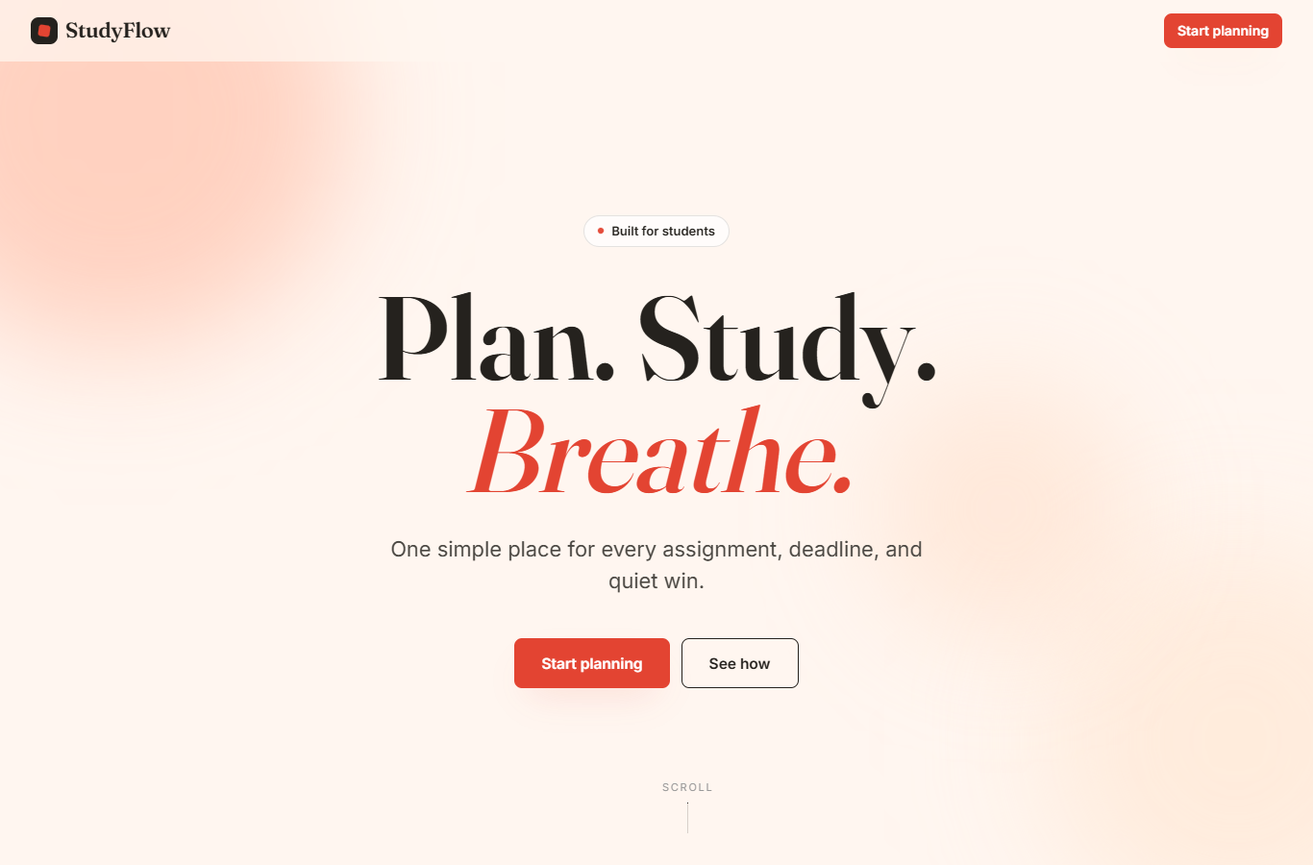
Figure 1: Home page of StudyFlow.

Result
The user understands that StudyFlow is for planning study work and reducing missed deadlines.

9. Today Dashboard

What Is the Feature?
The Today Dashboard is the main working screen for the student.

Why This Feature Matters
Students need to see current work quickly. The dashboard shows progress, remaining time, weekly completion, and saved data status in one place.

What Was Implemented
- summary cards for today, time remaining, weekly completion, and data saving,
- sidebar filters,
- subject filters,
- task list rows,
- task completion controls,
- delete controls,
- quick add button.

Figure 2
Today Dashboard screen.
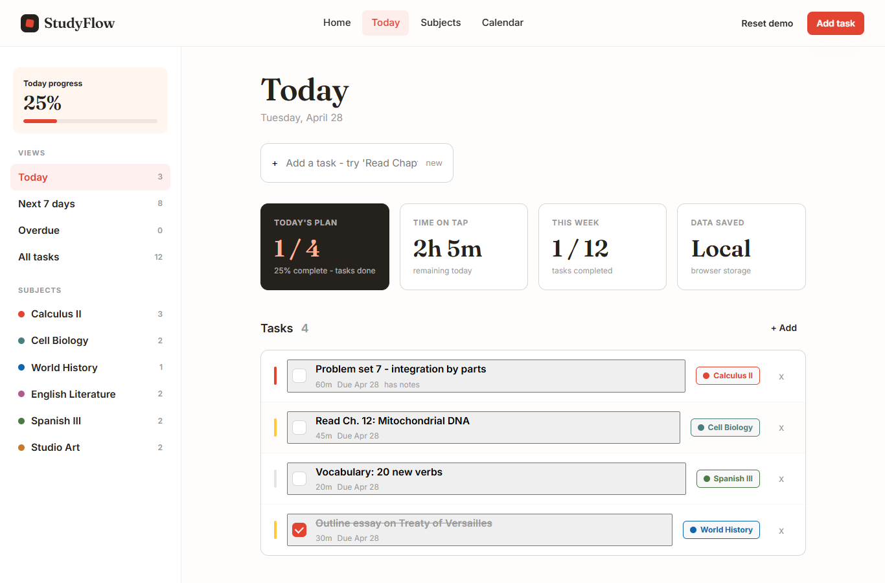
Figure 2: Today Dashboard screen.

Result
The user can decide what to study next without opening every subject one by one.

10. Add Task Modal

What Is the Feature?
The Add Task modal is the form used to create a new study task.

Why This Feature Matters
Students need a fast way to enter assignments, deadlines, priority, estimated time, and notes.

What Was Implemented
- task title input,
- subject selector,
- due date input,
- priority buttons,
- time estimate input,
- notes field,
- cancel and submit buttons,
- Escape key and overlay close behavior.

Figure 3
Add Task modal form.
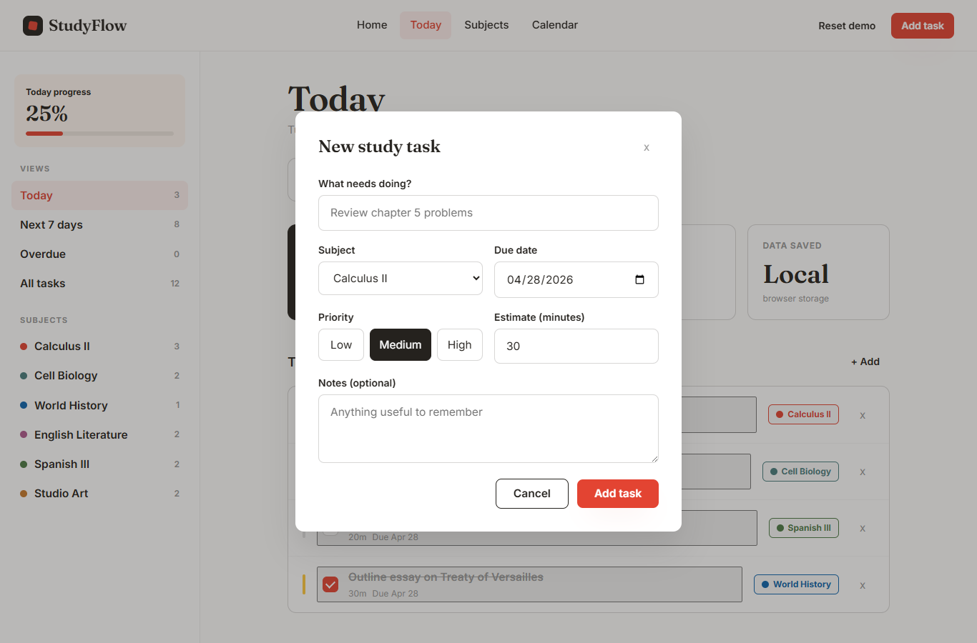
Figure 3: Add Task modal form.

Result
The user can add a complete task without leaving the current planner screen.

11. Subjects Page

What Is the Feature?
The Subjects page groups study work by course.

Why This Feature Matters
A student may have several courses with different workloads. Grouping tasks by subject makes it easier to compare which course needs attention.

What Was Implemented
- subject cards with colored top bars,
- course code labels,
- open and completed task counts,
- estimated work left,
- progress bars,
- next task details,
- add subject card and form.

Figure 4
Subjects page.
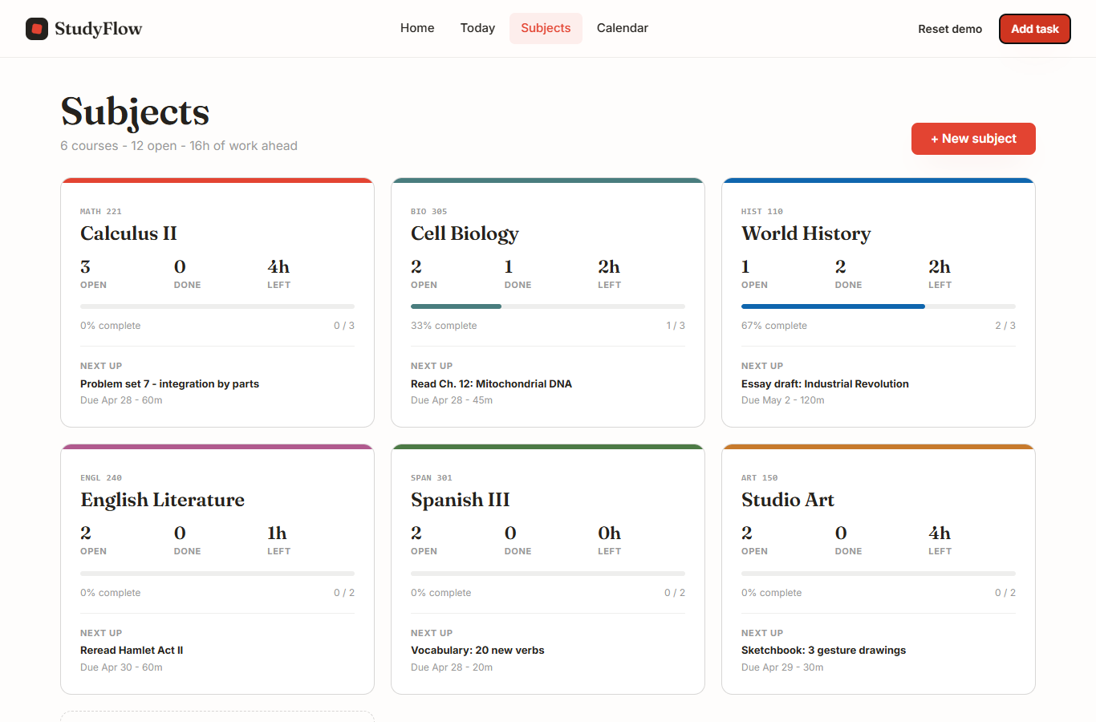
Figure 4: Subjects page.

Result
The user can compare courses and balance study time across the week.

12. Calendar Page

What Is the Feature?
The Calendar page shows tasks across one week.

Why This Feature Matters
A weekly view helps the user notice busy days before they arrive.

What Was Implemented
- previous week, Today, and next week controls,
- weekly workload bars,
- subject legend,
- seven-day task grid,
- task cards inside each day,
- add task button for a selected date.

Figure 5
Weekly Calendar page.
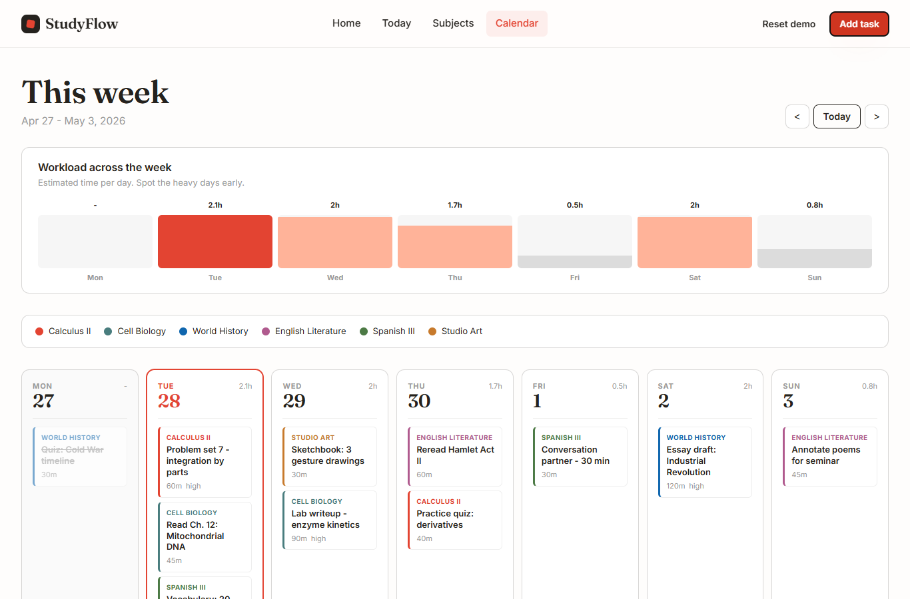
Figure 5: Weekly Calendar page.

Result
The user can plan ahead and adjust study work before deadlines build up.

13. Navigation and User Experience

What Is the Navigation System?
The navigation system uses header links and URL hash routes.

Why Navigation Matters
The user needs to move between major sections without losing context or needing a page reload.

What Was Implemented
- Home, Today, Subjects, and Calendar links,
- active navigation styling,
- header actions for common tasks,
- buttons placed near the work they affect,
- modal forms that return the user to the current screen after saving.

Result
The user always has a clear route to the main areas of the planner.

14. Animation and Visual Polish

What Is the Landing Animation?
The landing animation is a group of CSS keyframe animations used on the Home page.

Why This Feature Matters
The animation gives the first screen a more finished feel while still staying simple enough to explain in a beginner web programming report.

What Was Implemented
- floating background color blobs,
- pulsing red dot in the Built for students badge,
- headline text that rises into place,
- supporting paragraph and buttons that appear after the headline,
- animated scroll indicator,
- task preview card with a soft entrance animation,
- prefers-reduced-motion support.

Figure 6
Landing page animation after visual polish.
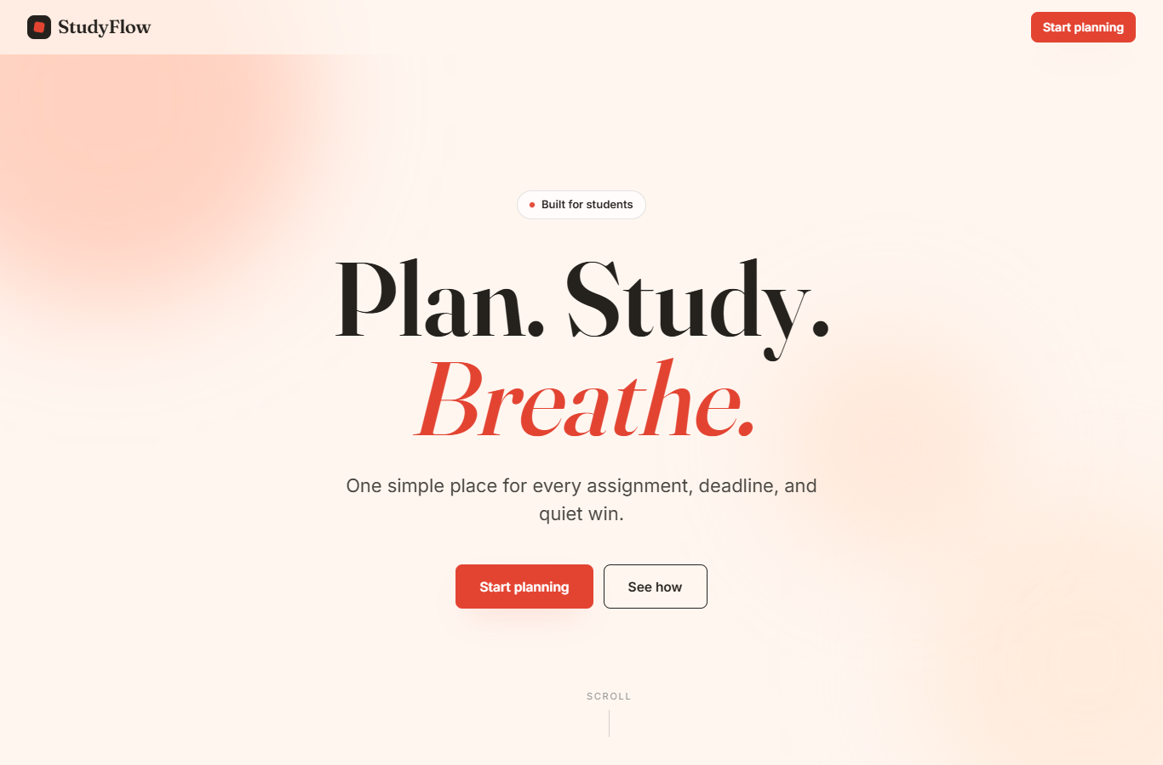
Figure 6: Landing page animation after visual polish.

Result
The Home page feels active without requiring any animation library.

15. Visual Review and Improvements

What Was Reviewed?
The final static website was visually reviewed page by page against the original prototype files.

Why Review Was Needed
The project was converted from a prototype into plain HTML, CSS, and JavaScript. A visual pass was needed to keep the final version close to the intended layout.

What Was Implemented
- the Today quick-add row was made full width like the original dashboard,
- default browser button styling was removed from task rows,
- header action alignment was adjusted,
- the Subjects page kept three columns until the desktop breakpoint,
- the Calendar and Add Task modal were checked and needed no major layout correction,
- the landing header and footer were cleaned for clearer screenshots.

Figure 7
Page visual review evidence for the Today Dashboard.
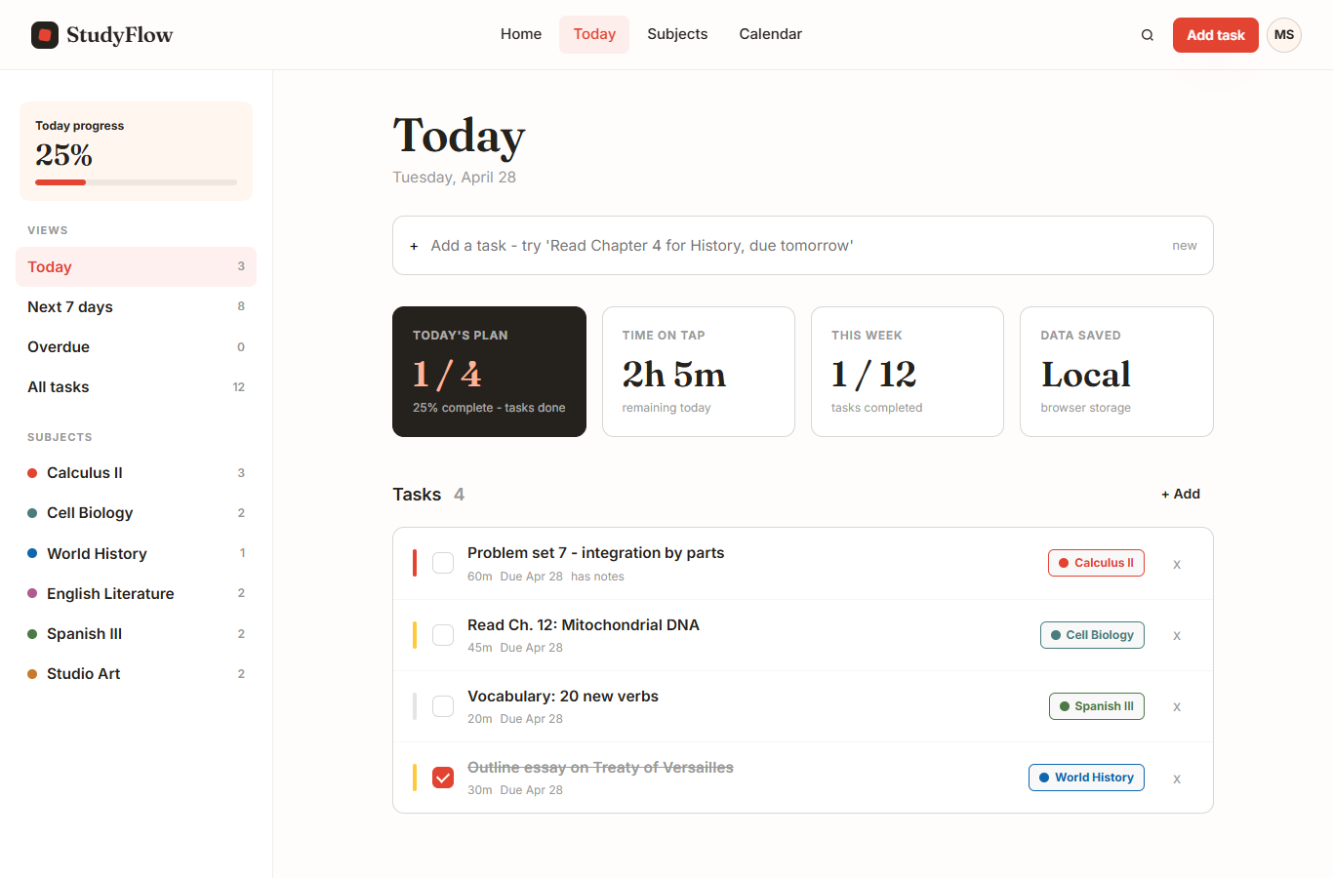
Figure 7: Page visual review evidence for the Today Dashboard.

Result
The final website matches the prototype closely enough for report screenshots and course submission.

16. Challenges and Solutions

Challenge 1: Converting Prototype Ideas
The earlier design used prototype-style files and component ideas. The final course project needed a plain static website.

Solution
The screens were converted into JavaScript render functions inside script.js, with index.html kept as the base document.

Challenge 2: Keeping the Visual Design
The project needed to keep the StudyFlow identity while reducing the final runtime to three main files.

Solution
The colors, typography, shadows, cards, progress bars, and modal styles were moved into one organized stylesheet.

Challenge 3: Saving Data Without a Backend
A server database would be too large for this assignment.

Solution
The website uses localStorage for tasks and subjects. This is enough for a single-browser student planner.

Challenge 4: Adding Motion Carefully
The Home page needed polish, but the code still had to remain explainable.

Solution
The animation was implemented with CSS keyframes and a reduced-motion media query instead of an external library.

Result
The final project meets the course requirements while staying simple enough to present and defend.

17. GitHub Repository Information

GitHub Username
[Add GitHub username]

Public Repository Link
[Add public GitHub repository link]

Repository Notes
The repository should include the final runtime files, documentation files, screenshots, and this Word report. The public link should be added before submission.

18. Final Result

Final Result
StudyFlow is a complete static study-planning website built with HTML, CSS, and JavaScript. It includes clear navigation, reusable design components, interactive task features, subject grouping, weekly calendar planning, CSS animation, responsive layout, and browser-based data handling.

Submission Reminder
Before submitting, replace the placeholders for student name, student number, submission date, GitHub username, and public repository link. Print the report and sign it if the teacher requires a printed signed submission.

19. Signature

Student Name
[Add name]

Student Number
[Add student number]

Submission Date
[Add submission date]

Signature
________________________

Submission Checklist
- Report is at least 1000 words.
- Screenshots are added and labeled as figures.
- Student name and student number are added.
- GitHub username is added.
- Public GitHub repository link is added.
- Report is printed and signed if required.
Signature: ________________________

20. Code Snippets and File Connections
This section explains the important code connections in the final StudyFlow project. The website does not use fetch() or an external API because the assignment is a static HTML, CSS, and JavaScript project. Instead, the code reads from localStorage, updates an in-memory state object, and re-renders the correct screen into the page.

Code Connection Map
File | Important code | What it does | Connected to
index.html | #app | Empty main container where views are rendered. | render() in script.js
index.html | #modal-root | Empty container for task and subject forms. | renderModal() in script.js
styles.css | :root variables | Stores the design system colors, fonts, shadows, and spacing values. | all page classes
script.js | loadState() | Reads saved tasks and subjects from localStorage or creates seed data. | state
script.js | saveState() | Writes the current state back to localStorage. | setState()
script.js | render() | Chooses which screen to display based on the URL hash. | renderHome(), renderDashboard(), renderSubjects(), renderCalendar()
script.js | getDashboardTasks() | Filters task data for today, upcoming, overdue, all, or subject view. | renderDashboard()
script.js | renderTaskModal() | Builds the Add Task form markup. | bindModalEvents()
script.js | renderCalendar() | Groups tasks by date and displays the weekly planner. | state.tasks and state.subjects

HTML Container Connection
The main HTML file does not contain all dashboard, subject, or calendar markup. It provides shared navigation and two empty containers. JavaScript fills these containers when the user changes screens or opens a form.
<nav class="nav-links" aria-label="Main navigation">
<a href="#home" data-route="home">Home</a>
<a href="#today" data-route="today">Today</a>
<a href="#subjects" data-route="subjects">Subjects</a>
<a href="#calendar" data-route="calendar">Calendar</a>
</nav>
<main id="app" tabindex="-1"></main>
<div id="modal-root"></div>
<script src="script.js"></script>
The #app element is connected to the render() function in script.js. When the route is today, the dashboard HTML is inserted into #app. When the route is subjects, the subject page HTML is inserted instead. The #modal-root element is separate because modals must appear above the current page without replacing it.

Route and Render Flow
StudyFlow uses hash navigation. That means the part of the URL after # controls the active screen. The browser does not load a new file. The hashchange listener updates the route variable, then calls render().
window.addEventListener("hashchange", () => {
route = normalizeRoute(location.hash);
render();
});
function render() {
document.body.classList.toggle("home-active", route === "home");
updateNav();
if (route === "home") app.innerHTML = renderHome();
if (route === "today") app.innerHTML = renderDashboard();
if (route === "subjects") app.innerHTML = renderSubjects();
if (route === "calendar") app.innerHTML = renderCalendar();
bindViewEvents();
renderModal();
}
This is the central connection in the project. The navigation links in index.html change the hash. The hash chooses a route. The route chooses a render function. The render function returns HTML text, and app.innerHTML places it on the page. After that, bindViewEvents() attaches click events to the new buttons because the old buttons were replaced when the view changed.

Data Loading Instead of fetch()
A normal web application might use fetch() to request tasks from a server. StudyFlow does not need that because it is a static course project with no backend. The closest data-loading function is loadState(). It fetches saved data from the browser's localStorage.
function loadState() {
try {
const raw = localStorage.getItem(STORAGE_KEY);
if (raw) return JSON.parse(raw);
} catch (error) {
console.warn("Could not read saved StudyFlow data.", error);
}
const initial = {
subjects: structuredClone(seedSubjects),
tasks: structuredClone(seedTasks)
};
saveState(initial);
return initial;
}
function saveState(nextState = state) {
localStorage.setItem(STORAGE_KEY, JSON.stringify(nextState));
}
The important connection is localStorage -> state -> render functions. loadState() first checks whether saved data exists. If it exists, JSON.parse() converts it back into JavaScript objects. If no saved data exists, the website uses seedSubjects and seedTasks so the planner has example data. saveState() converts the current state back into JSON and stores it in the browser.

State Update Connection
Every important data change goes through setState(). This function updates the state, saves it, then re-renders the screen. That keeps the interface and saved data in sync.
function setState(updater) {
state = typeof updater === "function" ? updater(state) : updater;
saveState();
render();
}
For example, when a user adds a task, the submit handler creates a new task object and passes an updater function into setState(). The new task is added to the front of the tasks array, then saveState() stores it and render() redraws the current page.

Add Task Form Connection
The Add Task modal is made in two parts. renderTaskModal() returns the HTML for the form. bindModalEvents() attaches the submit event after the modal has been placed inside #modal-root.
taskForm.addEventListener("submit", (event) => {
event.preventDefault();
const form = new FormData(taskForm);
const title = String(form.get("title") || "").trim();
if (!title) return;
setState((prev) => ({
...prev,
tasks: [{
id: `t${Date.now()}`,
title,
subjectId: String(form.get("subjectId")),
due: String(form.get("due") || todayISO(0)),
priority: String(form.get("priority") || "medium"),
est: Number(form.get("est") || 30),
done: false,
notes: String(form.get("notes") || "").trim()
}, ...prev.tasks]
}));
closeModal();
});
This code connects the form fields to the data model. FormData reads the values from the modal. The task gets an id, title, subjectId, due date, priority, estimate, done value, and notes. subjectId links the task to one subject from the subjects array. This is how the dashboard, subject page, and calendar can all display the same task in different ways.

Dashboard Filtering Connection
The dashboard does not show a separate copy of task data. It filters the main state.tasks array depending on the selected sidebar filter.
function getDashboardTasks() {
let list = [...state.tasks];
if (dashboardFilter.type === "today") {
list = list.filter((task) => task.due === todayISO(0));
}
if (dashboardFilter.type === "upcoming") {
list = list.filter((task) => {
const diff = daysFromToday(task.due);
return diff > 0 && diff <= 7;
});
}
if (dashboardFilter.type === "overdue") {
list = list.filter((task) => daysFromToday(task.due) < 0 && !task.done);
}
if (dashboardFilter.type === "subject") {
list = list.filter((task) => task.subjectId === dashboardFilter.subjectId);
}
return sortTasks(list);
}
This function is important because it explains how one data source supports several views. The same task array can become today's tasks, upcoming tasks, overdue tasks, all open tasks, or tasks for one subject. The dashboard then passes the filtered list into renderTaskList().

Calendar Grouping Connection
The Calendar page changes the same task data into a weekly structure. It creates seven dates, groups tasks by due date, then renders each day column.
function renderCalendar() {
const subjectsById = byId(state.subjects);
const days = Array.from({ length: 7 }, (_, index) => {
const date = addDays(weekStart, index);
return { date, iso: toISO(date) };
});
const tasksByDate = {};
state.tasks.forEach((task) => {
tasksByDate[task.due] = tasksByDate[task.due] || [];
tasksByDate[task.due].push(task);
});
}
The connection here is state.tasks -> tasksByDate -> day cards. The due value stored when a task is created becomes the key used to place that task on the calendar. subjectsById is also created so each calendar task can show the correct subject color.

CSS Design System Connection
styles.css connects the visual design to the HTML classes created by JavaScript. The root variables define the design system once, then the page components reuse those values.
:root {
--charcoal: #25221e;
--cream: #fff6f0;
--accent: #e34432;
--blue: #0f66ae;
--teal: #497d7e;
--font-display: "Fraunces", Georgia, serif;
--font-body: "Inter", system-ui, -apple-system, sans-serif;
}
For example, a subject card rendered by script.js can use a subject color, while styles.css controls the card shape, spacing, border, and progress bar styling. This keeps the JavaScript focused on data and the CSS focused on presentation.

Animation and Accessibility Connection
The landing animation is also handled in CSS. The JavaScript does not animate the hero manually. It only renders the right elements, and CSS applies the motion.
@keyframes rise {
from {
opacity: 0;
transform: translateY(32px);
}
to {
opacity: 1;
transform: translateY(0);
}
}
@media (prefers-reduced-motion: reduce) {
*,
*::before,
*::after {
animation-duration: 0.01ms !important;
animation-iteration-count: 1 !important;
scroll-behavior: auto !important;
transition-duration: 0.01ms !important;
}
}
This shows a clean separation of responsibility. The JavaScript decides what screen should be visible. The CSS decides how that screen looks and how the animation behaves. The reduced-motion media query is included so users who prefer less motion are not forced to see long animations.

Summary of Important Function Flow
- index.html creates #app and #modal-root.
- script.js loads saved task and subject data with loadState().
- render() chooses the active page from the URL hash.
- renderDashboard(), renderSubjects(), and renderCalendar() turn the same state data into different screens.
- bindViewEvents() connects buttons to actions after each render.
- setState() updates data, saves it to localStorage, and re-renders the interface.
- styles.css applies the shared visual system to the markup produced by JavaScript.

