StudyFlow
Project Report

Internet Programming / Web Programming Fundamentals

Student Name: [Add name]
Student Number: [Add student number]
GitHub Username: [Add GitHub username]
Submission Date: [Add submission date]

1. Project Aim and Target Users

What Is StudyFlow?
StudyFlow is a study-planning website that runs entirely in the browser. It lets students track their subjects, tasks, deadlines, and weekly workload from one screen.

Why This Website Was Built
Students often keep their assignments in different places: a notes app for one course, a calendar for another, memory for the rest. StudyFlow puts everything in one place. The dashboard shows what is due today and what is coming next, so the student does not need to switch between tools.

What Was Implemented
- A home landing page that explains the planner.
- A Today dashboard that shows current tasks, progress, and filters.
- A Subjects page that groups tasks by course.
- A Calendar page that shows the full week ahead.
- Modal forms for adding tasks and subjects.
- Browser-based data saving so the study plan survives a page refresh.

Target Users
The website is built for secondary and university students who manage several courses at once. It suits students who want a simple tool without creating an account or installing an app.

Result
The user can open StudyFlow in any browser, see the full study plan, and update it without setting anything up.

2. Planning Before Coding

Scrapping the Initial Designs
Before any code was written, rough page layouts were sketched out for each view. These early designs were reviewed and then scrapped. The initial drafts were too complicated: too many UI elements on each screen, unclear navigation flows, and a layout that would have been hard to build cleanly in plain HTML and CSS.

Starting over with simpler layouts made the project more manageable. Each page was reduced to its core purpose. The Today view shows tasks. The Subjects view shows courses. The Calendar view shows the week. Removing visual noise from the early sketches made the final website easier to use and easier to explain in this report.

What Was Decided
- One HTML file for the page structure.
- One CSS file for the complete design system.
- One JavaScript file for all dynamic behavior.
- One report guide to track what needed to be documented.

Result
The decision to scratch the early page designs led to a cleaner, simpler website. Every feature has a clear place in the code, and every section of this report maps directly to a part of the project.

3. Project File Structure

The project uses three runtime files and a documentation folder.

studyflow/
index.html ← page structure and navigation
styles.css ← design system, layout, and animation
script.js ← routing, rendering, data, and events
docs/ ← screenshots and report notes

index.html defines the header, the main content area, and the modal container. It does not contain any content. All screen content is generated by script.js at runtime.

styles.css defines CSS custom properties for every color, font, spacing value, and shadow. All components use these variables rather than hardcoded values. This makes the visual identity consistent across all four views.

script.js is wrapped in an immediately-invoked function expression (IIFE) so that all variables stay private and do not pollute the global scope. It handles routing, view rendering, form modals, task and subject data, and localStorage.

4. HTML Structure

The HTML file is the skeleton of the website. It defines the regions that JavaScript fills in at runtime. The file uses semantic elements throughout: the header holds the site logo, four navigation links, and an action bar; the main element with the id "app" is the target for all dynamic content; and a separate div with the id "modal-root" holds task and subject forms when they are open.

<header class="site-header" id="site-header">
<a href="#home" class="logo">StudyFlow</a>
<nav class="nav-links" aria-label="Main navigation">
<a href="#home" data-route="home">Home</a>
<a href="#today" data-route="today">Today</a>
<a href="#subjects" data-route="subjects">Subjects</a>
<a href="#calendar" data-route="calendar">Calendar</a>
</nav>
</header>
<main id="app" tabindex="-1"></main>
<div id="modal-root"></div>

The navigation links use data-route attributes so JavaScript can read the intended route without parsing the href. The main element uses tabindex="-1" so JavaScript can move focus to it after a route change, which improves keyboard accessibility.

The HTML file is only 49 lines long. All page content is created by script.js, so the HTML stays short and readable.

Result
The HTML gives the browser enough structure to display the header and handle navigation. JavaScript fills in the rest.

5. CSS Styling and Design System

The design system is a collection of CSS custom properties, component classes, and layout rules defined once and shared across all views. A color or spacing value only needs to be changed in one place to update the entire website.

Colors and Typography
The color palette uses three brand colors: charcoal (#25221E) for text and borders, cream (#FFF6F0) for the home page background, and coral/accent (#E34432) for buttons and active states. Six subject colors are also defined, one per default course.

:root {
--charcoal: #25221e;
--cream: #fff6f0;
--accent: #e34432;
--subj-1: #e34432; /* Calculus */
--subj-2: #497d7e; /* Biology */
--subj-3: #0f66ae; /* History */
--subj-4: #b05a8e; /* Literature */
--subj-5: #4c7a45; /* Spanish */
--subj-6: #c77a2c; /* Art */
--font-display: "Fraunces", Georgia, serif;
--font-body: "Inter", system-ui, sans-serif;
}

Fraunces is used for headings. It is a variable-font serif with optical sizes, which gives the landing page headlines a distinct look. Inter is used for body text, labels, and interface elements. Both fonts are loaded from Google Fonts.

Components
The stylesheet defines reusable component classes for buttons, cards, tags, progress bars, and modals. Buttons come in three styles: primary (coral background), secondary (outlined), and ghost (transparent). Cards use a white background, a small border-radius, and a subtle shadow. Tags display the subject color for each task.

Responsive Layout
Media queries adjust the layout for smaller screens. The dashboard sidebar switches from a side column to a row above the task list. The calendar grid collapses to a scrollable single-column view on narrow screens. The home page hero uses the clamp() function on font sizes so headings scale smoothly between screen widths.

Result
The website looks consistent on every page because all components share the same variables and class names.

6. JavaScript Dynamic Features

JavaScript controls everything the user sees after the page loads. It reads the URL hash to decide which view to show, generates the HTML for that view, binds all click and submit events, and updates the display whenever data changes.

Routing
The website uses hash-based routing. When the user clicks a navigation link, the browser adds a hash to the URL (for example, #today). JavaScript listens for the hashchange event and re-renders the correct view.

window.addEventListener("hashchange", () => {
route = normalizeRoute(location.hash);
render();
});
function render() {
document.body.classList.toggle("home-active", route === "home");
updateNav();
if (route === "home") app.innerHTML = renderHome();
if (route === "today") app.innerHTML = renderDashboard();
if (route === "subjects") app.innerHTML = renderSubjects();
if (route === "calendar") app.innerHTML = renderCalendar();
bindViewEvents();
renderModal();
}

State Management
All data is stored in a single state object that holds a subjects array and a tasks array. A setState function accepts either a new state object or an updater function. After updating the state, it saves to localStorage and calls render() to refresh the view.

function setState(updater) {
state = typeof updater === "function" ? updater(state) : updater;
saveState();
render();
}

What Was Implemented
- Hash navigation between the four views.
- Rendering Home, Today, Subjects, and Calendar screens from JavaScript template strings.
- Adding new tasks through a modal form.
- Marking tasks as done or not done.
- Deleting tasks.
- Adding new subjects with a custom color.
- Moving forward and backward through calendar weeks.
- Opening and closing modals, including keyboard support (Escape key closes a modal).

Result
The static HTML file behaves like a small interactive application. The user can create and manage a study plan without any page reloads.

7. Data Handling with localStorage

What Is localStorage?
localStorage is a browser API that lets a website save small amounts of text data on the user's computer. The data persists after the tab is closed. It is not sent to any server. StudyFlow uses it to keep the study plan available between sessions.

How It Works in StudyFlow
When the website loads, it checks localStorage for a saved state. If the data is there, it parses the JSON and loads it into the state variable. If there is nothing saved (first visit or after a reset), it falls back to seed data: six default subjects and fifteen sample tasks.

function loadState() {
try {
const raw = localStorage.getItem("studyflow_static_v1");
if (raw) return JSON.parse(raw);
} catch (error) {
console.warn("Could not read saved StudyFlow data.", error);
}
// Fall back to seed data
const initial = {
subjects: structuredClone(seedSubjects),
tasks: structuredClone(seedTasks)
};
saveState(initial);
return initial;
}
function saveState(nextState = state) {
localStorage.setItem("studyflow_static_v1", JSON.stringify(nextState));
}

Seed Data
The seed data includes six subjects (Calculus II, Cell Biology, World History, English Literature, Spanish III, and Studio Art) and fifteen tasks spread across the current week. Each task has a title, subject ID, due date, priority, time estimate, done status, and optional notes.

Reset
A reset button removes the localStorage entry and reloads the seed data. This lets a user start fresh or restore the original demo state.

Result
Tasks and subjects saved in one session are still there the next time the user opens the website, as long as they use the same browser.

8. Home Page

The Home page is the first thing a new user sees. It explains what StudyFlow does and guides the user toward the Today dashboard.

What Was Implemented
- A hero section with an animated badge, headline, paragraph, and two call-to-action buttons.
- Three animated background blobs for visual depth.
- A scroll cue that moves the user down the page.
- A task completion preview card that shows a sample study day.
- A three-step explainer section (Add subjects, Drop in a task, Check things off).
- A second call-to-action section at the bottom.
- A footer with the StudyFlow brand name.

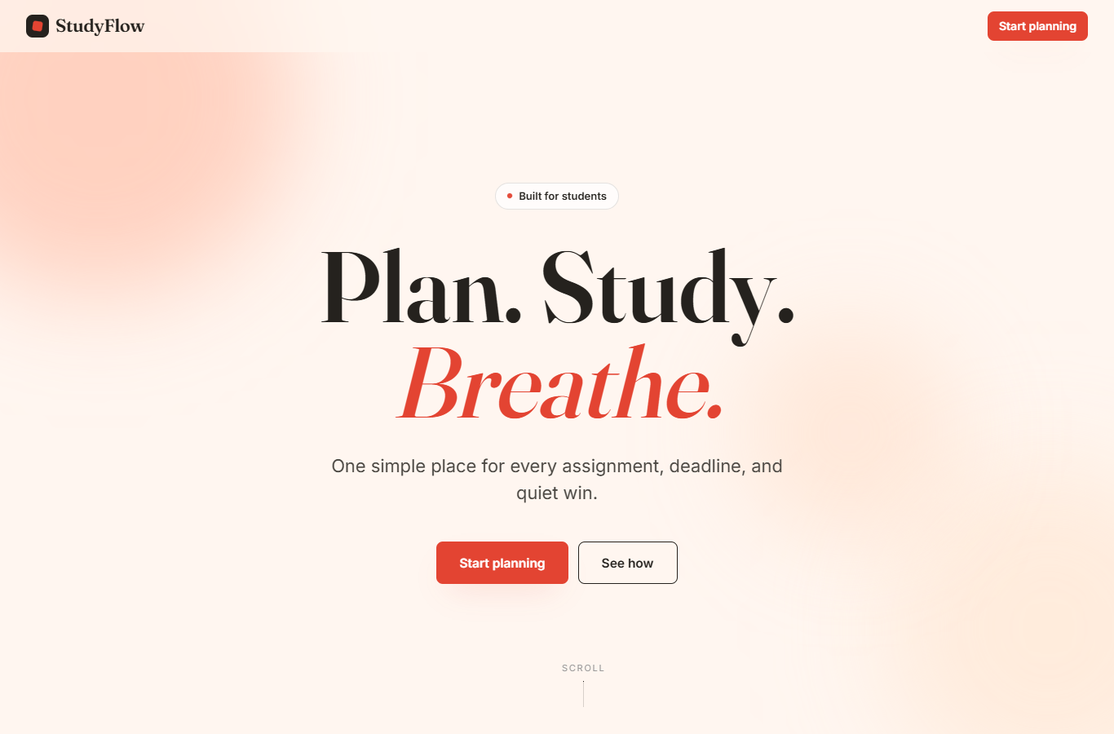
Figure 1. Home page of StudyFlow showing the hero section, headline, and call-to-action buttons.

Result
The user understands immediately that StudyFlow is a planner and can click Start planning to go to the Today dashboard.

9. Today Dashboard

The Today Dashboard is the main working screen of StudyFlow. It shows a progress summary at the top and the full task list below, with filters to narrow down what the user sees.

What Was Implemented
- Progress cards at the top that show total tasks, tasks done today, tasks overdue, and estimated hours remaining.
- A quick-add area where the user can open the Add Task modal.
- A task list with completion checkboxes, subject tags, priority badges, and due dates.
- A sidebar with filters for All, Today, Due This Week, and Overdue views.
- Subject filters so the user can see tasks from one course only.

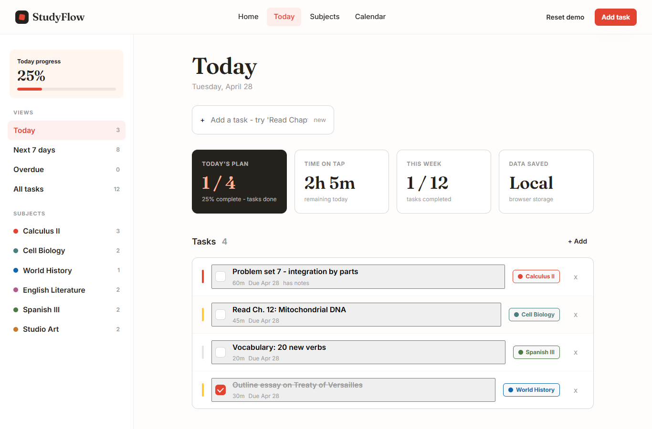
Figure 2. Today Dashboard showing progress cards, task list, and sidebar filters.

Result
The user can see the full study plan, filter it to what matters today, and mark tasks as done without leaving the screen.

10. Add Task Modal

The Add Task modal is a form that opens on top of the current view. The user fills it in to create a new study task without navigating away from the screen they are on.

What Was Implemented
- A task title text input.
- A subject dropdown that lists all saved subjects.
- A due date input.
- Three priority buttons: High, Medium, and Low.
- A time estimate input (minutes).
- A notes text area for optional details.
- A Save button and a Cancel button.
- Keyboard support: pressing Escape closes the modal.

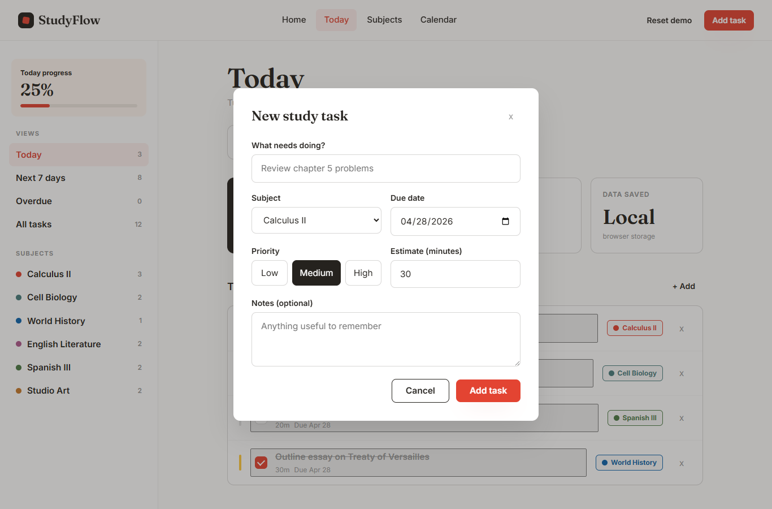
Figure 3. Add Task modal form with subject selector, priority buttons, and time estimate.

Result
The user can add a complete task in a few seconds without leaving the current page.

11. Subjects Page

The Subjects page groups all study work by course. Each course gets a card that shows its task summary and progress, so the user can see at a glance which subject has the most work left.

What Was Implemented
- One card per subject, colored with that subject's assigned color.
- Open task count and completed task count per subject.
- Estimated hours of work remaining per subject.
- A progress bar showing the percentage of tasks done.
- An Add Subject form that lets the user create a new course with a custom color.

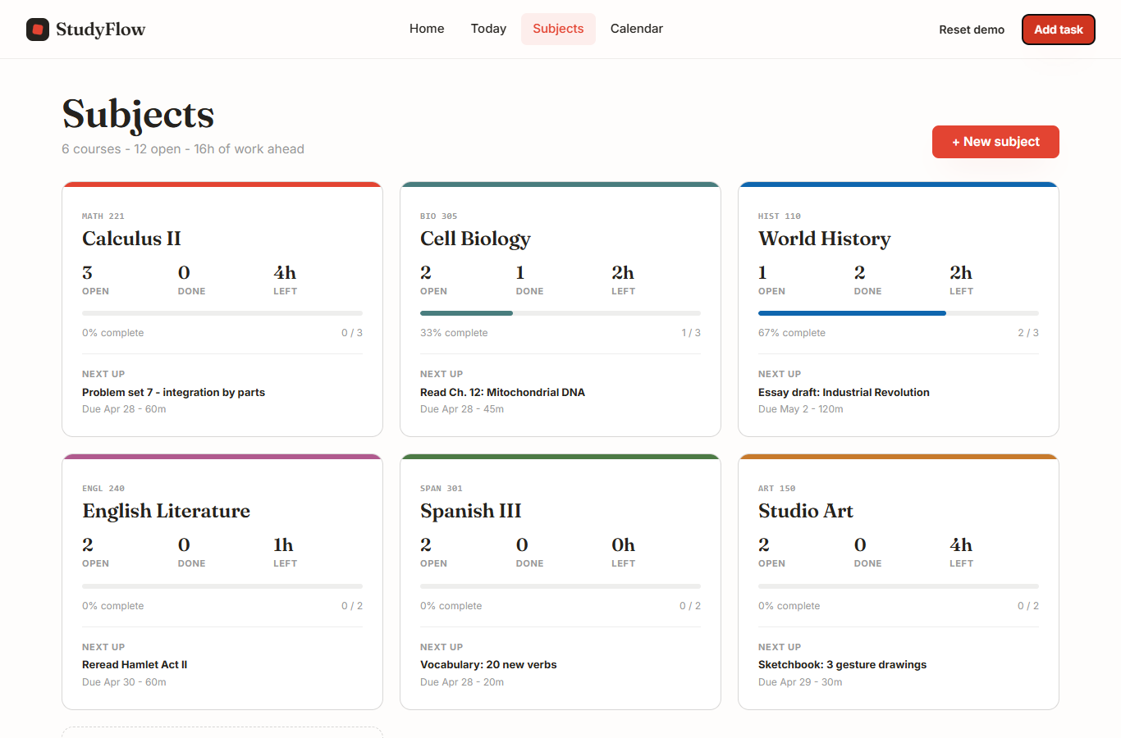
Figure 4. Subjects page showing course cards with progress bars and task counts.

Result
The user can compare courses at a glance and see which subject needs the most attention.

12. Calendar Page

The Calendar page shows all tasks across one week in a grid layout. Each day column lists the tasks due on that day, so the user can see the full week at once and spot busy days before they arrive.

What Was Implemented
- A seven-column weekly grid, one column per day.
- Previous and Next week navigation buttons.
- A Today button that jumps back to the current week.
- Task cards inside each day column, colored by subject.
- A workload chart that shows estimated hours per day.
- A subject legend at the top of the page.
- An Add Task shortcut on each day column.

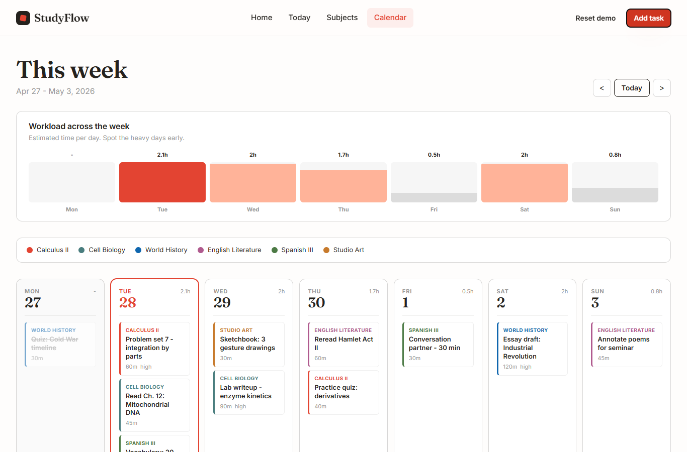
Figure 5. Calendar page showing a weekly grid with tasks organized by day and color-coded by subject.

Result
The user can spot heavy workload days before they arrive and move tasks or plan study time accordingly.

13. Navigation and User Experience

Navigation uses standard HTML anchor links with hash routes. Clicking a link updates the URL hash, which triggers a JavaScript event that re-renders the page with the correct view.

How Active State Works
Each navigation link has a data-route attribute. After every render, JavaScript compares the current route to each link's data-route value and adds or removes the active CSS class.

function updateNav() {
document.querySelectorAll("[data-route]").forEach((link) => {
link.classList.toggle("active", link.dataset.route === route);
});
}

UX Decisions
The header stays fixed at the top of every view so the user can always navigate without scrolling back up. The active nav link is underlined so the user knows which section is open. Modals dim the background so focus stays on the form. All primary actions (Start planning, Add task, Add subject) use the coral accent color so they are easy to find.

Result
The user always knows where they are and what to do next.

14. Animation and Visual Polish

The home page uses CSS keyframe animations for the entrance sequence. The badge, headline lines, paragraph, buttons, scroll cue, and task preview card each animate in with a separate delay, creating a staggered entrance effect.

@keyframes fadeUp {
from { opacity: 0; transform: translateY(24px); }
to { opacity: 1; transform: translateY(0); }
}
.hero-eyebrow { animation: fadeUp 0.5s ease forwards; animation-delay: 0.1s; }
.hero-line:nth-child(1) { animation: fadeUp 0.5s ease forwards; animation-delay: 0.2s; }
.hero-line:nth-child(2) { animation: fadeUp 0.5s ease forwards; animation-delay: 0.3s; }

Three background blobs use a slow, looping scale and translate animation to add movement behind the headline. The scroll cue arrow bounces gently using a separate keyframe loop.

Reduced Motion Support
A prefers-reduced-motion media query disables all animations for users who have that system setting turned on. This is an accessibility requirement and was added to make the website usable for people who experience motion sickness or vestibular disorders.

@media (prefers-reduced-motion: reduce) {
*, *::before, *::after {
animation-duration: 0.01ms !important;
transition-duration: 0.01ms !important;
}
}

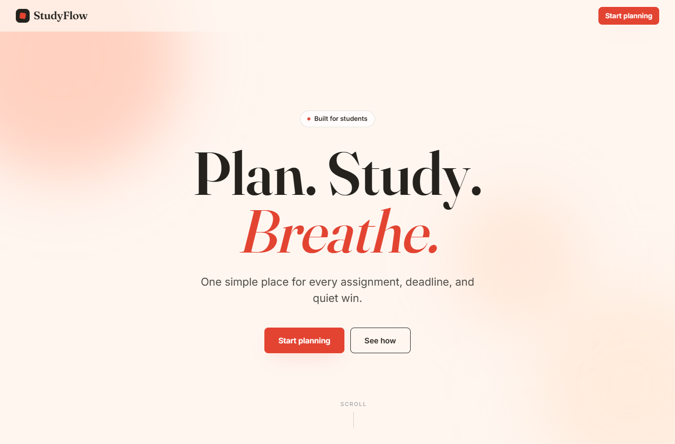
Figure 6. Home page after the entrance animation has settled into its final state.

Result
The landing page feels polished and lively without breaking accessibility standards.

15. Visual Review and Improvements

After the main features were working, each page was reviewed in a browser window at 1366px width. Any spacing, alignment, or content issues found were fixed before taking the final screenshots.

Fixes Made
The home page header originally included a Sign In link that was not part of the final project. It was removed. The landing header was also widened to fill the full viewport. In the footer, a redundant technology sentence was removed and the StudyFlow brand was centered.

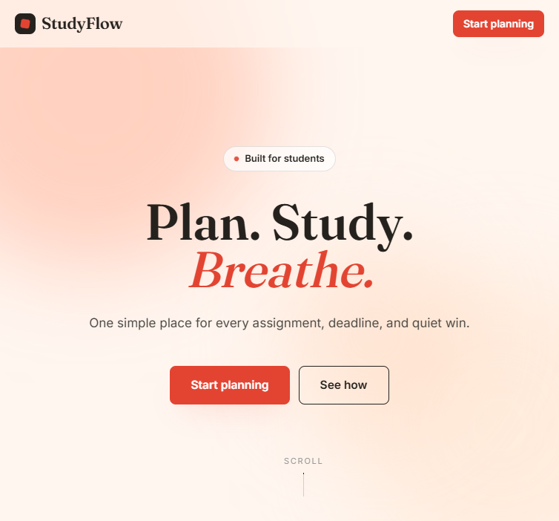
Figure 7a. Home page header after cleanup: Sign In link removed, full-width layout applied.

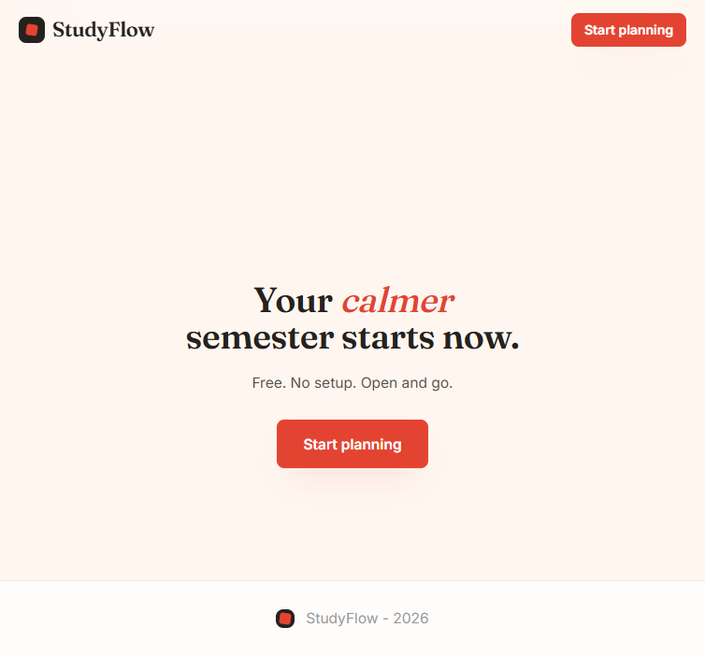
Figure 7b. Home page footer after cleanup: centered brand, redundant text removed.

The Today, Subjects, and Calendar pages were also reviewed. Spacing between cards was adjusted and color contrast on tags was checked.

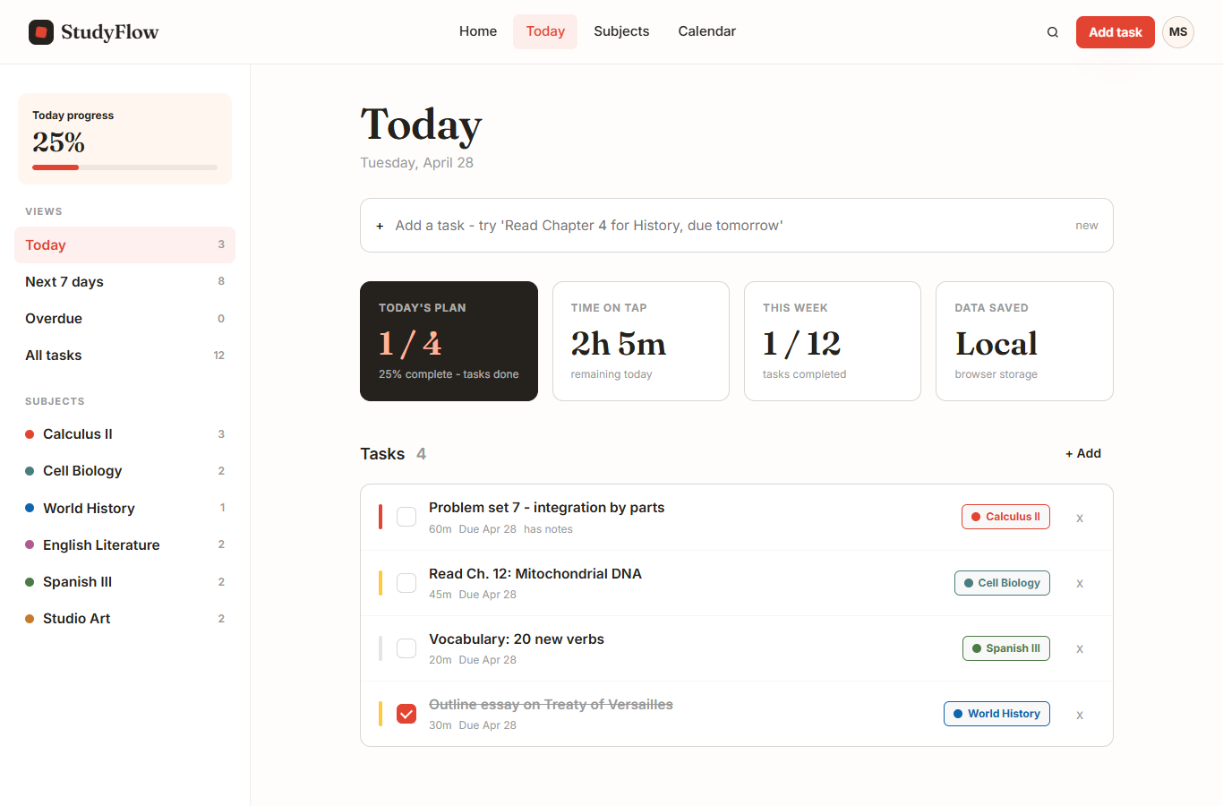
Figure 8. Today Dashboard after visual review pass.

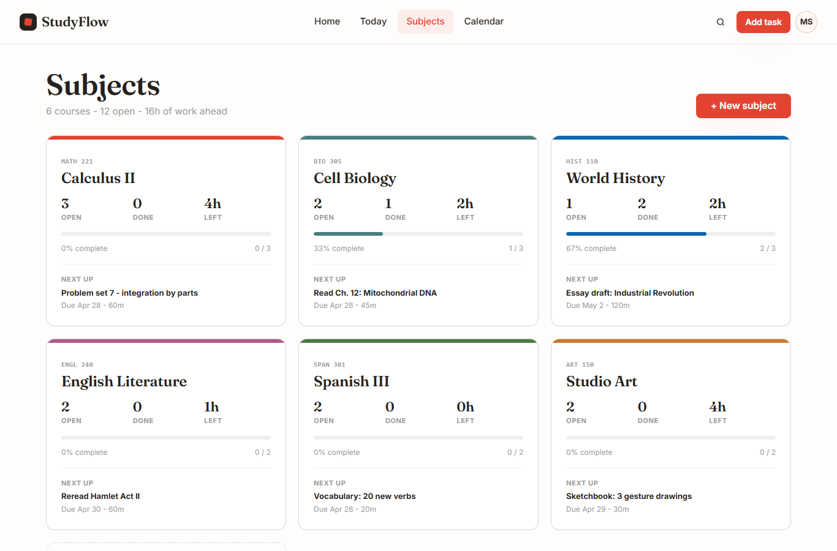
Figure 9. Subjects page after visual review pass.

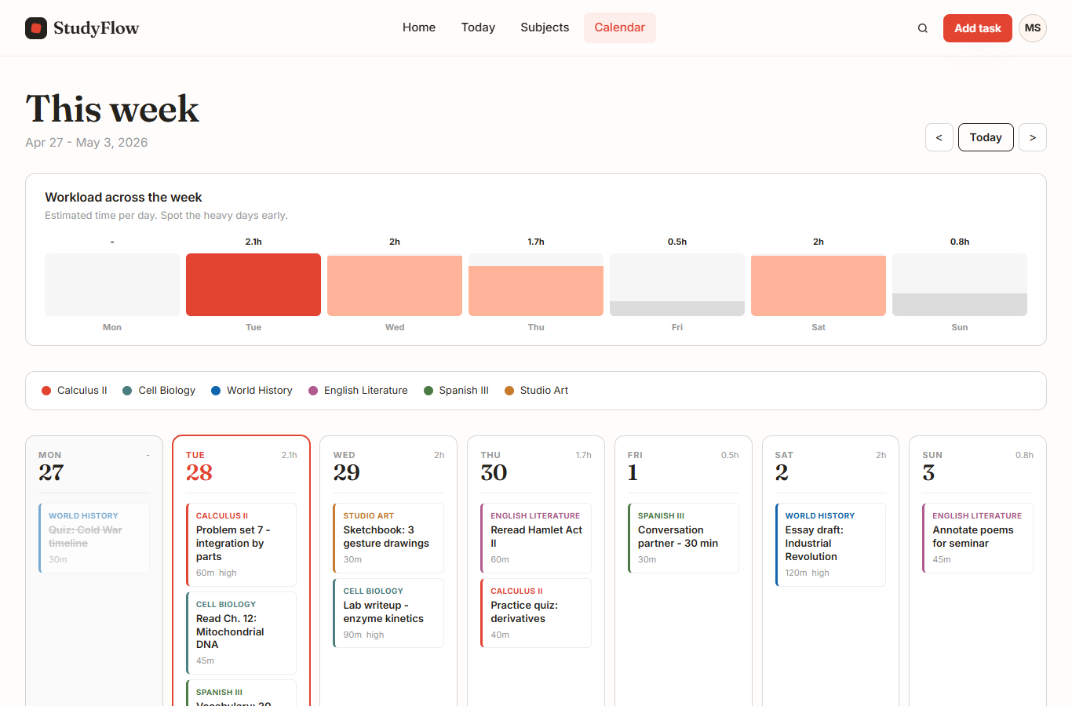
Figure 10. Calendar page after visual review pass.

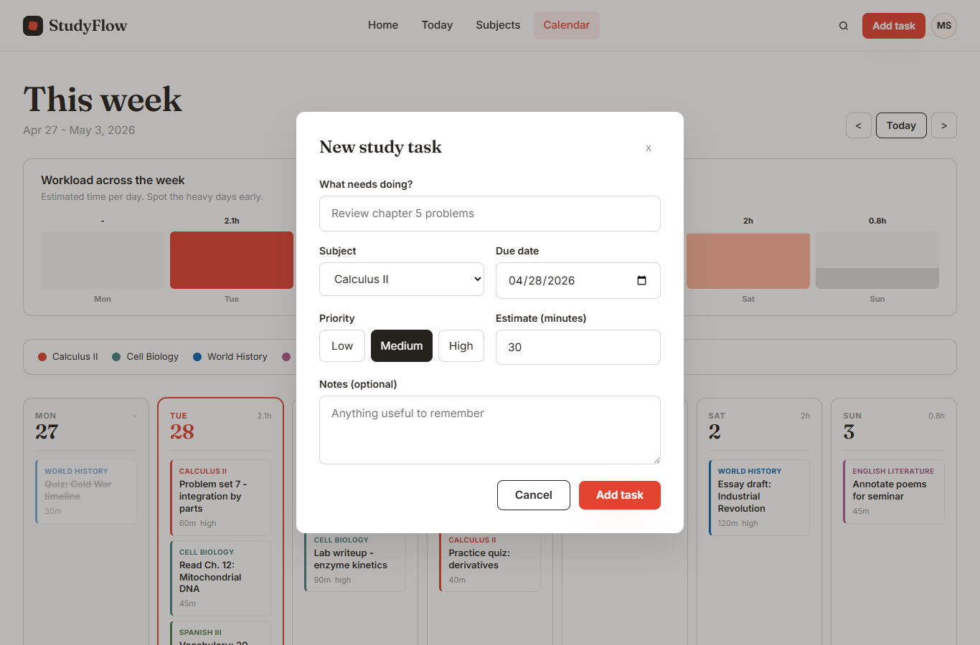
Figure 11. Add Task modal after visual review pass.

Result
Every page screenshot was taken after the visual review so the report shows the finished state of the project.

16. Challenges and Solutions

Challenge 1: Converting from React to Plain JavaScript
The original prototype was built with React and JSX. The course required a static website with no framework.
Solution
Each React component was rewritten as a JavaScript function that returns an HTML string. The same screen layouts were reproduced using template literals. Event listeners were attached after the HTML was written to innerHTML.

Challenge 2: Keeping the Visual Design
The React prototype had a detailed design system. Moving to plain CSS risked losing that consistency.
Solution
All design tokens (colors, fonts, spacing values, shadows, and border-radius values) were moved into CSS custom properties. Component class names stayed the same, so the visual output matched the original.

Challenge 3: Saving Data Without a Backend
The project could not use a server or database.
Solution
localStorage was used to save the state object as a JSON string after every change. On load, the website reads the saved string and parses it back into the application state.

Challenge 4: Final Visual Cleanup
Before taking the report screenshots, the home page header and footer had leftover elements from the earlier version.
Solution
The Sign In link was removed from the header. The footer technology sentence was removed. The landing header was made full-width. Screenshots were taken after these fixes.

Challenge 5: Adding Animation Without Breaking the Single-File Rule
The landing page needed animation but the project had to stay as three plain files.
Solution
All animations were written as CSS keyframes in styles.css. No JavaScript animation library was needed. The prefers-reduced-motion media query was added to turn off animations for users who need it.

Result
Each challenge was solved within the constraints of the assignment. The final project uses only HTML, CSS, and JavaScript.

17. GitHub Repository Information

The source code for StudyFlow is stored in a public GitHub repository.

GitHub Username: [Add GitHub username]
Repository Link: [Add public GitHub repository link]

The repository contains all three runtime files (index.html, styles.css, script.js) and the docs folder with screenshots and report notes.

18. Final Result

StudyFlow is a complete, static, single-page study planner built with HTML, CSS, and JavaScript. It runs in any modern browser without a server or build step.

The website has four views: a home landing page, a Today dashboard, a Subjects page, and a Calendar page. Users can add subjects and tasks, mark tasks as done, filter the task list, and navigate the weekly calendar. All data is saved in the browser using localStorage.

The visual design uses a consistent set of CSS variables, the Fraunces and Inter fonts, and a charcoal and cream color palette. Six subject colors keep tasks visually organized across all views. The layout is responsive and works on narrow screens.

The home page includes a CSS animation sequence and a prefers-reduced-motion fallback for accessibility. Every page was reviewed in the browser before the final screenshots were taken.

The project meets all course requirements: it is a static website, it uses HTML, CSS, and JavaScript, it handles data in the browser, and it has a consistent, readable design.

19. Signature

I confirm that this report and the accompanying website are my own work.

Name: ________________________________

Student Number: ________________________________

Signature: ________________________________

Date: ________________________________

