**Cinema Management System**

**Assignment# 1**

Submitted by:

Inaya Hassan

Reg no.

CIIT/SP25-BCS-052/LHR

Course Name/Code:

Object Oriented Programming

Lab

CSC-241

Instructor:

M.Shahid Bhatti

Section:

A

08/10/2025

**COMSATS University Islamabad,**

**Lahore**

**Seat.java**

public boolean bookSeat() {

if (isAvailable) {

isAvailable = false;

return true;

}

return false;

}

public boolean isAvailable() {

return isAvailable;

}

public boolean cancelBooking() {

if(!isAvailable) {

isAvailable = true;

return true;

}

return false;

}

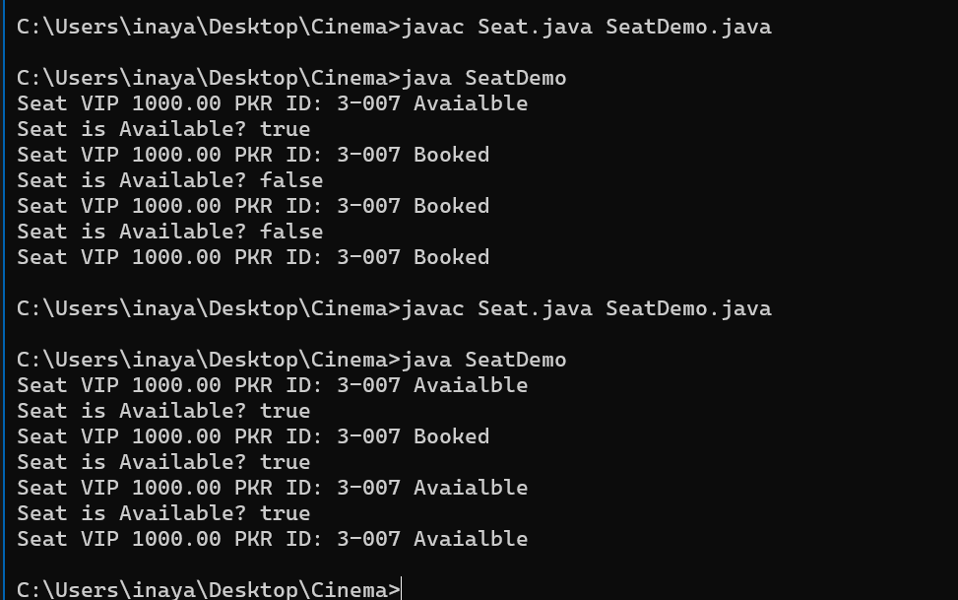

**Screen.java**

public boolean bookSeat(int row, int column) {

checkBounds(row, column);

int rows = row - 1;

int columns = column - 1;

Seat seat = getSeat(rows, columns);

if(seat != null) {

return seat.bookSeat();

}

return false;

}

public boolean bookSeat(String id) {

Seat seat = getSeat(id);

if(seat != null) {

return seat.bookSeat();

}

return false;

}

public boolean cancelBooking(int row, int column) {

checkBounds(row, column);

int rows = row - 1; //to convert java array system to human

int columns = column - 1;

Seat seat = getSeat(rows, columns);

if(seat != null) {

return seat.cancelBooking();

}

return false;

}

public boolean cancelBooking(String id) {

Seat seat = getSeat(id);

if(seat != null) {

return seat.cancelBooking();

}

return false;

}

**Cinema.java + CityCinema.java**

public boolean bookSeat(int screenIndex, String seatId) {

Screen seat = getScreen(screenIndex);

if(seat != null) {

return seat.bookSeat(seatId);

}

return false;

}

public boolean cancelSeat(int screenIndex, String seatId) {

Screen seat = getScreen(screenIndex);

if(seat != null) {

return seat.cancelBooking(seatId);

}

return false;

}

public int getTotalSeats() {

int total = 0;

for (int i = 0; i < counter; i++) {

total += screens[i].getTotalSeatCount();

}

return total;

}

public int getAvailableSeats() {

int total = 0;

for (int i = 0; i < counter; i++) {

total += screens[i].getAvailableSeatCount();

}

return total;

}

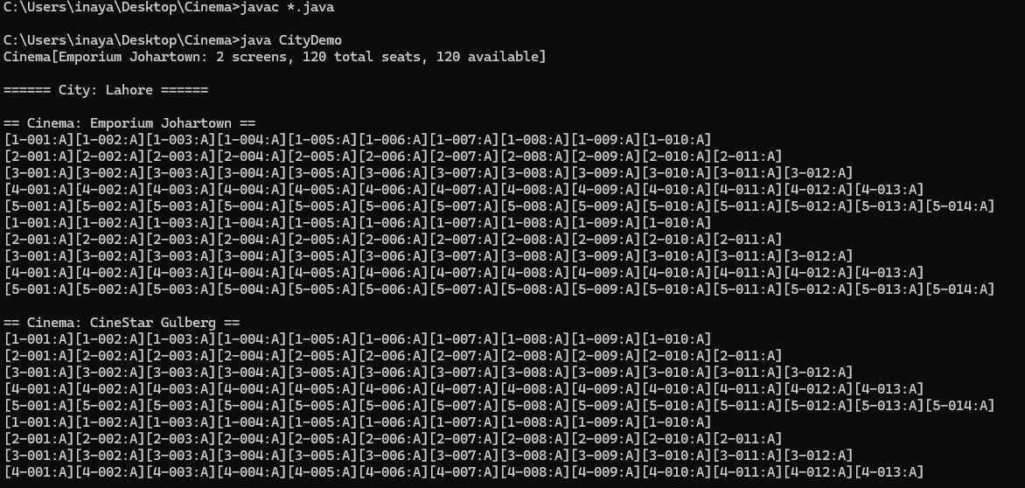

**Other sample output taken along the way:**

