A Project report on
“Inventory Management System
For Rifat Enterprise”
Kamani science &prataprai art’s collage Amreli

Developed By:
Bukera Inayat (Enrol No-23SI002UG05179)
Boricha Jaysukh (Enrol No-23SI002UG05178)

Guided By::
Prof. ParasKumar Thummar
Intern Supervisor
Altaf Naya

Year Of Submission
On
Submitted In partial fulfilment of the requirement
For the award of the degree of Bachelor of Computer Application
(BCA Sem-6)
2025-2026

Saurashrta University-Rajkot
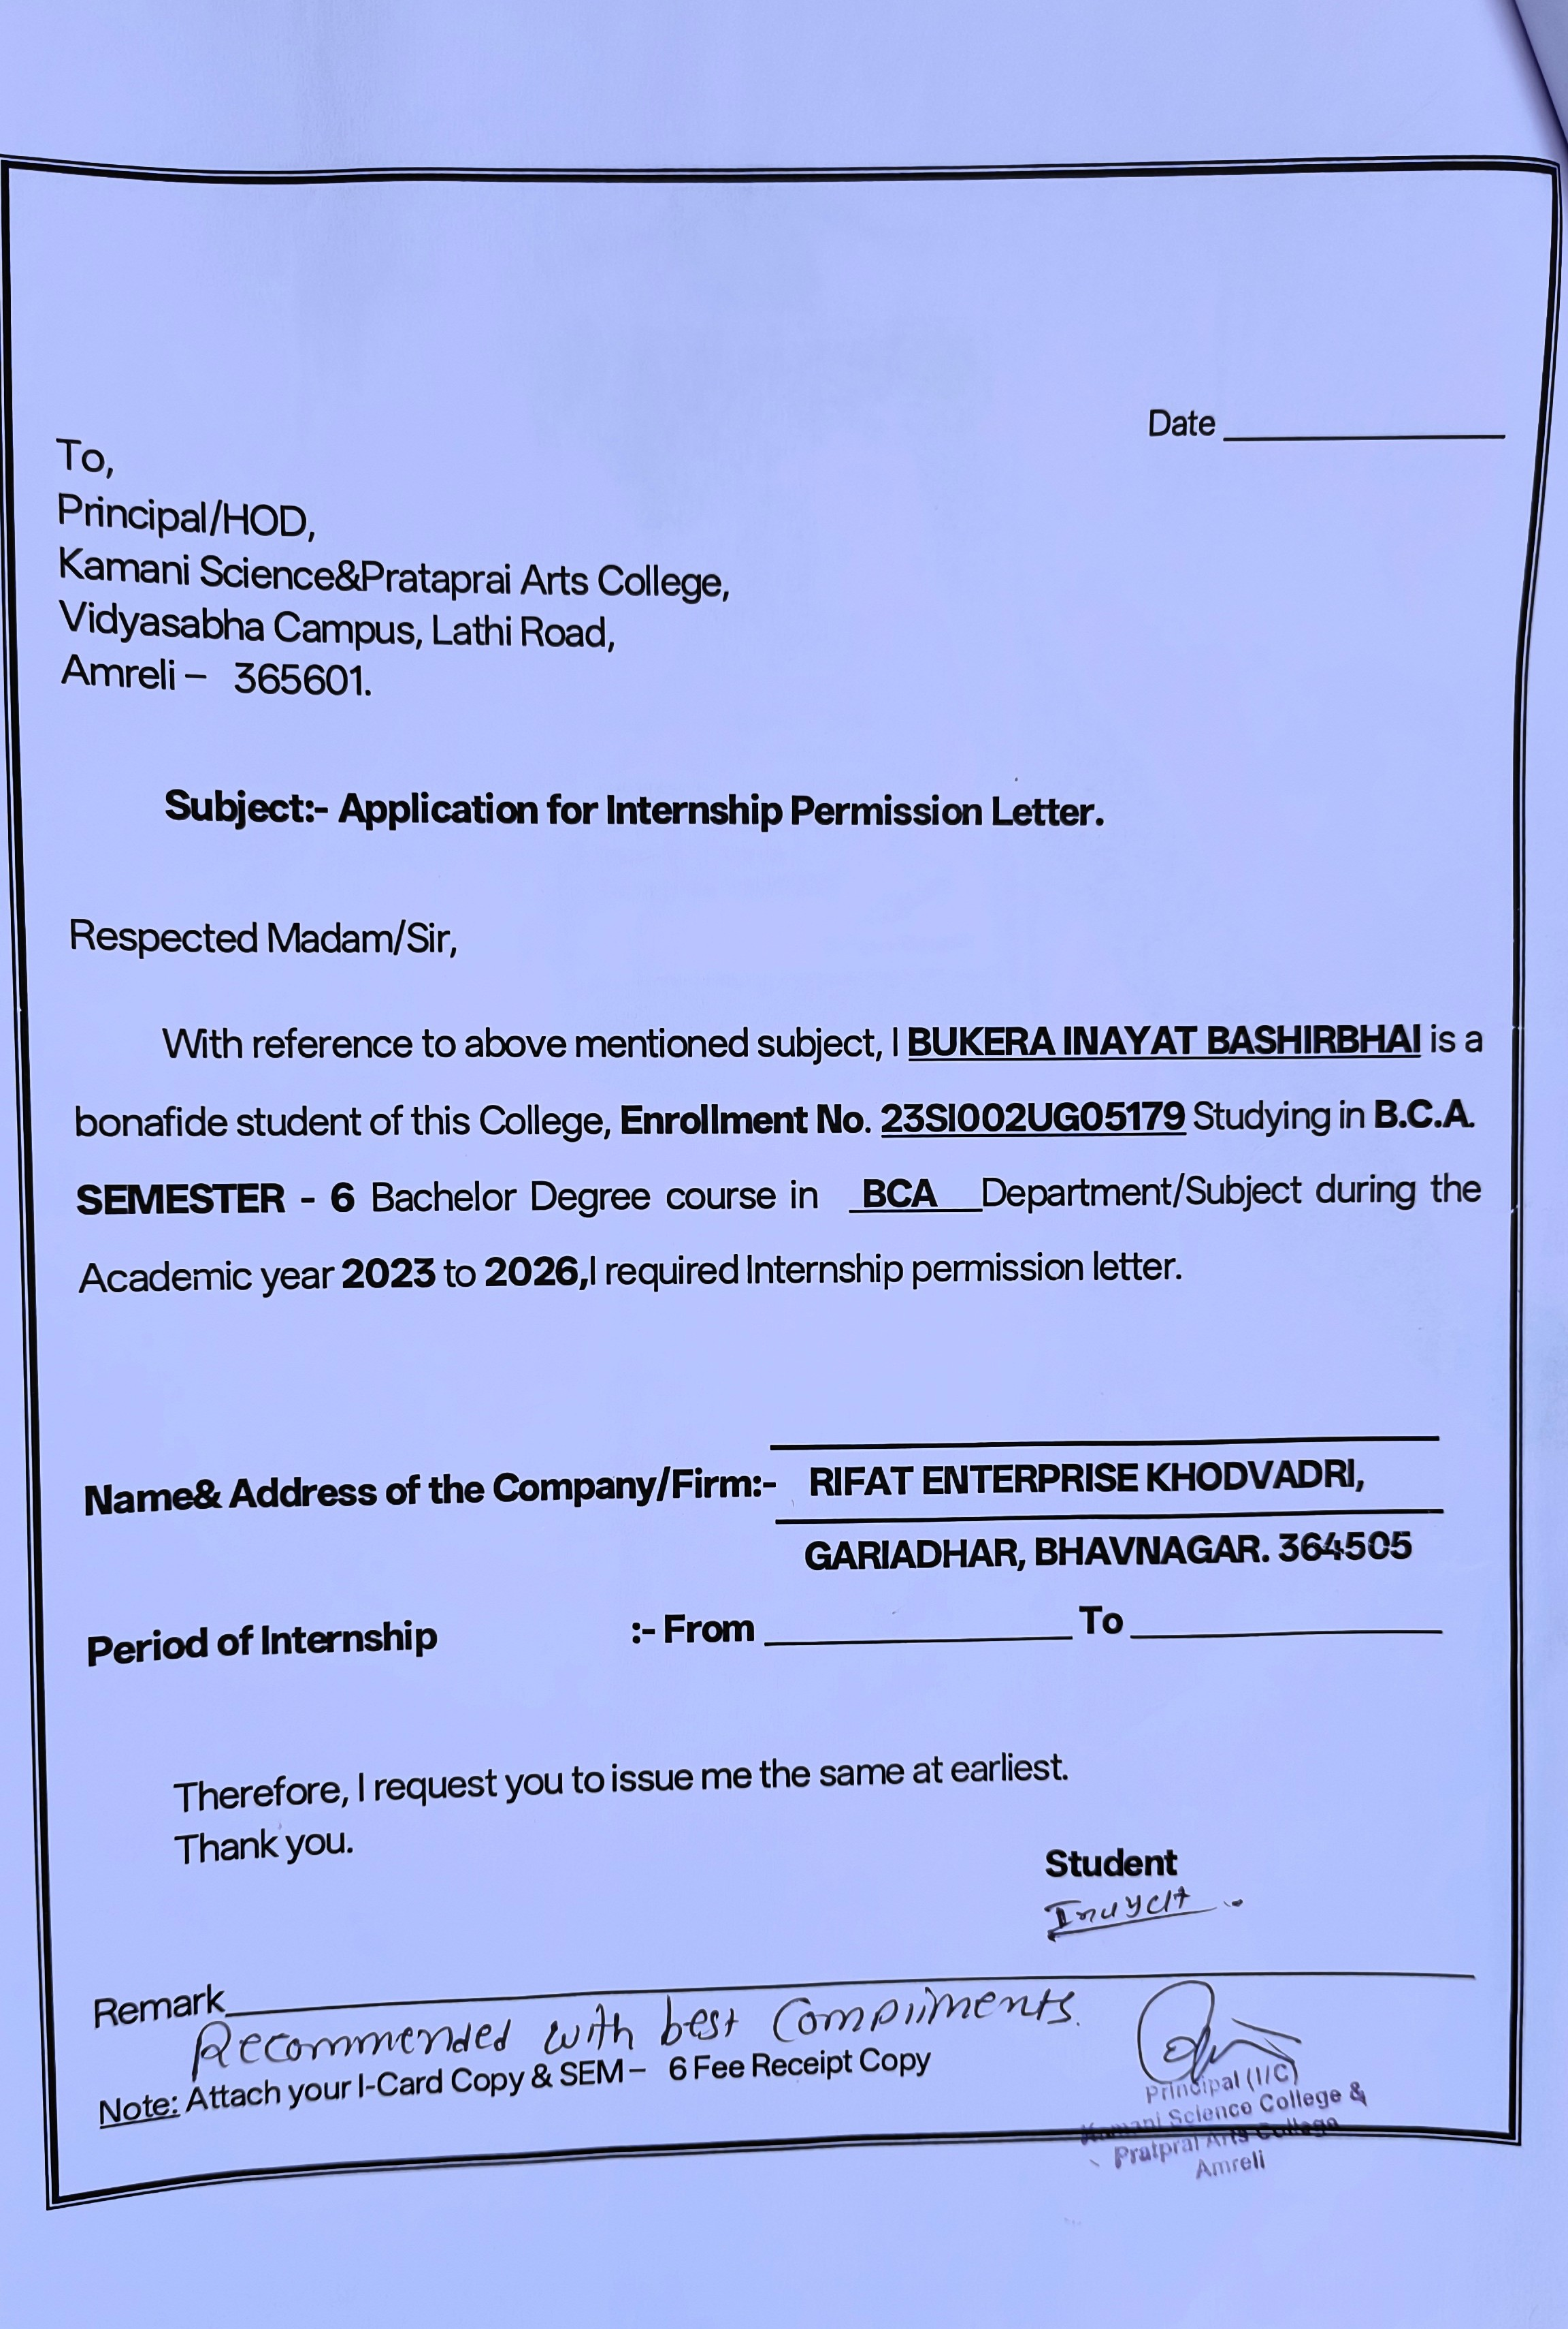
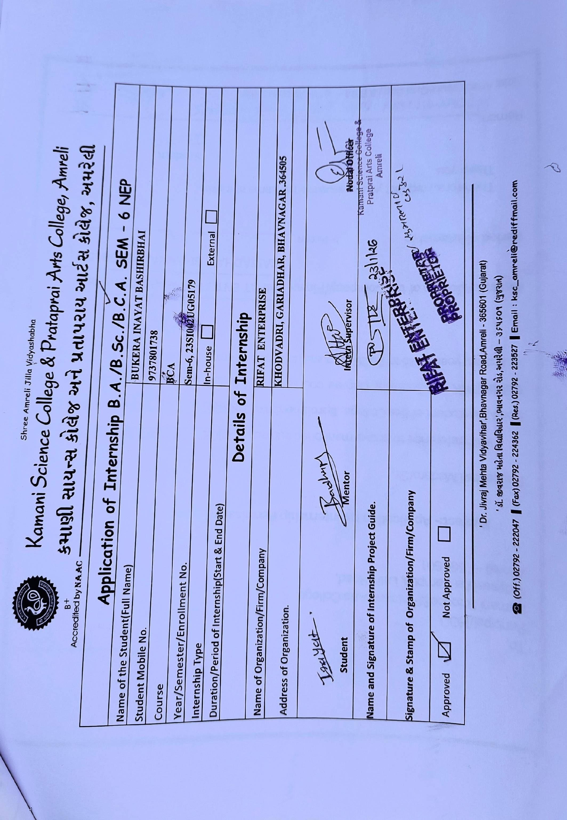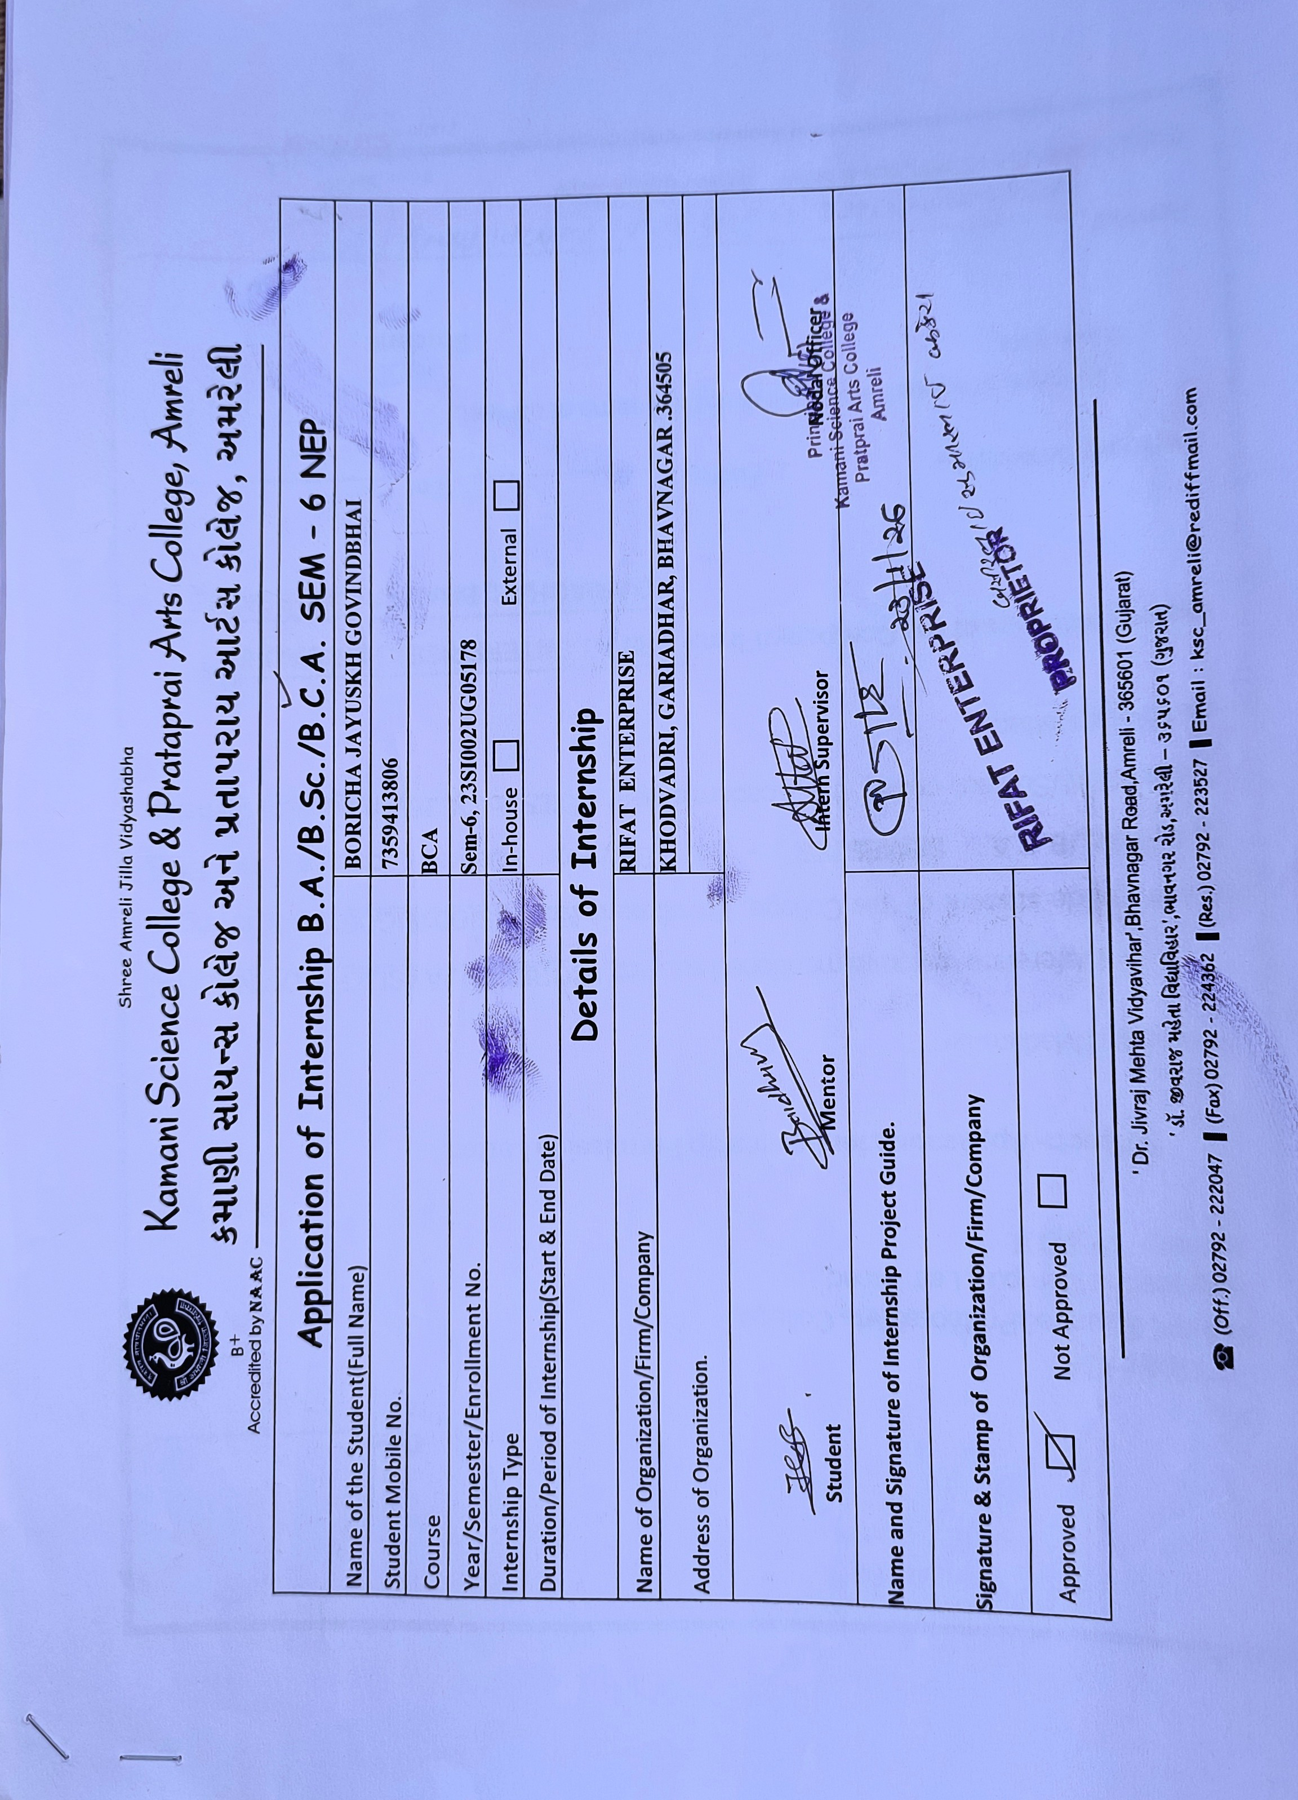

Date:
To,
Concerned Authority
Subject: Internship Completion Certificate
This is to certify that Mr. Bukera Inayat has successfully completed 120 hours of internship at Rifat Enterprise from 01/12/2025 to 15/03/2026.
During the internship period, he worked on the development of a Web-Based Inventory Management System for our organization. He demonstrated dedication, technical knowledge, and professionalism while completing tasks related to raw material management, production tracking, sales management, and reporting modules.
His performance during the internship was satisfactory, and we wish him success in his future academic and professional endeavours.
Sincerely,

__________________________
Authorized Signatory
Rifat Enterprise
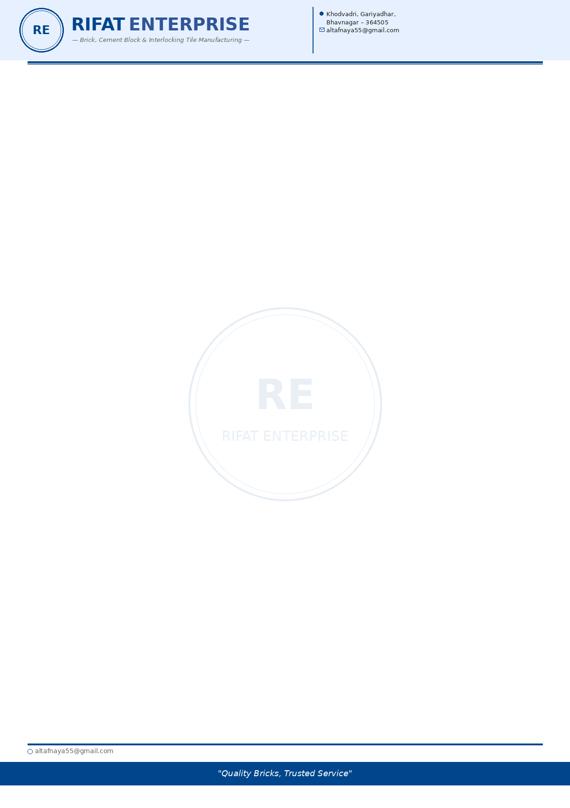



Date:
To,
Concerned Authority
Subject: Internship Completion Certificate
This is to certify that Mr. Boricha Jaysukh has successfully completed 120 hours of internship at Rifat Enterprise from 01/12/2025 to 15/03/2026.
During the internship period, he worked on the development of a Web-Based Inventory Management System for our organization. He demonstrated dedication, technical knowledge, and professionalism while completing tasks related to raw material management, production tracking, sales management, and reporting modules.
His performance during the internship was satisfactory, and we wish him success in his future academic and professional endeavours.
Sincerely,

__________________________
Authorized Signatory
Rifat Enterprise

Index
Sr. no. | TITLE | Page No.
1 | Preface | 5
2 | Acknowledgement | 6
3 | abstract | 7
4 | introduction | 8
5 | Time line chart | 9
6 | System analysis requirement gathering | 10-11
7 | Profile Page | 12
8 | Hardware & Software Requirement | 13
9 | Problem Definition | 14
10 | Feasibility Study | 15
11 | Record Review | 16
12 | Objective of Project | 17
13 | Project Structure Diagram | 18
14 | Data Dictionary | 19-20
15 | Data Flow Diagram | 21-23
16 | ER Diagram | 24
17 | UML | 25-26
18 | Sequence Diagram | 27
19 | Class Diagram | 28
20 | Application Screenshot | 29-35
21 | Code Screenshot | 36-39
22 | Testing | 40-42
23 | Pros And Cons for System | 43
24 | Bibliography | 44

Preface

The main objective of this project is to gain practical knowledge and hands-on experience in web development, which is an essential skill for any computer science student. Developing an Inventory Management System for Rifat Enterprise allowed us to combine both theoretical concepts and practical implementation, providing a comprehensive learning experience.
During the course of this project, we explored various aspects related to system design, database management, user interface development, and inventory tracking. This process helped us enhance our problem-solving abilities and understand the challenges involved in developing a real-world business application.
Through this project, we learned how to manage raw materials, production data, product stock, and sales information efficiently using a web-based system. The development process also helped us understand how software solutions can improve business operations by replacing manual record-keeping with a structured digital system.
We are pleased to present this project report, which has been carefully organized for easy understanding. Throughout the development process, several software engineering principles and best practices have been applied to ensure that the system is reliable, efficient, and user-friendly. This project has been an important step in strengthening our technical knowledge and preparing us for future opportunities in the field of software development.

Acknowledgment

We, the students of BCA Semester-5 at kamani Science College, Amreli, would you like to express our heartfelt Gratitude We sincerely thank Prof. Paraskumar Thummar for their invaluable guidance, motivation, and constant support of this project. Their insights and encouragement have played a crucial role in helping us understand The technical and conceptual aspects of the system.

We are also deeply grateful to the head of Department for providing us with the opportunity and inspiration to take this project. A special thanks to all faculty members and administrative staff of our institute for their continued support and resources.

Lastly, we extend our warm thanks to our friends for their help and cooperation , whether directly or indirectly, and to our families for their endless encouragement and support throughout this journey.

Thank to all !

Bukera Inayat
Boricha Jaysukh.

Abstract

The Rifat Enterprise Inventory Management System is a web-based platform designed to efficiently manage and monitor the inventory operations of the organization. This system aims to streamline stock tracking, product management, and overall inventory control through a centralized and user-friendly interface.

The project focuses on developing a modern and efficient system where administrators and staff can add, update, and manage product details, monitor stock levels, and maintain accurate records of incoming and outgoing goods. It includes features such as product categorization, real-time stock updates, supplier management, sales tracking, and automated alerts for low inventory levels.

The platform benefits the organization by reducing manual errors, improving operational efficiency, and ensuring better decision-making through accurate data management. With an intuitive layout and secure access controls, the system enhances productivity and helps Rifat Enterprise maintain optimal stock levels while minimizing losses and delays.

Additionally, the system supports report generation and data analysis, enabling management to track inventory trends and improve future planning. Overall, the Inventory Management System serves as a reliable and scalable solution for modern business inventory operations.

Introduction

An Inventory Management System for Rifat Enterprise for Blocks is a software-based solution designed to efficiently track and control the business stock of concrete blocks, raw materials, and related supplies.

The system helps the enterprise maintain accurate records of incoming and outgoing blocks, monitor stock levels in real time, and prevent shortage or overstock situations.

By organizing inventory data such as supplier details, quantities in hand, and transaction records, the system supports better planning, reduces manual errors, and improves overall operational efficiency in fulfilling customer orders and managing daily transactions.

The proposed system aims to replace the traditional manual method with a digital inventory management system that improves accuracy, efficiency, and reliability. By using this system, the administrator can easily record and monitor all important business activities such as raw material purchases, block production, finished goods stock, and sales transactions.

Objective Of Project
Welcome to the Inventory Management System developed for Rifat Enterprise, a business involved in the manufacturing and trading of bricks, cement blocks, and interlocking tiles. This system is designed to improve the efficiency of managing raw materials, production processes, and sales activities.
The proposed system is a web-based application that helps the organization maintain accurate records of raw materials, production details, product stock, and customer sales. It replaces the traditional manual record-keeping system and provides a faster, more reliable way to manage business operations.
The platform allows administrators and staff to easily monitor inventory levels, record production activities, manage sales transactions, and generate reports. This system improves transparency, reduces human errors, and supports better decision-making for the business.

Benefits of the system :
1. Efficient Inventory Management:
The system allows administrators to easily add, update, and track raw materials and finished products, ensuring accurate stock records.
2. Production Tracking:
The platform records daily production activities and automatically updates product stock based on raw material usage.
3. Sales Management:
Staff can manage sales transactions details, and generate reports, helping the business monitor revenue and profit.

Time Line
Time Line Chart

1. Study Of Existing System 10 Days
2. System Analysis 15 Days
3. System Design 20 Days
4. Coding 40 Days
5. Testing 10 Days
6. Documentation 10 Days

Profile Page

PROJECT DETAILS
Project Name | Inventory Management System for Rifat Enterprise
Project Details | System used for managing raw materials, production, sales, customers, suppliers, and easy data analysis.
Front-end Tools | HTML, JavaScript, CSS
Back-end Tools | PHP, MySQL
Operating System | Windows 10/11, Linux, MacOS
Completion Time | 3.5 Months
TEAM INFORMATION
Developed By | Boricha Jaysukh  EN. No: 23SI002UG051780  Bukera Inayat  EN. No: 23SI002UG05178
Guided By | Prof. ParasKumar Thummar
Submitted To | Saurashtra University, Rajkot

Saurashtra University, Rajkot

Hardware & Software Requirement

Hardware Requirement
Jaysukh.

- 512+MB of Ram
- Multimedia keypad and mouse
- GHs processor
- Monitor

Software Requirement

- Operating System: Microsoft Window 10
- Front-end Tool: HTML, JS,CSS
- Back-end Tool: PHP, Mysql
- Documentation Tool: MS Visio

Requirement Specification

Rifat Enterprise Inventory Management System – Q&A

Q1. What is the name of your factory?
- Rifat Enterprise.
Q2. Who can use this system?
- Admin only.
Q3. What are the main benefits of the website?
- The system allows the admin to manage raw materials, products, and sales efficiently.
Q4. What is the problem definition statement and why does Rifat Enterprise need an inventory management system?
- Rifat Enterprise currently faces difficulties in manually managing raw materials, production records, stock levels, and sales. Manual record keeping often leads to errors, stock mismatches, and poor decision making. Therefore, an inventory management system is required to automate stock tracking and manage production and sales more efficiently.
Q5. What are the functional and non functional requirements?
- Functional requirements include managing raw materials, production, finished goods, sales, suppliers, customers, and generating analysis reports.
Non functional requirements include system security through user authentication, fast response time, data accuracy, reliability, and an easy to use interface.
Q6. What are the technical, economic, and operational feasibilities of developing the system?
- The system is technically feasible because it is developed using PHP, MySQL, HTML, CSS, and JavaScript, which are widely available and easy to implement technologies.
Q7. Which type of system architecture is followed?
- Three tier architecture consisting of User Interface (UI), Application Logic, and Database layers.
Q8. How is stock updated in the system?
- Stock is automatically updated during production entries and sales entries.
Q9. Which type of blocks are produced?
- Two types of blocks are produced:
1. Bricks
2. Cement Blocks
Q10. How is system security maintained?
- System security is maintained through user authentication, role based access control, and session management.
Q11. What is raw material management in your system?
- Raw material management allows the admin to add, update, and monitor the stock levels of materials such as cement, sand, aggregate, and red sand used in production.
Q12. What is production management in the system?
- Production management records the daily production of bricks and cement blocks and automatically updates raw material consumption and finished product stock.
Q13. How does the system help in sales management?
- The system records product sales, customer information, quantity sold, and total amount, which helps in tracking revenue and stock levels.
Q14. What are the limitations of your system?
- The system currently supports only admin access and basic reporting. Advanced analytics and multi-user roles can be added in future versions.
Q15. What testing methods were used during development?
- The system was tested using unit testing, integration testing, and system testing to ensure accuracy and reliability.
Q16. What is the role of suppliers in the system?
- Suppliers provide raw materials, and their details are stored in the system to track material purchases and supplier transaction.

Project Planning & Scheduling

1. Planning
Planning is the process of deciding in advance what needs to be done, how it will be done, and who will be responsible for completing the tasks. In this project, planning helped us clearly define the system objectives, project scope, required technologies, and development timeline.
During the planning phase, our team discussed the business requirements of Rifat Enterprise, which manufactures and sells bricks, cement blocks, and concrete interlocking tiles. The current manual record keeping system creates difficulties in tracking raw materials, production, and sales. Therefore, we planned to develop a web-based Inventory Management System to solve these problems.
The system was divided into the following main modules:
• Login authentication for secure system access
• Raw material management (Add, Update, Delete, View materials)
• Supplier management
• Production management for bricks, cement blocks, and tiles
• Finished product stock management
• Sales management and order tracking
• Revenue and loss reporting dashboard
Our team also selected the technologies required for system development. The system is developed using HTML, CSS, and JavaScript for frontend design, PHP for backend logic, and MySQL for database management.
Since this is a team project, responsibilities such as frontend development, backend programming, and database design were handled collaboratively. Proper planning helped us divide work efficiently, maintain coordination among team members, and ensure smooth development of the system.

1. Scheduling
Scheduling is the process of organizing project activities in a logical order along with their time duration. After defining the system modules during the planning phase, a schedule was created to complete each phase of the project within the given internship period.

The project development was carried out in the following sequence:
• Requirement analysis of Rifat Enterprise inventory system
• System design including DFD, Use Case Diagram, Class Diagram, and Sequence Diagram
• Database design for managing raw materials, production records, products, and sales
• Frontend interface design for user dashboard and forms
• Backend development for handling system logic and database interaction
• Integration of frontend, backend, and database modules
• System testing and debugging
• Final implementation and project documentation
Scheduling provided a clear development roadmap and ensured that the team completed tasks in a systematic and timely manner.

Relationship between Planning & Scheduling
• Planning answers: What needs to be done in the project?
• Scheduling answers: When and in what order will the tasks be completed?
Both planning and scheduling worked together to ensure that the project development remained organized, efficient, and completed successfully within the allocated time.

(SDLC)

Software Development Life Cycle

The Software Development Life Cycle is the cost effective an time – efficient process that development teams use to design and build high – quality software.

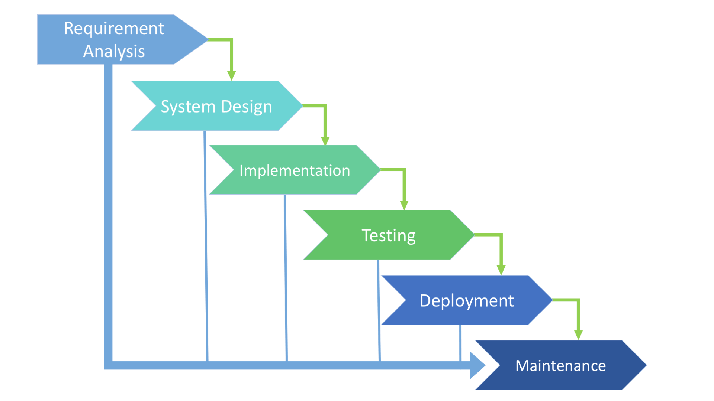

System Analysis

Existing System
In the existing system, inventory records at Rifat Enterprise are mostly maintained manually using paper registers and notebooks. Information about raw materials, production, stock levels, and sales is recorded by hand. This manual process makes it difficult to track the exact quantity of materials such as cement, sand, aggregate, and red sand used during production.
Production details of bricks, cement blocks, and concrete interlocking tiles are also written manually, which increases the chances of calculation mistakes and missing records. Managing product stock and recording daily sales becomes time-consuming and sometimes leads to incorrect stock information.
Searching, updating, and maintaining records becomes more difficult as the amount of data increases. There is no centralized system to store and organize the information. Generating reports such as stock status, sales records, and revenue analysis requires a lot of time and manual effort.
Because of these limitations, the current manual system is slow, error-prone, and inefficient, making it difficult for the business to manage inventory and production effectively.

Proposed System
The proposed Inventory Management System for Rifat Enterprise is a web-based application designed to automate and simplify the management of raw materials, production, and sales.
The system provides a secure login for the administrator and stores all information in a centralized database. It allows easy management of raw materials, suppliers, production records, finished product stock, and sales transactions.
The system automatically updates stock levels when materials are purchased, products are produced, or items are sold. It also generates organized records and reports such as stock reports, production reports, and revenue analysis.
By replacing the manual record-keeping process with a computerized system developed using HTML, CSS, JavaScript, PHP, and MySQL, the enterprise can save time, reduce errors, improve data accuracy, and manage inventory more efficiently.
The proposed system will make business operations more organized, transparent, and reliable for managing production and sales activities.

Problem Definition

Rifat Enterprise currently manages its inventory using manual methods such as paper records and basic spreadsheets. This traditional system creates several operational challenges that affect the efficiency, accuracy, and productivity of the business.
Due to the absence of a computerized inventory system, the organization faces difficulties in tracking stock levels, updating product information, monitoring supplier details, and generating reports. Manual data entry increases the chances of human error, duplication of records, misplaced files, and incorrect stock calculations.
The existing system also makes it hard to:
- Maintain real-time stock updates
- Track sales and purchase records efficiently
- Identify low-stock or out-of-stock items
- Generate accurate billing and invoices
- Prepare monthly or yearly inventory reports
- Maintain proper supplier and customer records
As the business grows, handling inventory manually becomes time-consuming and inefficient. Delays in stock updates may lead to overstocking or stock shortages, resulting in financial loss and poor customer satisfaction.
Therefore, there is a need to develop a computerized Inventory Management System (IMS) for Rifat Enterprise. The proposed system will automate inventory tracking, manage product details, maintain stock records, generate bills and reports, and improve overall operational efficiency.
The system aims to:
- Reduce manual errors
- Improve data accuracy
- Provide real-time inventory updates
- Enhance decision-making through reports
- Save time and operational costs

Feasibility Study

1). Technical feasibility:
The proposed system can be developed using standard web technologies such as:
Front-end: Html, Css, JavaScript
Back-end : PHP,
Database : MySQL
Hosting : XAMPP (for local)
The Required Software and tools are easily available and simple to use
2). Operational feasibility:
The System is user-Friendly and easy to operate by staff and admin.
It will reduce manual record keeping and paperwork.
The admin can easily manage raw Materials, Production, and Sales.
The System helps in tracking Stock, Revenue and Profit efficiently.

3). Economic feasibility:
Development costs is low because open source technologies are used.
Hosting and Maintenance Costs are Minimal.
The System Reduce Financial Losses created by Stock Mis-Management

Record Review
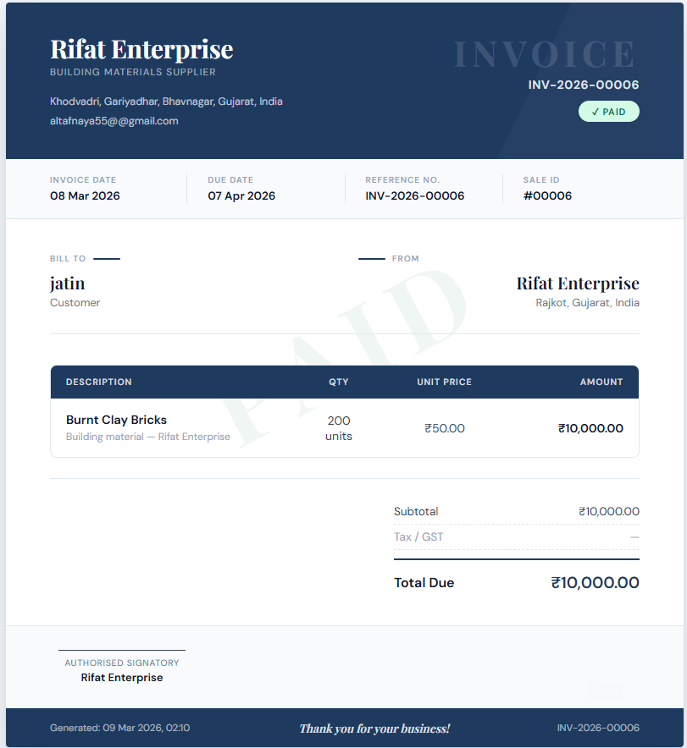

Project Structure Diagram

1. Diagram :-

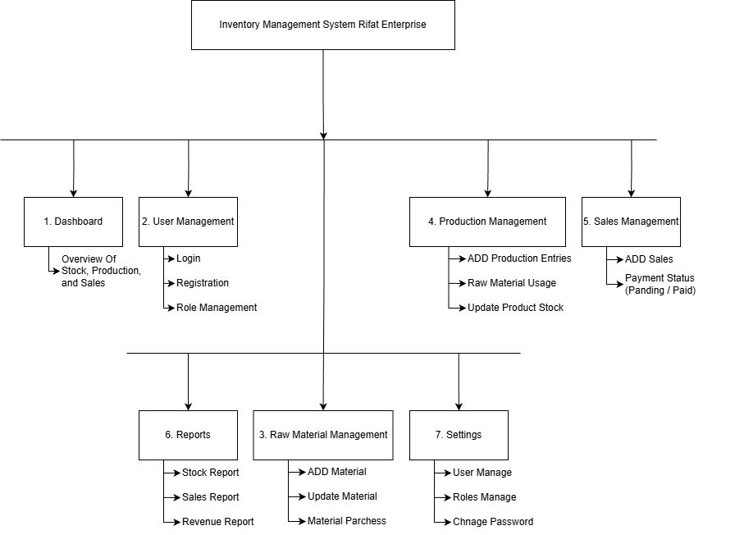

Data Dictionary
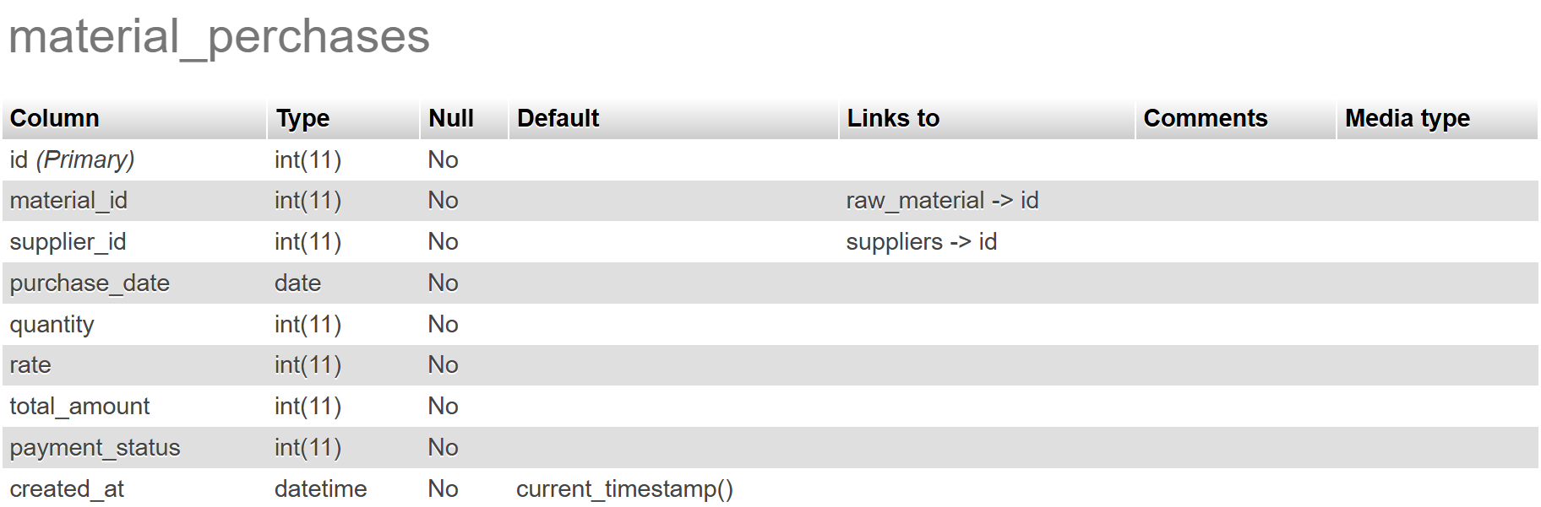
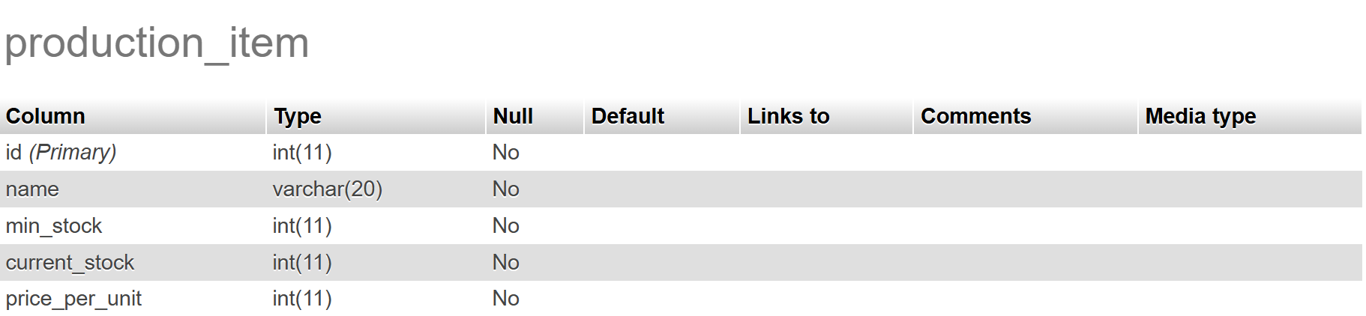
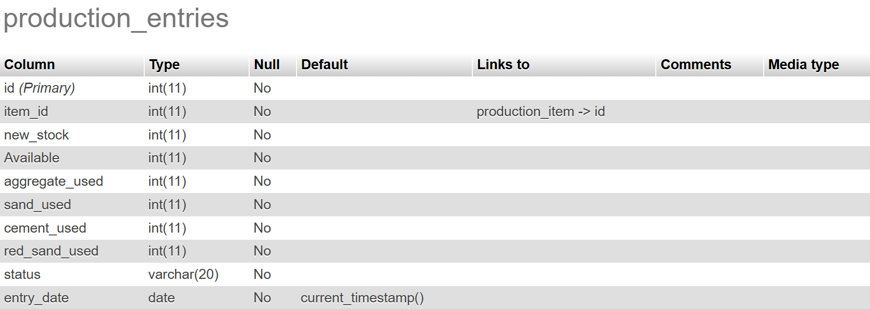
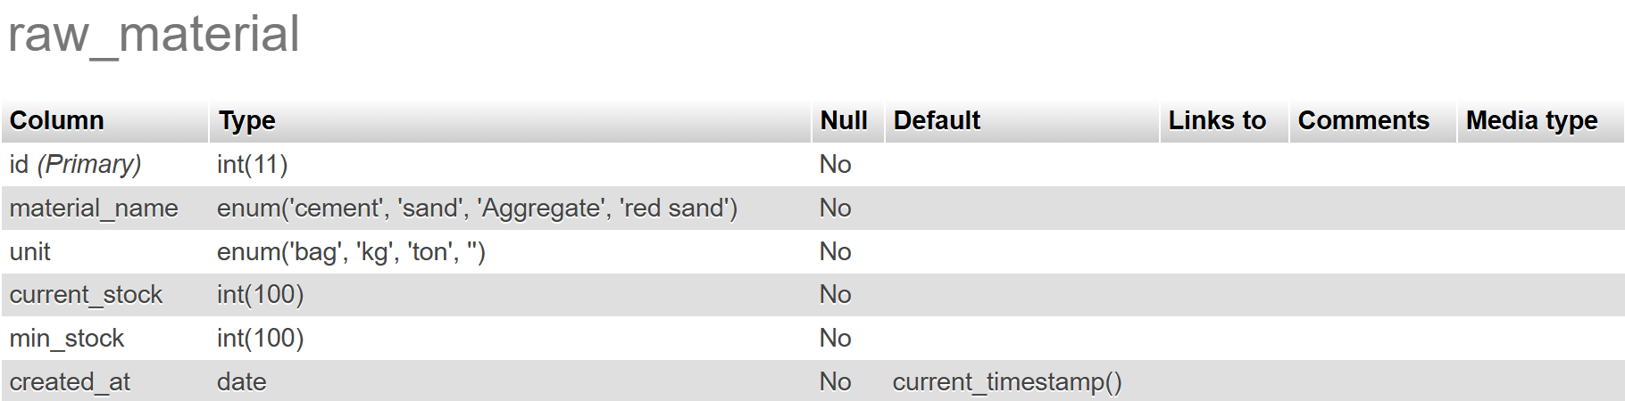
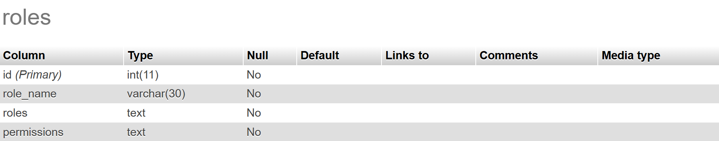
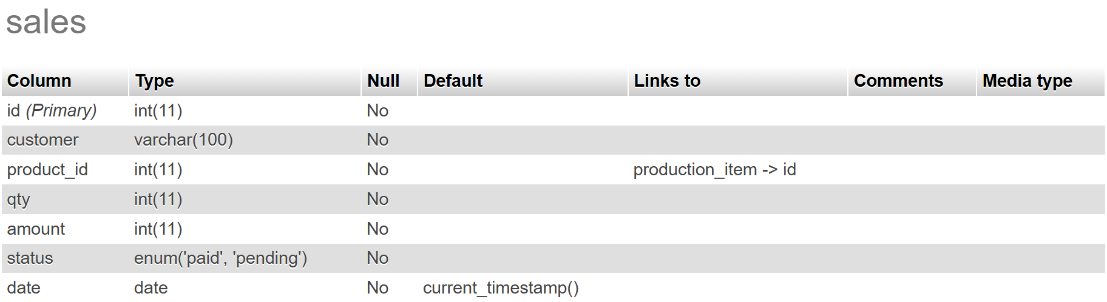
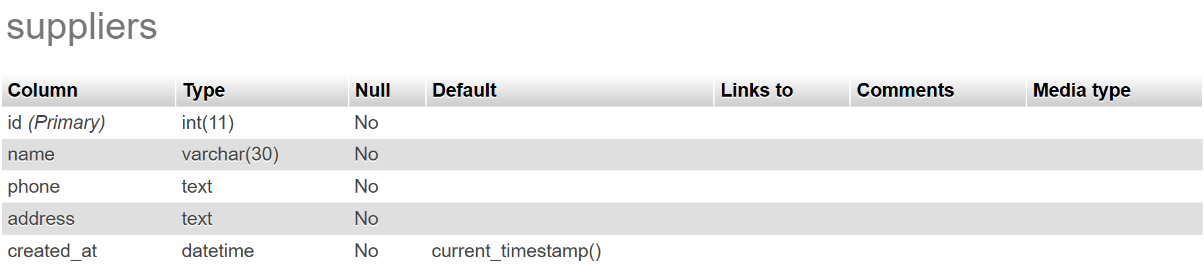
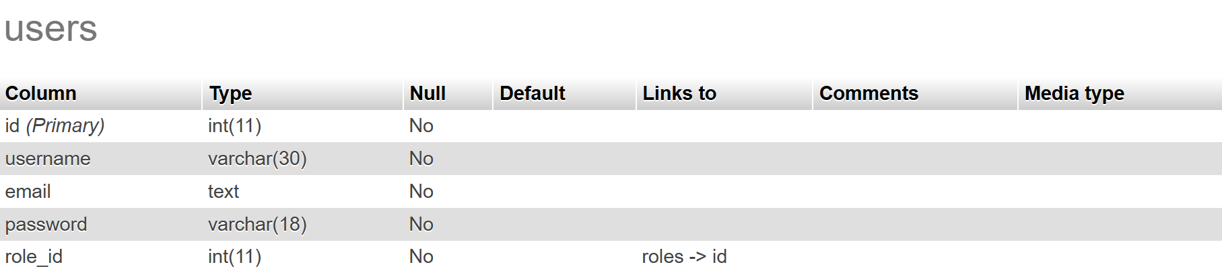

Data Flow Diagram
FLOW LINES

PROCESS

DATA STORE

ENTITY

- Context Level DFD for Rifat Enterprise IMS(0 level):

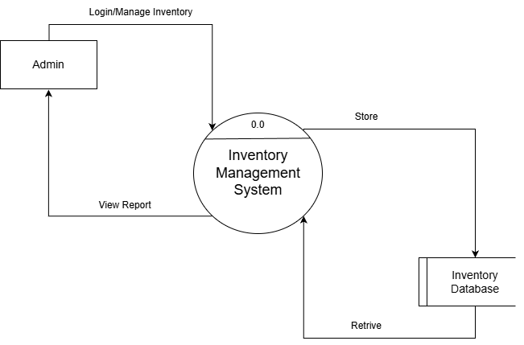

- First Level DFD for Rifat Enterprise IMS (1 level):

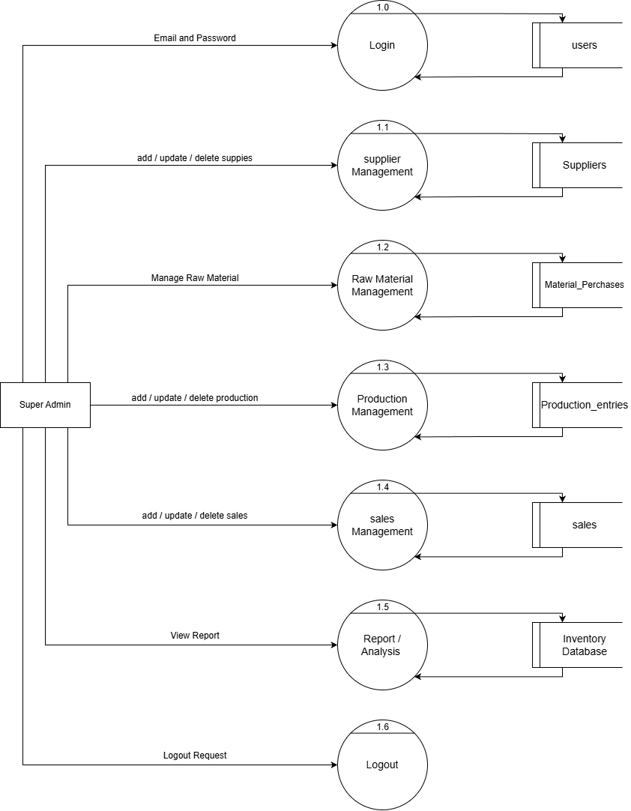

ER Diagram

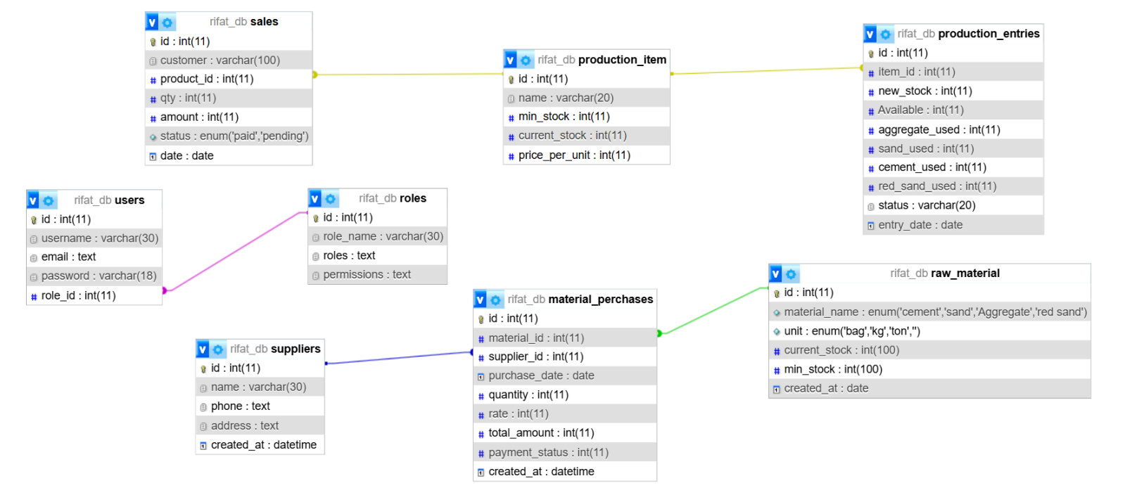

UML Diagram

UML:- A system diagram is a way to visualize systems and software using unified modelling language.
1. Use Case Diagram

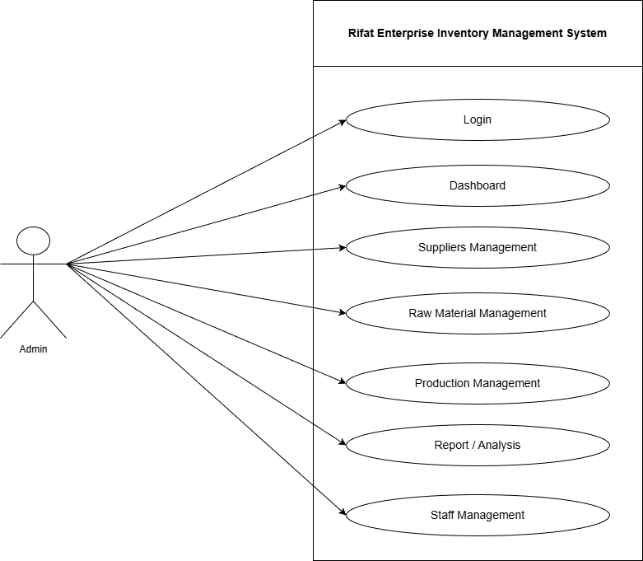

2. Activity Diagram

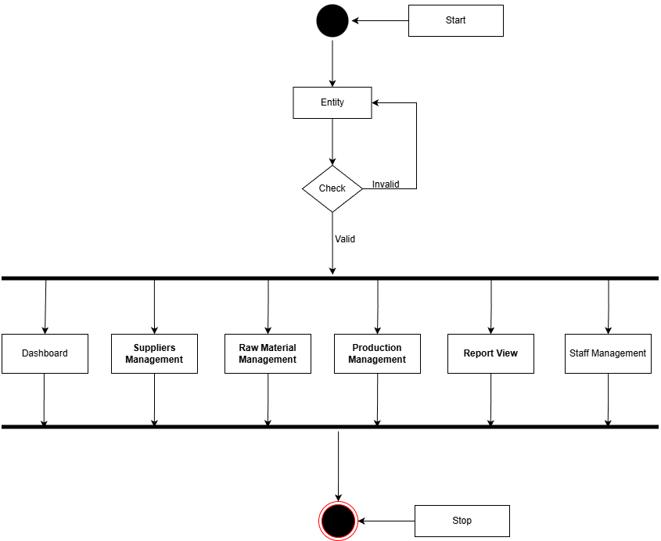

Sequence Diagram

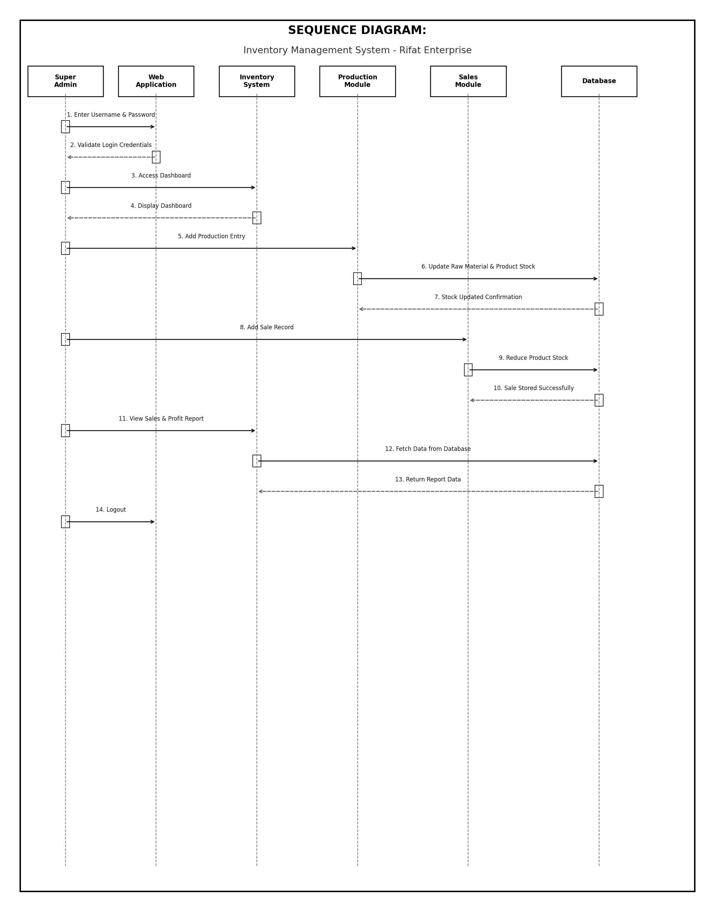

Class Diagram

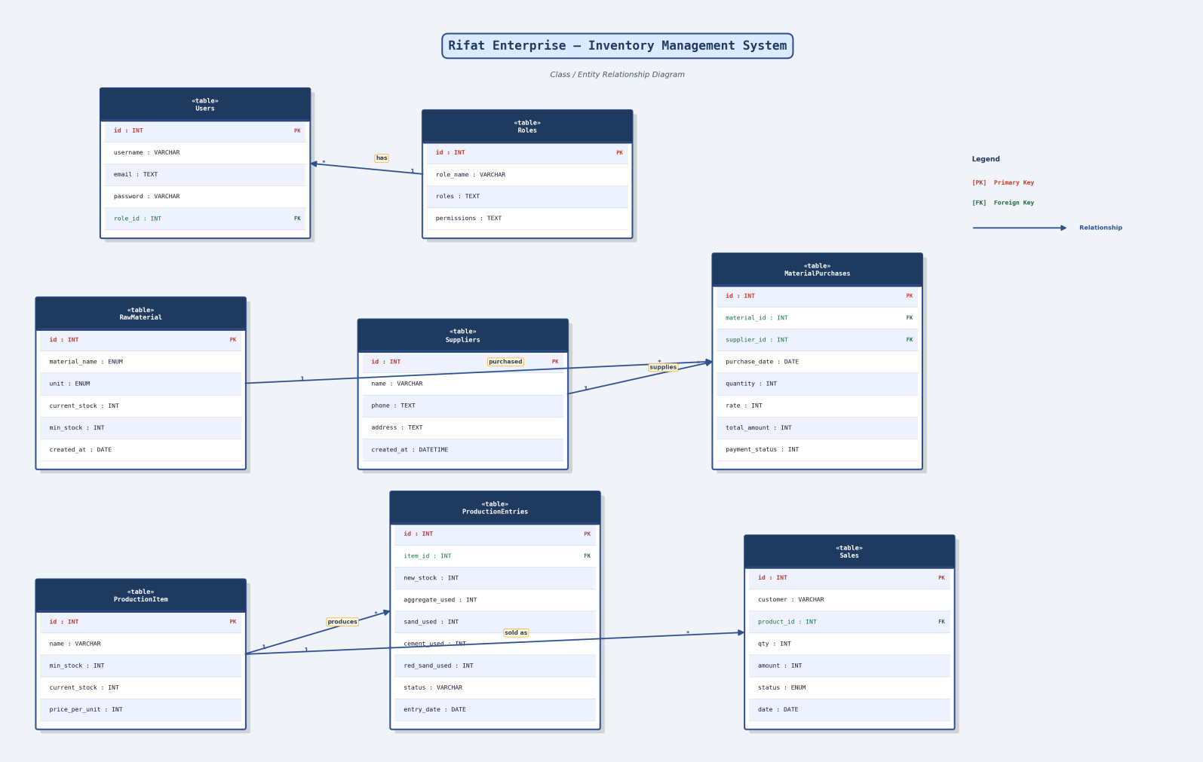
Application Screenshot
Login :-
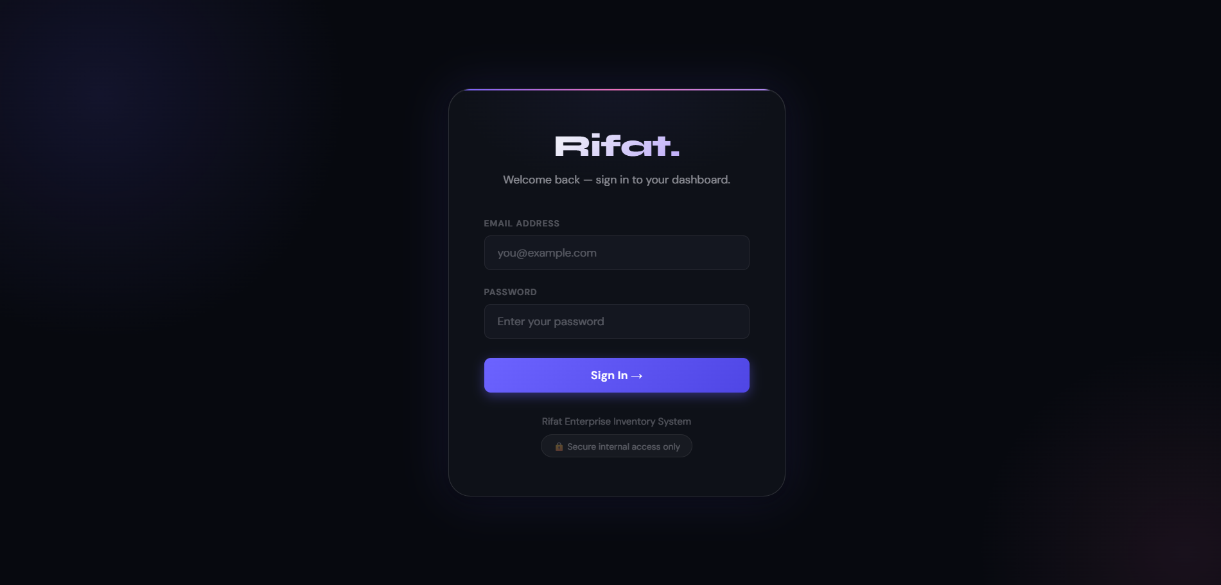

Dashboard :-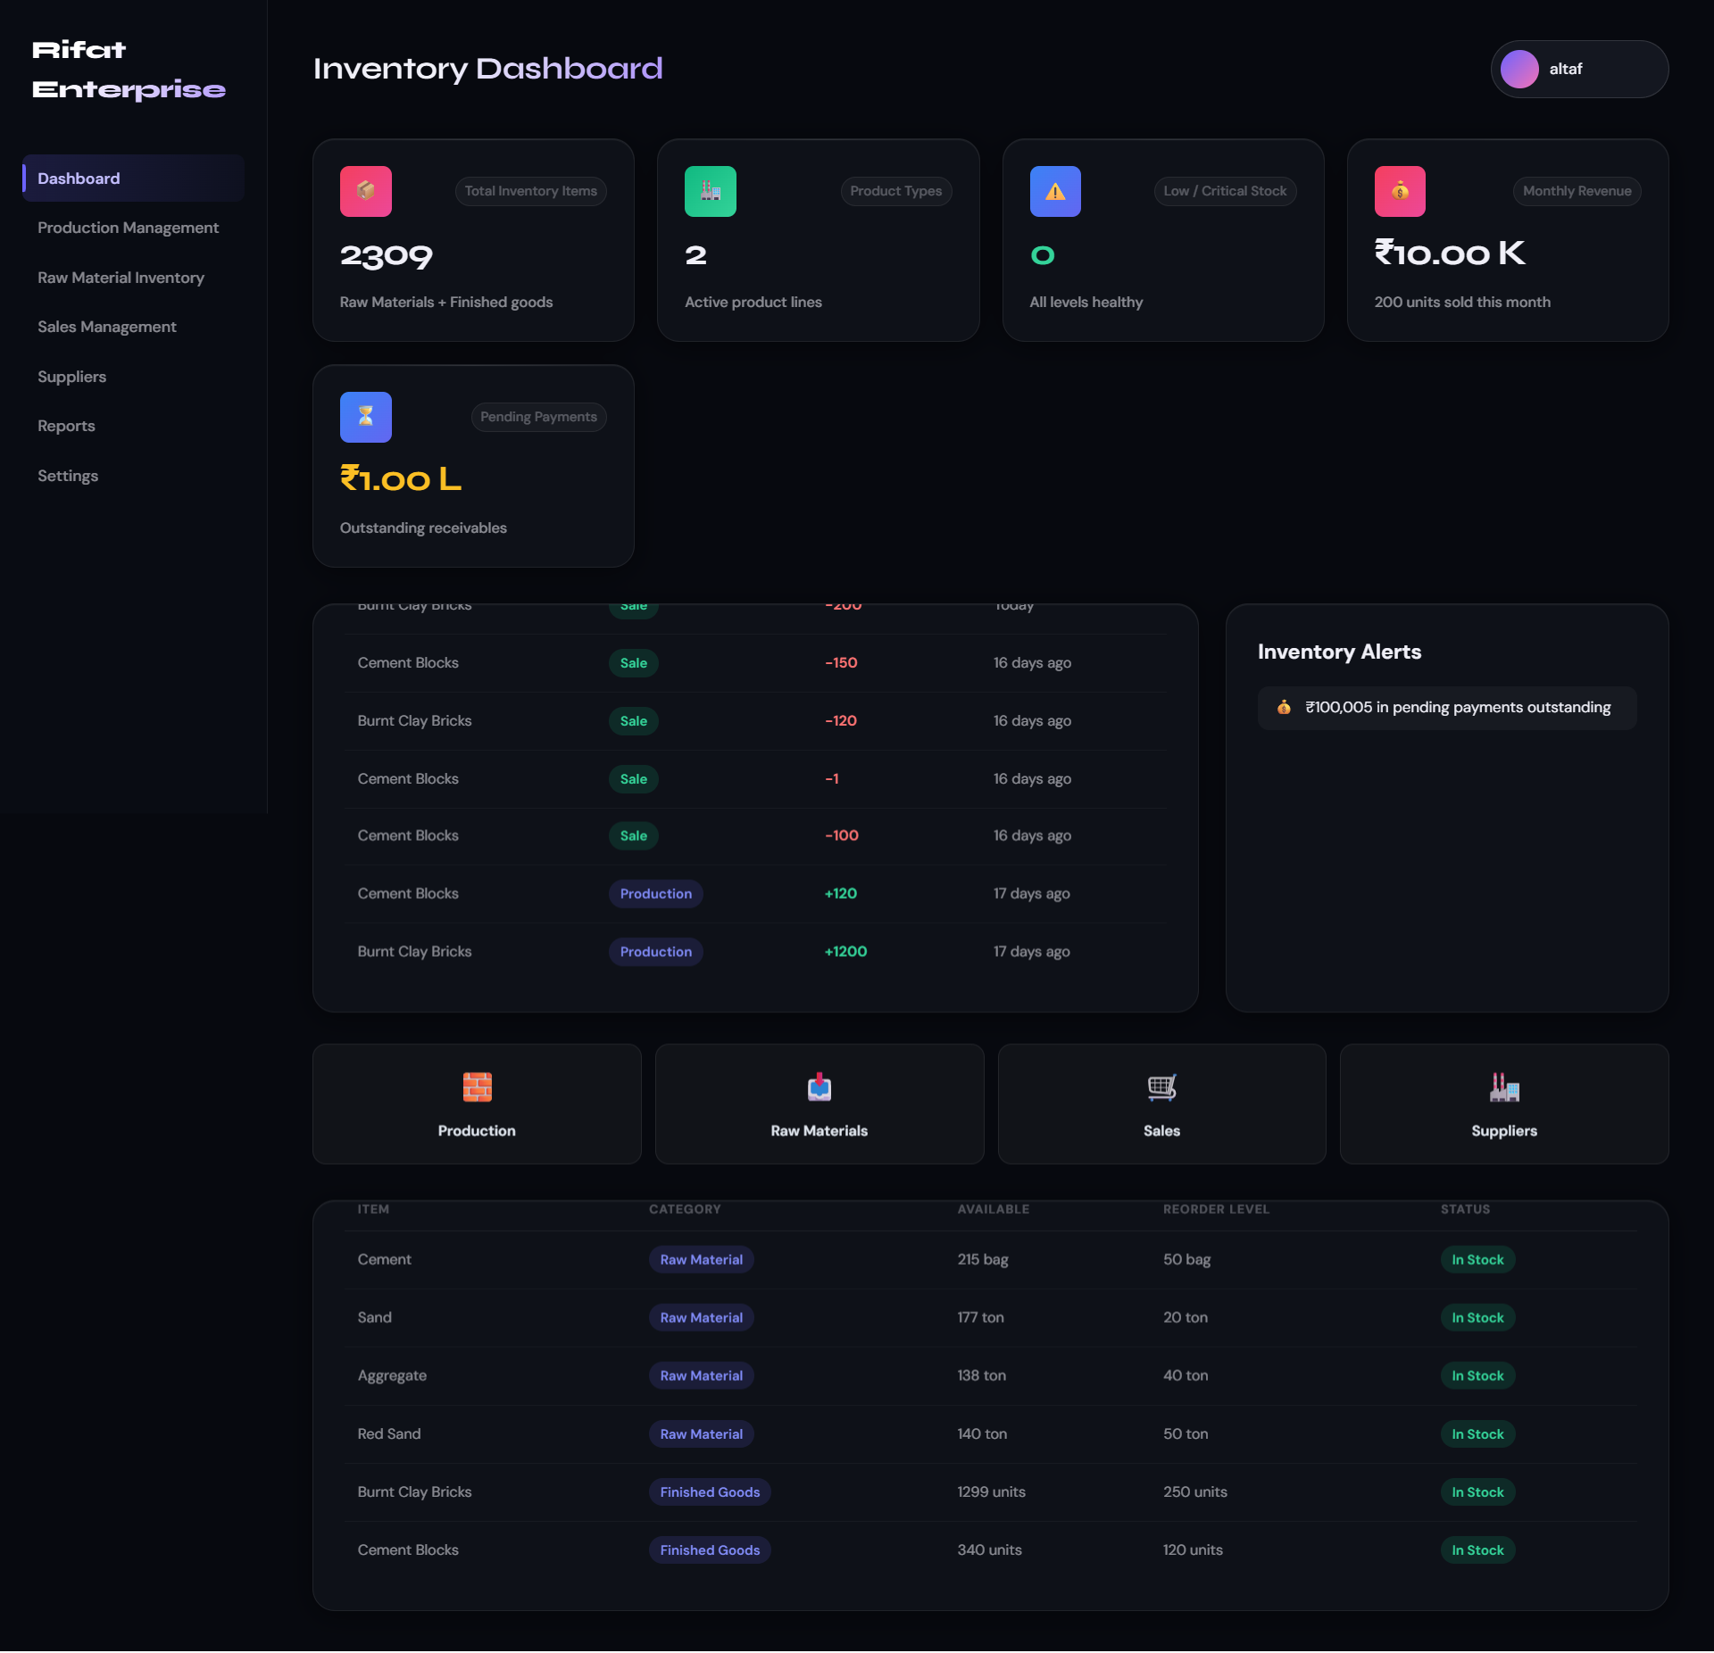

Production Management :-
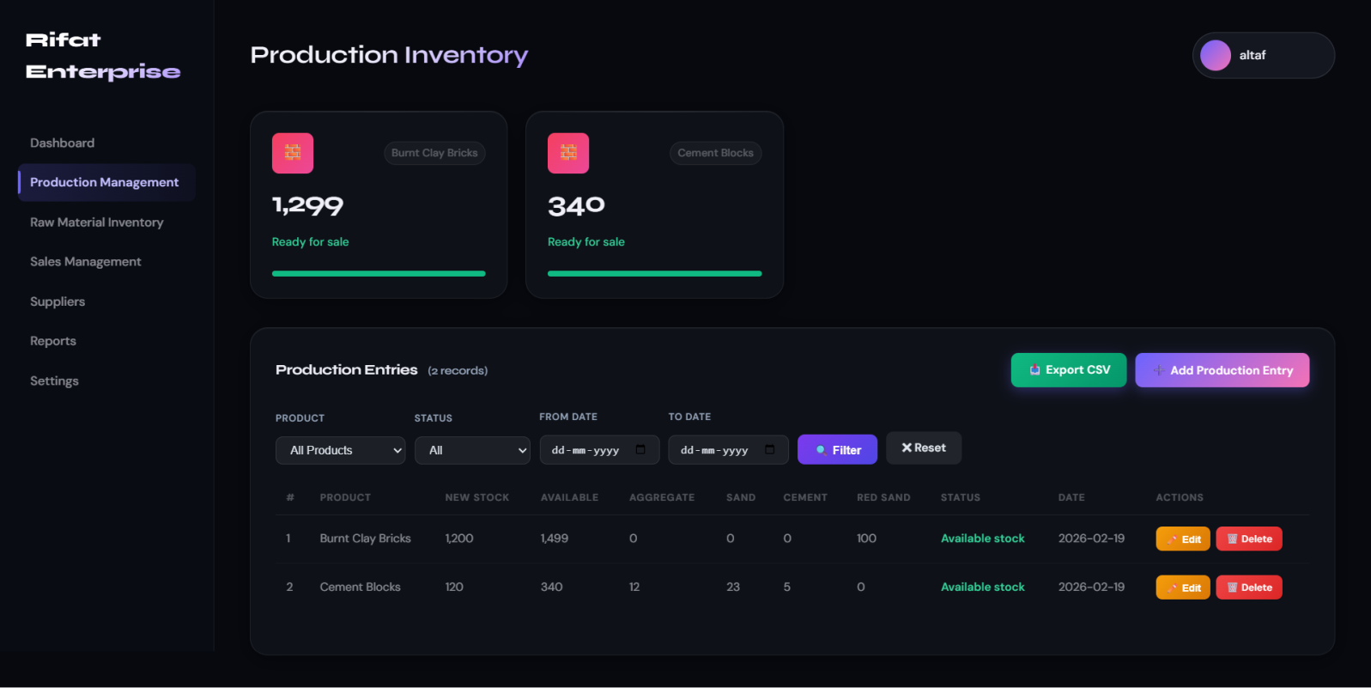

Raw Material Management :-
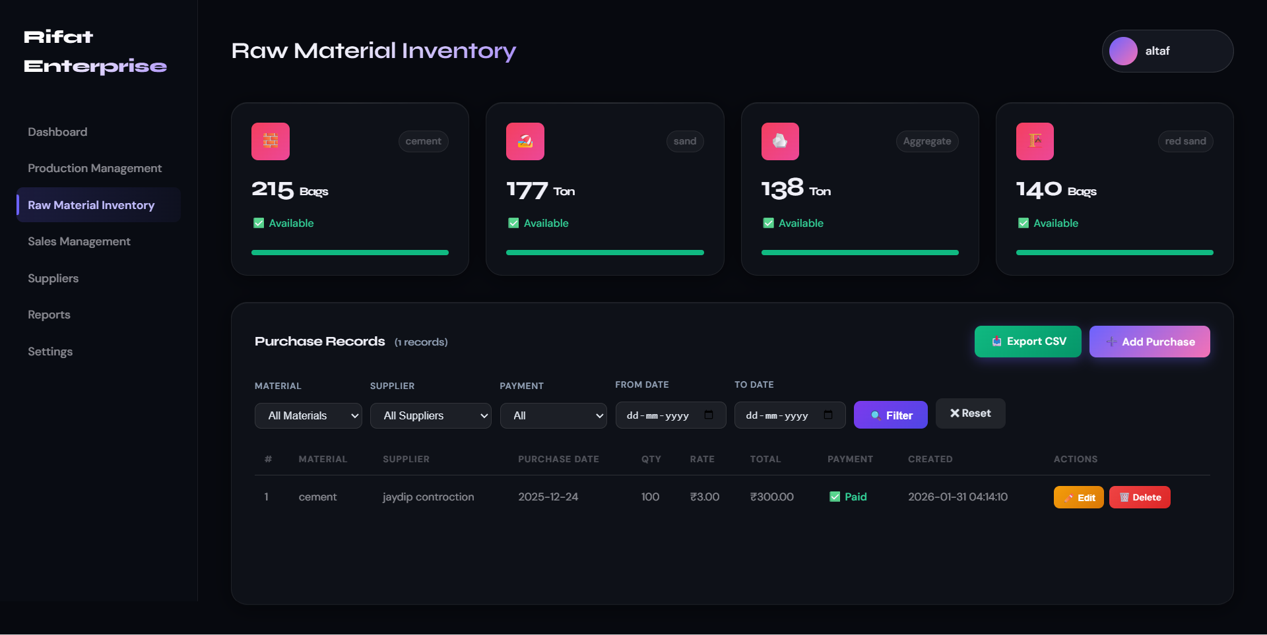

Sales Management :-
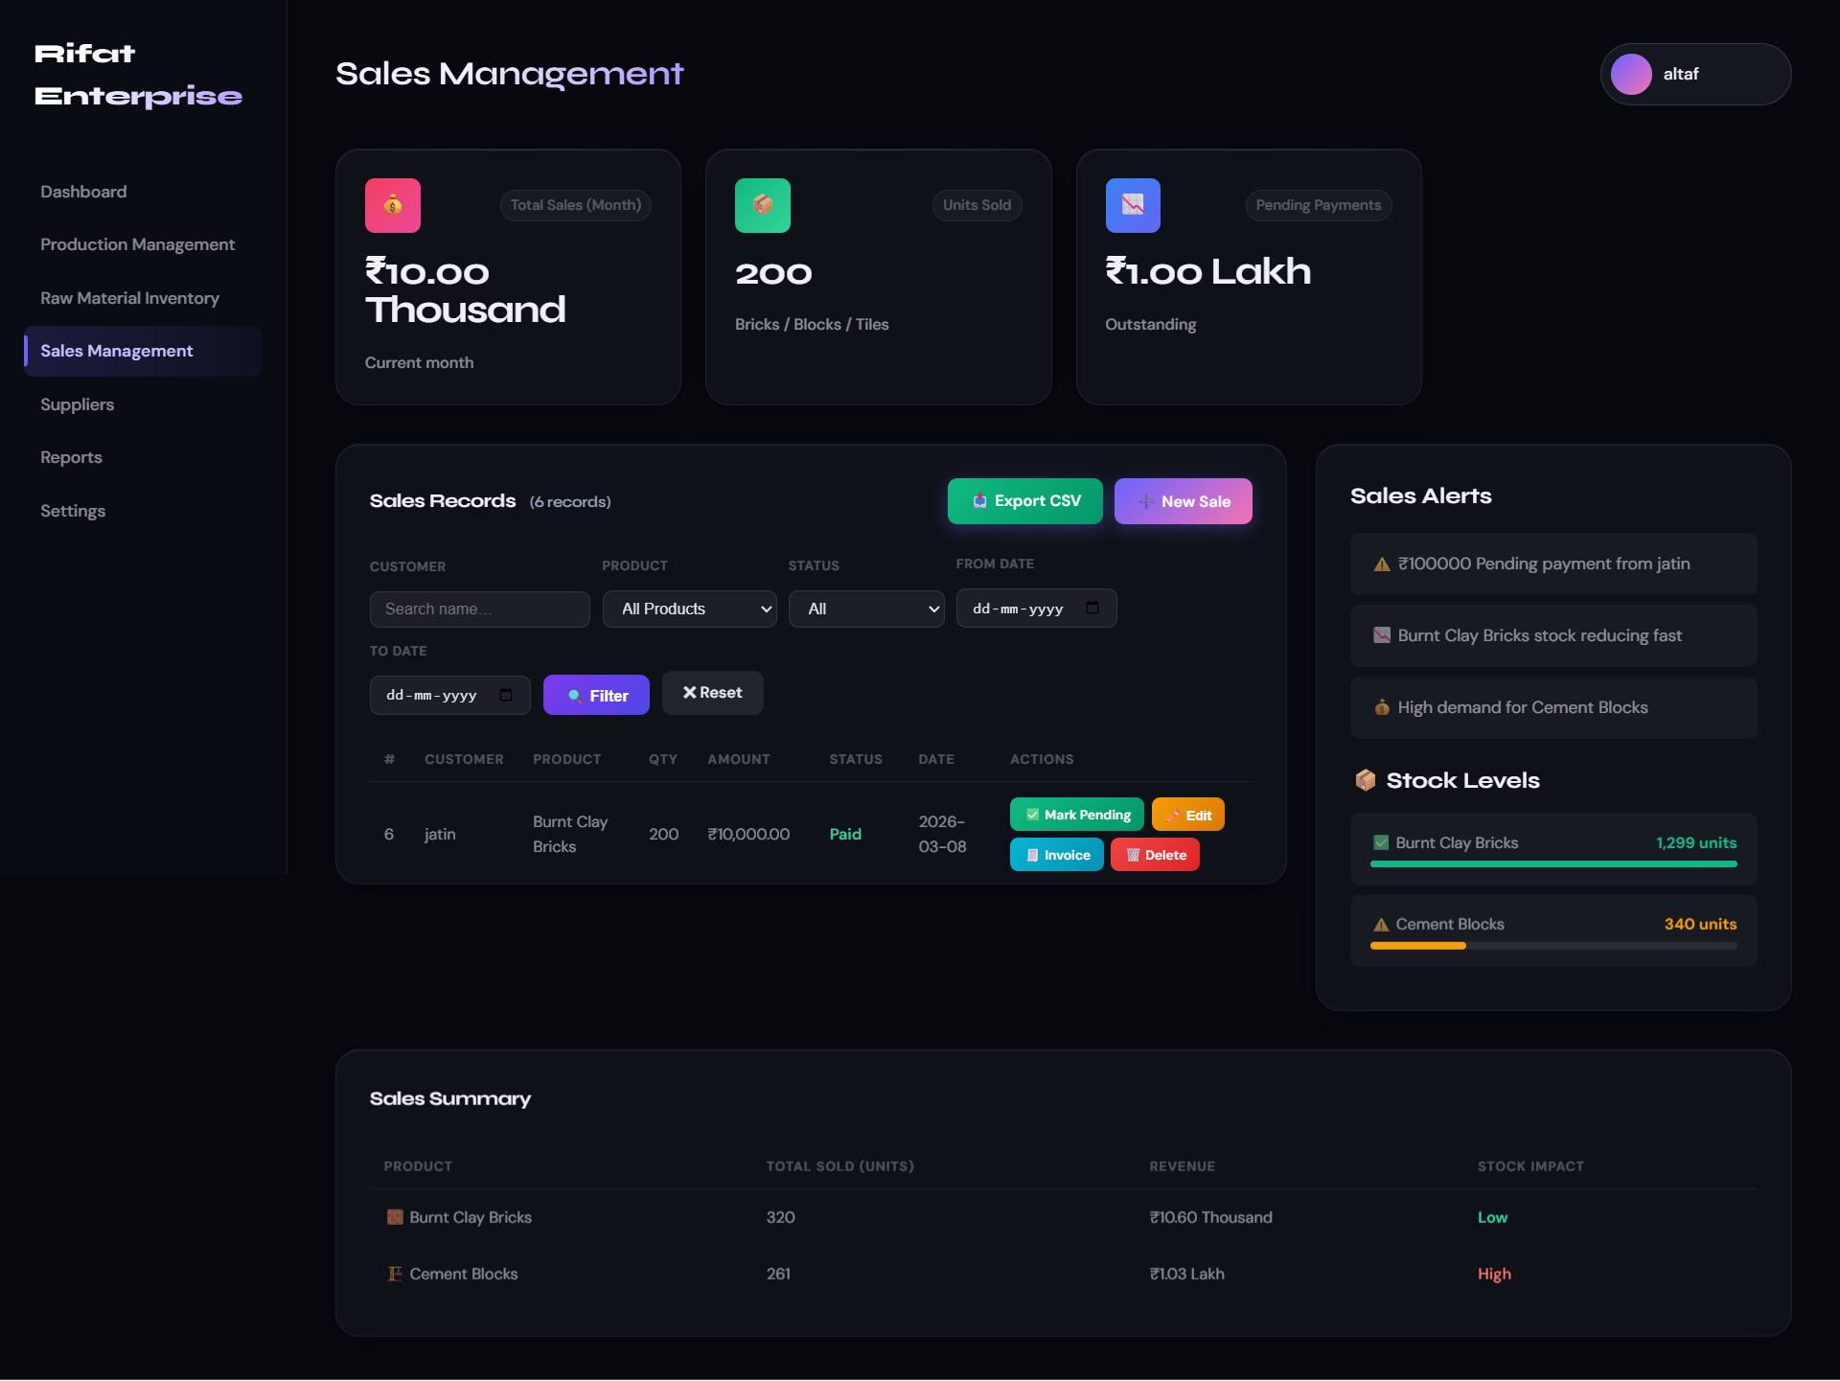

Suppliers Management :-
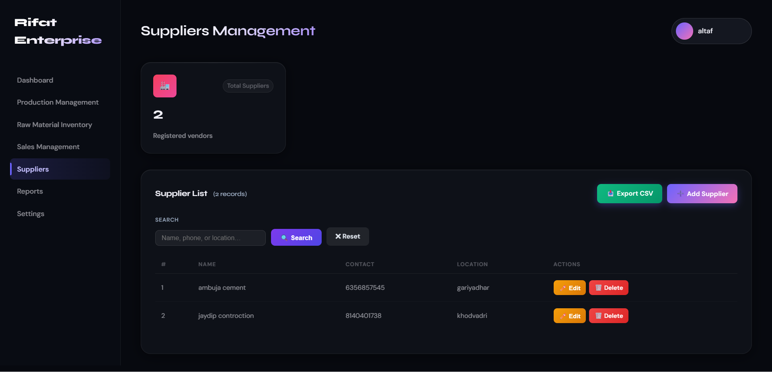
Sales Management :-
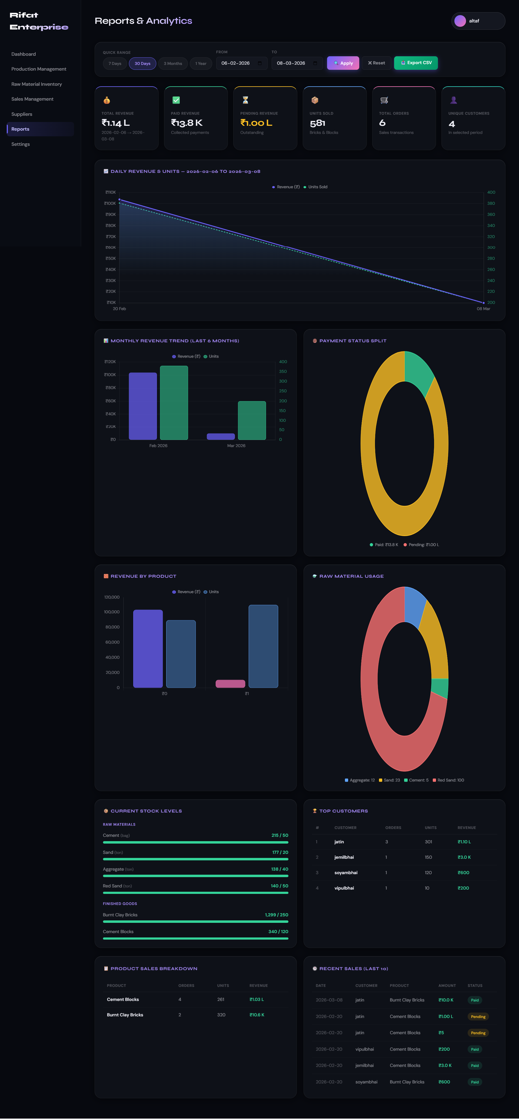
Settings :-
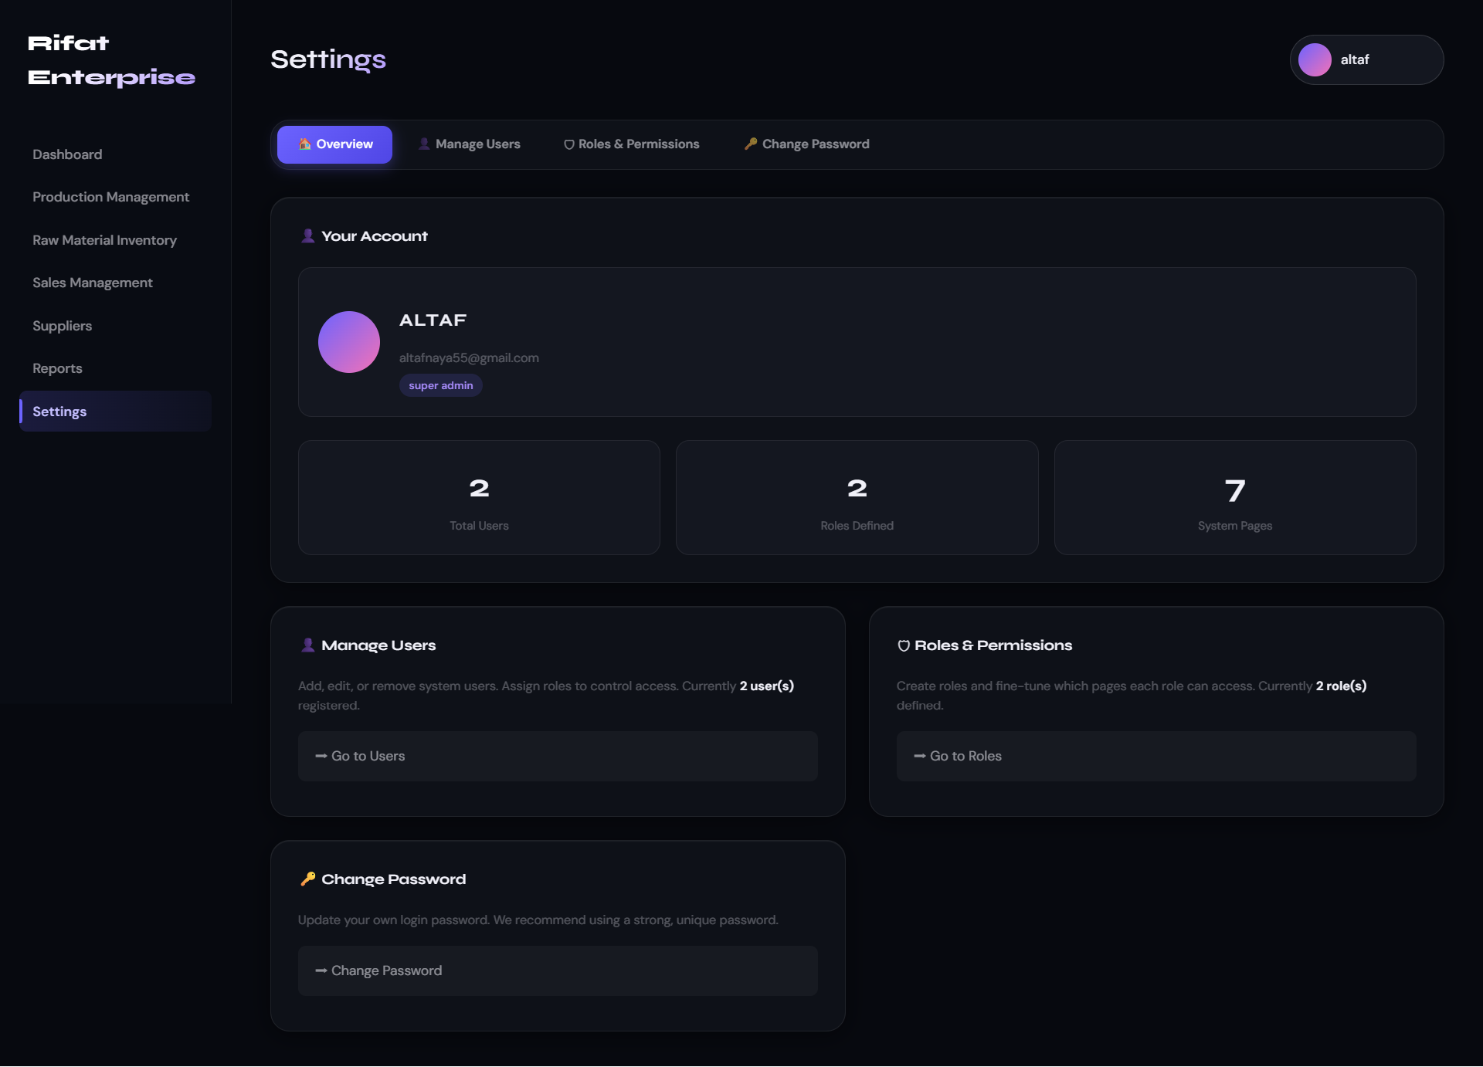

Sales Management :-
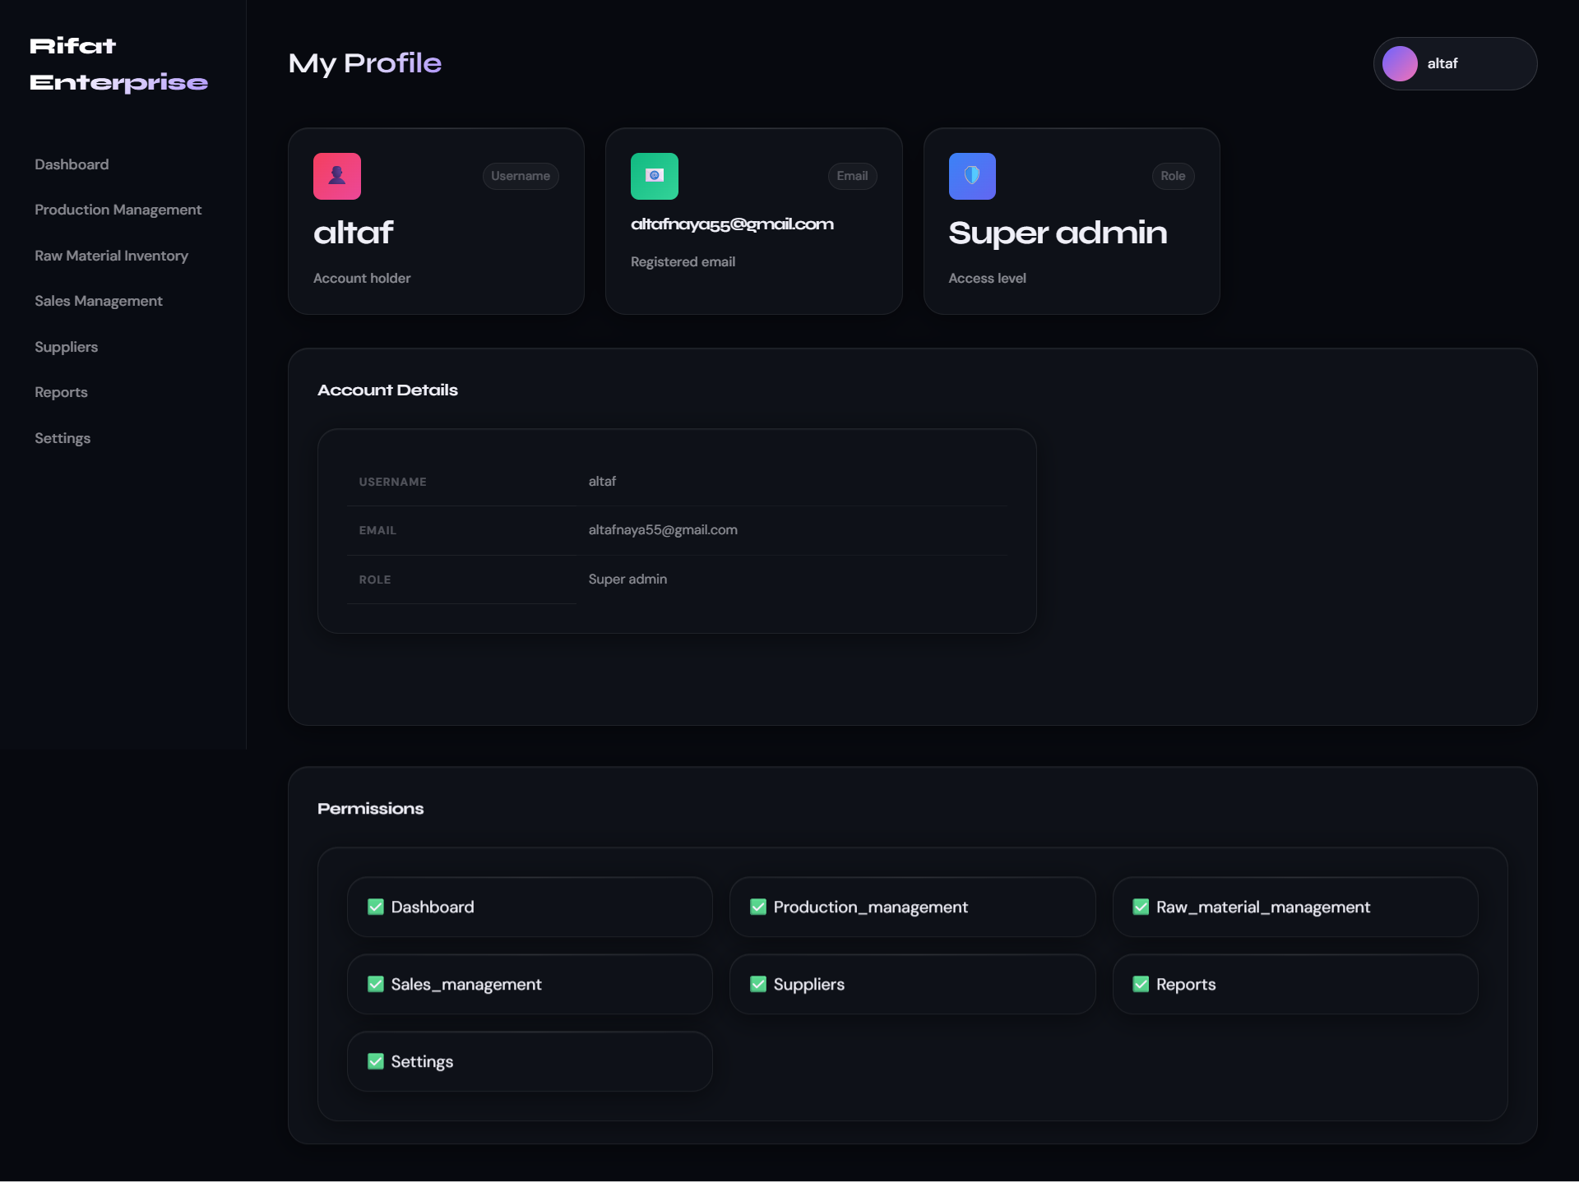

Code Screenshot
User Login/Register page :-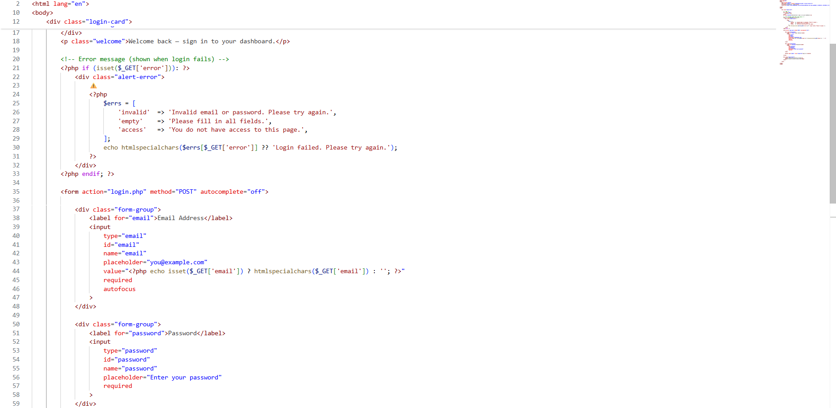

Home page :-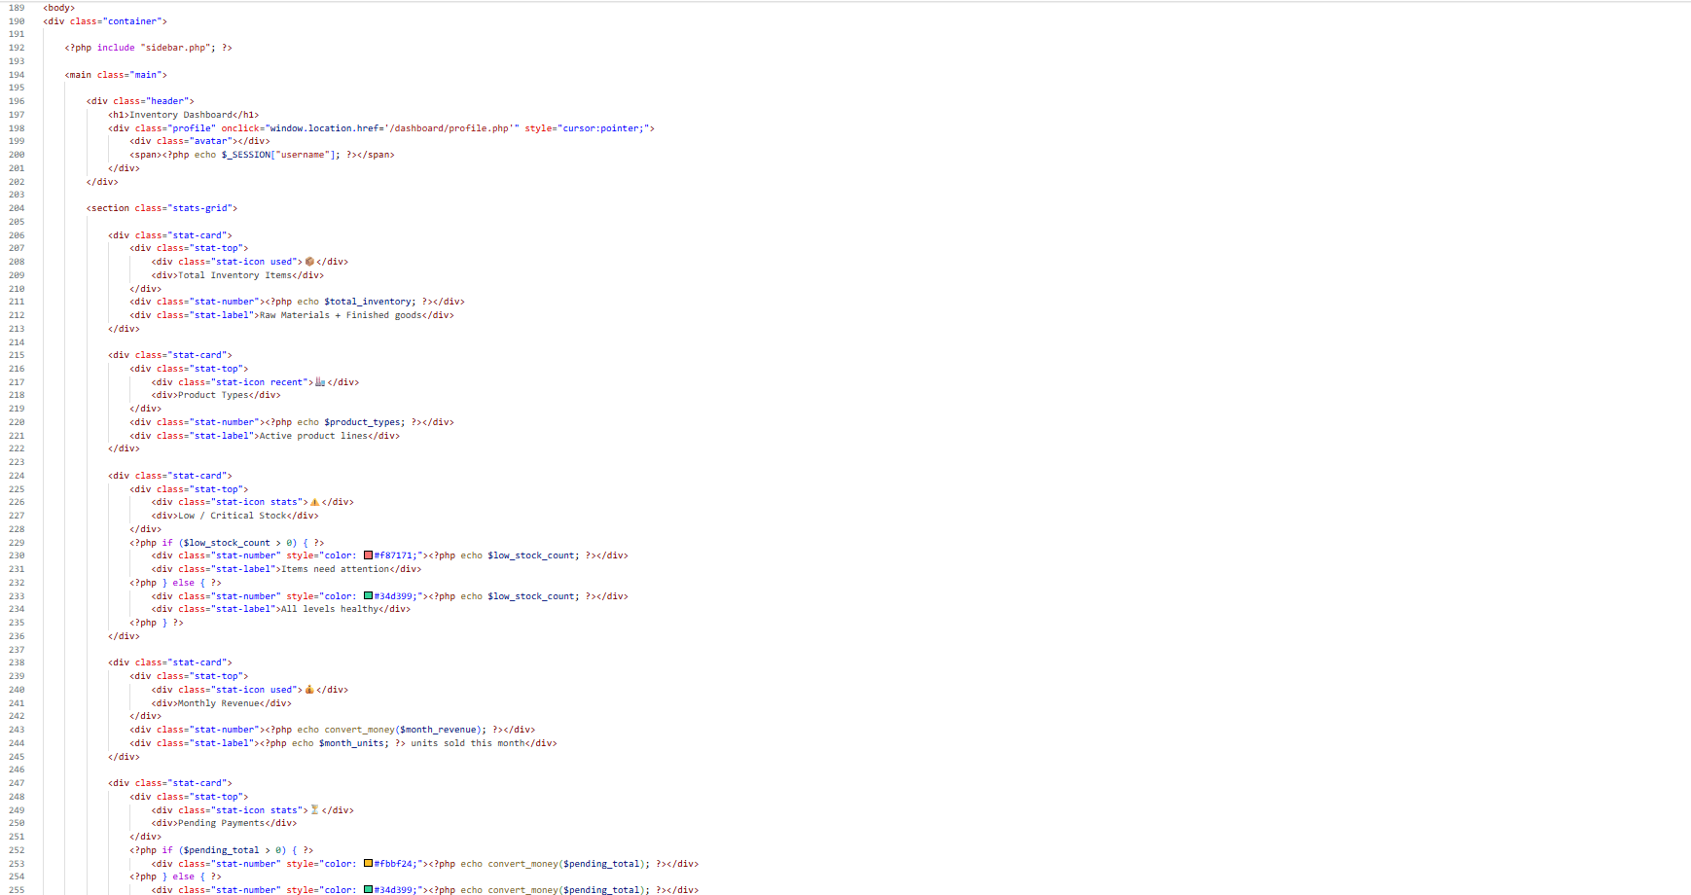 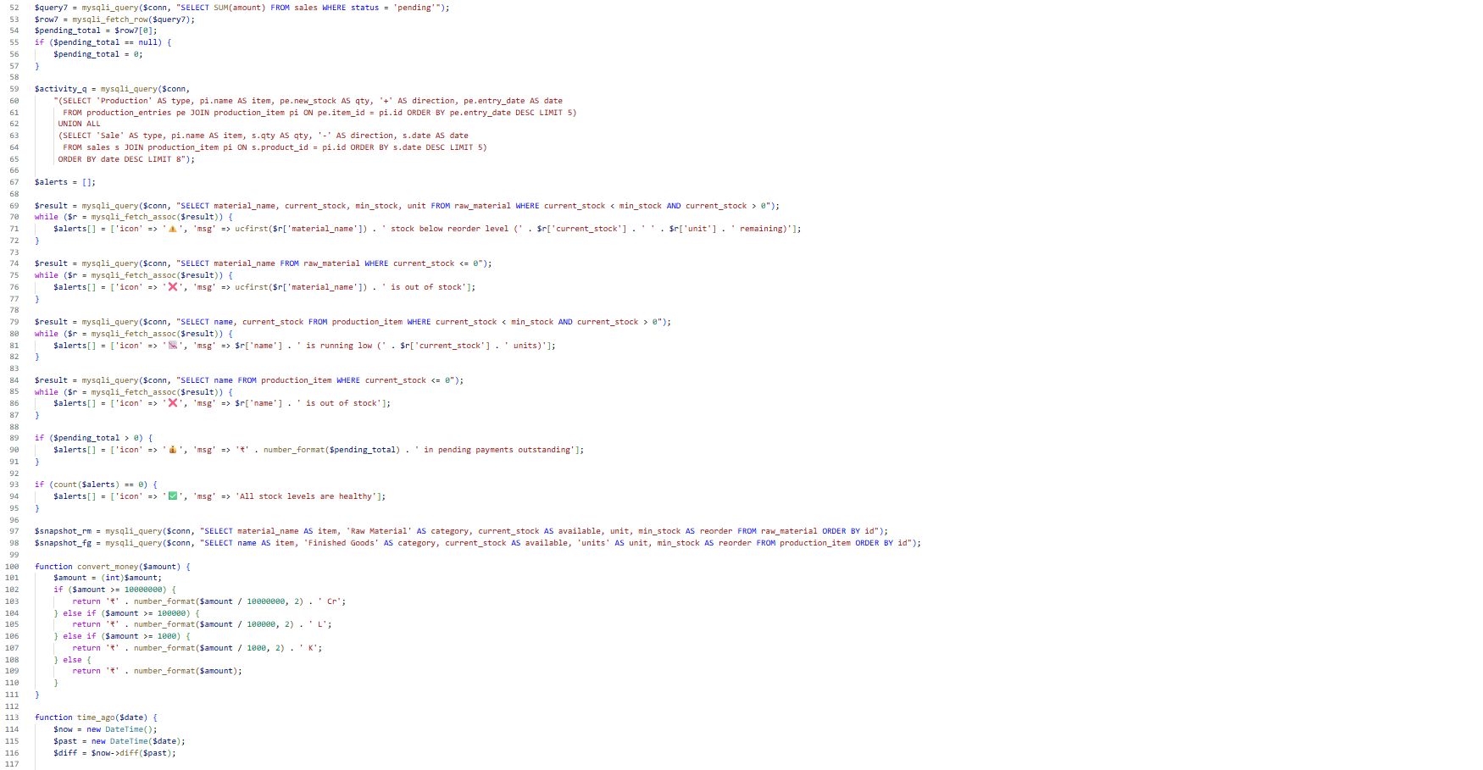

Production Management page :-
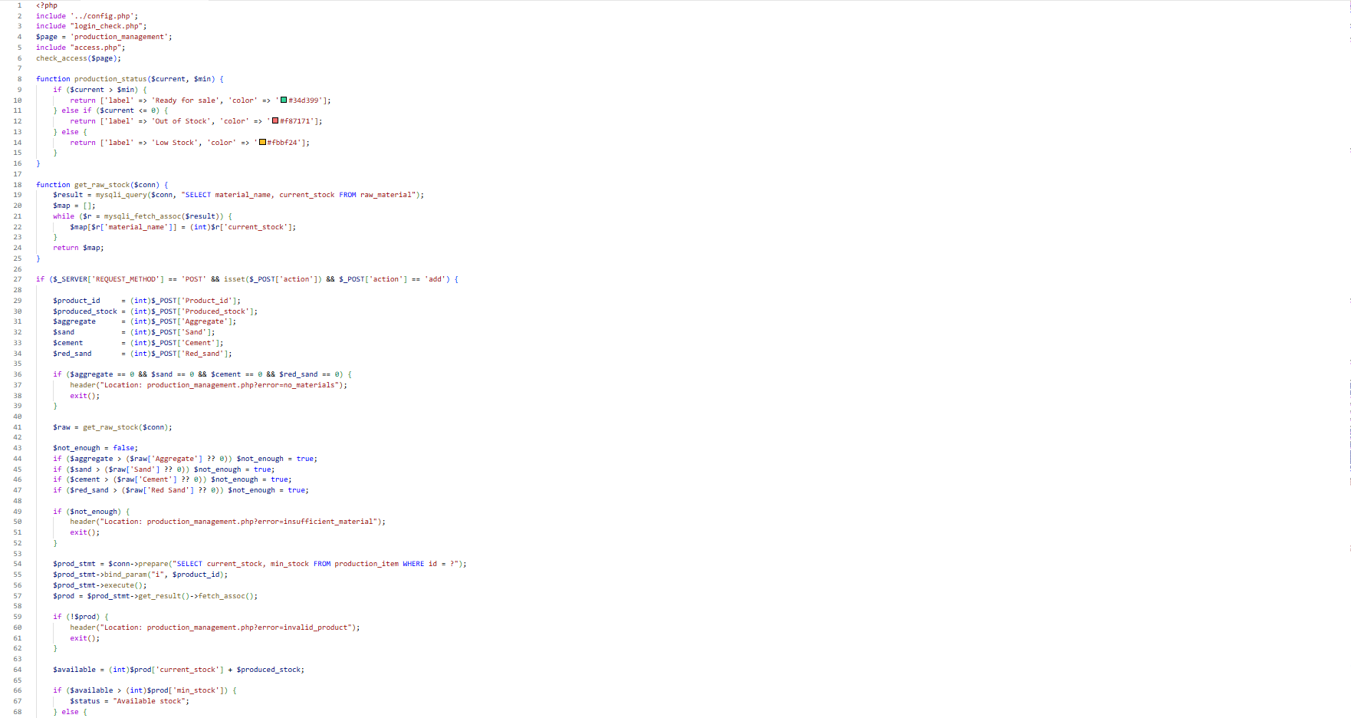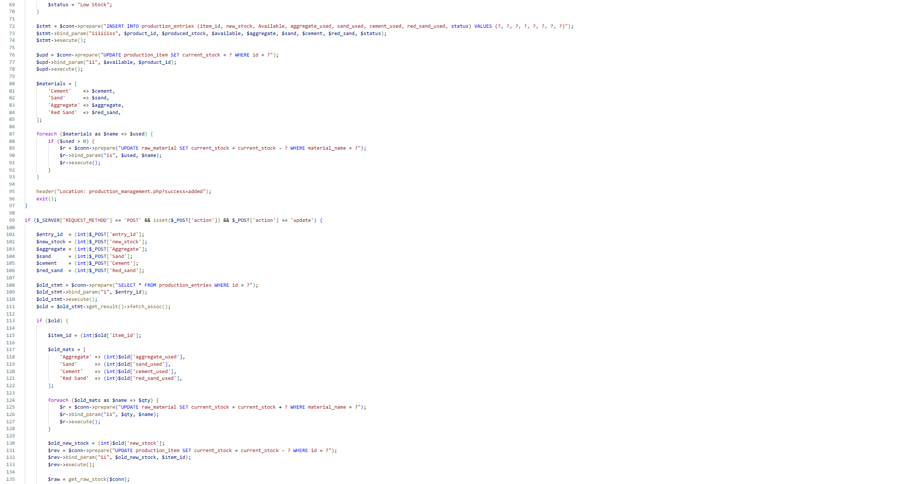

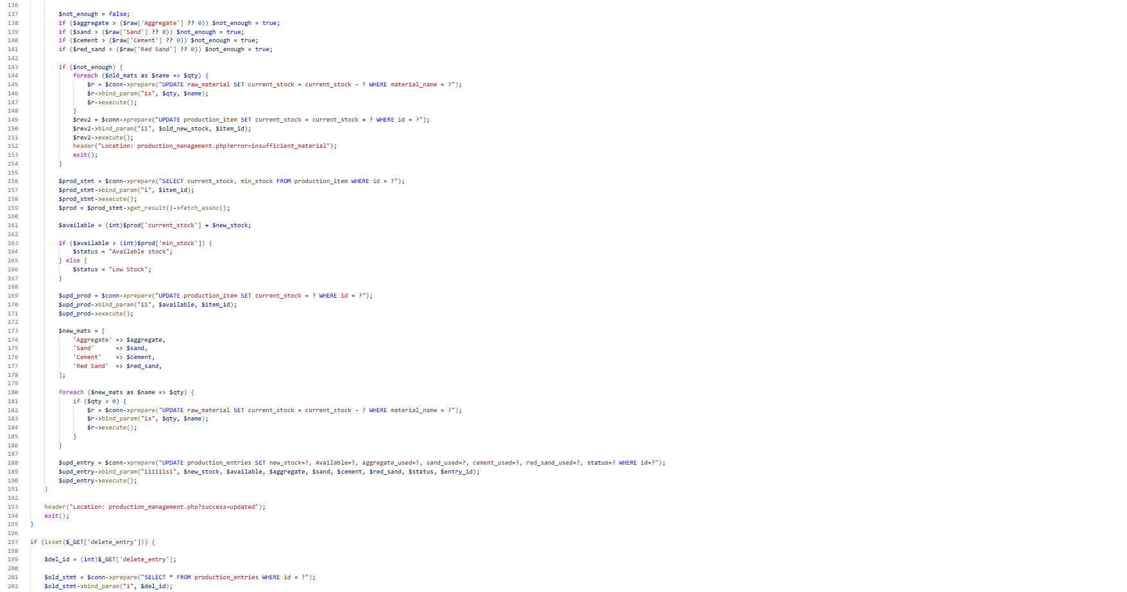

Testing

What is Testing ?

Testing is the process of evaluating and verifying that a software product or application.

Does what it is supposed to do.

Types of Testing
- Manual testing
- Automation testing
Manual Testing



- White Box Testing:-
- It is Software testing technique that
Involves testing the internal structure and working of a software application.

- Black Box Testing:-
- A form of testing that is performed with no knowledge of a systems
Internals.

- Gray Box Testing:-
- In Gray box testing, the tester is not required to design test case.

Test Case

Login Form
Test case ID | Test Step | Input Data | Expected Result | Actual Result | Execution status
01 | Enter Email and  Password &click on Login button | Enter Valid Email & Password | User Should be go on Dashboard page | User Login Successfully | Successfully
02 | Enter Email and  Password &click on Login button | Enter invalid Email& Valid  Password | Invalid email or password  message will be display | User Not Login Successfully | Successfully
03 | Enter Email and  Password &click on Login button | Enter valid Email & invalid  Password | Invalid email or password  message will be display | User Not Login  Successfully | Successfully
04 | Enter Email and  Password &click on Login button | Enter invalid Email &  Password | Invalid email or password  message will be display | User Not Login Successfully | Successfully
05 | Enter any page with unauthorized access | Without email & password | Redirect to login page | Redirecting to login page | successfully

Pros and Cons For System

- Advantage Of Project (Pros):-

- Reduce Manual Paper work and Error.
- Provide real time Stock Tracking.
- Save Time in Inventory Management.
- Easy Report Generation.
- Secure Role Based and login access Controls.

- Limitations of Projects (Cons):-

- Requires Internet or System availability.
- Staff need basic training to use system.
- Risk of data loss without proper backup
- Dependence on computer system

Bibliography

Bibliography means take reference to prepare any project.
Here we are concern the book and websites which takes reference is as under.

- Reference :-

1. Google Search Engine :
- https://www.google.com
2. Youtube :
- https://www.youtube.com
3.Geeksfogeeks :
- https://www.geeksforgeeks.org
3.Claude AI :
- https://www.claude.ai

