1. **Flowchart:**

Flowchart diagram of the given quick sort algorithm is shown in the below:

**Algorithm:**

**QUICKSORT(A, p, r)**

**if p < r**

**then q ← PARTITION(A, p, r)**

**QUICKSORT(A, p, q − 1)   
QUICKSORT(A, q + 1, r)**

**where the PARTITION procedure is as follows:  
PARTITION(A, p, r)**

**x ← A[r]   
i ← p − 1   
for j ← p to r − 1**

**do if A[j] ≤ x**

**then i ← i + 1**

**exchange A[i] ↔ A[j]**

**exchange A[i + 1] ↔ A[r]  
return i + 1**

**Flowchart diagram:**

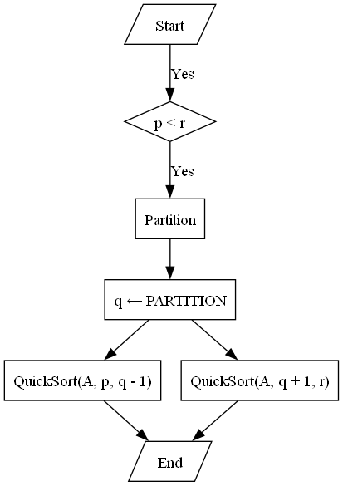

1. **Graph:**

Here is the graph of the given algorithm where n1, n2, n3… shows the nodes and e1, e2, e3… shows the edges of the graph.  
**Graph image:**

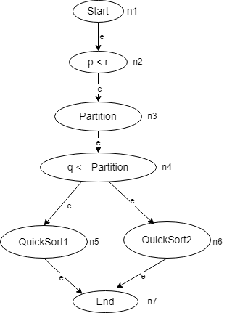

1. **cyclomatic complexity:**

cyclomatic complexity of the given quick sort algorithm can be calculated by:  
  
**M = E - N + 2**

Where:

* M is the cyclomaticcomplexity.
* E is the number of edges in the graph.
* N is the number of nodes in the graph.

From the above graph, we can count the number of edges (E) and nodes (N)

M = E - N + 2

= 8 - 7 + 2

= 3

**So cyclomatic complexity = 3**