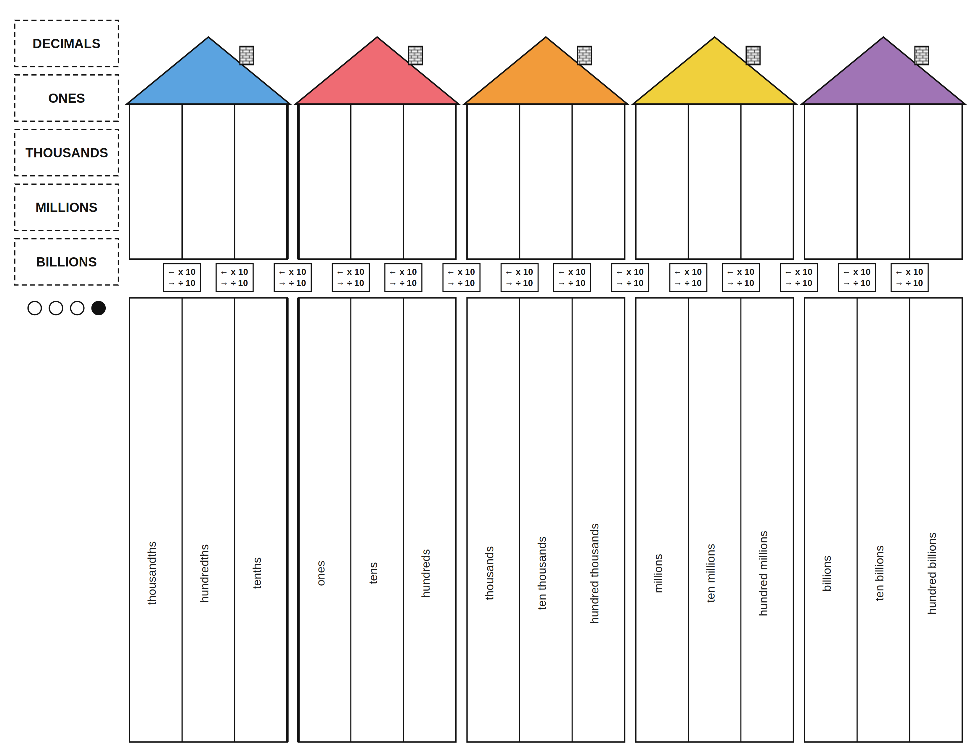
DECIMALS
ONES
THOUSANDS
MILLIONS
BILLIONS

