DESIGN ALGORITHM AND ANALYSIS

Lab-1

Name : Inbarasu S S
Roll No: ch.sc.u4cse24242

1) Write a program to find the sum of n natural numbers using user defined function
Code:
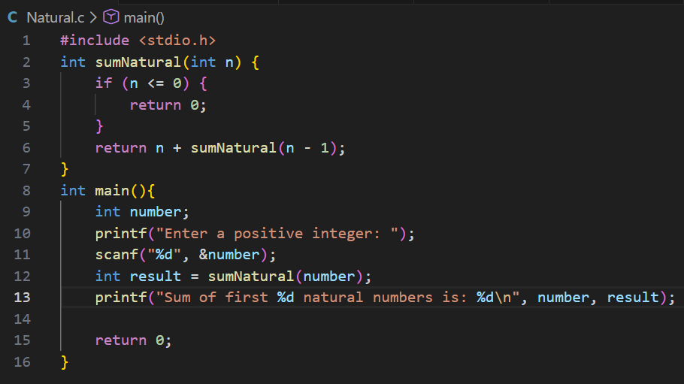
Output:
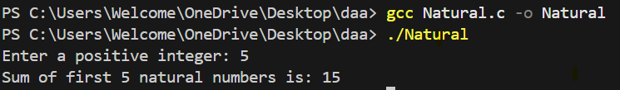
Interpretation:
Say n=5;
By iterating through recursive call
N+sumnatural(n-1); where n<=0
sumNatural(0) = 0
sumNatural(1) = 1 + 0 = 1
sumNatural(2) = 2 + 1 = 3
sumNatural(3) = 3 + 3 = 6
sumNatural(4) = 4 + 6 = 10
sumNatural(5) = 5 + 10 = 1
2) Write a program to find the sum of squares of n natural numbers using user defined function
Code:
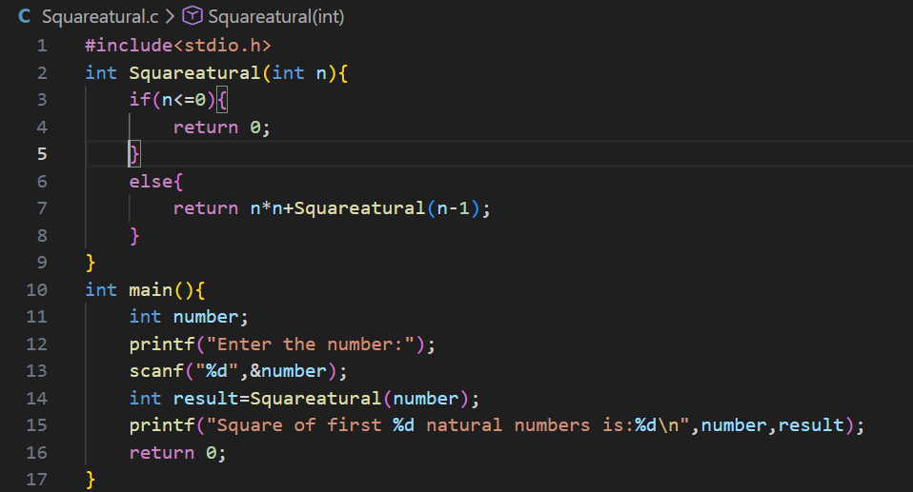Output:
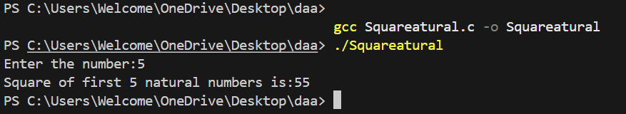

Interpretation:
Say n=3;
By the recursive call n*n+squareNatural(n-1); base condition: n<=0;
3*3+squareNatural(2)
Squareatural(0) = 0
Squareatural(1) = 1 + 0 = 1
Squareatural(2) = 4 + 1 = 5
Squareatural(3) = 9 + 5 = 14
3) Write a program to find the sum of cubes of first n natural numbers
Code:
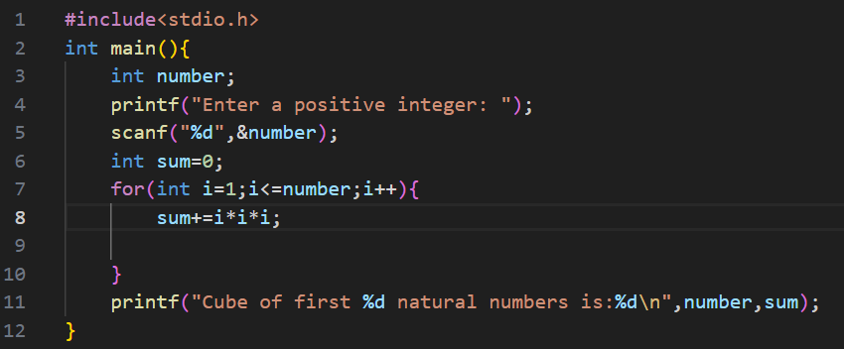
Output:
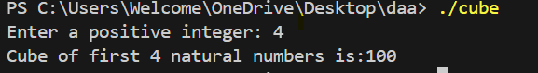

Interpretation:
Say number=4;
For(int i=0;i<n;i++){
Sum+=i*i*i
1*1*1+2*2*2+3*3*3+4*4*4=1+8+27+64=100

4) Write a program to find the factorial of the give number using recursive function
Code:
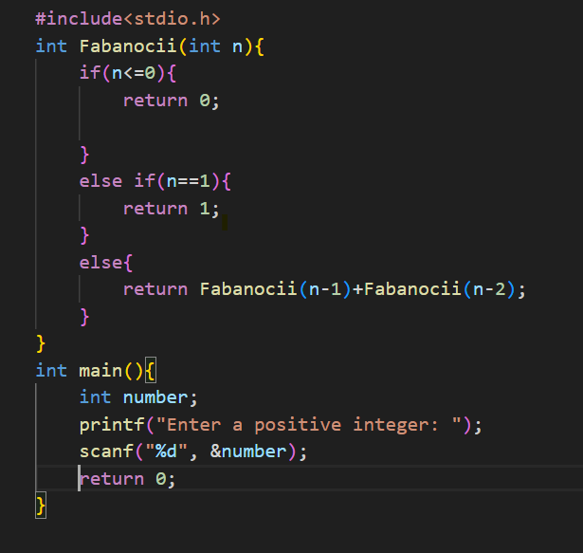
Output:
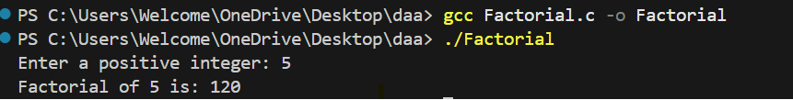
Interpretation:
Base condition: if(n<=0) the iteration stops
If the give number is 1 then the Fibonacci number is 1 give in the if condition
Else: say n=5
factorial(1) = 1
factorial(2) = 2 * 1 = 2
factorial(3) = 3 * 2 = 6
factorial(4) = 4 * 6 = 24
factorial(5) = 5 * 24 = 120
5) Write a program to find the transpose of a Matrix using a user defined function
Code:
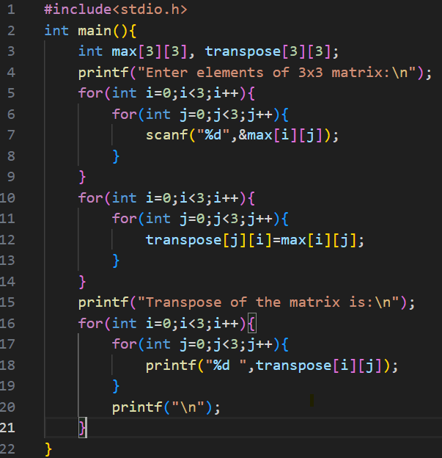
Output

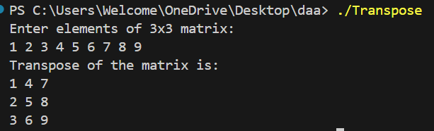
Interpretation:
Getting the input matrix, then run a loop to iterate then for the condition
transpose[i][j]=matrix[j][i]
It will change the rows to column and column to rows

6) Write a program to print the Fibonacci series up to a given number using a user-defined function
Code:
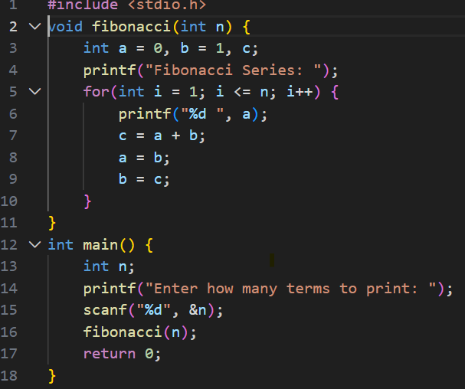
Output:
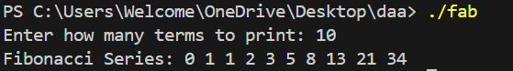
Interpretation:
n = 4
a = 0
b = 1
Iteration 1 (i = 1):
Print: 0
c = a + b = 0 + 1 = 1
a = b = 1
b = c = 1
Iteration 2 (i = 2):
Print: 1
c = a + b = 1 + 1 = 2
a = b = 1
b = c = 2
Iteration 3 (i = 3):
Print: 1
c = a + b = 1 + 2 = 3
a = b = 2
b = c = 3
Iteration 4 (i = 4):
Print: 2
c = a + b = 2 + 3 = 5
a = b = 3
b = c = 5
Final Output:
Fibonacci Series: 0 1 1 2

