1. **To automated Facebook signup?**

* Code output:

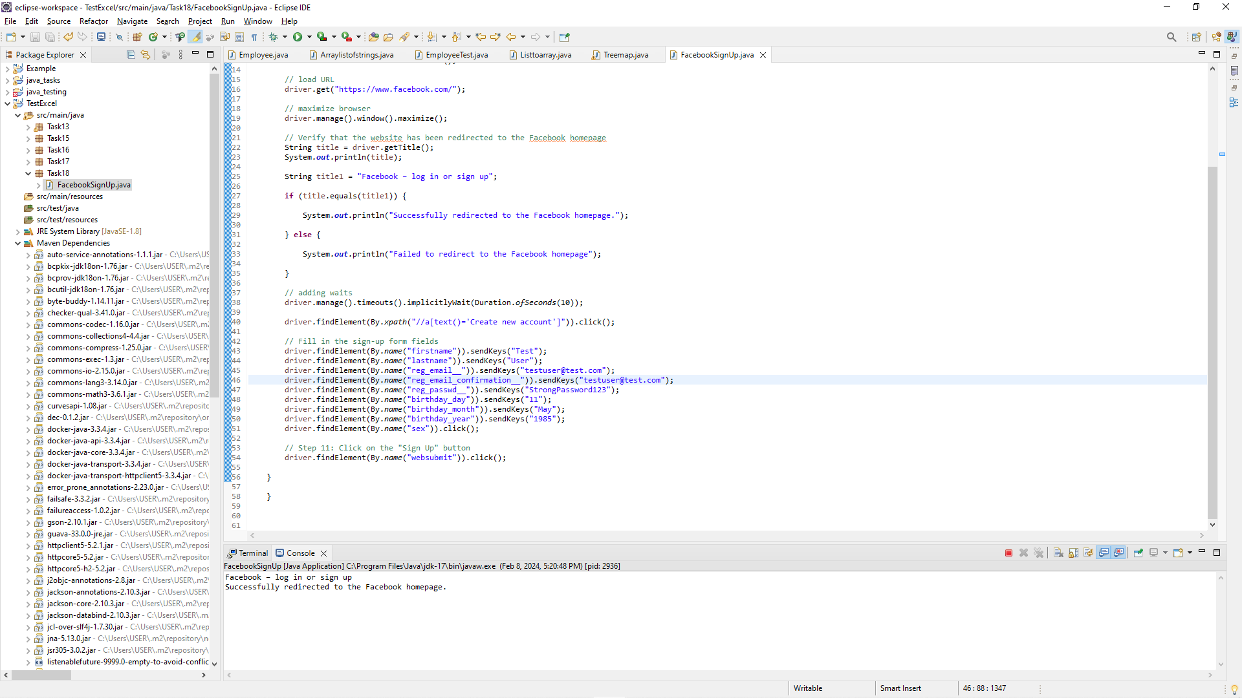

* Browser output:

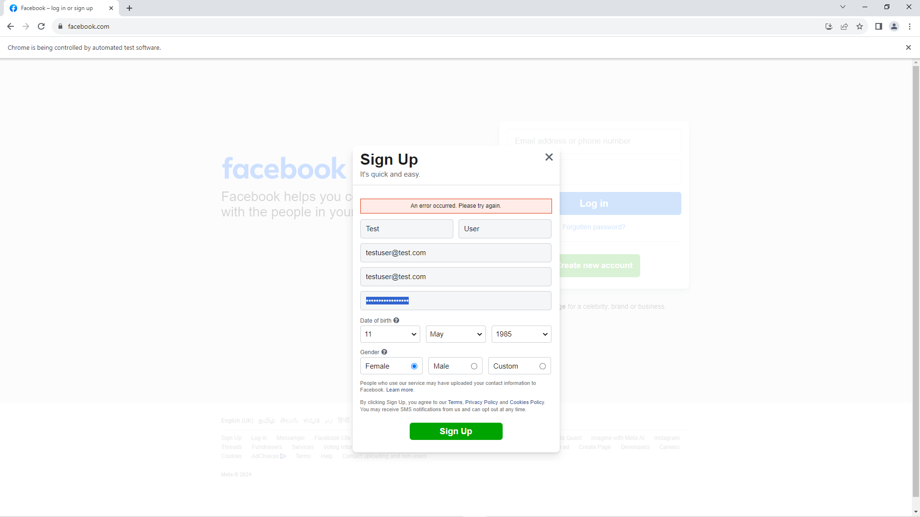

1. **To automate drag and drop operation?**

* **Browser output**

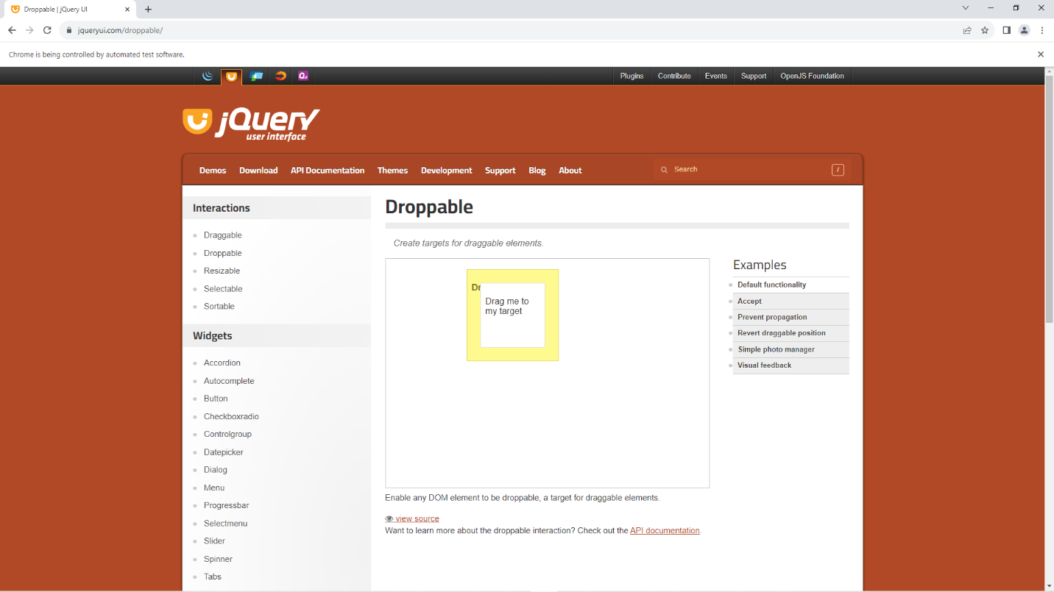

* **Code output**

