**Program:**

BLOCKCHAIN TECHNOLOGY

ASSIGNMENT

// SPDX-License-Identifier: MIT

pragma solidity ^0.8.0;

contract ZoneNameContract {

    function getZoneName() public pure returns (string memory)

     {

        return "Zone name";

     }

}

# ABI:

[

{

"inputs": [],

"name": "getZoneName", "outputs": [

{

"internalType": "string", "name": "",

"type": "string"

}

],

"stateMutability": "pure", "type": "function"

}

]

# Bytecode:

608060405234801561001057600080fd5b50610173806100206000396000f3fe6080604052348015610010576

00080fd5b506004361061002b5760003560e01c8063235ed70f14610030575b600080fd5b61003861004e565b

604051610045919061011b565b60405180910390f35b60606040518060400160405280600981526020017f5a6 f6e65206e616d650000000000000000000000000000000000000000000000815250905090565b600081519050 919050565b600082825260208201905092915050565b60005b838110156100c5578082015181840152602081

0190506100aa565b60008484015250505050565b6000601f19601f8301169050919050565b60006100ed82610

08b565b6100f78185610096565b93506101078185602086016100a7565b610110816100d1565b840191505092

915050565b6000602082019050818103600083015261013581846100e2565b90509291505056fea2646970667 358221220d3d743a58da137e00a73e6844dab7d80779238ffd59dd52ea1c33b98e8daa91564736f6c634300081 20033

# Output:

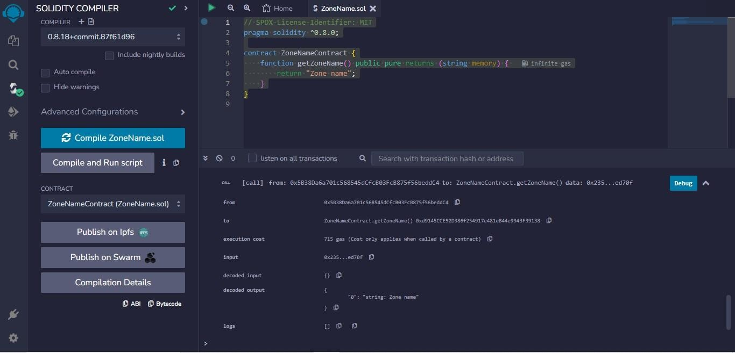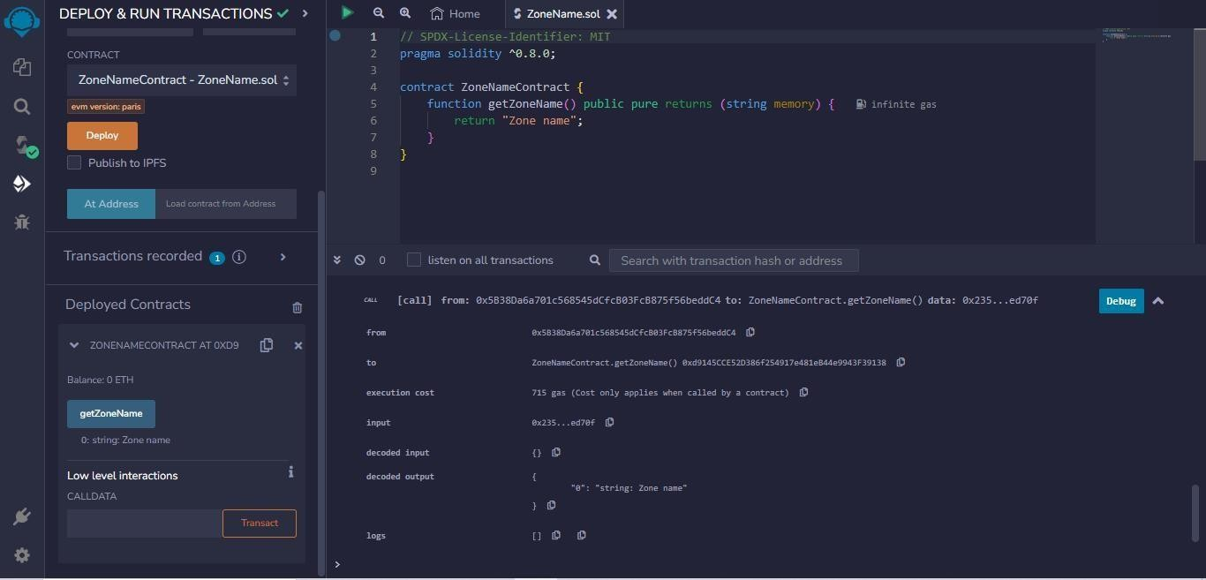

**Submitted By ,**

Inbaraj.K - 812020106011