|  |  |
| --- | --- |
|  | Central Bank Smart Contract |

**Step 1:**Open [Remix IDE](https://remix.ethereum.org/).

**Step 2:**Click on File Explorers and select Solidity in the environment and create a new file Banking.sol by clicking on New File section.

**Step 3:**Add the solidity code in the Banking.sol file.

// SPDX-License-Identifier: MIT

pragma solidity >=0.7.0 <0.9.0;

contract DBank

{

address Owner;

// We are creating the Mapping for the Adding & Transfer Amount in Account

mapping(address=>uint)Balance;

// constructor for the address of the Owner

constructor()

{

Owner = msg.sender;

}

// function for adding the Ethereum in Account

function addBalance(uint amount) public returns(uint)

{

// first we have to check the is it Owners Account or Not

require(msg.sender == Owner, "Yes it is Owner Account !!");

Balance[msg.sender] = Balance[msg.sender] + amount;

return Balance[msg.sender];

}

// function for Get the Balance from an Account

function getBalance() public view returns(uint)

{

return Balance[msg.sender];

}

// to transfer the Amount from Owner to Recipient

function Transfer(address recipient, uint amount) public

{

// check the Self account is or not

require(msg.sender != recipient, "Can't Transfer !! Self Account.");

// check the owner has balance is available or not

require(Balance[msg.sender] >= amount, "No, We Can't Transfer. Insufficient Balance !!");

_transfer(msg.sender, recipient, amount);

}

function _transfer(address From, address To, uint Amount) private

{

Balance[From] = Balance[From] - Amount;

Balance[To] = Balance[To] + Amount;

}

}

**Step 4:**Build a smart contract that contains all the details of the Bank with the help of Remix IDE by clicking on the file name, also check the compiler version at the top.

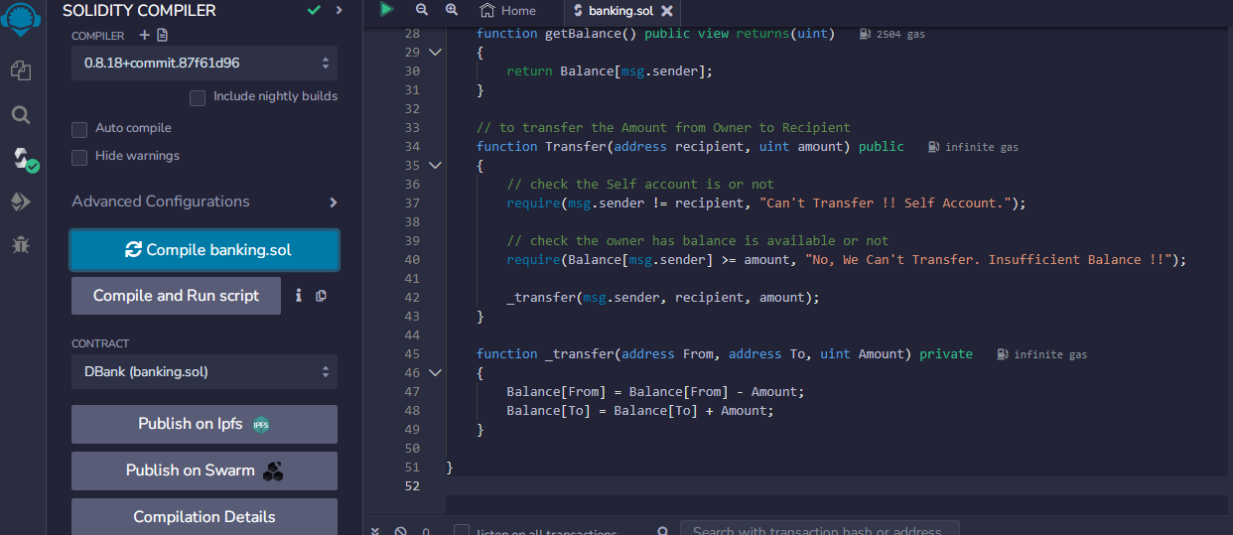

**Step 5:** After successful compilation, to deploy the contract. And the Contract Should be selected as Banking.sol

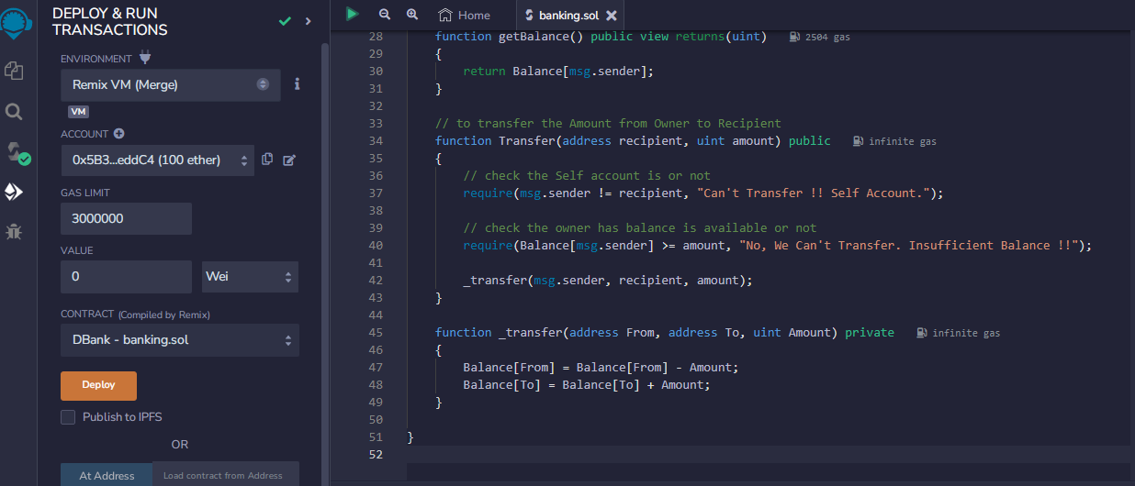

**Step 6:**If the contract is successfully deployed then the deployed contract is obtained. Open the deployed contract and add the details and transact it.

OUTPUT:

**1. Add Balance and Check Balance**

Add the Balance in DBank Press on Transact. It will show in the all transaction tab (bottom size). After adding get the balance as the amount that are we adding

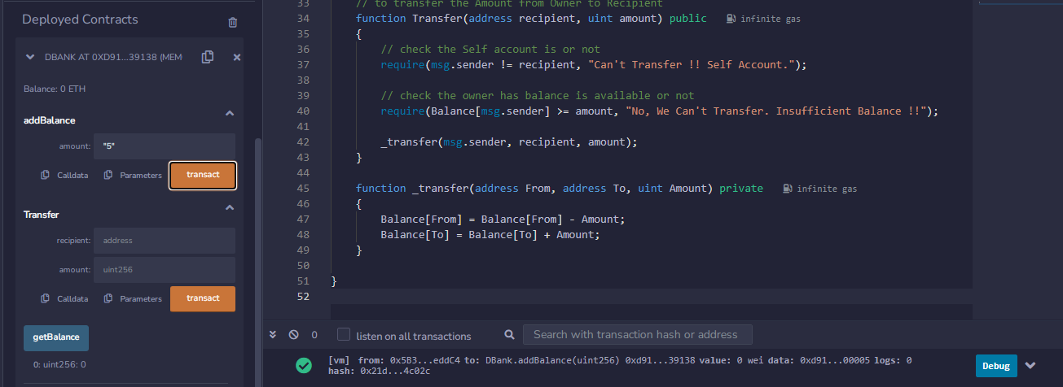

### 2. Transfer Balance and Check Balance

If the owner has to transfer money to another account then he required the address of the account and a sufficient amount of balance so that the transaction should be successful.

