CS323 Project Phrase 1 Report

12112421 王德涵 12112620 徐霄阳 12112822 孔繁初

**Lexical Analysis**

We use **Flex** for lexical analysis; the token specification is shown in the chart below:

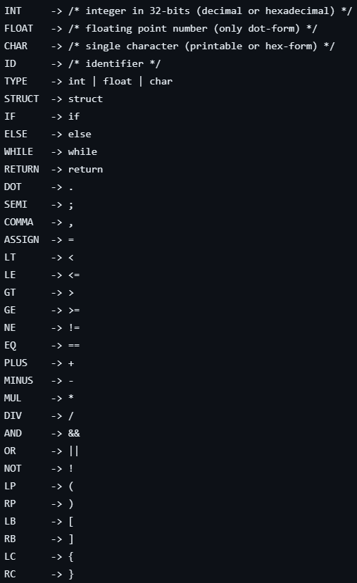

We also support **single and multiple line comment**:

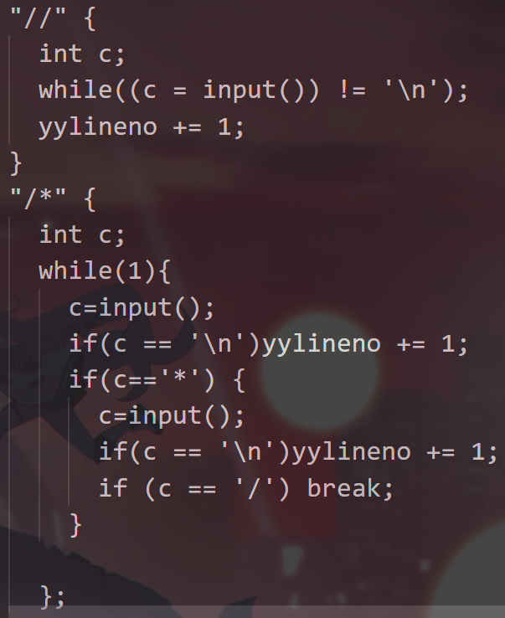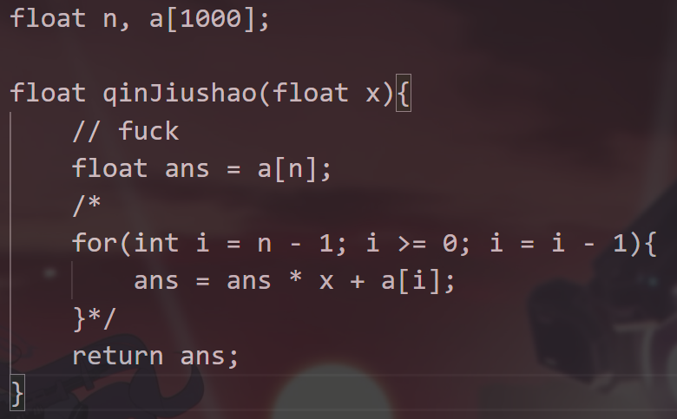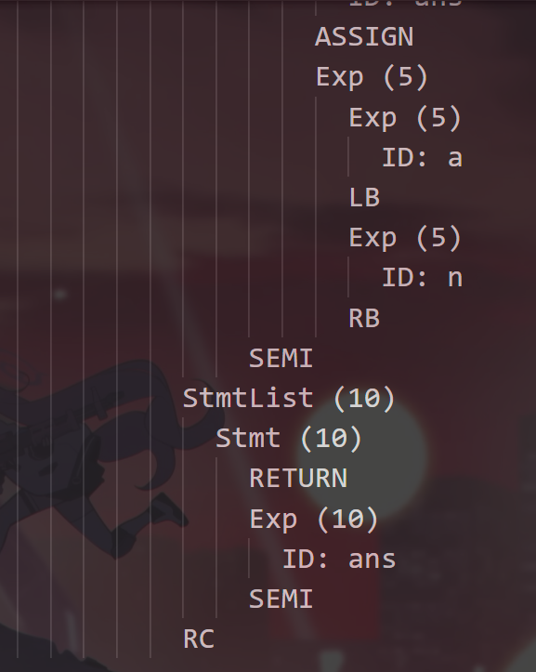

Furthermore, invalid hex char, hex number, id and undefined lexemes can also be detected.

**Syntax Analysis**

We use **Bison** for lexical analysis; our grammar design is based on the given grammar:

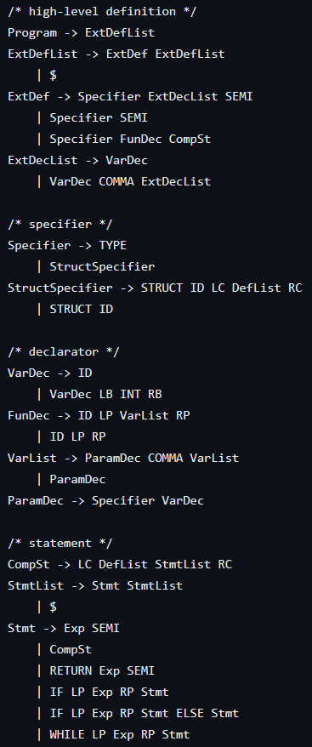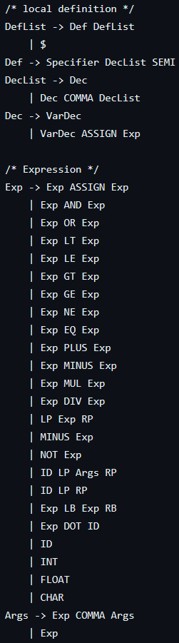

Furthermore, we also added the following syntax rule to deal with **empty statement**, **unexpected comma**, and **missing closing symbol**:

