Methodology:
To get IPM application measurements of TeraGrid systems [described elsewhere?], we leveraged a user-level monitoring tool called Inca, already in use by TeraGrid. Inca is a Grid monitoring tool designed to detect Grid infrastructure problems by executing automated, user-level testing of Grid software and services [1]. Originally designed for TeraGrid, Inca has been monitoring TeraGrid since 2003 and is also used in other large-scale global grid projects including ARCS [2], DEISA [3], and NGS [4]. Inca improves the reliability of Grid software and services by detecting user-level failures and providing detailed information about its tests and their execution to aid in debugging problems. Grid managers can use Inca to identify failure trends and verify that resource providers fulfill Grid requirements. System and administrators and users may use Inca to debug and resolve user account and environment issues.
A majority of the ~2500 Inca tests currently running on TeraGrid resources verify the individual tools and services provided by the “Common TeraGrid Software and Services” environment. These tests monitor basic tool and service functionality and interoperability with other components. Inca had previously limited testing of the batch queues in order to have a low impact on the systems it was monitoring. However, in doing so it was also missing a critical component of the user perspective. Because of IPM’s low overhead and the applications and their sizes [described elsewhere?], it was a natural fit to integrate Inca with IPM to get detailed user-level monitoring of HPC system capabilities while still maintaining low impact to the users.
To gather IPM application measurements from TeraGrid using Inca, a new deployment of Inca was installed on a server at SDSC called sapa.sdsc.edu, as shown in Figure1, and Inca clients were configured to run on NCSA’s Abe machine, NICS’ Kraken machine, and TACC’s Ranger machine. A small Inca IPM “reporter” script was written to handle IPM environment setup, application invocation, clean up, and ftp of IPM XML data files to a disk at SDSC. This Inca IPM reporter was coupled with a special “batch reporter” that submitted the Inca IPM reporter as a batch job to a machine’s particular batch queue system (e.g., SGE, PBS). To vary the machine measurements times, we configured Inca to execute each application twice day; once during work hours and once during night hours. To randomize the times, the batch reporter was invoked at 6am and 6pm, waited a random wait time between 0-12 hours, and then submitted the Inca IPM reporter to the batch queue. The number of measurements collected during March for each application varied due to machine downtimes or system errors as shown in Table 1. Note, that due to an unknown configuration problem on TACC’s Ranger, we were unable to get measurements for AMR.

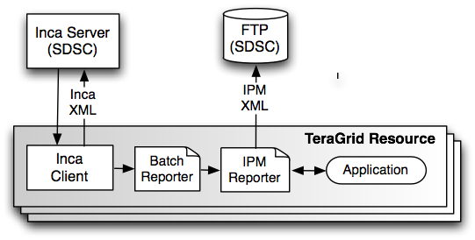
Figure 1: Inca deployment to collect IPM data from TeraGrid resources.

 | NCSA Abe | NICS Kraken | TACC Ranger
AMR | 60 | 37 | 0
IOR | 50 | 29 | 51
PARATEC | 38 | 22 | 36
WRF | 42 | 37 | 51
Table 1: Number of measurements collected for each application on TeraGrid machines

References:
[1] Smallen, S., Ericson, K., Hayes, J., and Olschanowsky, C. 2007. User-level grid monitoring with Inca 2. In Proceedings of the 2007 Workshop on Grid Monitoring (Monterey, California, USA, June 25 - 25, 2007). GMW '07. ACM, New York, NY, 29-38.
[2] The Australian Research Collaboration Service Web Page, http://www.arcs.org.au/.
[3] The Distributed European Infrastructure for Supercomputing Applications Web Page, http://www.deisa.eu.
[4] The National Grid Service Web Page, http://www.grid-support.ac.uk/.

