Inca TG GIG Report

Between April and June 2008, the Inca team finished a redesign of the Inca Web server that improves both its customization abilities and design. The Inca Web server is now based on to JSP 2.1 and Jetty 6 (from JSP 1.1 and Jetty 5) and also includes the following three new historical data views:

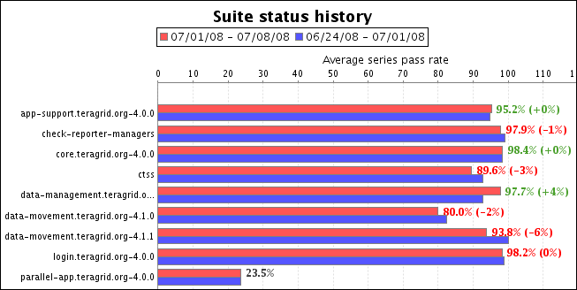
Figure 1 – Partial screenshot of weekly status report. Compares the test results grouped by kit for the past 7 days (red bar) to the previous week (blue bar) to show whether the average test pass rate was higher (highlighted in green), lower (highlighted in red), or did not change (highlighted in gray). Similar graphs are also created for each resource. Clicking on the bar in the figure above (e.g., core.teragrid.org-4.0.0) will show that kit status on each resource.

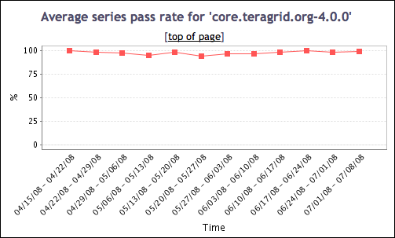
Figure 2 – Sample graph from historical summary test status page. Shows average test (series) pass rate for the core kit over the past 12 weeks. Graphs for the other kits and resources can also be found on this page.

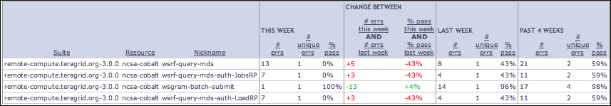
Figure 3 – Error history detail page. Shows the tests with errors in the past week in a sortable table and compares it to previous weeks to show what the trend (more or less errors) has been in the past. The statistics for the past 10 weeks is also included on this page.

In addition the above changes, the new version of the Inca Web server also provides an interface for creating customized views of latest test results, which can be queried in raw XML form or displayed in a HTML table. For example, we created a customized view for the portal group that contains the results of the SSH and batch job tests which they fetch in XML format and will summarize and display as an up/down arrow in their Resources viewer.

The Inca team also developed a plug-in for the TeraGrid Inca deployment that allows Inca to recognize scheduled downtimes. The new plug-in marks incoming test results with a special tag in the Inca database if they contain errors and come from a resource in downtime. The Inca Web pages then recognize the tag and display the errors neutrally. Similarly, the Inca team also started work to display errors in the all-to-all tests more fairly, i.e., to assign fault for all-to-all errors appropriately in historical reports (e.g., when a GRAM test from siteA to siteB fails because siteB’s server is not running, then it should be recorded that siteA was not at fault).

Two new machines were added to the TeraGrid deployment – Purdue’s condor resource and ANL’s RHEL test node (which subsequently replaced its ia64 login node). The Inca team added email notifications for all tests running on LSU and added new NCSA admin to notifications for the real-time tests. Overall, 16 TeraGrid tests were modified and 3 new tests were written, configured and deployed. At the time of this report, 2702 pieces of test data are being collected across TeraGrid platforms.

Inca also participated in, wrote minutes for, and sometimes led (depending on the AD’s availability) the bi-weekly TeraGrid operations calls from April – June. On alternating weeks when there were no operations calls, Inca distributed a written TeraGrid status summary and identified detected failures for the RP system administrators to address. The Inca team also participated in and responded to action items (e.g., custom tests and web pages) from weekly Gateway Debug (gateway-debug) calls from April – May and Architecture calls from April – June. Finally, we contributed a digital poster to TG08 and attended and participated in TG08 staff meetings.

