Inca

Between July and September 2010, the Inca team continued to support and maintain the Inca deployment on TeraGrid and helped system administrators to debug failures on their machines. In response to IIS changes and requests from the gig-pack, security and QA groups, existing Inca test suites were modified. Two existing TeraGrid reporters were also modified and deployed. At the time of this report 3,007 pieces of test data are being collected across TeraGrid platforms. Two machines, NICS’ Athena and NCSA’s Ember, were added to the Inca TeraGrid deployment during this time. TACC’s Ranch system was removed from Inca testing. A depot redundancy upgrade to the Inca TeraGrid deployment is still planned, which will allow data to continue to be collected and queried at another site if the SDSC server fails. The depot redundancy feature is currently being tested with TeraGrid Inca data.

The Inca team also worked with an UCSD undergraduate student over the summer to develop an Iphone webapp for the Inca Web status pages using JQuery APIs. Below are sample screenshots from a test deployment using TeraGrid data. We plan to deploy this in production next quarter.

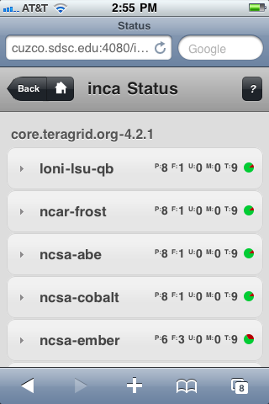  Summary status of a kit on multiple resources. | 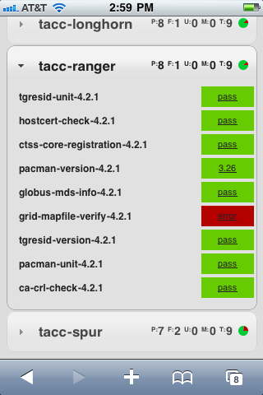  Status of kit tests for a single resource. | 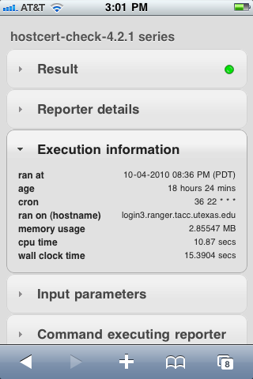  Detailed test execution information.

During the August Inca Workshop at SDSC, the Inca team met with a member of XD TAS to discuss collaboration and support for using Inca as part of their MoD portal.

Two members of the Inca team led the QA working group and monitored the activity of the operations working group. The activities of the QA group are described below.

Quality Assurance

Between July and September 2010, the QA group worked
- Continued GRAM5 testing

to test and debug CTSS services that the group considered to be most relevant for users. After reviewing CTSS usage and reliability last quarter, QA decided to focus on GRAM and GridFTP testing and debugging. In particular, evaluating the upcoming GRAM5 release was a high priority. The QA group collaborated with the Gateway working group in ongoing debugging discussion of GRAM5 experiences and participated in the TeraGrid user portal forum thread related to GRAM5 debugging. QA also monitored the activities of others involved in the GRAM5 release – mainly the Software and Gig-pack working groups. The QA group gathered its own early GRAM5 test results using Inca and compared them to results from other Gateway testing (the nanoHUB grid probes). While reviewing test errors the QA group discussed how errors are logged and subsequently submitted requests for improved logging to Globus developers. The GRAM5 test sources yielded different information – although the Inca testing was mostly successful because it was fairly lightweight, it did indicate a problem with lingering zombie processes that has since been addressed. The nanoHUB testing was successful overall on Lonestar but was mostly failing on Queenbee. The Queenbee issues are still being debugged and led to the administrator upgrading the GRAM5 software. Some of the differences between the Inca and nanoHUB testing are that Inca tests are submitted to the local GRAM service while nanoHUB submits them remotely, and nanoHUB doesn't take downtimes into account as Inca does. The QA group is currently beginning to leverage some of the previous Gateway GRAM scalability testing to run tests on a Ranger test node, where a GRAM5 installation was deployed for QA and is also now being used for Gateway testing. As the Ranger node will soon become a production login node, the QA group is investigating the possibility of using FutureGrid to continue testing.

In addition to the GRAM5 testing, the QA group created new tests for Condor-g matchmaking and Karnak. Tests for Condor were also updated as well as the usage reporter for GRAM. The group continued to monitor the CUE working group’s progress on its upcoming module release and will test CUE deployments when available. Also, the QA group recommended that the QBETS service be labeled as experimental in the user portal and documentation due to intermittent failures experienced by users and a lack of available tests to detect failures.

Finally, the QA group continued work to create a sustainable process for collecting and analyzing usage data in order to determine which services are most important to users. A member of the group wrote a script to automate the reporting of CTSS processing accounting data and the group created an informational wiki article to help explain the process of doing this: http://www.teragridforum.org/mediawiki/index.php?title=QA_Process_Accounting. Efforts to further automate this process and to generate consistent and meaningful reports are ongoing.

