Monitoring User-Level Grid Functionality and Performance Using Inca

<http://inca.sdsc.edu>

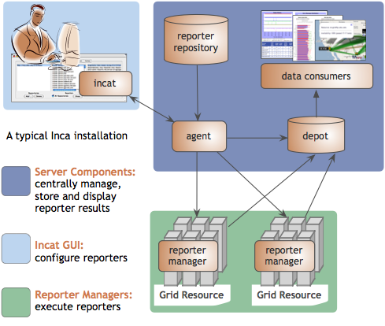Inca is a system that improves the reliability of Grid software and services by detecting user-level failures and providing detailed information about its tests and their execution to aid in debugging. Originally designed for the TeraGrid project, Inca has been monitoring TeraGrid since 2003 and is also used in other large-scale global Grid projects including ARCS, DEISA, and NGS. Grid managers can use Inca to identify failure trends and verify that resource providers fulfill operations requirements. System administrators and users may use Inca to debug and resolve user account and environment issues.

Figure : Inca deployment

Inca automates the installation, execution, and maintenance of a large variety and number of reporters (monitoring scripts) consistently across Grid resources. Monitoring results are collected, archived, and displayed through web status pages. The core of the Inca architecture is formed by four server components: the agent, depot, data consumer, and reporter repository (see Figure 1). The agent controls the deployment and maintenance of the Inca installation, while the depot provides data storage. A reporter repository contains a set of Grid tests and benchmarks, and the data consumer displays the collected results as web status pages. An additional Inca component called the reporter manager runs on each monitored resource to collect status and performance data. The final component of Inca is a GUI tool (incat) used by Inca administrators to configure and maintain their Inca deployments.

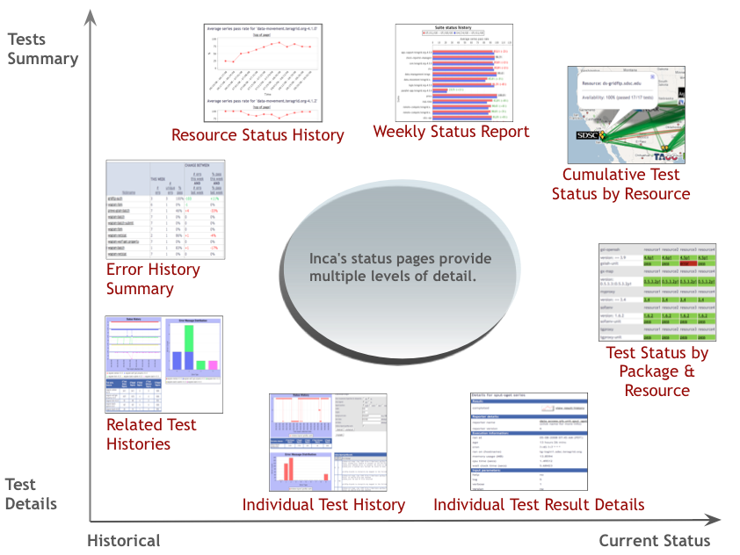Support from the SDCI award has enabled Inca to become a better tool for assessing and improving Grid stability. Inca has enhanced its web status pages to offer a range of Grid reliability and performance data views, from detailed test information to summary and historical reports (see Figure 2). Other major improvements include more interactive debugging support and fault tolerance of Inca components. New Inca deployments have been added to Open Source DataTurbine projects such as CREON and GLEON, the UC (University of California) Grid, and will soon be deployed to the new FutureGrid project. The current release of Inca is version 2.5.

Figure : Inca web status page views