Charlene Kritschmar, Lucie Kaffee

Ex 3

1. For each of the following seven program fragments, do the following:
- Give a Big-Oh analysis of the running time (you can even do this before you come to lab!)
Fragment #1
The complexity is O(N), because there is one loop in it.
Fragment #2
The complexity is O(N²), because there is a nested loop in it.
Fragment #3
It should be faster than #2 because it starts with i, so the bigger it gets, the bigger gets also the number where the inner loop starts. Anyways, the complexity is O(N²/2).
Fragment #4
First we thought, the complexity would be O(N²), but then we regognized, that there aren't curly brackets after the first loop to include the second one. Either the shift for the second loop is “false” or the curly braces are missing. Anyways, it will compile as it is now and so the complexity is O(2N), what equals O(N).
Fragment #5
There is a nested loop, but also n*n in the second loop, so it should be O(N²).
Fragment #6
There is a nested loops, but as in Fragment #4, it should be a bit faster, because the inner loop depends on the i of the first loop. So it should be O(N²).
Fragment #7
Something with O(N³).
- Implement the code in a simple main class and run it for several interesting values of N. What are interesting values?

We thought it would be a good idea to save the sums in an Array to print them out after the calulation. This didn't work at first. We think because if you set the numbers to 0, it kind of saves the ints as Integers in the Array and don't care about the old int anymore. So we had to change the “sum” in the fragments to the particular parts of the Array. Here is a before-after-picture:
Before:
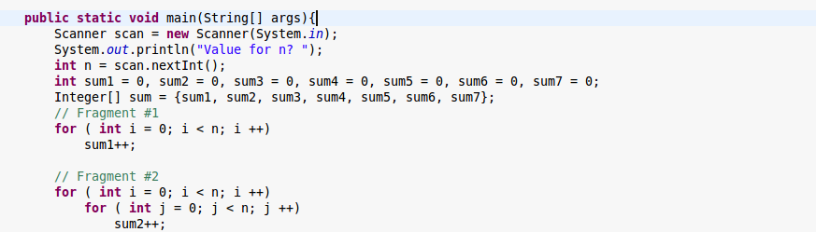

After:

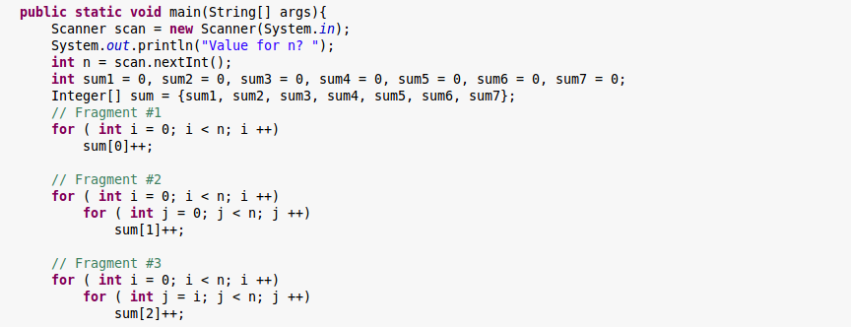
- Compare your analysis with the actual number of steps (i.e. the value of sum after the loop) for your report.
A prime number has no factors besides 1 and itself. Do the following:
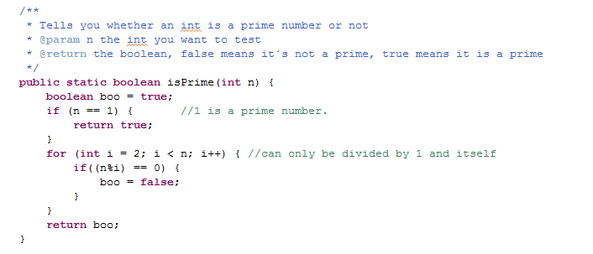
- Write a simple method
public static bool isPrime (int n) {...}
to determine if a positive integer N is prime.
Our first try looked like this:
- In terms of N, what is the worst-case running time of your program?
The worst case in the first try would be, if N is a prime number, because it has to go through all numbers less than N in the loop.
- Let B equal the number of bits in the binary representation of N. What is relationship between B and N?
- In terms of B, what is the worst-case running time of your program?
- Compare the running times needed to determine if a 20-bit number and a 40-bit number are prime by running 100 examples of each through your program. Report on the results in your lab report. You can use Excel to make some diagrams if you wish.

