LuCardioUNO v1.0 Assembly Specification

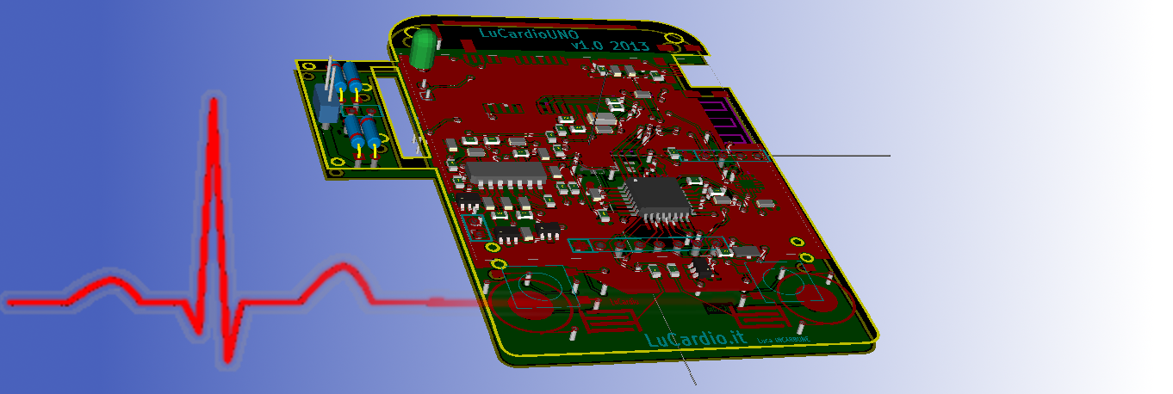
Including correction

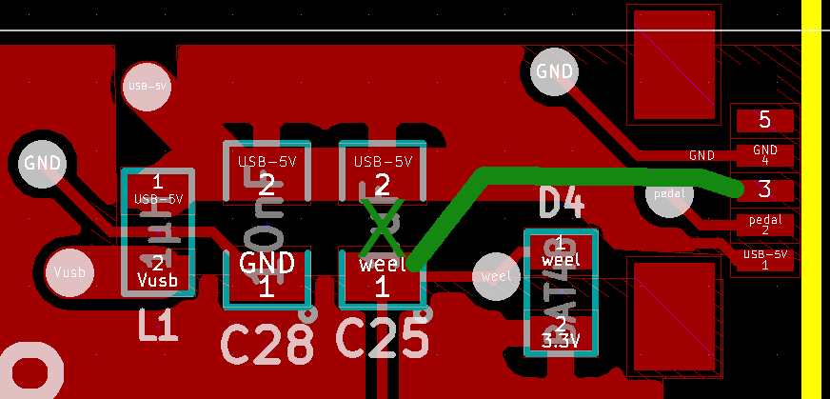
Weel sensor directly connected
USB PIN 5 have to be connected to GND
D4, D6, C25 not mounted
R19 not mounted if internal pull up resistor is set
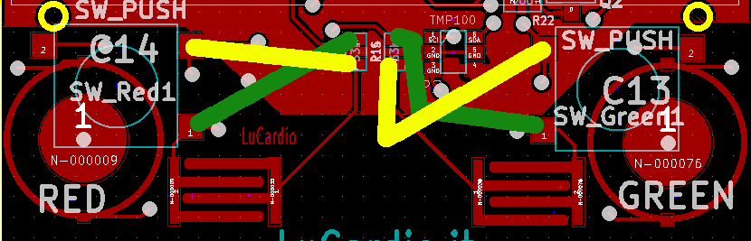
To use touch button do not mount R14 R15 connect

GSP serial/I2C bridge to add

LuCardioUNO 1.1
-Atmega1284P
-RF connection for belt
-contact-less sensor for HRB
-case for the battery

